**HW6:**

In all methods, the question asked to calculate GTE at the last solution point. Calculating the GTE at multiple points can be more computationally expensive and requires a slightly more sophisticated understanding of numerical error analysis. However, calculating the GTE at the last point can still provide a reasonable estimate of the error, especially for well-behaved numerical methods like the trapezoidal method. In general, calculating the GTE at multiple points is preferred, as it provides a more comprehensive picture of the error behavior over the entire solution domain. This allows for a more accurate assessment of the numerical method's performance and can help identify potential issues with stability or convergence.

The “forwardEuler function” is used for this method in the main script.

The **Forward Euler** method is a simple and explicit numerical technique used for solving ordinary differential equations. It is a first-order method that approximates the solution at the next time step based on the current value and the derivative at that point.

**Plots:** The main **black line** in each plot represents the numerical solution of “du/dt” vs “u”, obtained using the Forward Euler method. It shows how the solution evolves over time for different values of “u”. The **red line** in each plot represents the exact derivative du/dt calculated from the analytical solution. It provides a reference for the accuracy of the numerical solution. In smaller step sizes, the analytical solution and numerical solution converge better.

The degree to which the numerical solution matches the exact derivative indicates the order of accuracy of the Forward Euler method for different step sizes. Smaller step sizes generally lead to more accurate results. Comparing the numerical solution with the exact derivative helps assess the method's correctness and precision. If the solution becomes unstable or exhibits oscillations, it might indicate that the step size is too large.

|  |  |  |  |
| --- | --- | --- | --- |
| **Error 1** | **Error 2** | **Error 3** | **Error 4** |
| **4.04131189791742e-05** | **2.25367090515042e-05** | **4.95948183344870e-07** | **2.48203658844565e-07** |

The log-log plot of Global Truncation Error (GTE) versus step size helps analyze the convergence rate of the method. The slope of this plot is close to 1, indicating a first-order method as we expected, and the error decreases in each step. In this question, the Forward Euler is not efficient, and it will get worse as time goes on and goes further from the true solution. However, if we use smaller step sizes, it will perform better.

*“Calculated errors in different step sizes_ForwardEuler”*

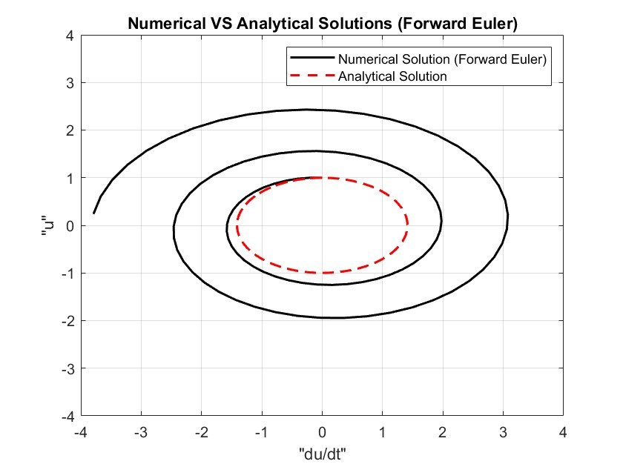

Slope of Forward Euler is 0.966258

The “backwardEuler function” is used for this method in the main script.

The **Backward Euler** method is an implicit numerical technique employed for solving ordinary differential equations. Unlike the Forward Euler method, it is **unconditionally stable** but requires solving nonlinear equations at each time step. The method approximates the solution at the next time step based on the derivative at that point, providing better stability for stiff ODEs, albeit with increased computational cost.

**Plots:** The log-log plot of GTE versus the step size helps assess the convergence behavior of the Backward Euler method. A slope close to 1 in the log-log plot suggests a first-order convergence, as the error decreases proportionally to the step size. The individual plots of the numerical solution (du/dt) versus u, along with the exact solution, help visualize how well the numerical method captures the behavior of the ODE. Discrepancies between the numerical and exact solutions, especially for larger step sizes, may indicate issues like numerical instability or a need for smaller step sizes. Smaller step sizes generally provide more accurate results, but the computational cost increases.

The slopes calculated and displayed give information about the order of accuracy. A slope closer to 1 suggests a first-order method which we have achieved in this question, and the error decreases in each step. Deviations from the expected slope may indicate issues or limitations with the Backward Euler method for the given ODE. In this question, the Backward Euler seems to be more efficient, but it is not perfect still. The advantage of this method is that it does not converge to infinity over time (despite the Forward Euler method).

|  |  |  |  |
| --- | --- | --- | --- |
| **Error 1** | **Error 2** | **Error 3** | **Error 4** |
| **5.87731183088911e-05** | **2.71265368668684e-05** | **4.97784208540464e-07** | **2.48662610548463e-07** |

*“Calculated errors in different step sizes_BackwardEuler”*

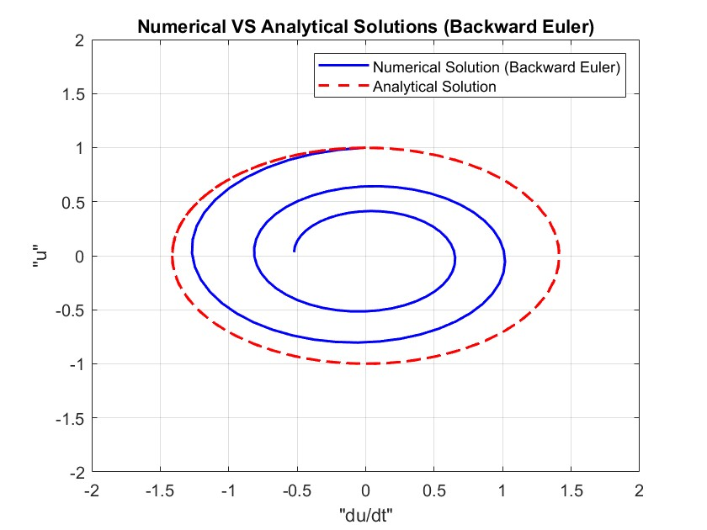

Slope of Backward Euler is 1.028165

Trapezoidal method: The “trapezoidal function” is used for this method in the main script.

The Trapezoidal method is a numerical integration technique used to approximate the solution of ordinary differential equations. The method calculates the solution at discrete time steps, iteratively updating the solution based on the trapezoidal rule, which combines the values of the function at the current and next time steps. The trap method performs better in comparison to the two other methods and converges to exact solutions much better.

In a well-behaved numerical method, the GTE should decrease as the step size decreases. The slope of the log-log plot provides information about the order of accuracy of the method; ideally, it should match the expected order which is 2. In this question, we will achieve the order of accuracy of 2 which we expected.

|  |  |  |  |
| --- | --- | --- | --- |
| **Error 1** | **Error 2** | **Error 3** | **Error 4** |
| **4.71400900043783e-06** | **1.17849967929372e-06** | **4.71420924866295e-10** | **1.17850364016181e-10** |

*“Calculated errors in different step sizes_Trapezoidal”*

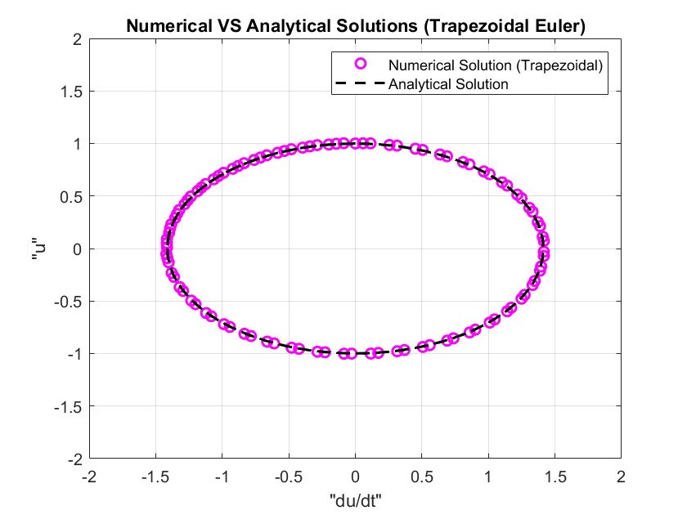

Slope of Trapezoidal is 1.999996.

Here is the GTE versus step size at the last  
solution point for all three methods. The order of accuracy for backward and forward Euler is close to 1, and for trapezoidal is close to 2.

