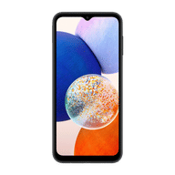
Samsung Galaxy A14 5G

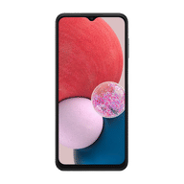
Samsung Galaxy A13

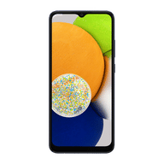
Samsung Galaxy A03

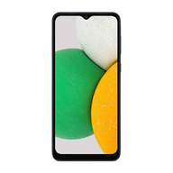
Samsung Galaxy A03 Core

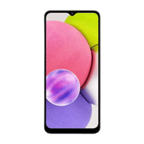
Samsung Galaxy A03s

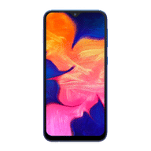
Samsung Galaxy A10

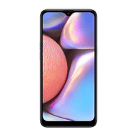
Samsung Galaxy A10s

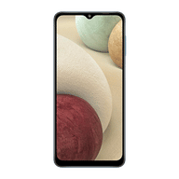
Samsung Galaxy A12

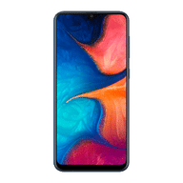
Samsung Galaxy A20

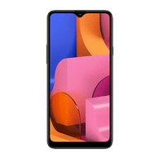
Samsung Galaxy A20s

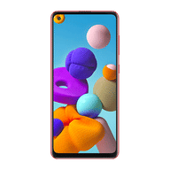
Samsung Galaxy A21s

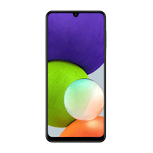
Samsung Galaxy A22


Samsung Galaxy A22 5G

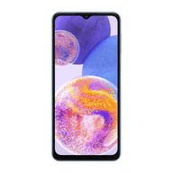
Samsung Galaxy A23

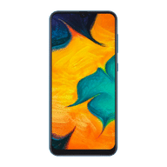
Samsung Galaxy A30

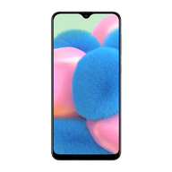
Samsung Galaxy A30s

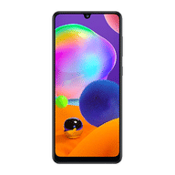
Samsung Galaxy A31

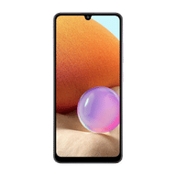
Samsung Galaxy A32

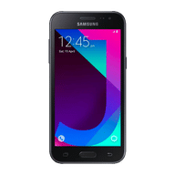
Samsung Galaxy A5 2017

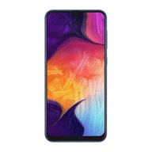
Samsung Galaxy A50

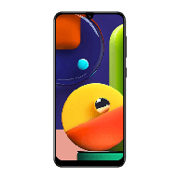
Samsung Galaxy A50s

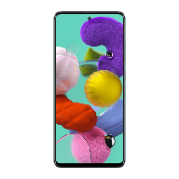
Samsung Galaxy A51

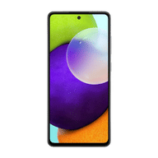
Samsung Galaxy A52

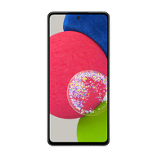
Samsung Galaxy A52s 5G

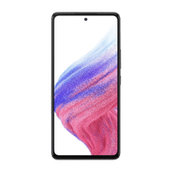
Samsung Galaxy A53 5G

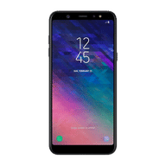
Samsung Galaxy A6

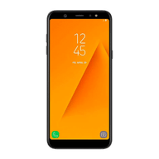
Samsung Galaxy A6 Plus

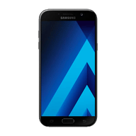
Samsung Galaxy A7 (2017)

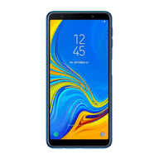
Samsung Galaxy A7 (2018)

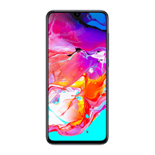
Samsung Galaxy A70

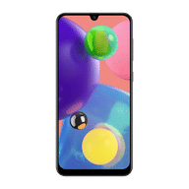
Samsung Galaxy A70s

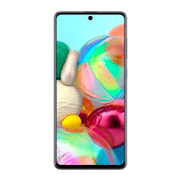
Samsung Galaxy A71

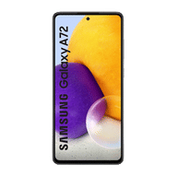
Samsung Galaxy A72

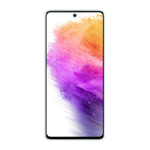
Samsung Galaxy A73 5G

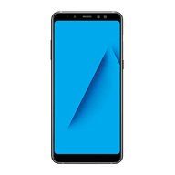
Samsung Galaxy A8 Plus

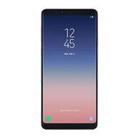
Samsung Galaxy A8 Star

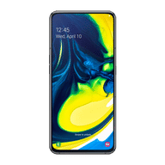
Samsung Galaxy A80

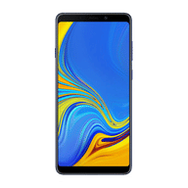
Samsung Galaxy A9 2018

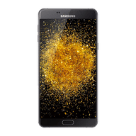
Samsung Galaxy A9 Pro

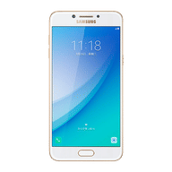
Samsung Galaxy C5 Pro

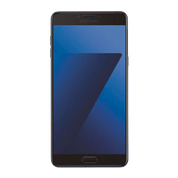
Samsung Galaxy C7 Pro

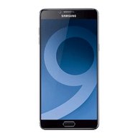
Samsung Galaxy C9 Pro

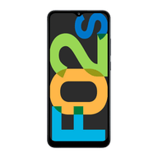
Samsung Galaxy F02s

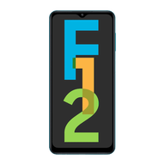
Samsung Galaxy F12

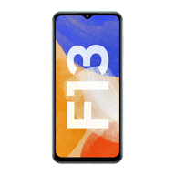
Samsung Galaxy F13

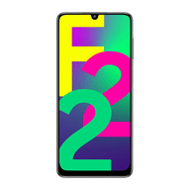
Samsung Galaxy F22

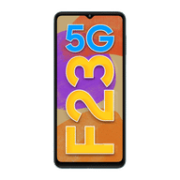
Samsung Galaxy F23 5G

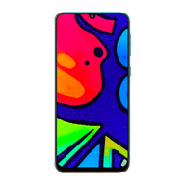
Samsung Galaxy F41

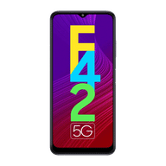
Samsung Galaxy F42 5G

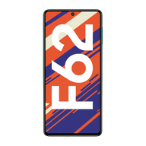
Samsung Galaxy F62

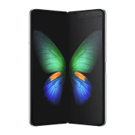
Samsung Galaxy Fold

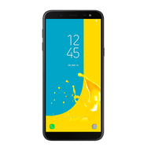
Samsung Galaxy J6

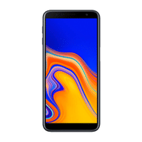
Samsung Galaxy J6 Plus

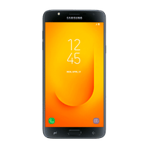
Samsung Galaxy J7 Duo

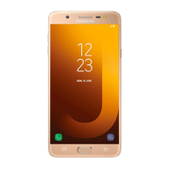
Samsung Galaxy J7 Max

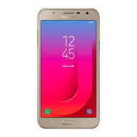
Samsung Galaxy J7 Nxt

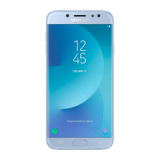
Samsung Galaxy J7 Pro

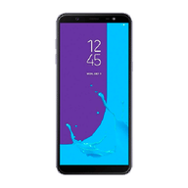
Samsung Galaxy J8

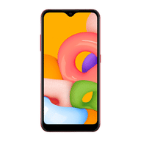
Samsung Galaxy M01

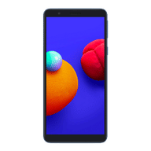
Samsung Galaxy M01 Core

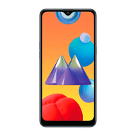
Samsung Galaxy M01s

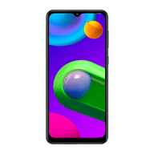
Samsung Galaxy M02

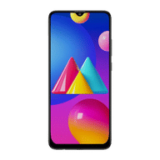
Samsung Galaxy M02s

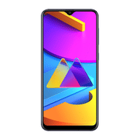
Samsung Galaxy M10s

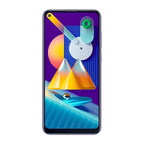
Samsung Galaxy M11

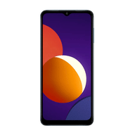
Samsung Galaxy M12

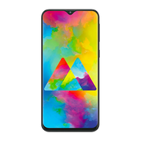
Samsung Galaxy M20

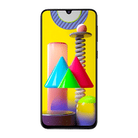
Samsung Galaxy M21

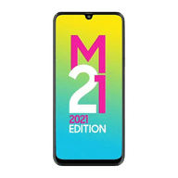
Samsung Galaxy M21 2021 Edition

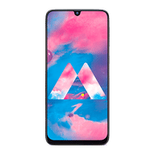
Samsung Galaxy M30

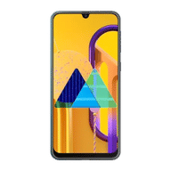
Samsung Galaxy M30s

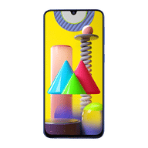
Samsung Galaxy M31

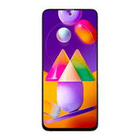
Samsung Galaxy M31s

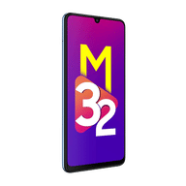
Samsung Galaxy M32

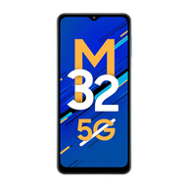
Samsung Galaxy M32 5G

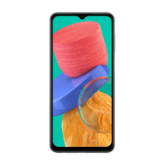
Samsung Galaxy M33 5G

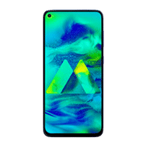
Samsung Galaxy M40

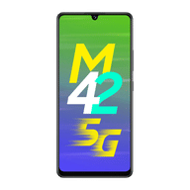
Samsung Galaxy M42 5G

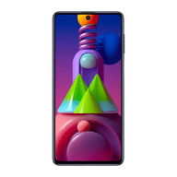
Samsung Galaxy M51

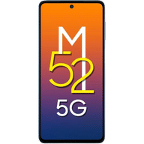
Samsung Galaxy M52 5G

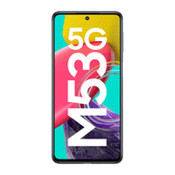
Samsung Galaxy M53 5G

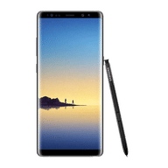
Samsung Galaxy Note 8

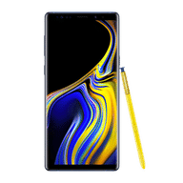
Samsung Galaxy Note 9

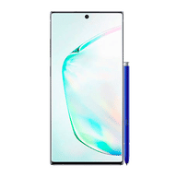
Samsung Galaxy Note 10

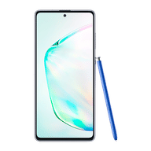
Samsung Galaxy Note 10 Lite


Samsung Galaxy Note 10 Plus

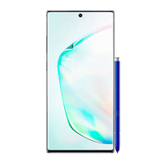
Samsung Galaxy Note 10 Plus 5G

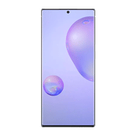
Samsung Galaxy Note 20

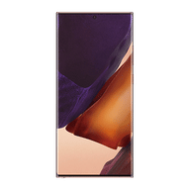
Samsung Galaxy Note 20 Ultra 5G

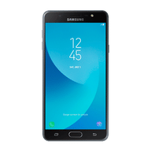
Samsung Galaxy On Max

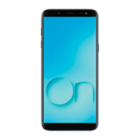
Samsung Galaxy On6

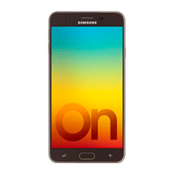
Samsung Galaxy On7 Prime

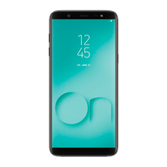
Samsung Galaxy On8 (2018)

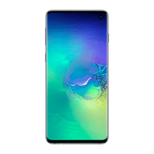
Samsung Galaxy S10

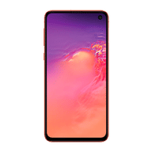
Samsung Galaxy S10e

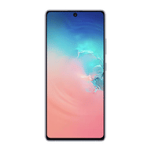
Samsung Galaxy S10 Lite

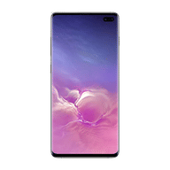
Samsung Galaxy S10 Plus

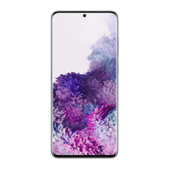
Samsung Galaxy S20

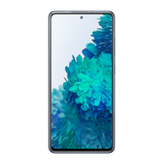
Samsung Galaxy S20 FE

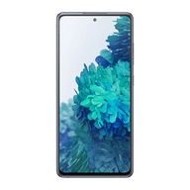
Samsung Galaxy S20 FE 5G

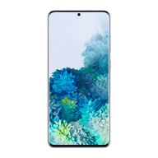
Samsung Galaxy S20 Plus

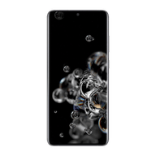
Samsung Galaxy S20 Ultra

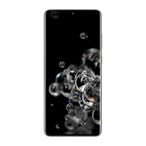
Samsung Galaxy S20 Ultra 5G

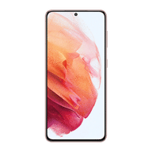
Samsung Galaxy S21 5G

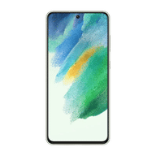
Samsung Galaxy S21 FE 5G

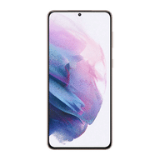
Samsung Galaxy S21 Plus 5G

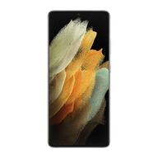
Samsung Galaxy S21 Ultra 5G

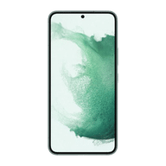
Samsung Galaxy S22 5G

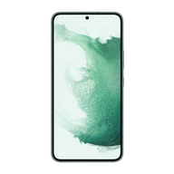
Samsung Galaxy S22 Plus 5G

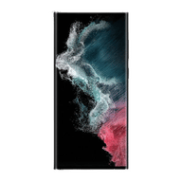
Samsung Galaxy S22 Ultra 5G

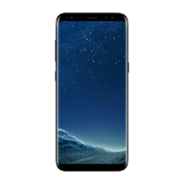
Samsung Galaxy S8

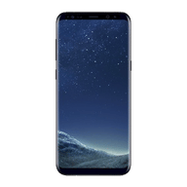
Samsung Galaxy S8 Plus

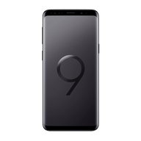
Samsung Galaxy S9

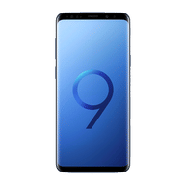
Samsung Galaxy S9 Plus

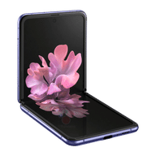
Samsung Galaxy Z Flip

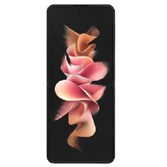
Samsung Galaxy Z Flip3 5G

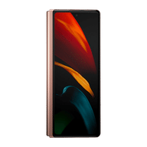
Samsung Galaxy Z Fold2 5G

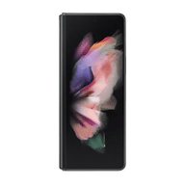
Samsung Galaxy Z Fold3 5G

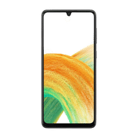
Samsung Galaxy A33 5G

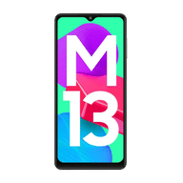
Samsung Galaxy M13

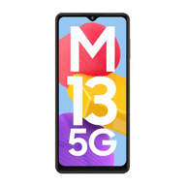
Samsung Galaxy M13 5G

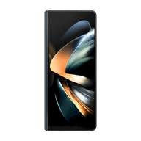
Samsung Galaxy Z Fold4

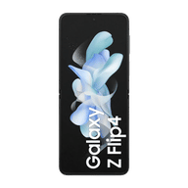
Samsung Galaxy Z Flip4

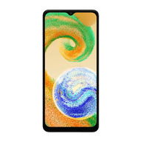
Samsung Galaxy A04s

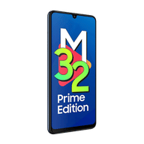
Samsung Galaxy M32 Prime Edition

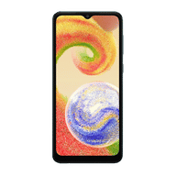
Samsung Galaxy A04

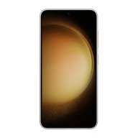
Samsung Galaxy S23 5G

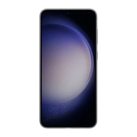
Samsung Galaxy S23 Plus 5G

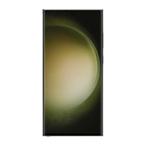
Samsung Galaxy S23 Ultra 5G

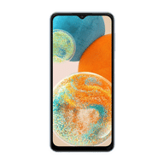
Samsung Galaxy A23 5G

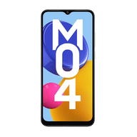
Samsung Galaxy M04

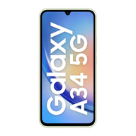
Samsung Galaxy A34 5G

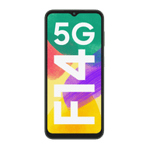
Samsung Galaxy F14 5G

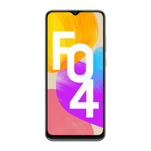
Samsung Galaxy F04

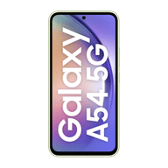
Samsung Galaxy A54 5G

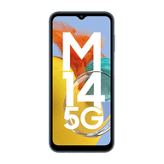
Samsung Galaxy M14 5G

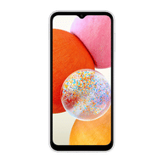
Samsung Galaxy A14

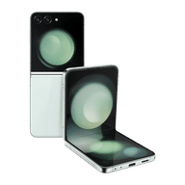
Samsung Galaxy Z Flip5

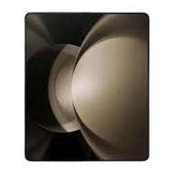
Samsung Galaxy Z Fold5

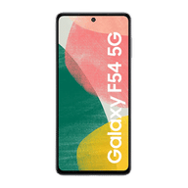
Samsung Galaxy F54 5G

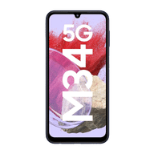
Samsung Galaxy M34 5G

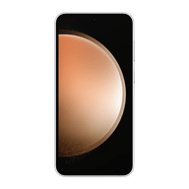
Samsung Galaxy S23 FE 5G

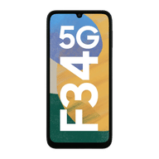
Samsung Galaxy F34 5G

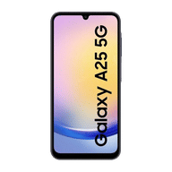
Samsung Galaxy A25 5G

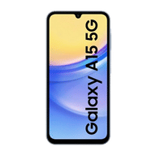
Samsung Galaxy A15 5G

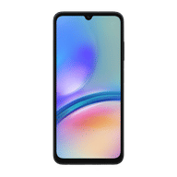
Samsung Galaxy A05s

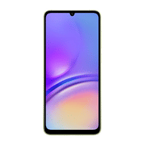
Samsung Galaxy A05

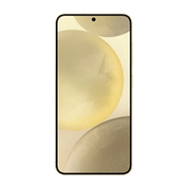
Samsung Galaxy S24 5G

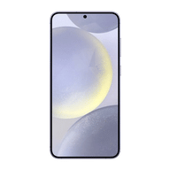
Samsung Galaxy S24 Plus 5G

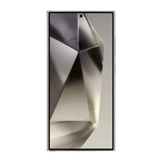
Samsung Galaxy S24 Ultra 5G

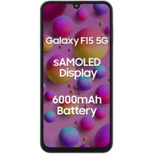
Samsung Galaxy F15 5G

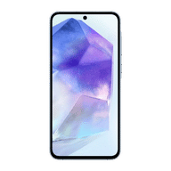
Samsung Galaxy A55 5G

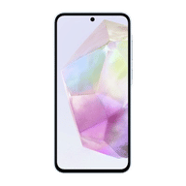
Samsung Galaxy A35 5G

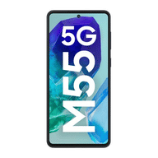
Samsung Galaxy M55 5G

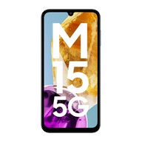
Samsung Galaxy M15 5G

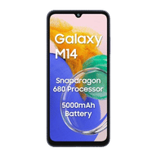
Samsung Galaxy M14 4G

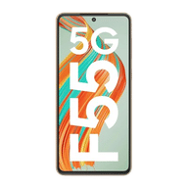
Samsung Galaxy F55 5G

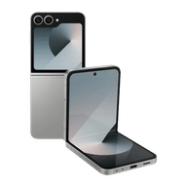
Samsung Galaxy Z Flip6 5G

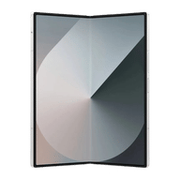
Samsung Galaxy Z Fold6 5G

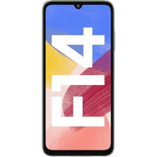
Samsung Galaxy F14

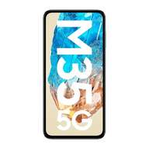
Samsung Galaxy M35 5G

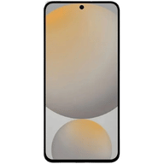
Samsung Galaxy S24 FE 5G

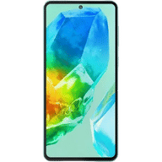
Samsung Galaxy M55s 5G

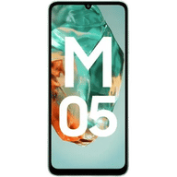
Samsung Galaxy M05

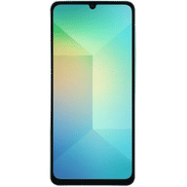
Samsung Galaxy A06

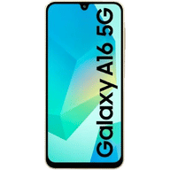
Samsung Galaxy A16 5G

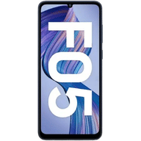
Samsung Galaxy F05

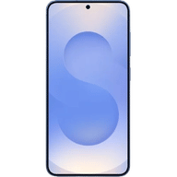
Samsung Galaxy S25 5G

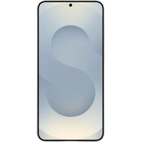
Samsung Galaxy S25 Plus 5G

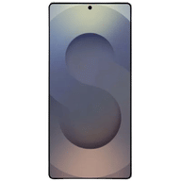
Samsung Galaxy S25 Ultra 5G

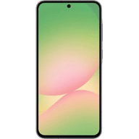
Samsung Galaxy A56 5G

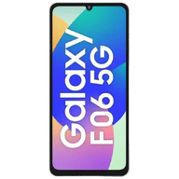
Samsung Galaxy F06 5G

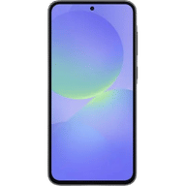
Samsung Galaxy A36 5G

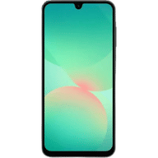
Samsung Galaxy A26 5G

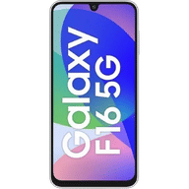
Samsung Galaxy F16 5G

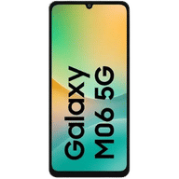
Samsung Galaxy M06 5G

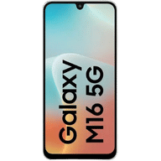
Samsung Galaxy M16 5G

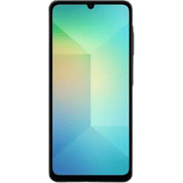
Samsung Galaxy A06 5G

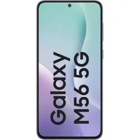
Samsung Galaxy M56 5G

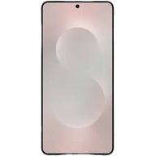
Samsung Galaxy S25 Edge

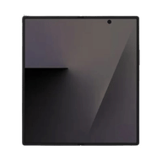
Samsung Galaxy Z Fold 7

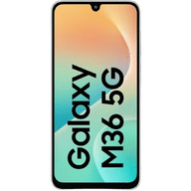
Samsung Galaxy M36 5G

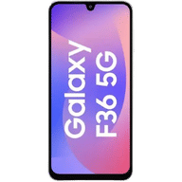
Samsung Galaxy F36 5G

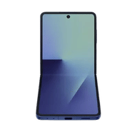
Samsung Galaxy Z Flip 7

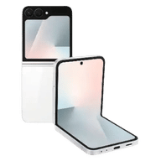
Samsung Galaxy Z Flip7 FE 5G

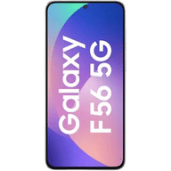
Samsung Galaxy F56 5G

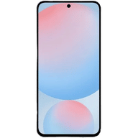
Samsung Galaxy A17 5G

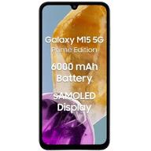
Samsung Galaxy M15 5G Prime Edition

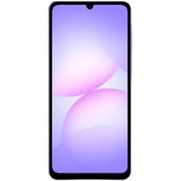
Samsung Galaxy A07

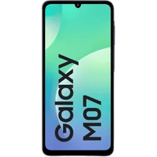
Samsung Galaxy M07

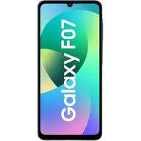
Samsung Galaxy F07

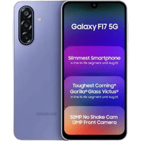
Samsung Galaxy F17 5G

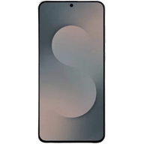
Samsung Galaxy S25 FE

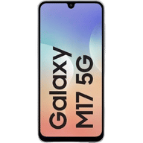
Samsung Galaxy M17 5G

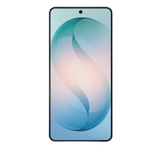
Samsung Galaxy S26

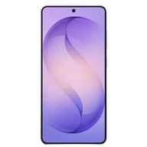
Samsung Galaxy S26 Plus


Samsung Galaxy S26 Ultra

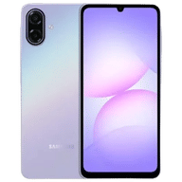
Samsung Galaxy A07 5G

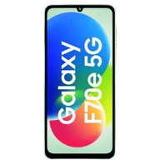
Samsung Galaxy F70e 5G

