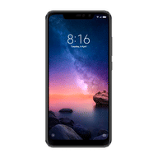
Xiaomi Redmi Note 6 Pro

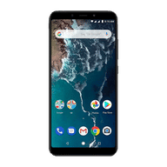
Xiaomi Mi A2

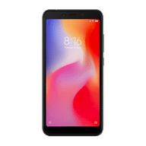
Xiaomi Redmi 6

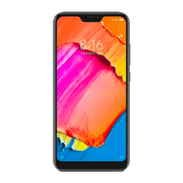
Xiaomi Redmi 6 pro

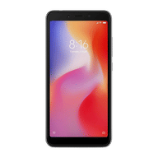
Xiaomi Redmi 6A

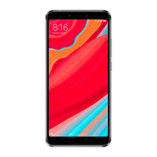
Xiaomi Redmi Y2

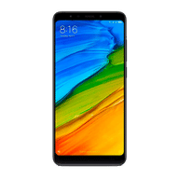
Xiaomi Redmi 5

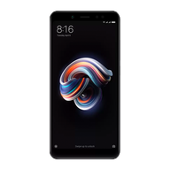
Xiaomi Redmi Note 5 Pro

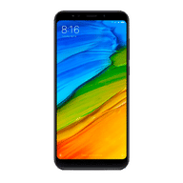
Xiaomi Redmi Note 5

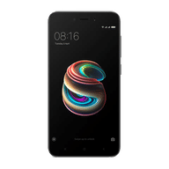
Xiaomi Redmi 5A

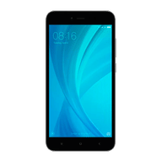
Xiaomi Redmi Y1

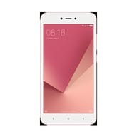
Redmi Y1 Lite


Mi Mix 2

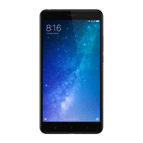
Xiaomi Mi Max 2

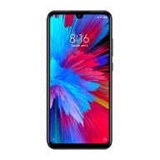
Xiaomi Redmi Note 7

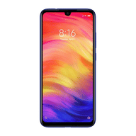
Xiaomi Redmi Note 7 Pro

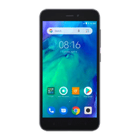
Xiaomi Redmi Go

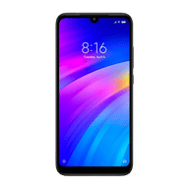
Xiaomi Redmi 7

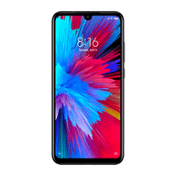
Xiaomi Redmi Note 7S

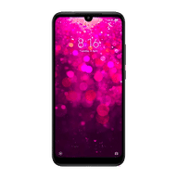
Xiaomi Redmi Y3

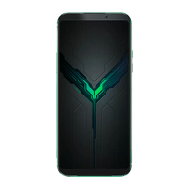
Xiaomi Black Shark 2

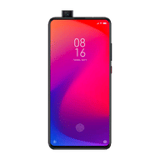
Xiaomi Redmi K20

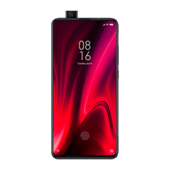
Xiaomi Redmi K20 Pro

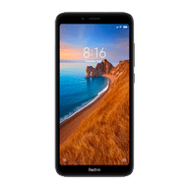
Xiaomi Redmi 7A

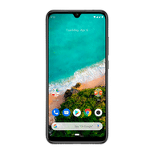
Xiaomi Mi A3

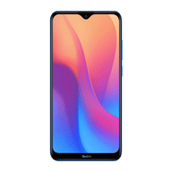
Xiaomi Redmi 8A

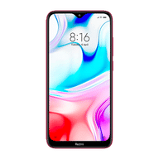
Redmi 8

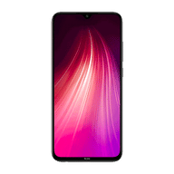
Xiaomi Redmi Note 8

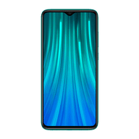
Xiaomi Redmi Note 8 Pro

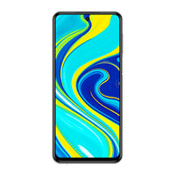
Xiaomi Redmi Note 9 Pro

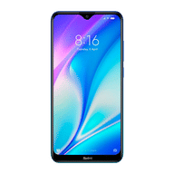
Xiaomi Redmi 8A Dual

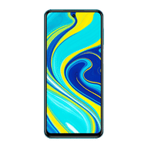
Xiaomi Redmi Note 9 Pro Max

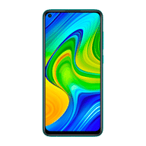
Xiaomi Redmi Note 9

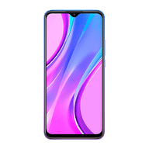
Xiaomi Redmi 9 Prime

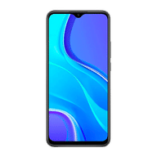
Xiaomi Redmi 9

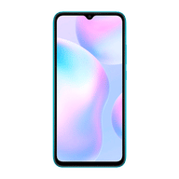
Xiaomi Redmi 9A

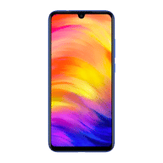
Xiaomi Redmi 9i

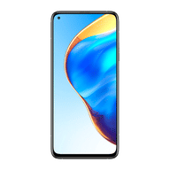
Xiaomi Mi 10T

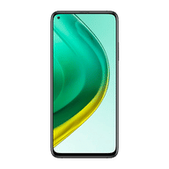
Mi 10T Pro


Xiaomi Mi 10i

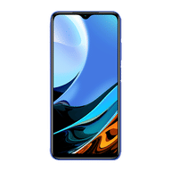
Xiaomi Redmi 9 Power

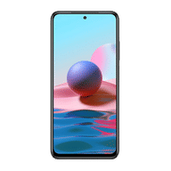
Xiaomi Redmi Note 10

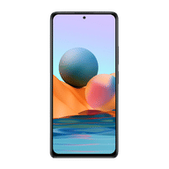
Xiaomi Redmi Note 10 Pro


Xiaomi Redmi Note 10 Pro Max

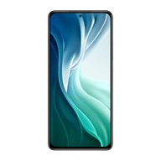
Xiaomi Mi 11X Pro

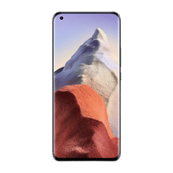
Mi 11 Ultra


Xiaomi Mi 11X

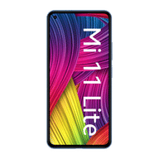
Xiaomi Mi 11 Lite

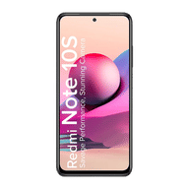
Xiaomi Redmi Note 10s

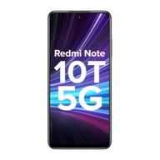
Xiaomi Redmi Note 10T 5G

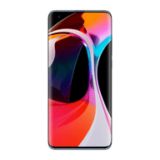
Xiaomi Mi 10

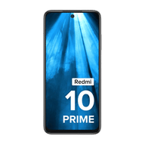
Xiaomi Redmi 10 Prime

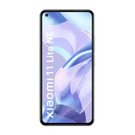
Xiaomi 11 Lite NE 5G

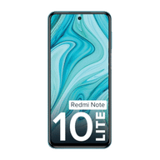
Xiaomi Redmi Note 10 Lite


Xiaomi Redmi Note 11T 5G

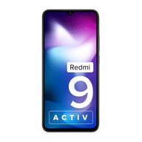
Xiaomi Redmi 9 Activ

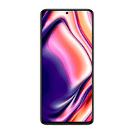
Xiaomi 11i 5G

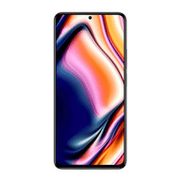
Xiaomi 11i HyperCharge 5G

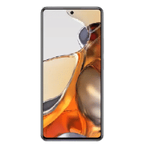
Xiaomi 11T Pro 5G

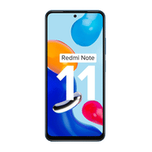
Xiaomi Redmi Note 11

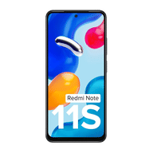
Xiaomi Redmi Note 11S

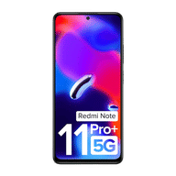
Xiaomi Redmi Note 11 Pro Plus 5G

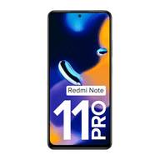
Xiaomi Redmi Note 11 Pro

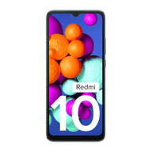
Xiaomi Redmi 10

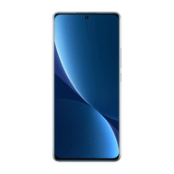
Xiaomi 12 Pro 5G

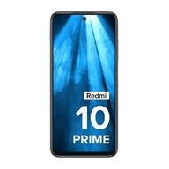
Xiaomi Redmi 10 Prime 2022

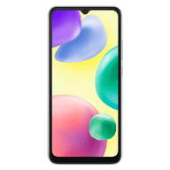
Xiaomi Redmi 10A

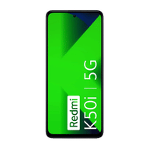
Xiaomi Redmi K50i 5G

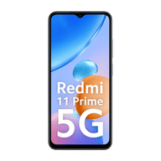
Xiaomi Redmi 11 Prime 5G

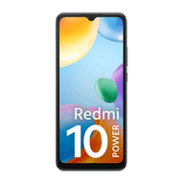
Redmi 10 Power

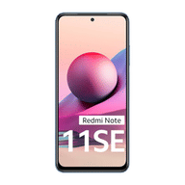
Redmi Note 11SE

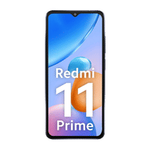
Xiaomi Redmi 11 Prime

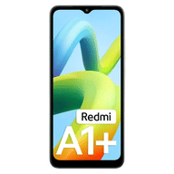
Xiaomi Redmi A1 Plus

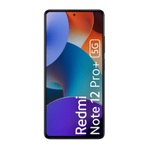
Xiaomi Redmi Note 12 Pro Plus 5G


Xiaomi Redmi Note 12 5G

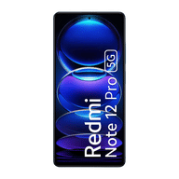
Xiaomi Redmi Note 12 Pro 5G

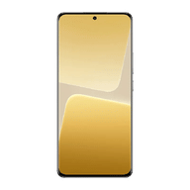
13 Pro 5G

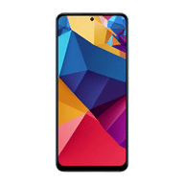
Xiaomi Redmi Note 12

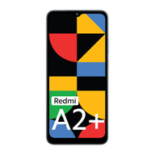
Xiaomi Redmi A2 Plus

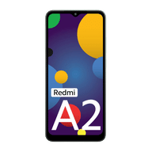
Xiaomi Redmi A2

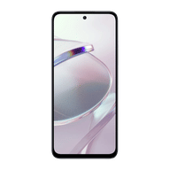
Xiaomi Redmi 12 5G

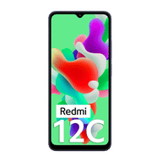
Xiaomi Redmi 12C

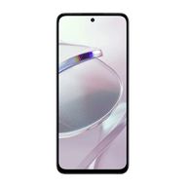
Xiaomi Redmi 12

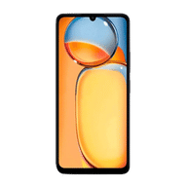
Xiaomi Redmi 13C

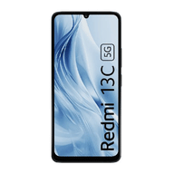
Xiaomi Redmi 13C 5G

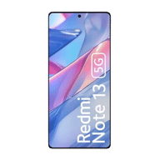
Xiaomi Redmi Note 13 5G

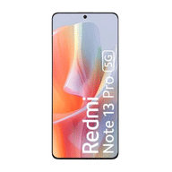
Xiaomi Redmi Note 13 Pro 5G

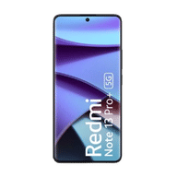
Xiaomi Redmi Note 13 Pro Plus 5G

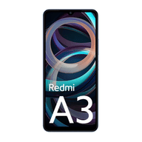
Xiaomi Redmi A3

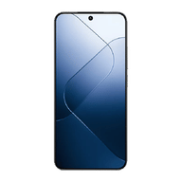
14

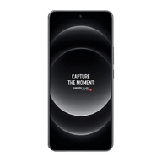
14 Ultra

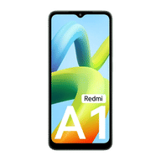
Redmi A1

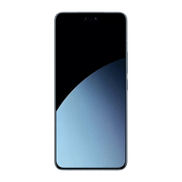
Xiaomi 14 CIVI

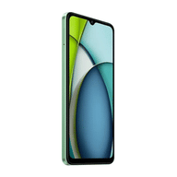
Xiaomi Redmi A3x

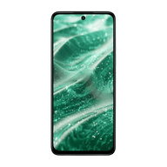
Xiaomi Redmi 13 5G

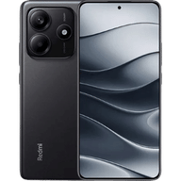
Xiaomi Redmi Note 14 5G

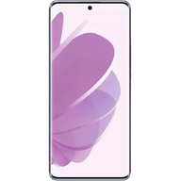
Xiaomi Redmi Note 14 Pro 5G

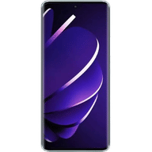
Xiaomi Redmi Note 14 Pro Plus 5G

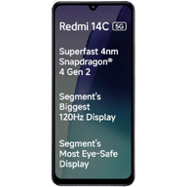
Xiaomi Redmi 14C 5G

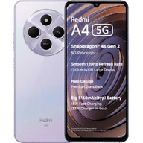
Xiaomi Redmi A4 5G

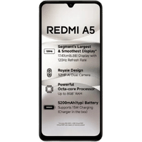
Xiaomi Redmi A5

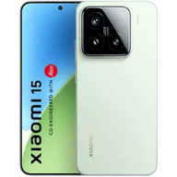
15

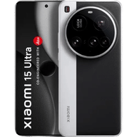
15 Ultra

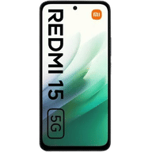
Xiaomi Redmi 15 5G

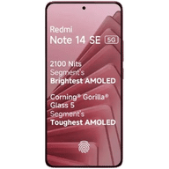
Xiaomi Redmi Note 14 SE 5G

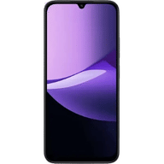
Xiaomi Redmi 15C 5G

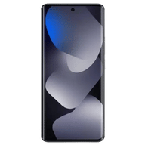
Xiaomi Redmi Note 15 5G

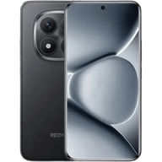
Xiaomi Redmi Note 15 Pro 5G

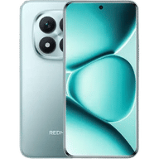
Xiaomi Redmi Note 15 Pro Plus 5G

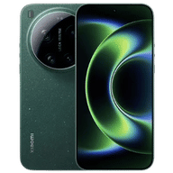
17 Ultra

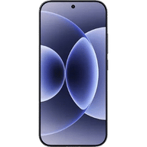
Xiaomi 17

