**Create project**

$ mvn archetype:generate -DgroupId=com.zaghir.project -DartifactId=hellomaven -DarchetypeArtifactId=maven-archetype-quickstart -DinteractiveMode=false

archetype = plugin

generate = goal

archetypeArtifactId = type of project (template)

maven-archetype-quickstart = template

interactiveMode = false == not select group arteacte

Profile maven

-P = profile  
mvn clean install -Pdev  
mvn clean install -Ppod  
mvn clean install -Ptest

Download Sonatype Nexus

<https://help.sonatype.com/repomanager3/product-information/download>

<https://hub.docker.com/r/sonatype/nexus3/>

<https://www.baeldung.com/ops/docker-cannot-connect>

$ wsl

$ systemctl start docker

$ sudo dockerd

In oder cls

$ wsl

$ docker run -d -p 8082:8081 --name nexus sonatype/nexus3

$ docker images

REPOSITORY TAG IMAGE ID CREATED SIZE

sonatype/nexus3 latest d2fd210c6f4c 7 days ago 545MB

$ docker container ls

CONTAINER ID IMAGE COMMAND CREATED STATUS PORTS NAMES

79f33dda77ac sonatype/nexus3 "/opt/sonatype/nexus…" About a minute ago Up About a minute 0.0.0.0:8081->8081/tcp, :::8081->8081/tcp nexus

<http://localhost:8081/>

wait a few miniutes

Password nexus

$ docker container exec nexus cat /nexus-data/admin.password

root@PAR-N-PW10-5273:/mnt/c/Users/yzaghir/Downloads/java_udemy/java10and14/target/classes/com/zaghir/projet/java13and14# docker container exec nexus cat /nexus-data/admin.password

**add4d476-eb3c-4c60-88f3-1056f0a16ed4**root@PAR-N-PW10-5273:/mnt/c/Users/yzaghir/Downloads/java_udemy/java10and14/target/classes/com/zaghir/projet/java13and14#

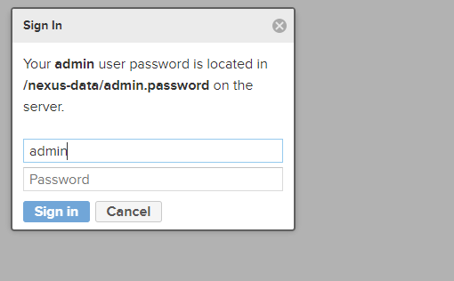

docker logs -f nexus

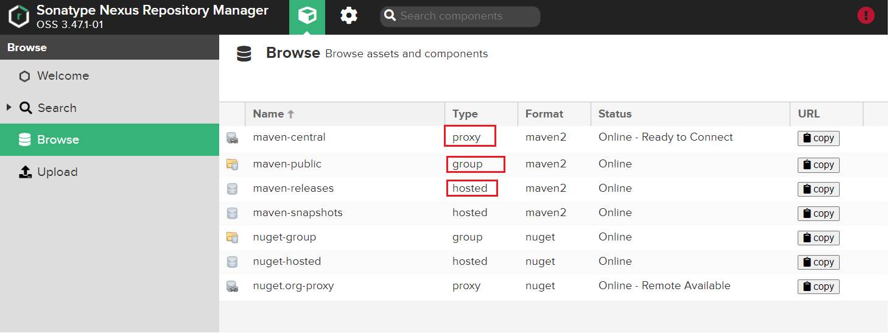

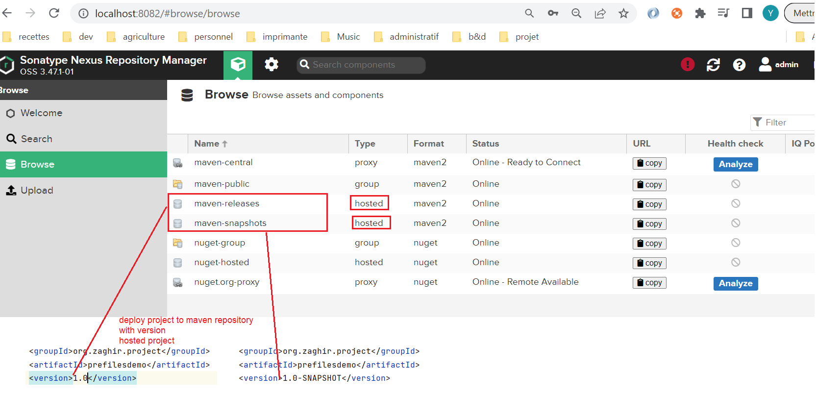

**Proxy**

proxy it will cache all the those dependencies that are there on the central repository or any other repository locally within your organization

**Group**

This is not a repository of its own, but it is a collection or repositories , as the name itself says

Instead of having Maven releases, maven snapshots on maven central in your configuration ,you will create a maven group and then he will use that maybe a group within your configuration files

**Create new repository**

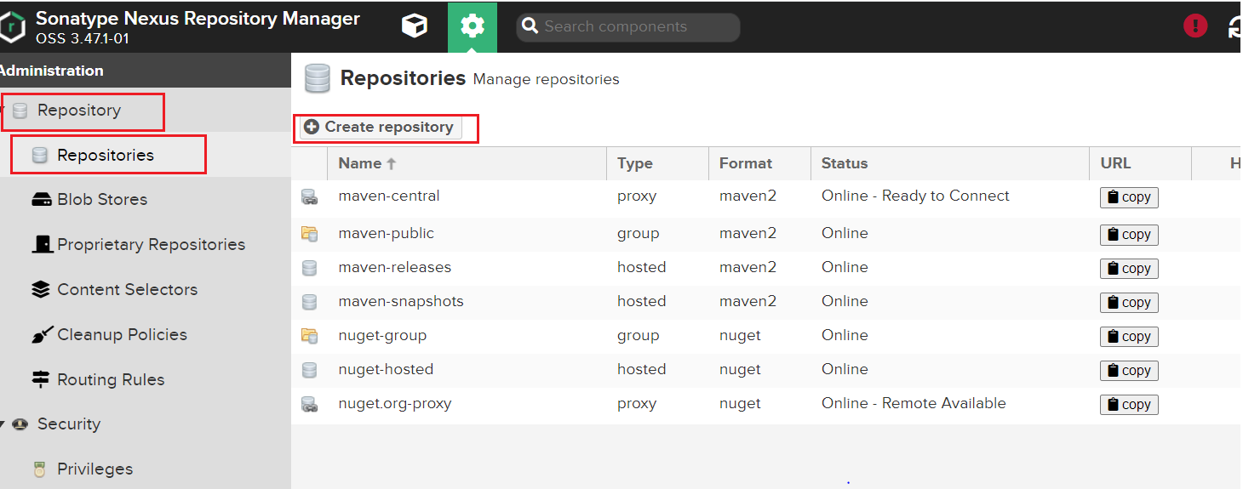

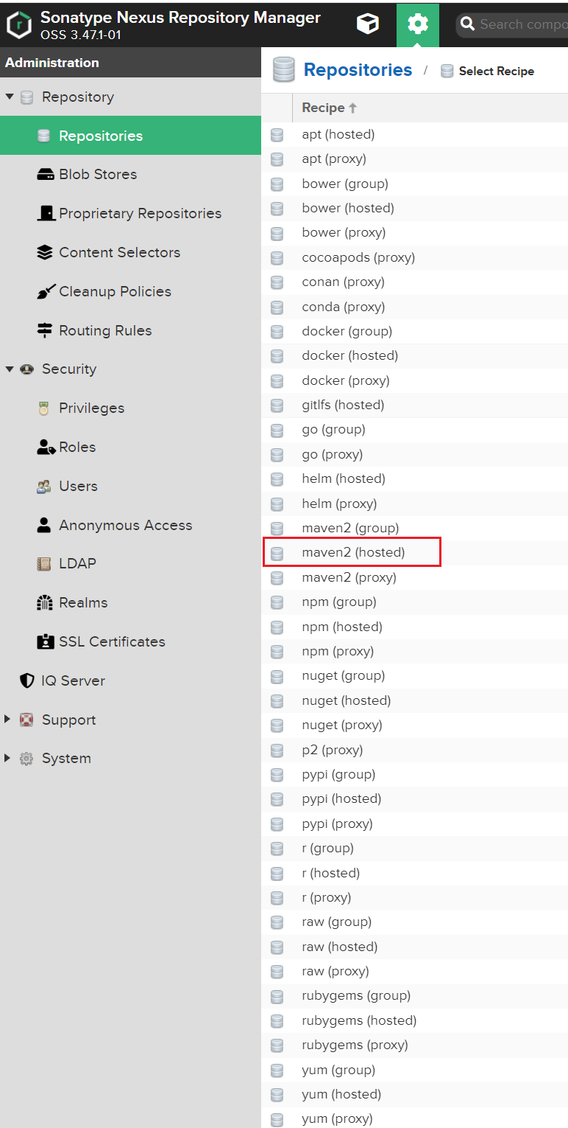

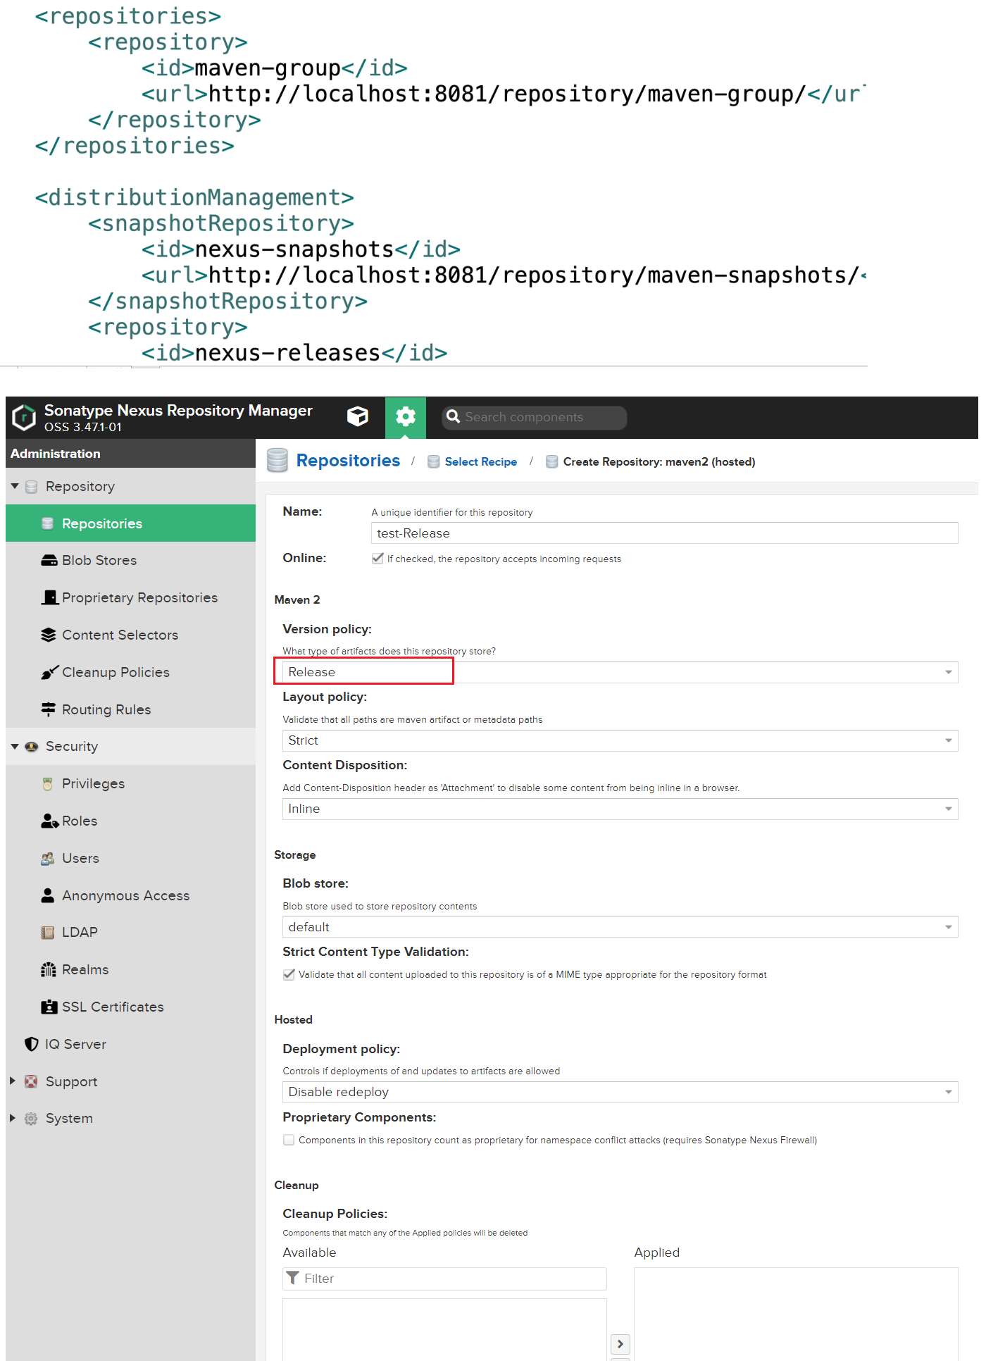

**Create Group**

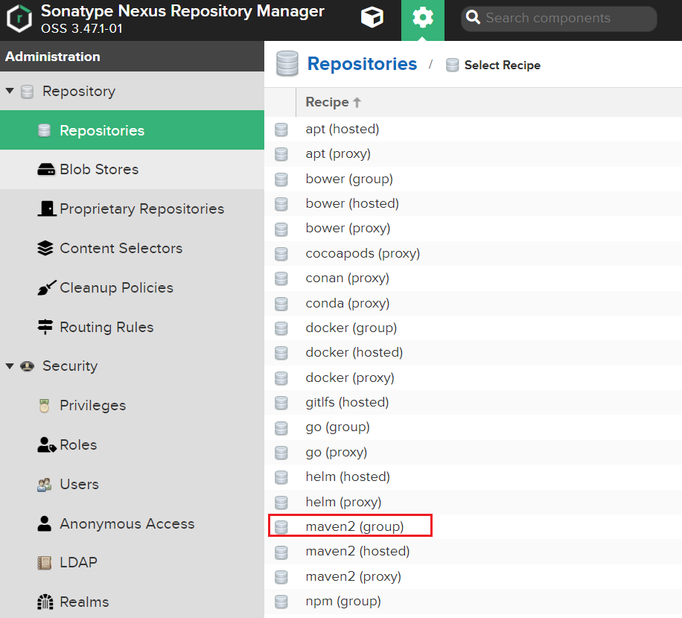

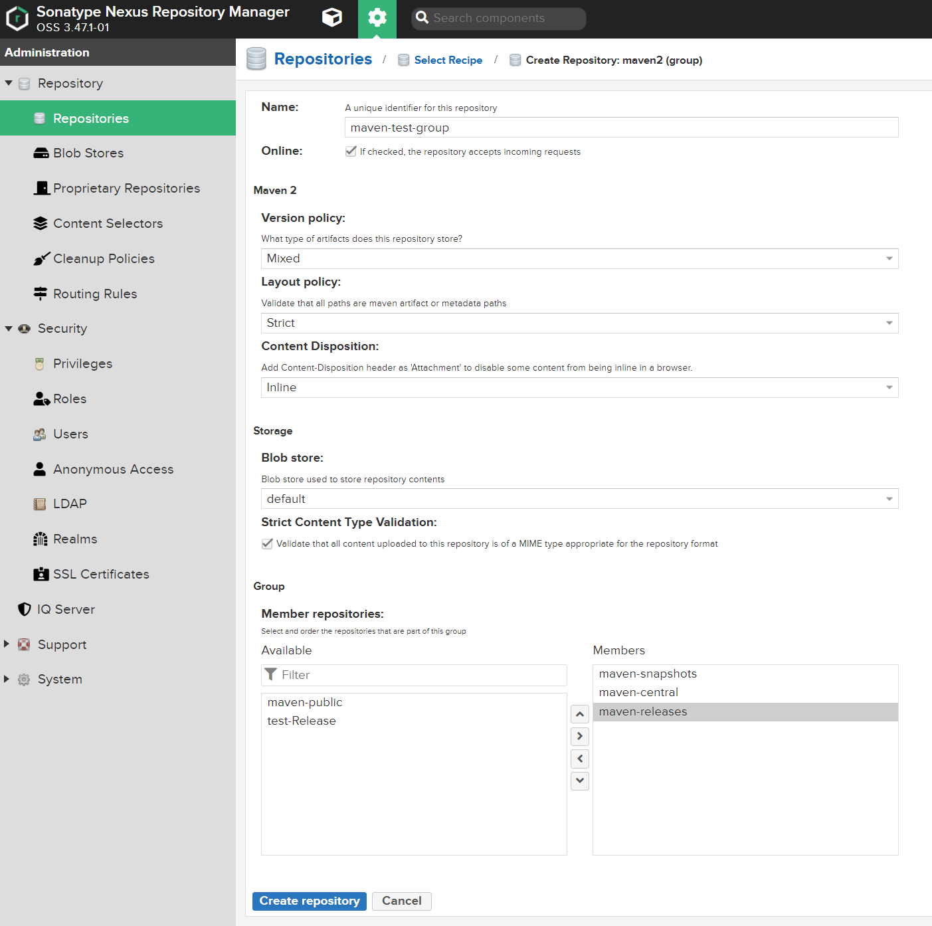

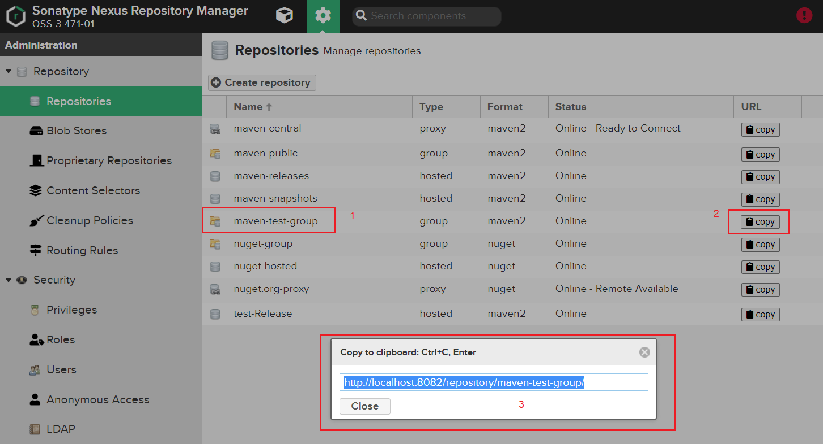

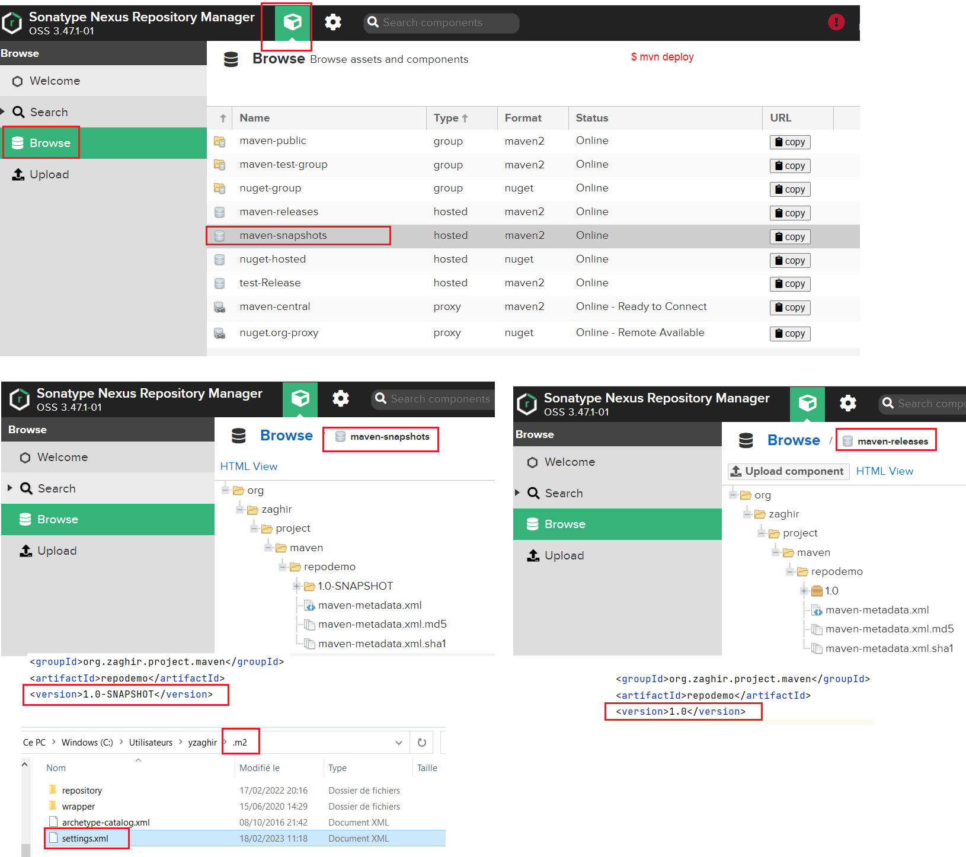

**Settings.xml**

*<?*xml version="1.0" encoding="UTF-8"*?>*<settings xmlns="http://maven.apache.org/SETTINGS/1.1.0"  
 xmlns:xsi="http://www.w3.org/2001/XMLSchema-instance"  
 xsi:schemaLocation="http://maven.apache.org/SETTINGS/1.1.0 http://maven.apache.org/xsd/settings-1.1.0.xsd">  
*<!-- copy this file in .m2 folder-->* <servers>  
 <server>  
 <id>nexus-snapshots</id>  
 <username>admin</username>  
 <password>admin</password>  
 </server>  
 <server>  
 <id>nexus-releases</id>  
 <username>admin</username>  
 <password>admin</password>  
 </server>  
 </servers>  
 <mirrors>  
 <mirror>  
 <id>central</id>  
 <name>central</name>  
 <url>http://localhost:8082/repository/maven-test-group/</url>  
 <mirrorOf>*</mirrorOf>  
 </mirror>  
 </mirrors>  
</settings>

Create plugin

$ mvn archetype:generate -DgroupId=com.zaghir.project -DartifactId=hellomaven -DarchetypeArtifactId=maven-archetype-plugin -DinteractiveMode=false

**Properties**

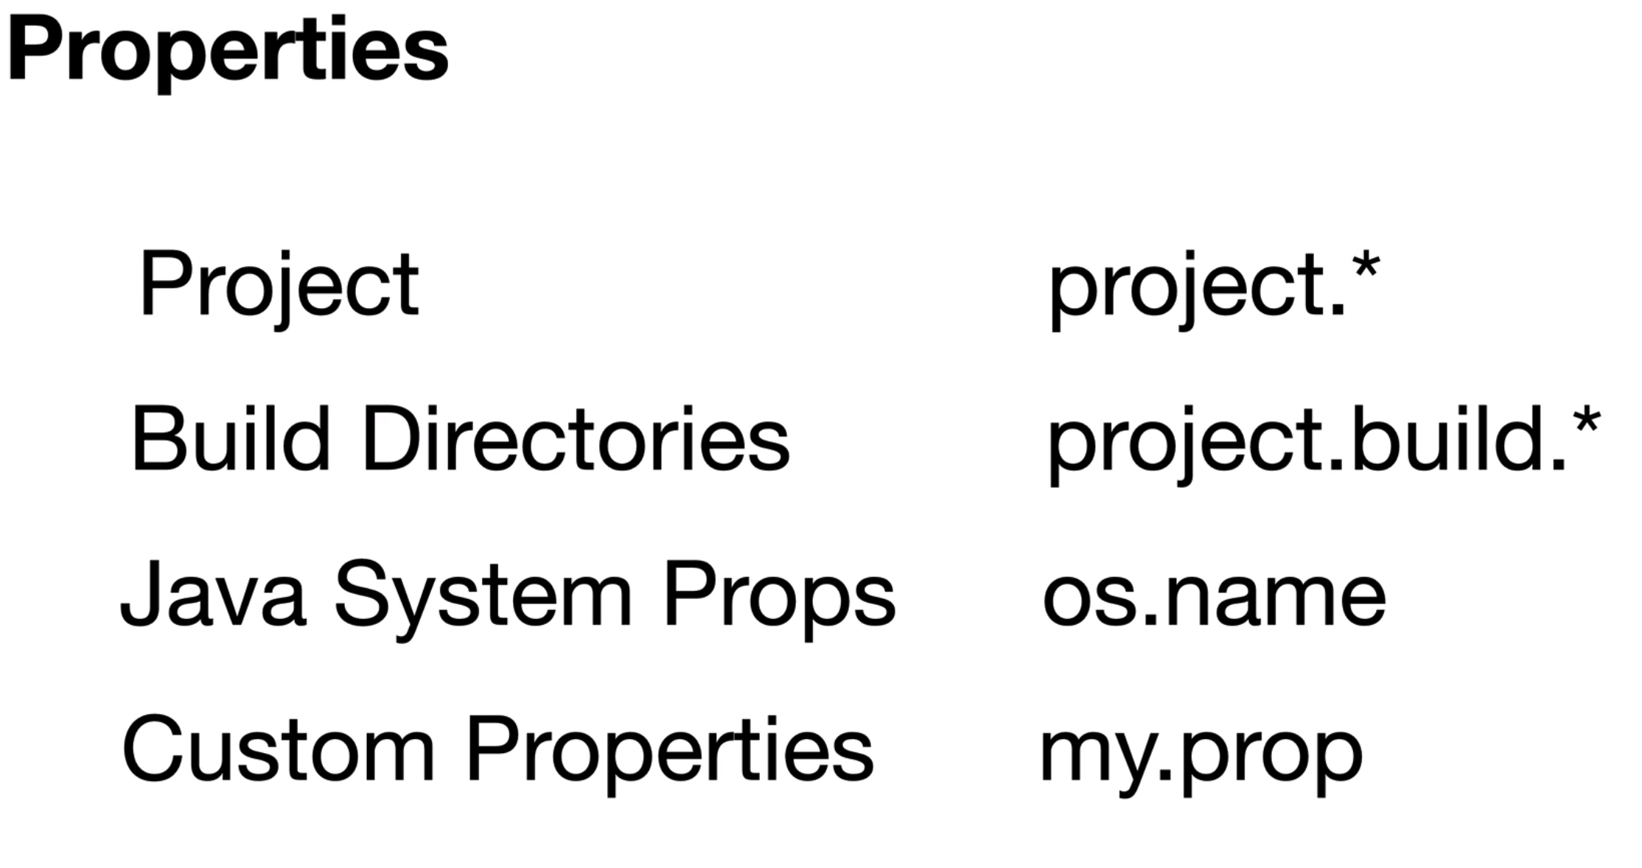



BOM

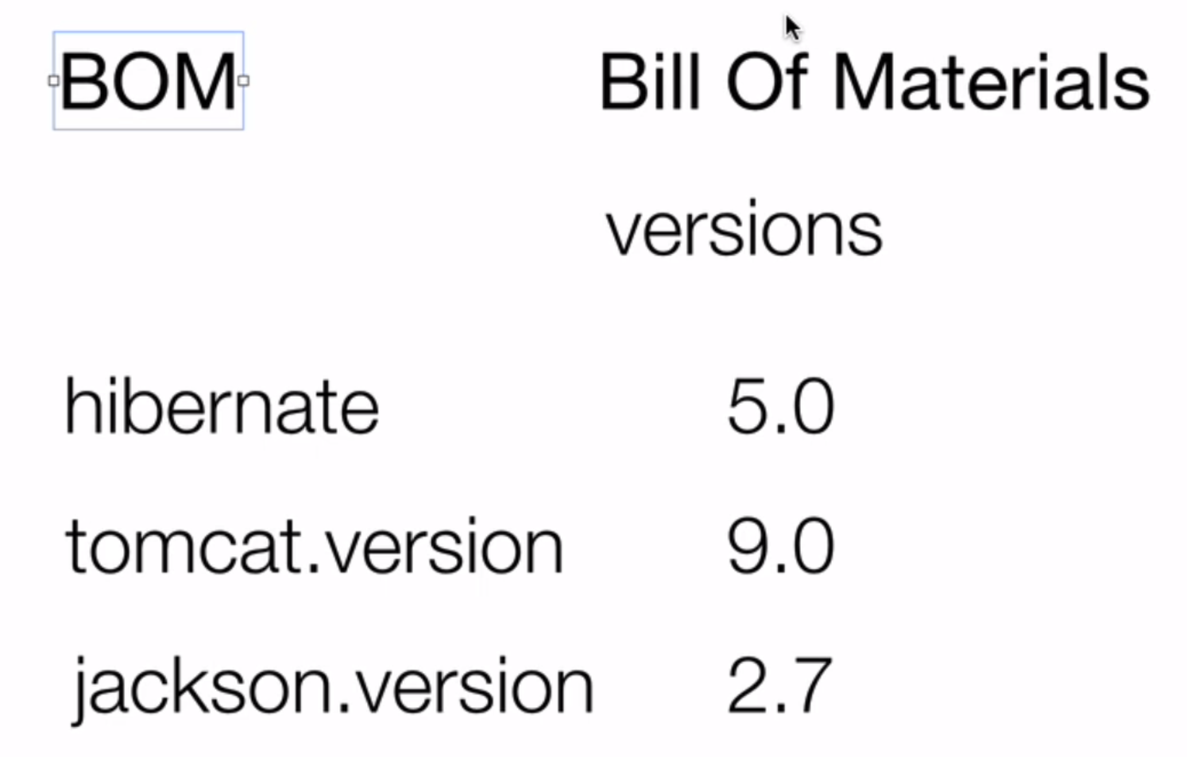

**CI/CD**

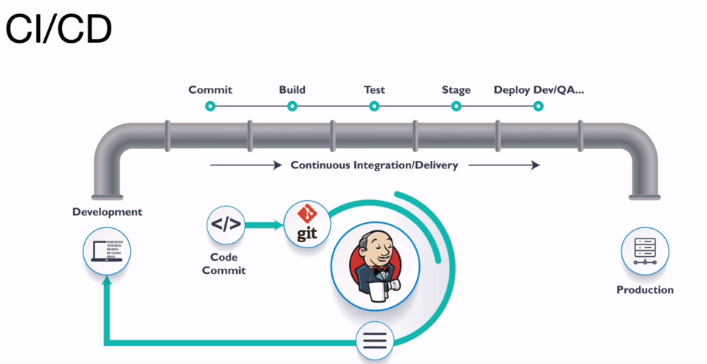

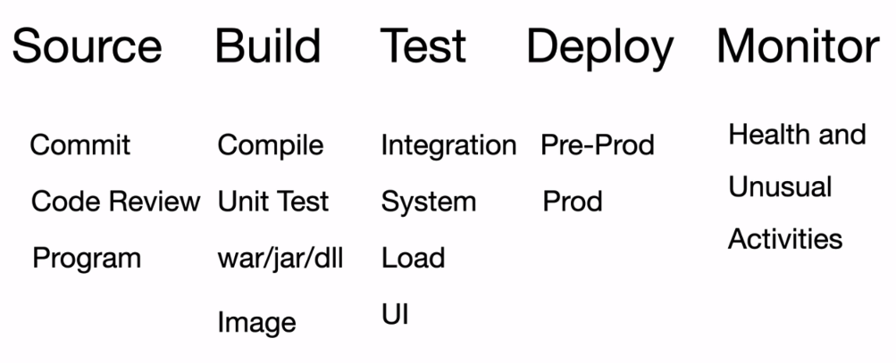

. 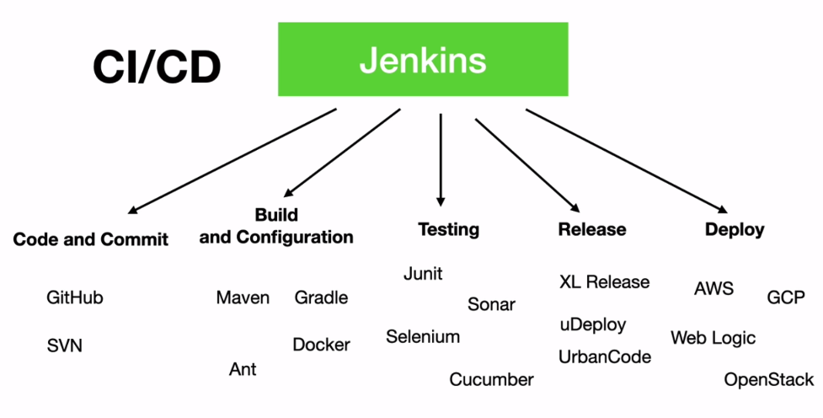

<https://hub.docker.com/_/jenkins>

<https://www.jenkins.io/doc/book/installing/docker/>

docker search jenkins

docker pull jenkins/jenkins:lts

docker run --name myjenkins --detach -p 8080:8080 --publish 50000:50000 –privileged --network jenkins --volume /your/home:/var/jenkins_home jenkins/jenkins

docker pull jenkins/jenkins:lts

docker run --name myjenkins -d -p 8083:8080 -p 50000:50000 --network jenkins -v jenkins-docker-volume:/var/jenkins_home jenkins/jenkins

Password jenkins

$ docker container exec myjenkins cat /var/jenkins_home/secrets/initialAdminPassword

docker logs <docker-container-name>

docker container restart myjenkins

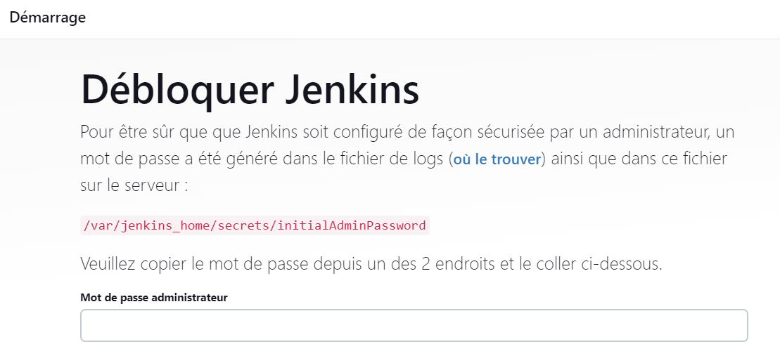

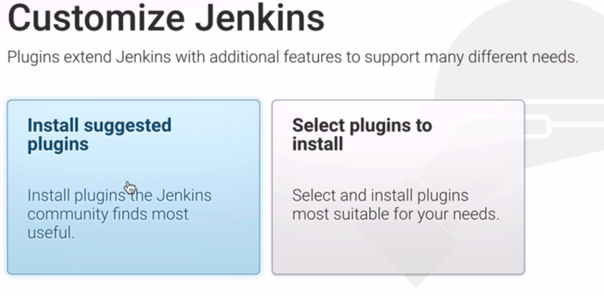

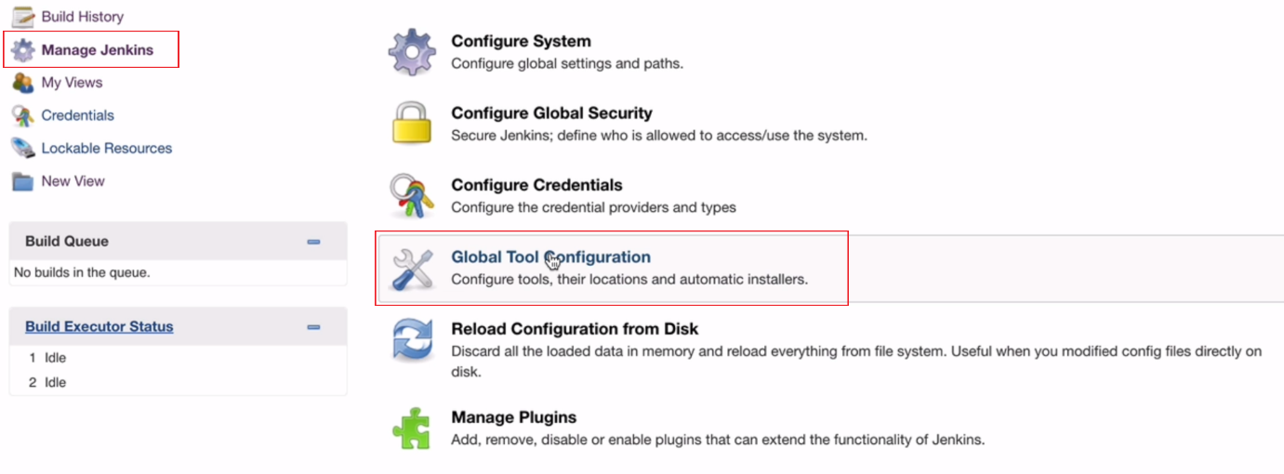

In Jenkins container

<https://upadhyaymanas3.medium.com/how-to-reset-jenkins-password-in-docker-containers-in-just-10-simple-steps-1370c049bbd7>

# docker exec -it –user=root myjenkins /bin/bash

# apt update

# apt-get install software-properties-common

# apt-get update

# apt-get install mvn

# which java

/opt/java/openjdk/bin/java

Add jdk to Jenkins

Path = /opt/java/openjdk

Git

# apt-get install git

# which git

/usr/bin/git

Add git to Jenkins with path = /usr/bin/git

Maven

# mvn -version

Apache Maven 3.6.3

Maven home: /usr/share/maven

Java version: 11.0.18, vendor: Eclipse Adoptium, runtime: /opt/java/openjdk

Default locale: en, platform encoding: UTF-8

OS name: "linux", version: "5.10.102.1-microsoft-standard-wsl2", arch: "amd64", family: "unix"

Add maven to Jenkins with path = /usr/share/maven

**Change Langue**

<https://stackoverflow.com/questions/12350707/jenkins-in-windows-shows-ui-in-russian-language>

Locale.ENGLISH

