Web SCRAPING and CRAWLING Using Python:

Python has a large collection of mature libraries. For example, requests, beautifulsoup4 could help us fetch URLs and pull out information from web pages. In addition, re, numpy and pandas could help us clean and process the data.

Prerequisites
- Python 3.5
- requests
- beautifulsoup4
- pandas

To install Beautiful Soup, you can use pip or you can install it from the source.

Install it using pip like this:

$ pip install beautifulsoup4

To check if it’s installed or not, open your editor and type the following:

from bs4 import BeautifulSoup

Then run it:

$ python myfile.py

If it runs without errors, that means Beautiful Soup is installed successfully.

Now, install requests library.

$ pip install requests

Step 1: Import Python library

In this tutorial, we would show you how to scrape reviews from Yelp. We will use two libraries: BeautifulSoup in bs4 and request in urllib. These two libraries are commonly used in building a web crawler with Python.

Step 2: Extract the HTML from web page

We need to extract reviews from

“https://www.yelp.com/biz/milk-and-cream-cereal-bar-new-york?osq=Ice+Cream”. So first, let’s save the URL in a variable called url. Then we could access the content on this webpage and save the html in “ourUrl”.
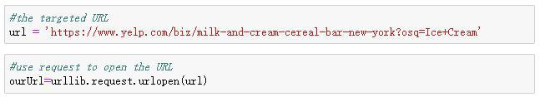
Then we use BeautifulSoup to parse the page.

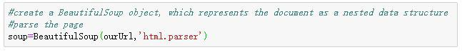

Now we have the “soup”, which is the raw HTML for this website. We could use prettify() to clean the raw data and print it to see the nested structure of HTML in the “soup”.
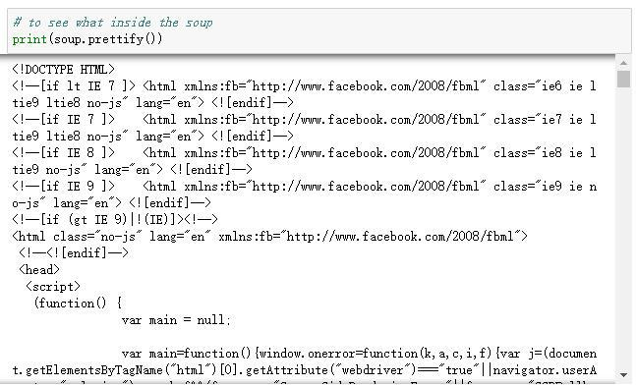

Step 3: Locate and scrape the reviews
Next, we should find the HTML reviews in this web page, extract them and store them. For each element in the web page, they would have a unique HTML “ID”. To check their ID, we would need to INSPECT them in web page.
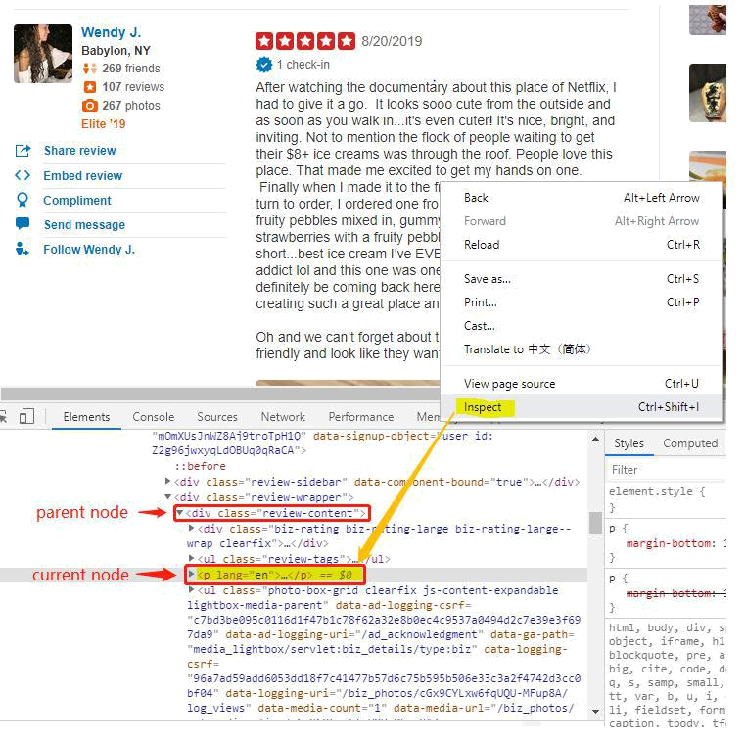

In this case, the reviews are located under the tag called ”p”. So we will first use the fuction called find_all() to find the parent node of this reviews. And then locate all elements with the tag “p” under the parent node in a loop. After finding all “p” elements, we would store them in an empty list called “review”.
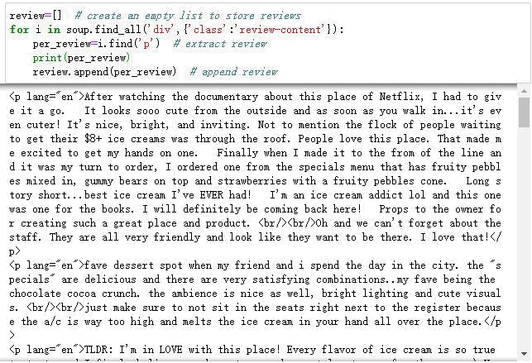

Now we get all the reviews from that page. Let’s see how many reviews have we extracted.

Step 4: Clean the reviews

You must notice that there still some symbols such as “<p lang=’en’>” at the beginning of each review, “<br/>” in the middle of the reviews and “</p>” at the end of each review. “<br/>” stands for a single line break. We don’t need any line break in the reviews so we will need to delete them. Also, “<p lang=’en’>” and “</p>” are the beginning and ending of the HTML and we also need to delete them.

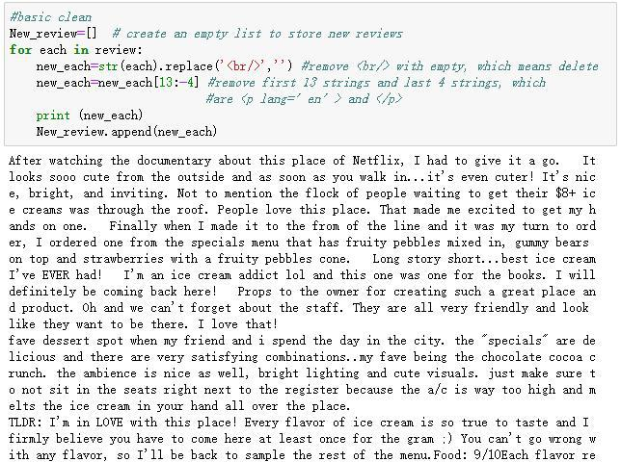

Now we successfully get all the clean reviews with less than 20 lines of code.

EXAMPLE 2:

import requests

from bs4 import BeautifulSoup

def web(page,WebUrl):

if(page>0):

url = WebUrl

code = requests.get(url)

plain = code.text

s = BeautifulSoup(plain, "html.parser")

for link in s.findAll('a',

{'class':'s-access-detail-page'}):

tet = link.get('title')

print(tet)

tet_2 = link.get('href')

print(tet_2)

web(1,'http://www.amazon.in/s/ref=s9_acss_bw_cts_VodooFS_T4_w?rh=i%3Aelectronics%2Cn%3A976419031%2Cn%3A%21976420031%2Cn%3A1389401031%2Cn%3A1389432031%2Cn%3A1805560031%2Cp_98%3A10440597031%2Cp_36%3A1500000-99999999&bbn=1805560031&rw_html_to_wsrp=1&pf_rd_m=A1K21FY43GMZF8&pf_rd_s=merchandised-search-3&pf_rd_r=2EKZMFFDEXJ5HE8RVV6E&pf_rd_t=101&pf_rd_p=c92c2f88-469b-4b56-936e-0e65f92eebac&pf_rd_i=1389432031’)

EXERCISE:
We want to scrape the data of an online book store: http://books.toscrape.com/ and gather the following information about all the products of the website:
- book title
- price
- availability
- image
- category
- rating

