**Chapter 4**

**Experimental Setup**

**Chapter 4**

**Experimental Setup**

4.1 Introduction

The following components are needed in our research work.

4.1.1 Sensor

A sensor [25] is a device, part, or subsystem whose drive is to sense actions or deviations in its environment and direct the information to other electronics such as regularly a computer processor. We used the following sensor showed in figure 4.1. We usually use the following sensor to detect the patient’s physiological data. Heat beat rate is measured using two sensors.

1. DS18B20 temperature sensor ----------> body temperature measurement
2. Heart Rate Sensor Module --------- > hear beat rate measurement
3. MAX30105 sensor ---------- > hear beat rate measurement
4. MAX30105 sensor ---------- > SpO2 measurement

4.1.2 Temperature Sensor

This probe is a DS18B20 temperature sensor [26] enclosed in a stainless steel head on a durable 90cm rubberized cable, making this sensor ideal for exposed temperature measurements including aquarium applications, a resistor is included as showed in figure 4.1(a). Operating Voltage: 3.0-5.5VDC, Operating Current: <1mA, Temperature Range: -55°C to 125°C (±0.2°C), 36" waterproof cable,4.7kΩ resistor included.



4.1.3 Heart Rate Sensor Module

The heat beat sensor module [27] is used to get the patient’s heart beat rate as shown in figure 4.1(b). The sensor model is MOD-00158. The heart rate sensor is based on the principle of photogrammetry. This measurement measures the volume of blood through each organ in the body, which changes the intensity of light through that organ (vascular area). In applications where the body's rhythm needs to be controlled, simultaneous pulse synchronization is more important. The volume of blood is determined by the frequency of the heartbeat, and since light is absorbed by the blood, the signal pulses are equivalent to the heart pulses.

4.1.3 Sparkfun Particle Sensor – MAX30105

The SparkFun MAX30105 particle sensor [28] is a powerful, flexible sensor that enables distance detection, heart rate, body rhythm, particle detection and even eye flash as showed in figure 4.1(c). The MAX30105 is equipped with three LEDs and a highly sensitive photon detector. The idea is to pulse the different LEDs, then detect what amount light is reflected. Based on the reflected signature, various types of particles or substances (such as oxygenated blood or smoke from fire) can be detected. The MAX30105 uses red LED, green light, and IR (infrared) light to measure presence, heart rate, and heart rate monitoring across a wide range of applications, including pulse oximetry. The MAX30105 is designed for 5V operation and can communicate with both 3.3V and 5V microcontrollers.

4.1.4 Arduino Uno

Arduino [29] is defined as an open source platform or board and software used to program it. Arduino is used to make electronics in creating objects or interactive environments that can sense and control objects in the physical world. An Arduino board is showed in Figure 4.2.

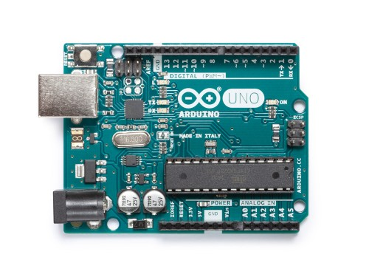

Figure 4.2: Arduino Uno

4.1.6 Bluetooth Module

**HC‐05 module** [30] is used as a Bluetooth module which is designed for transparent wireless serial connection setup. Master and Slave configuration, makes it a great solution for wireless communication. The Bluetooth module and the interfacing Bluetooth module with Arduino is showed in figure 4.3 and figure 4.4 respectively.

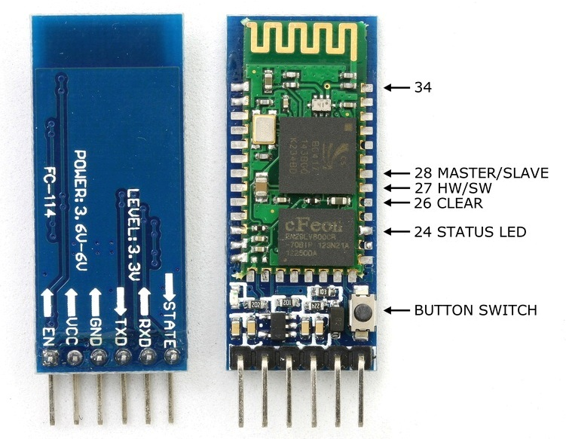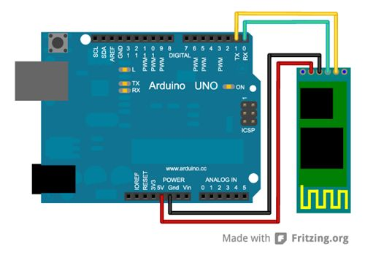

Figure 4.3: Bluetooth module Figure 4.4: Bluetooth module with Arduino uno

4.3 Hardware Operation

Figure 4.5 shows the hardware operation. Arduino is supplied the DC 5V power after the circuit setup. It needs to enable the Bluetooth in the android device and wait for a connection. Bluetooth module of the circuit is found name HC-05, pair with it by using default password 1234.

After the Bluetooth connection establishment, data are transferred to the android device and check it is connected or not to the Android app. If not then again try to be connected with the android phone. If connected then, the android phone (patient’s device) send the data to the server for further processing.

Patient’s device waits for a certain period for getting information from the Bluetooth module. After sometimes it takes the data from Arduino via the Bluetooth module periodically send the data to the server.

Figure 4.5: Workflow in hardware

Start

Configure Bluetooth and wait for a connection

Is connected?

No

Yes

Observe the sensor data

Send parameters to server

Wait for a certain period