**Chapter 7**

**Application Design**

**Chapter 7**

**Application Design**

7.1 Introduction

We need to develop two Android Application, one for the Patient named PatientApp and other for the Doctor named DoctorApp. The detailed feature of the of the application software are described below.

7.2 Patient’s Application Design

After launching the patient’s application program, the login activity is come to login, if the user in new then there is another option to register as a patient. After successful login using the email and password, the login information is stored in the database. The application is manually connected to the Arduino to get the data via Bluetooth module. After the getting the data it sends the patient physical information to the server for further processing. The patient application life cycle is showed in figure 7.1.

After launching the app, the login activity is opened a sign in as showed in figure 7.1 and home activity will open. Figure 7.2 shows the home activity.

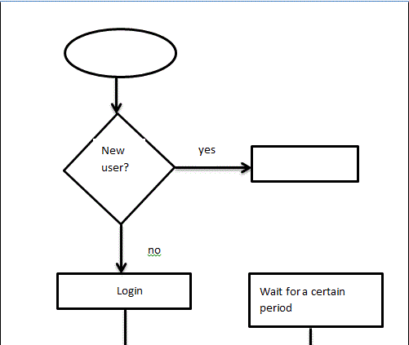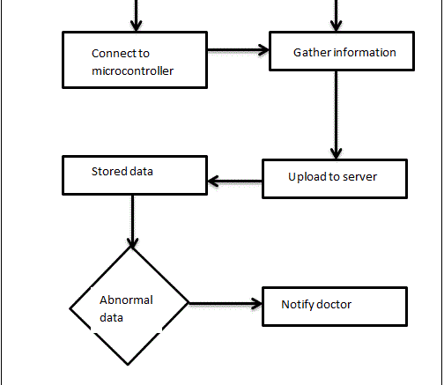

Figure 7.1: patient’s application lifecycle

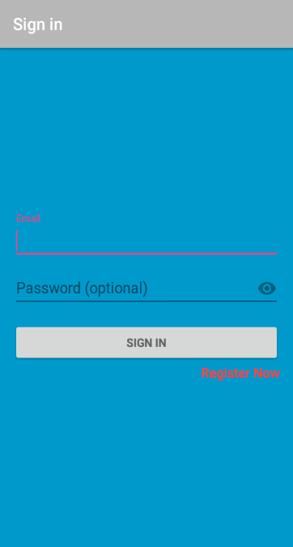 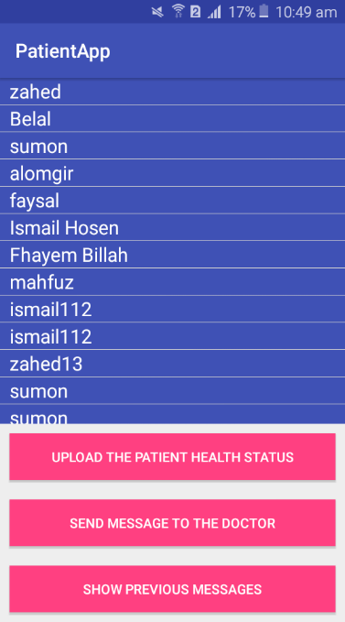 Figure 7.2: login and registration activity Figure 7.3: home activity.

The activity is used to upload patient’s physical information to the server. The following activity is used to send message to the data. The data upload activity and message sending activity are showed in figure 7.4 and figure 7.5 respectively.

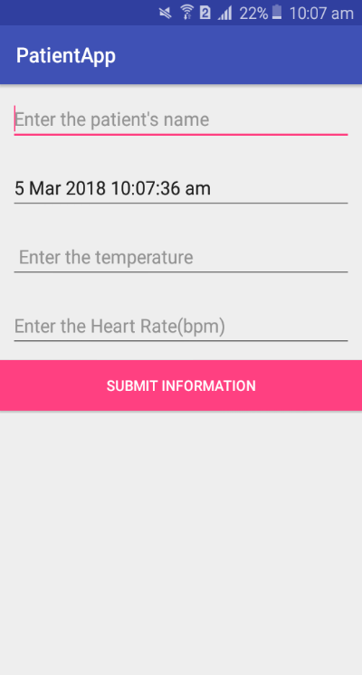 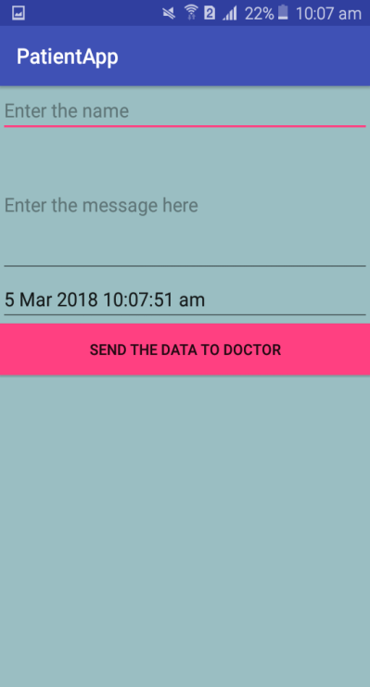

Figure 7.4: data upload activity Figure 7.5: message sending activity

This activity is used to see the previous message between the doctor and patient as showed in figure 7.6.

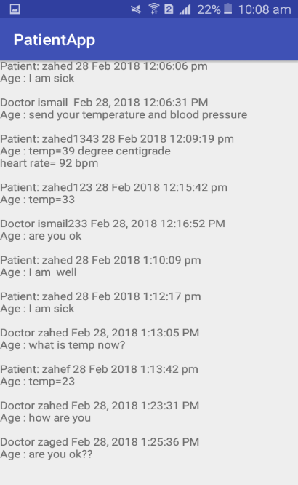

Figure 7.6: previous message showing activity.

7.3 Doctor’s Application Design

When the app is first launched then it goes to the sing in activity. If the doctor is new then click on the register option go to the registration activity. After successfully sign in, Home activity will be opened. The launching and home activity are showed in the figure 7.8 and figure 7.9 respectively.

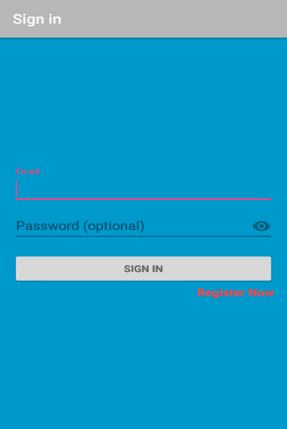 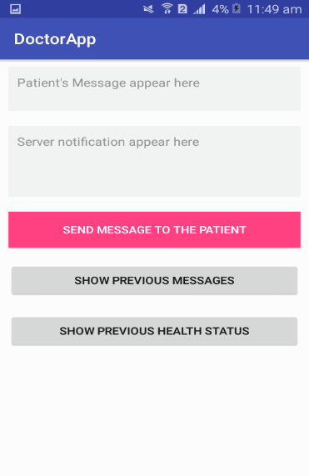

Figure 7.8: Sign in Activity Figure 7.9: Home activity

In the home activity, there are two text fields, first one is used to see the Patient’s Message, Notification from the server is appeared in the second text fields. There are three other option. These are used to send message to the patient, show previous messages, message, show previous health status.

The following two activity is used to see the previous message between doctor and the patient which is shown in figure 7.10 and the other activity is used to see the previous health status which is uploaded to the server by the patient application as shown in figure 7.11.

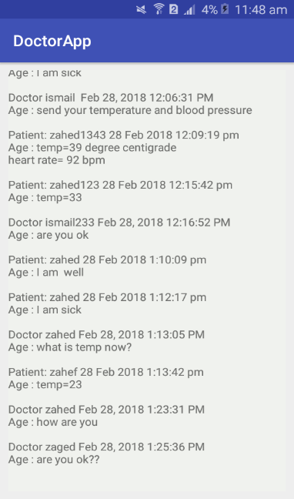 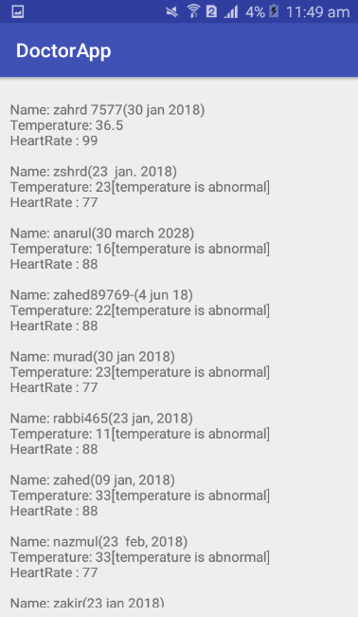

Figure 7.10: message activity Figure 7.11: previous message showing activity

The next one activity is responsible to send a reply message or any query to the patient as shown in figure 712.

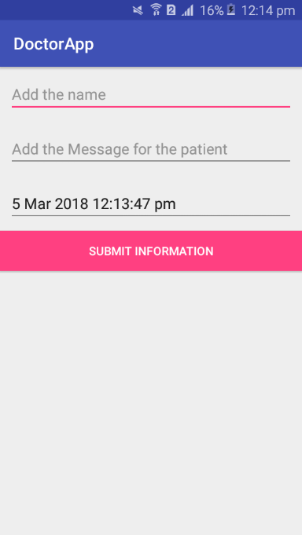

Figure 7.12: sending message to patient activity