TECHNICAL REPORT
Week 2: LDA and BERTopic
Topic modeling of 587 Apache MapReduce design issues
Field | Value
Project | Apache MapReduce
Corpus | 587 issue summaries + descriptions
Models | LDA and BERTopic
Reproducibility | Random seed 42; issue-level assignments retained

Executive result
The refined LDA model selected 9 topics at the highest tested c_v coherence (0.4095). BERTopic produced 16 focused semantic clusters and treated 193 issues as outliers. Together, the models reveal recurring concerns around execution lifecycle, scheduling, data movement, storage formats, resource limits, reliability, and security.

1. Method

1.1 LDA iteration 1 - baseline
The first iteration used the Week 1 stemmed tokens, 10 topics, and low document-topic and topic-word priors (alpha = 0.01; beta = 0.01). This sparse prior reflects the expectation that one issue discusses few topics and each topic is expressed by a limited term set. The baseline still contained project-specific and generic terms, so several topics overlapped.

1.2 LDA iteration 2 - refined vocabulary
High-frequency generic/project tokens were removed. Terms with a confident semantic role were replaced by ontology classes: Component, Connector, Data, Solution, and separate quality-attribute classes for performance, reliability, security, scalability, and maintainability. Models with 3 through 10 topics were then fitted under identical priors.

1.3 BERTopic
BERTopic embedded the original summary and description text with all-MiniLM-L6-v2, reduced the embeddings with UMAP, clustered them with HDBSCAN, and extracted topic terms with class-based TF-IDF. A leaf-based density configuration was used after the initial broad cluster was found too coarse. Outliers were retained as outliers rather than force-assigned.

2. LDA optimization
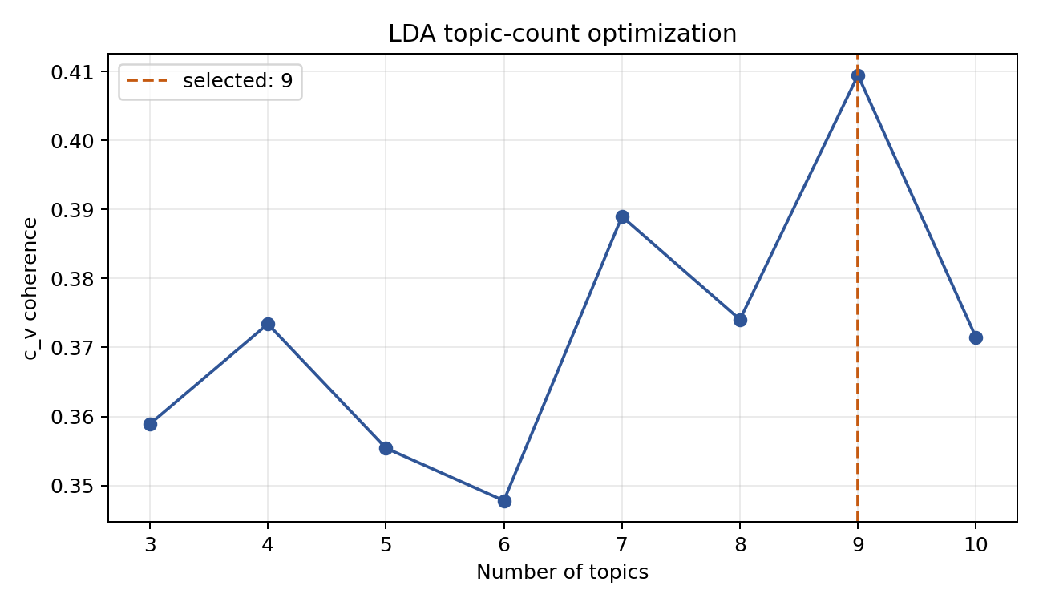
Figure 1. c_v coherence for 3-10 refined LDA topics. Nine topics achieved the maximum score.
Topics | c_v coherence | Decision
3 | 0.3589
4 | 0.3734
5 | 0.3554
6 | 0.3478
7 | 0.3890
8 | 0.3741
9 | 0.4095 | Selected
10 | 0.3714
The 9-topic model was selected because its c_v coherence of 0.4095 was the highest tested value. The drop at 10 topics suggests that an additional topic fragmented coherent themes rather than adding useful separation.
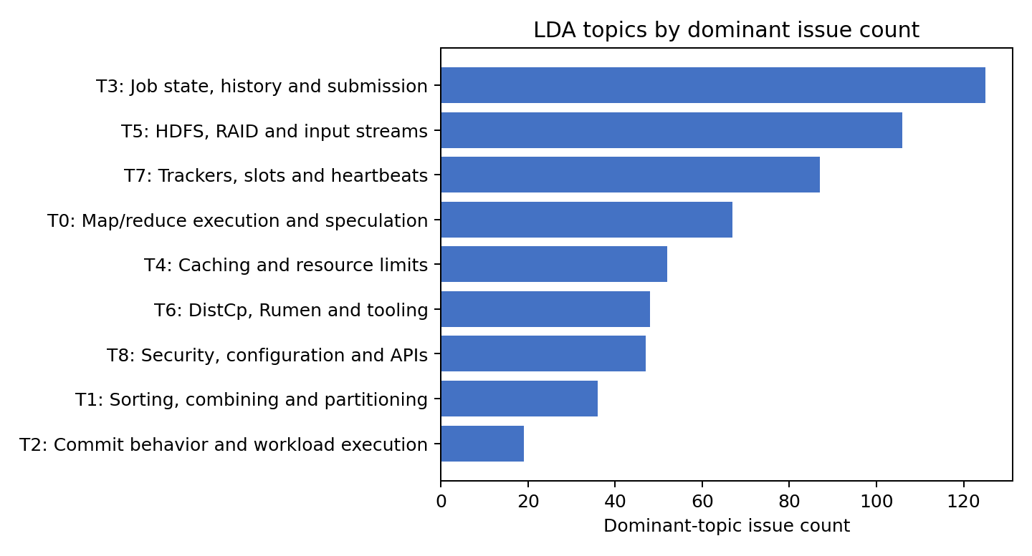
Figure 2. Issues counted by dominant LDA topic.

3. Final LDA topics
ID | Interpretation | Issues | Top keywords
L0 | Map/reduce execution and speculation | 67 | component, reduc, connector, map, time, run, phase, specul
L1 | Sorting, combining and partitioning | 36 | data, quality_performance, reduc, connector, map, sort, combin, merg
L2 | Commit behavior and workload execution | 19 | solution, component, map-reduc, simul, host, quality_performance, committ, workload
L3 | Job state, history and submission | 125 | component, data, run, quality_reliability, solution, histori, time, state
L4 | Caching and resource limits | 52 | component, quality_performance, cach, data, resourc, reduc, limit, map
L5 | HDFS, RAID and input streams | 106 | data, component, directori, raid, stream, hdfs, inputformat, size
L6 | DistCp, Rumen and tooling | 48 | solution, data, quality_scalability, info, jira, distcp, common, rumen
L7 | Trackers, slots and heartbeats | 87 | component, tracker, contain, slot, solution, quality_reliability, run, attempt
L8 | Security, configuration and APIs | 47 | quality_security, component, connector, user, interfac, apach, org, java
Table 1. Issue counts use each issue's dominant LDA topic; keywords are ordered by topic weight.

Topic proportions per issue
At a probability threshold of 0.20, issues contain an average of 1.74 LDA topics. 212 issues have one topic above the threshold and 375 have multiple topics. The mean dominant-topic probability is 0.688, showing that LDA commonly captures a strong primary concern plus secondary concerns.

4. BERTopic results
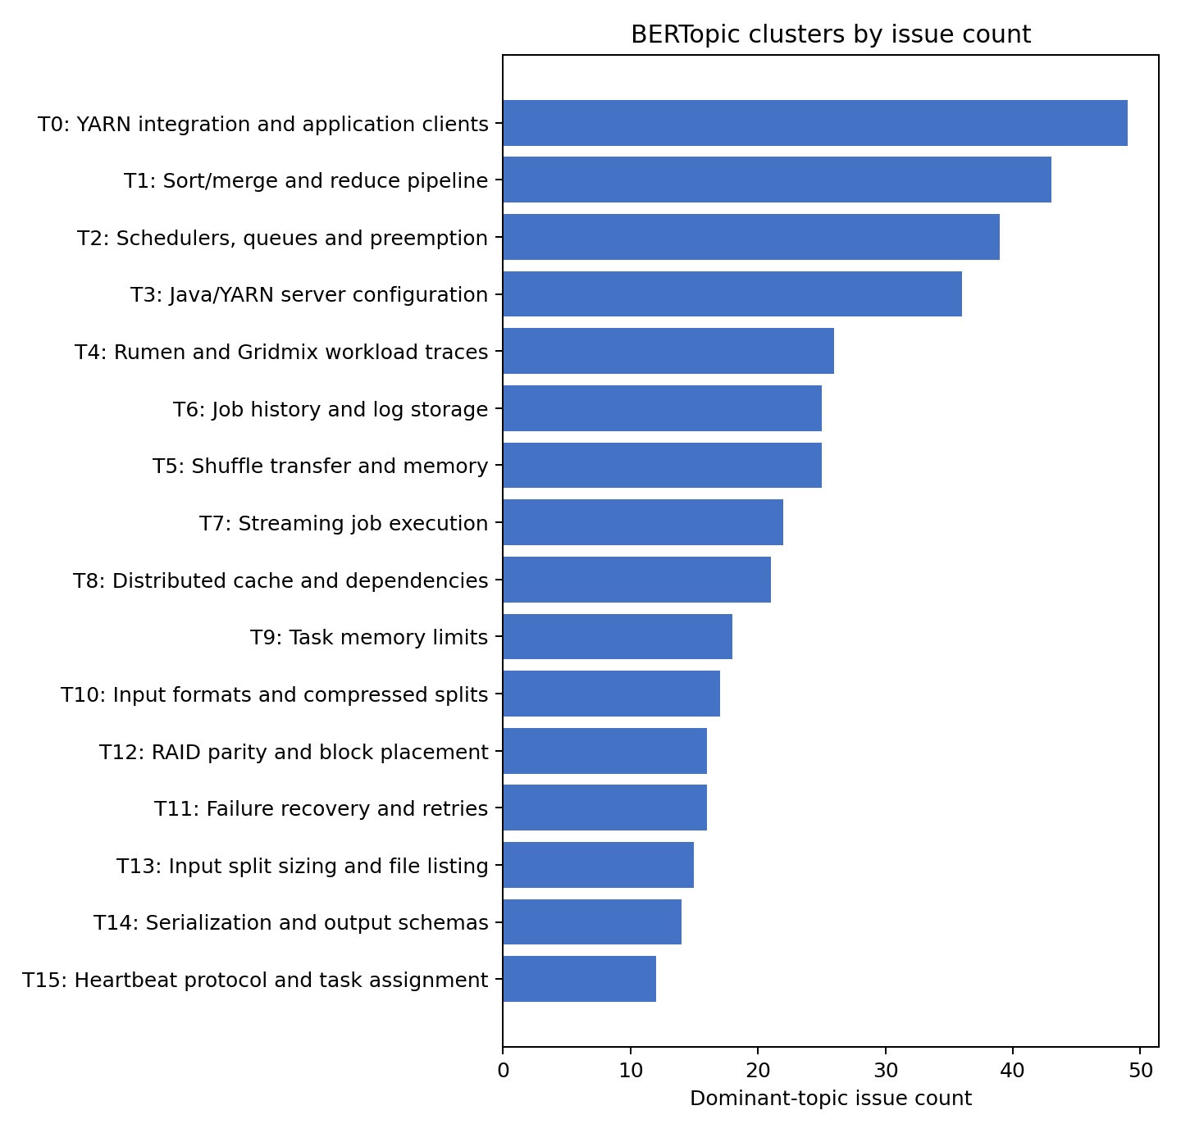
Figure 3. BERTopic cluster sizes, excluding the outlier class.
BERTopic found 16 interpretable clusters covering 394 issues. The remaining 193 issues (32.9%) were marked as outliers by HDBSCAN. This is expected in density-based topic modeling and is preferable to assigning isolated or ambiguous issues to an artificial topic.
ID | Interpretation | Issues | Top keywords
B0 | YARN integration and application clients | 49 | yarn, rm, mr, jhs, client, app, token
B1 | Sort/merge and reduce pipeline | 43 | sort, reduce, combiner, reducer, map, hash, merge
B2 | Schedulers, queues and preemption | 39 | scheduler, capacity, jobs, fair, queue, tasks, cluster
B3 | Java/YARN server configuration | 36 | java, yarn, apache, org apache, org, server, nodemanager
B4 | Rumen and Gridmix workload traces | 26 | rumen, job, jobs, gridmix, traces, information, load
B5 | Shuffle transfer and memory | 25 | shuffle, reduce, version, memory, map output, connection, map
B6 | Job history and log storage | 25 | history, job history, history server, history files, server, files, job
B7 | Streaming job execution | 22 | job, input, streaming, command, dfs, data, time
B8 | Distributed cache and dependencies | 21 | cache, distributed cache, distributed, distributedcache, jars, files, file
B9 | Task memory limits | 18 | memory, task, tasks, reduce, tasktracker, running, limit
B10 | Input formats and compressed splits | 17 | text, file, split, recordreader, inputformat, compressed, data
B11 | Failure recovery and retries | 16 | fail, job, bad, failures, failed, map, mapred local
B12 | RAID parity and block placement | 16 | blocks, raid, files, parity, block, raided, policy
B13 | Input split sizing and file listing | 15 | input, files, size, data, implementations, splits, split
B14 | Serialization and output schemas | 14 | field, record, multipleoutputs, write, schema, serialization, parameter
B15 | Heartbeat protocol and task assignment | 12 | heartbeat, tasktracker, interval, task, message, tasks, send
Table 2. BERTopic cluster definitions and issue counts; the outlier class is excluded.

5. Answer to Research Question 1
RQ1: What topics emerge from LDA and BERTopic, what are their common keywords, and how many issues discuss each topic?
LDA produced nine broad themes. The largest were Job state, history and submission (125 issues), HDFS/RAID/input streams (106), and Trackers/slots/heartbeats (87). BERTopic separated these broad themes into sixteen narrower clusters. Its largest non-outlier clusters were YARN integration/application clients (49), Sort/merge/reduce pipeline (43), and Schedulers/queues/preemption (39). Complete keywords and counts appear in Tables 1 and 2 and in the accompanying CSV files.

Cross-model interpretation
- Execution management appears in both models: LDA execution/tracker topics correspond to BERTopic clusters for YARN clients, task memory, job history, and heartbeats.
- Data processing is broad in LDA but separates in BERTopic into sort/merge, shuffle transfer, streaming, distributed cache, input formats, RAID blocks, split sizing, and serialization.
- Scheduling is stable across methods: LDA scheduling/coordination themes align with the BERTopic scheduler, queue, preemption, and workload-trace clusters.
- Reliability and security are visible in LDA ontology-aware topics; BERTopic isolates a specific failure/retry cluster but security is distributed mainly across YARN/client and configuration clusters.

Usefulness and limitations
The refined LDA topics are useful for broad retrieval categories and allow multi-topic issue proportions. BERTopic is stronger for fine-grained technical search but leaves ambiguous issues unclustered. Topic labels are analyst interpretations of the reported keywords, not ground-truth classes. Results are stochastic in general; the pipeline fixes seeds and saves models and assignments to make this run reproducible.

6. Reproducibility and outputs
- week2_topic_modeling.py - end-to-end LDA and BERTopic pipeline
- lda_iteration1_topics.csv - baseline 10-topic result
- lda_coherence_scores.csv and lda_coherence.png - optimization evidence
- lda_final_topics.csv and lda_issue_topics.csv - final definitions and issue proportions
- bertopic_topic_summary.csv and bertopic_issue_topics.csv - semantic clusters and assignments
- lda_final_model.joblib and bertopic_model/ - saved models

Sources
• BERTopic algorithm and modular pipeline: https://maartengr.github.io/BERTopic/algorithm/algorithm.html
• BERTopic API and output attributes: https://maartengr.github.io/BERTopic/api/bertopic.html
• Gensim c_v coherence model: https://radimrehurek.com/gensim/models/coherencemodel.html
• Scikit-learn LDA API: https://scikit-learn.org/stable/modules/generated/sklearn.decomposition.LatentDirichletAllocation.html

