7.Start a Docker container and set up a web-server (e.g. apache2 or Python based Flask micro web framework) on the instance. Map the host directory as a data volume for the container.

✅ PART 1 – Python Web Server (Flask)
We’ll use Flask inside a Docker container.

🔹 Step 1: Create Project Folder on Windows
Open Command Prompt (CMD):
cd D:\
mkdir flask-app
cd flask-app

🔹 Step 2: Create Flask App File
Create a file:
notepad app.py
Paste this:
from flask import Flask
app = Flask(__name__)

@app.route('/')
def home():
return "Hello from Flask inside Docker!"

if __name__ == '__main__':
app.run(host='0.0.0.0', port=5000)
Save and close.

🔹 Step 3: Create requirements.txt
notepad requirements.txt
Add:
Flask==2.3.3
Save and close.

🔹 Step 4: Create Dockerfile
notepad Dockerfile
Paste:
FROM python:3.11

WORKDIR /app

COPY requirements.txt .
RUN pip install -r requirements.txt

COPY . .

EXPOSE 5000

CMD ["python", "app.py"]
Save and close.

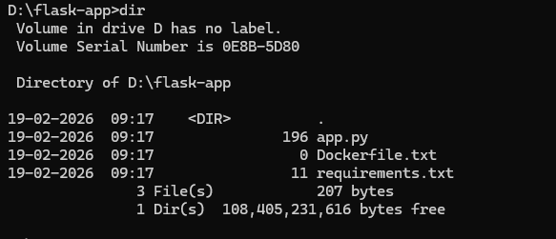

Here you need to create a Dockerfile but in most of the windows systems taking file extensions as .txt

So we need to rename the file.

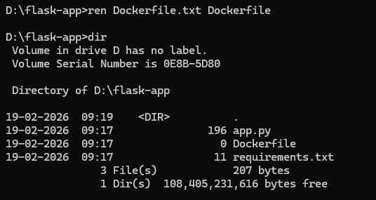

Floder structure should be like this.

🔹 Step 5: Build Docker Image
Make sure you're inside D:\flask-app
docker build -t flask-image .

🔹 Step 6: Run Container with Volume Mapping
docker run -d -p 5000:5000 -v D:\flask-app:/app --name flask-container flask-image

🔎 What this does:
- -d → Run in background
- -p 5000:5000 → Map port 5000
- -v D:\flask-app:/app → Map Windows folder to container
- --name flask-container → Container name

🔹 Step 7: Test in Browser
Open:
http://localhost:5000
You should see:
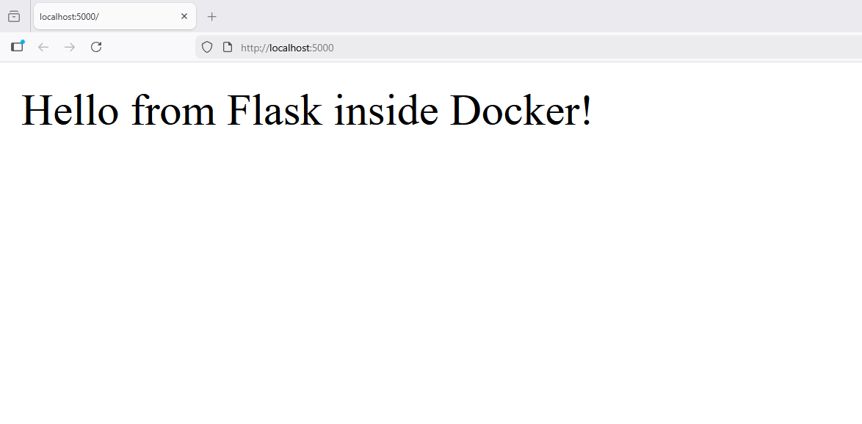

✅ Step-by-Step: Run a Simple JSP File in Docker (Windows CMD)

🔹 Step 1: Create Project Folder
Open Command Prompt:
cd D:\
mkdir jsp-app
cd jsp-app

🔹 Step 2: Create Simple JSP File
notepad index.jsp
Paste this simple JSP code:
<%@ page import="java.util.*" %>
<html>
<body>
<h2>6-Digit OTP Generator</h2>
<%
Random r = new Random();
int otp = 100000 + r.nextInt(900000); // ensures 6 digits
%>
Your OTP is: <h3><%= otp %></h3>
</body>
</html>
Save and close.

🔹 Step 3: Pull Tomcat Docker Image
docker pull tomcat

🔹 Step 4: Run Tomcat Container with Volume Mapping
docker run -d -p 9090:8080 -v D:\jsp-app:/usr/local/tomcat/webapps/ROOT --name jsp-container tomcat

🔎 What this command does:
- -d → Run in background
- • 9090 → Windows (host port)
- • 8080 → Tomcat inside container
- -v D:\jsp-app:/usr/local/tomcat/webapps/ROOT → Maps your JSP folder to Tomcat ROOT app
- --name jsp-container → Container name
- tomcat → Official Tomcat image
output:
