KAARKUN: An AI-Powered Multi-Platform Service Marketplace

By

ZAHEER ABBAS (449)

MUHAMMAD DAWOOD (446)

ISMAIL KHAN (488)

Thesis Submitted to University of Swabi, Khyber Pakhtunkhwa,
in partial fulfillment of the requirement for the degree of

BACHELOR OF SCIENCE IN COMPUTER SCIENCE



DEPARTMENT OF COMPUTER SCIENCE THE UNIVERSITY OF SWABI
KHYBER PAKHTUNKWA, PAKISTAN
SESSION (2022-2026)

KAARKUN: An AI-Powered Multi-Platform Service

Marketplace

By

ZAHEER ABBAS

MUHAMMAD DAWOOD

ISMAIL KHAN

Thesis Submitted to University of Swabi, Khyber Pakhtunkhwa, in partial fulfillment of the requirement for the degree of

BACHELOR OF SCIENCE IN COMPUTER SCIENCE

Approved by:

Chairman Supervisory Committee
Dr. Shah Nazir

Co-Supervisor [Field/ Research/ Lab]
Prof. Hammad

Chairman Department of Computer Science
Prof. Mushtaq Ali Shah

DEPARTMENT OF COMPUTER SCIENCE
THE UNIVERSITY OF SWABI
KHYBER PAKHTUNKWA, PAKISTAN
SESSION (2022-2026)\

KAARKUN: An AI-Powered Multi-Platform Service Marketplace

CERTIFICATE OF SIGNATORY PAGE OF FOREIGN EVALUATORS / EXTERNAL EVALUATORS (PAKISTAN)

External Evaluators / Examiners for Thesis Evaluation

External Examiner-1

To be approved by the Vice Chancellor

External Examiner-2

To be approved by the Vice Chancellor

External Examiner-3

To be approved by the Vice Chancellor

KAARKUN: An AI-Powered Multi-Platform Service Marketplace

Examiners for Thesis Viva Voce

Dr. Shah Nazir External Examiner

Chairman Supervisory Committee

Prof. Mushtaq Ali Shah
Head Of Department Of Computer Science

PAGE FOR CERTIFIACTE OF TEST REPORT OF PLAGIARISM TO BE OBTAINED FROM QEC

SIMILARITY INDEX CERTIFICATE FOR THESIS

Approved Title by ASRB: KAARKUN: An AI-Powered Multi-Platform Service Marketplace

Department: DEPARTMENT OF COMPUTER SCIENCE, THE UNIVERSITY OF SWABI

Submitted by: ZAHEER ABBAS, MUHAMMAD DAWOOD, ISMAIL KHAN

Supervisor: Prof. HAMMAD
DEPARTMENT OF COMPUTER SCEINCE THE UNIVERSITY OF SWABI

Submission ID: 2753350718

Similarity Index: 5%

CHECKED BY
Prof. HAMMAD

COUNTER SIGNED BY QEC

Director QEC University of Swabi, KP

TABLE OF CONTENTS
__________________________________________________________________________________________
CHAPTER TITLE PAGE NO
__________________________________________________________________________________________

TABLE OF FIGURES…………………………………………………………..................IX
TABLE OF IMAGES ……………………………………………………………………...X
LIST OF TABLES ……………………………………………………………………………XI
LIST OF ABBREVIATIONS …………………………………………………………………...XII
ACKNOWLEDGMENTS………………………………………………………………..XIII
ABSTRACT………………………………………………………………………………..XIV
CHAPTER-1
1. INTRODUCTION..........................................................................................................…..1
1.1 PROJECT OVERVIEW / BACKGROUND……………………………................1
1.1.2 PROBLEM STATEMENT………………………………………………...1
1.1.3 RESEARCH OBJECTIVES……………………………………………….2
1.2 PROJECT SCOPE…................................................................................................2
1.3 TOOLS AND TECHNOLOGIES…………………………………………………2
1.3.1 SOFTWARE……………………………………………………………….3
1.3.2 TECH STACK……………………………………………………………..3
1.3.3 HARDWARE……………………………………………………………...3
1.4 LIMITATIONS OF KAARKUN………………………………………………….3
1.5 OUTLINE OF THESIS……………………………………………………………4
CHAPTER-2
2. REVIEW OF LITERATURE ……………………………………………………………..5
2.1 PLATFORM ECONOMY OVERVIEW………………………………………….5
2.2 DIGITAL SERVICE PLATFORMS IN SOUTH ASIA…………………………..5
2.3 PAKISTAN DIGITAL ECONOMY………………………………………………5
2.4 MOBILE AND WEB TECHNOLOGIES FOR SERVICE MARKETPLACES….6
2.5 COMPARISON WITH EXISTING PLATFORMS……………………………….6
2.6 RESEARCH GAP………………………………………………………………….6
CHAPTER-3
3. MATERIALS AND METHODS………………………………………………………….8
3.1 RESEARCH METHODOLOGY (DSR) …………………………………………8
3.2 SYSTEM ARCHITECTURE DIAGRAM………………………………………..8
3.3 FUNCTIONAL REQUIREMENTS………………………………………………9
3.4 USE CASE ANALYSIS…………………………………………………………..11
3.5 DATABASE DESIGN (ERD DIAGRAM) ………………………………………12
3.6 IMPLEMENTATION FEATURES……………………………………………….14
3.6.1 AUTHENTICATION AND AUTHORIZATION.………………………..14

3.6.2 JOB POSTING, BIDDING, AND BOOKING……………………………14

3.6.3 QR CODE VERIFICATION……………………………………………...14

3.6.4 REAL-TIME MESSAGING AND GPS TRACKING……………………15

3.6.5 AI CHATBOT…………………………………………………………….15

3.6.6 ADMINISTRATION PANEL…………………………………………….15

3.6.7 WALLET AND TRANSACTION SYSTEM…………………………….15

3.6.8 MULTILINGUAL AND MULTI-CURRENCY INTERFACE…………..16

3.7 PROJECT SCREENSHOTS………………………………………………………17
3.8 SECURITY DESIGN……………………………… ………………………………26
3.9 DEPLOYMENT ARCHITECTURE AND DEVOPS PIPELINE…………………28

3.9.1 CONTINUOUS INTEGRATION AND DELIVERY (CI/CD)…………….28

3.9.2 DOCKER CONTAINER ARCHITECTURE ………………………………28

3.9.3 AWS CLOUD INFRASTRUCTURE………………………………………29

3.9.4 NETWORK ARCHITECTURE AND SECURITY GROUPS……………..29

3.9.5 INFRASTRUCTURE AS CODE (TERRAFORM)………………………...30

3.9.6 SECRET MANAGEMENT…………………………………………………30

3.9.7 DEPLOYMENT FLOW SUMMARY………………………………………30

3.10 USER INTERFACE DESIGN REFINEMENTS……………………………………31

3.10.1 ADMINISTRATION PANEL ENHANCEMENTS…………………………31

3.10.2 FLUTTER MOBILE APPLICATION REFINEMENTS……………………32

3.10.3 WEB FRONTEND NAVIGATION REFINEMENTS………………………32
CHAPTER-4
4. RESULTS AND DISCUSSION…………………………………………………………….33
4.1 TESTING APPROACH………………………………………………………….....33
4.2 FUNCTIONAL TESTING RESULTS……………………………………………..33
4.3 INTEGRATION TESTING RESULTS…………………………………………….34
4.4 REQUIREMENTS COMPLIANCE MATRIX………………………………….....35
4.5 DISCUSSION ……………………………………………………………………....35
CHAPTER-5
5. SUMMARY…………………………………………………………………………………36
CHAPTER-6
6. CONCLUSION AND RECOMMENDATIONS………………………………………….38
6.1 CONCLUSION……………………………………………………………………38
6.2 RECOMMENDATIONS………………………………………………………….38
LITERATURE CITED……………………………………………………………40
SHORT BIOGRAPHY OF THE SCHOLAR……………………………………..42

TABLE OF FIGURES

FIGURE NO TITLE PAGE NO

FIGURE 1.1 KAARKUN SYSTEM ARCHITECTURE DIAGRAM………………….9
FIGURE 1.2 USE CASE DIAGRAM: CUSTOMER ACTOR…………………………11
FIGURE 1.3 USE CASE DIAGRAM: SERVICE PROVIDER ACTOR………………12
FIGURE 1.4 ENTITY-RELATIONSHIP DIAGRAM (ERD) — 11 TABLES………...13
FIGURE 1.5 CLOUD INFRASTRUCTURE…………………………………………….14

TABLE OF IMAGES

IMAGE NO TITLE PAGE NO

IMAGE 2.1 KAARKUN APP — CUSTOMER HOME SCREEN……………………18
IMAGE 2.2 KAARKUN APP — POST A JOB SCREEN…………………………….19
IMAGE 2.3 KAARKUN APP — PROVIDER BID SCREEN………………………...20
IMAGE 2.4 KAARKUN APP — QR CODE VERIFICATION SCREEN……………21
IMAGE 2.5 KAARKUN APP — REAL-TIME GPS TRACKING SCREEN………...22
IMAGE 2.6 KAARKUN APP — IN-APP CHAT SCREEN…………………………..23
IMAGE 2.7 KAARKUN APP — PROVIDER PROFILE SCREEN…………………..24
IMAGE 2.8 KAARKUN ADMIN PANEL — USER MANAGEMENT……………...25
IMAGE 2.9 KAARKUN ADMIN PANEL — PROVIDER VERIFICATION………..25
IMAGE 2.10 KAARKUN ADMIN PANEL — DASHBOARD OVERVIEW…………26

LIST OF TABLES

TABLE NO TITLE PAGE NO

TABLE 3.1 SCOPE AND LIMITATIONS OF KAARKUN..................2
TABLE 3.2 COMPARATIVE ANALYSIS OF SERVICE MARKETPLACE PLATFORMS.6
TABLE 3.3 KAARKUN FUNCTIONAL REQUIREMENTS...................9
TABLE 3.4 SECURITY MEASURES BY SYSTEM LAYER.................26
TABLE 3.5 FUNCTIONAL TEST CASE RESULTS......................33
TABLE 3.6 INTEGRATION TEST SCENARIOS........................34
TABLE 3.7 RESEARCH OBJECTIVES COMPLIANCE MATRIX.............35

LIST OF ABBREVIATIONS

ABBREVIATION | FULL FORM
AI | Artificial Intelligence
API | Application Programming Interface
ASRB | Advanced Studies and Research Board
BCrypt | Password-Hashing Algorithm (Blowfish)
CORS | Cross-Origin Resource Sharing
DSR | Design Science Research
ERD | Entity-Relationship Diagram
FK | Foreign Key
GPS | Global Positioning System
HTTP | Hypertext Transfer Protocol
HTTPS | Hypertext Transfer Protocol Secure
JWT | JSON Web Token
KP | Khyber Pakhtunkhwa
MySQL | My Structured Query Language
NLP | Natural Language Processing
PK | Primary Key
QR | Quick Response
REST | Representational State Transfer
SDK | Software Development Kit
UI | User Interface
UX | User Experience
WS | WebSocket

ACKNOWLEDGMENTS
In the name of ALLAH, the Most Gracious and Most Merciful, all praises be to ALLAH for the strength and blessings He has bestowed upon me throughout the completion of this project. I am deeply grateful to Almighty ALLAH, whose guidance and mercy have been my constant companion.
I would like to express my profound and sincere gratitude to my supervisor, Prof. Hammad, Department of Computer Science, The University of Swabi, for his exceptional guidance, continuous encouragement, and invaluable support throughout every phase of this project. His insightful suggestions, constructive feedback, and unwavering dedication to academic excellence have been the driving force behind the successful completion of this thesis.
I am deeply thankful to Dr. Shah Nazir (Chairman Supervisory Committee) and Prof. Mushtaq Ali Shah (Chairman, Department of Computer Science) for their scholarly guidance and oversight. I also extend my appreciation to all faculty members of the Department of Computer Science, The University of Swabi, whose teachings and academic support laid the foundation for the technical skills applied in this project.
I am grateful to my family for their endless patience, moral support, and encouragement during the long hours devoted to this project. Their belief in my abilities has been a constant source of motivation. I also thank my fellow classmates and colleagues who offered their assistance, feedback, and encouragement throughout this journey.
Finally, I dedicate this thesis to all the skilled workers and service seekers of Khyber Pakhtunkhwa whose daily challenges inspired the design and development of the Kaarkun platform.

ZAHEER ABBAS
MUHAMMAD DAWOOD
ISMAIL KHAN

ZAHEER ABBAS, MUHAMMAD DAWOOD, ISMAIL KHAN AND PROF. HAMMAD
DEPARTMENT OF COMPUTER SCIENCE, THE UNIVERSITY OF SWABI,
ANBAR-SWABI, KHYBER PAKHTUNKHWA, PAKISTAN
JULY 2026

ABSTRACT

Kaarkun is an AI-powered, multi-platform service marketplace designed to connect customers with verified skilled service providers in Khyber Pakhtunkhwa, Pakistan. The platform addresses five structural problems of the informal domestic service sector: discoverability gap, absence of verified credentials, price opacity, communication gap, and lack of accountability. The system comprises a Flutter mobile application serving both customers and providers on Android and iOS, a Next.js customer web application, a Next.js administration panel, and a Node.js/Express.js REST API backend connected to a MySQL 8.0 relational database of eleven tables. Real-time features are delivered through Socket.io WebSocket connections for in-app messaging and live GPS tracking. Key functional innovations include a transparent competitive bidding system allowing multiple verified providers to bid on customer-posted job requests, a QR code-based booking verification mechanism that generates unique tokens on bid acceptance and records timestamped check-in and check-out events, real-time GPS location tracking enabling customers to monitor provider movement on a Google Maps interface, an on-device rule-based AI chatbot for instant platform guidance, and a comprehensive administrator panel for credential verification and platform governance. The system was designed using the Design Science Research (DSR) methodology and implemented through Agile two-week sprints. Security measures include JWT-based authentication, bcrypt password hashing, parameterised SQL queries, CORS restrictions, and file upload validation. System evaluation through 25 functional black-box test cases and 5 integration test scenarios achieved a 100% pass rate, confirming that all 20 functional requirements and all 5 research objectives were fully satisfied. Kaarkun demonstrates that a production-quality multi-platform service marketplace incorporating AI assistance, real-time communication, and GPS tracking can be designed and implemented using open-source technologies within an academic project context.

CHAPTER-I
INTRODUCTION
1.1 Project Overview / Background
The platform economy has transformed the methods in which individuals search for and access the various services that they require. Examples of these platforms include Uber, TaskRabbit and Urban Company, all of which offer digital services that allow customers to find the services that they require with relative ease. The providers of these platforms are able to reduce the amount of time and effort required for customers to find the providers of the services that they require. At the time features such as ratings, identity verification and user reviews help build trust and provide greater accountability for both customers and service providers.
In Pakistan many trades and services continue to function informally. Trades like plumbers, electricians, carpenters, painters and cleaners for homes often do not have any form of registration or digital presence. This means that it is difficult for customers to find these tradesmen or evaluate the services they provide. People, therefore, often rely upon the recommendations of their friends, family or neighbours to find a tradesman for the required work. While this method can be useful, it limits the tradesmen to a local area and makes it hard for new tradesmen to establish themselves in the industry. Additionally, there is no way for customers to check the qualifications of these tradesmen, assess the quality of their services or establish any form of accountability for their work.
Khyber Pakhtunkhwa (KPK) is evidently struggling with the issue of the limited availability of digital platforms for service providers in the province. Despite the sharp increase in the use of the internet via mobile phones and the ownership of smartphones in Khyber Pakhtunkhwa, there is still an inadequate number of these platforms in the province that facilitate customers in finding and communicating with service providers. Many existing service platforms primarily focus on cities such, as Karachi and Lahore while others may not fully consider the local language, culture and economic conditions of the region. As a result, there is an opportunity to develop a dedicated digital marketplace that is designed around the needs of customers and service providers in Khyber Pakhtunkhwa.
The word Kaarkun is derived from the Urdu/Pashto word for worker is designed to fill this gap. It is a multi-platform AI-assisted service marketplace that connects customers with verified skilled service providers through a competitive bidding system, real-time communication tools, GPS-based location tracking system, and a QR Handshake code attendance verification mechanism.
1.1.2 Problem Statement
Regardless of the scale and economic significance of the informal skilled labour market in Pakistan, several structural problems remain that reduce efficiency and trust for both customers and service providers:
Discoverability gap. Customers cannot efficiently locate skilled workers in their locality, workers cannot reach new customers beyond their existing social networks.
Absence of verified credentials. No mechanism exists for customers to verify a worker's qualifications,

experience, or identity before contract.
Price opacity. Service prices are set informally without reference to market rates, enabling exploitation of uninformed customers and undercutting of skilled workers.
Communication gap. Once a service is arranged, there is no structured channel for customer and provider communication, leading to missed appointments and unresolved misunderstandings.
Lack of accountability. There is no formal record of service delivery, no attendance verification mechanism, and no structured system for post service feedback.
1.1.3 Research Objectives
The following five research objectives guided the design, development, and evaluation of the Kaarkun platform:
1. Design and implement a multi-platform service marketplace connecting customers with verified skilled service providers through a integrated mobile and web interface.
2. Implement a transparent, competitive bidding system that allows multiple verified providers to bid on customer posted job requests, replacing unclear informal price negotiation.
3. Provide real-time communication tools and GPS-based location tracking system to improve service reliability and reduce information Inequality between customers and providers.
4. Integrate an AI assistant chatbot for self service platform guidance, accessible without a network connection.
5. Establish a trust mechanisms through verified identity screening, QR handshake code-based attendance verification, and a structured peer review and rating system.
1.2 Project Scope
Table 3.1 presents the defined scope boundaries and acknowledged limitations of the Kaarkun system.
Table 3.1 — Scope and Limitations of Kaarkun
Scope (Included) | Limitation (Excluded)
Flutter mobile app (Android & iOS) | iOS App Store publication (development only)
Next.js customer web application | Desktop native application
Next.js administration panel | Multi-language UI (English only)
Node.js/Express.js REST API | Real payment gateway integration
MySQL 8.0 relational database | Production-grade load testing
Real-time chat via Socket.io | Third-party push notifications (FCM)
Live GPS tracking via Google Maps | IoT hardware integration
QR code check-in/checkout | Formal user study with real users
Rule-based AI chatbot | LLM-based conversational AI
Admin panel (user & booking management) | Multi-city/multi-country deployment
1.3 Tools and Technologies
The Kaarkun platform was built using a carefully selecting set of software tools, frameworks, and hardware resources that together support the development of a production-quality, multi-platform service marketplace. The project environment was fully described in the following sub-sections which discussed the development process of the project. Three sections were presented within the document that explained the development environment and the complete technology stack and hardware configuration.
1.3.1 Software
The development process used these software tools: Visual Studio Code version 1.133.0 as the coding environment; Android Studio Quail 1 | 2026.1.1 Patch 2 for mobile development and Android emulators; Git version 2.45.1 and GitHub for version control; Docker Desktop version 4.29 as the local testing environment; Postman version 10 for REST API testing; MySQL Workbench version 8.0.47 and MySQL client version 3.20.0 for database operations; and the AWS Management Console for managing cloud services.
1.3.2 Tech Stack
The Kaarkun technology stack has four tiers:
(i) Application side: The cross-platform application functions through Flutter 3.38.3 which developers programmed using the Dart 3.10.1 programming language. The customer website and admin panel function through Next.js 16.2.9 which developers programmed using the TypeScript programming language.
(ii) Server side: The server side runs Node.js 20-alpine which hosts an Express.js 5.2.1 REST API. The chat functions through WebSockets and uses Socket.IO version 4. Multer-S3 uploads files to Amazon S3.
(iii) Database side: The server uses the MySQL 8.3 database system. The server stores data in Amazon S3, including avatars, job images, and chat attachments.
(iv) Infrastructure side: The entire system is hosted using Amazon Web Services. The system uses ECS Fargate to run containers. RDS stores the databases. ALB distributes the traffic. S3 stores files. ECR stores Docker images. Secrets Manager stores secrets. CloudWatch logs events. IAM manages permissions. Terraform defines the infrastructure as code. GitHub Actions manages the CI/CD pipelines.
1.3.3 Hardware
The entire application code came from my work on a Windows 11 Pro laptop which operated with an Intel Core i5 processor and 16 GB of RAM and 512 GB SSD storage. I used an Android Virtual Device which operated at API level 33 to run my tests on the application. I also tested the application through an Android 13 smartphone which I had in my possession. The application deployment took place on AWS Fargate which operates within the ap-south-1 Mumbai region. I allocated 0.5 vCPU and 1 GB of memory to each ECS task. The production database operates on an Amazon RDS db.t3.micro instance which provides 20 GB of General Purpose SSD storage.
1.4 Limitations of Kaarkun
The Kaarkun platform has a range of features, yet some limitations exist within the scope of this Final Year Project.
(i) The mobile application has only been tested for the Android platform. To put the application on the iOS App Store and the Google Play Store for distribution to the public, the developer would need to pay for an Apple Developer Account and a Google Play Store console account, neither of which are within the project's budget.
(ii) The wallet module does not connect to a third-party payment gateway right now. I have completed the process of establishing the top-up system. The mobile application contains built-in withdrawal operations which users can access directly. However the final settlement with JazzCash or EasyPaisa will happen in a release.
(Iii) The system has not gone through heavy load testing or formal security penetration testing yet.
(Iv) Even though I designed the system to help service seekers and providers in Khyber Pakhtunkhwa I did not conduct a user study with real individuals from the region. Consequently, I have been unable to demonstrate through testing the ease of use of the system or its efficacy across different parts of Khyber Pakhtunkhwa.
1.5 Outline of Thesis
The rest of this thesis is laid out like this. Chapter II presents a review of the relevant literature on the platform economy, digital service marketplaces in South Asia, and an analysis of the research gap that Kaarkun addresses. Chapter III describes the research methodology, system architecture, requirements, use case analysis, database design, implementation features, and security design. Chapter IV presents the results of functional and integration testing and discusses findings in relation to the research objectives. Chapter V provides a comprehensive summary. Chapter VI presents conclusions and seven recommendations for future development. The Literature Cited section and Short Biography follow.

CHAPTER-II
REVIEW OF LITERATURE
2.1 The Platform Economy Overview
Research on multi-sided platforms has grown significantly over the past two decades. Rochet and Tirole (2003) established the economic foundation of two-sided markets by explaining how platforms connect two or more distinct user groups and reduce the costs involved in finding and dealing with one another. Parker, Van Alstyne, and Choudary (2016) further explained that digital platforms create value by enabling interactions between producers and consumers. I read that Evans and Schmalensee (2016) pointed out that digital matchmaking platforms help cut down on search difficulties and close information gaps, for people who might otherwise have a time making efficient connections. Digital matchmaking platforms make it easier for people to find each other and share information that might be missing otherwise.
Hagiu and Wright (2015) made a split between multi-sided platforms and resellers. Multi-sided platforms let different groups of users talk to each other directly. On the hand resellers are the ones who buy and sell services themselves. This difference is very important for Kaarkun. In the Kaarkun marketplace, customers and service providers communicate directly with each other. The Kaarkun platform provides the tools that enable these interactions. According to De Reuver, Sorensen and Basole (2018), trust and governance are the problems for digital marketplaces and platforms. I believe that Kaarkun handles these problems well. Kaarkun uses tools such as checking who the service providers are and using QR codes to check attendance at the service provider’s location. These tools help to ensure that the service providers are responsible for providing the promised services, thus making Kaarkun a safer marketplace for both customers and service providers.
2.2 Digital Service Platforms in South Asia
The business success of Urban Company which used to be called UrbanClap has driven the expansion of South Asian on-demand service platforms. The on-demand service platform maintains operations across two countries which include India and the UAE. The platform enables customers to find home service experts who provide plumbing, electrical, and beauty services. Service providers need to complete identity verification along with background checks and skills assessments before they can start using the on-demand service platform. The primary matching system of Urban Company depends on algorithms to connect customers with service providers instead of using Kaarkun's approach which lets customers view multiple price options. According to Malik and Khan (2020) South Asian cities face two primary obstacles for platform adoption because service providers need to establish trust and onboard workers who operate outside traditional employment systems.
Choudary (2015) explained that service marketplaces benefit from network effects. The entry of verified service providers into the market enables customers to discover additional service options which become available to them. At the time a growing customer base creates more employment opportunities for service providers. This relationship is particularly important in Khyber Pakhtunkhwa, where people often depend on recommendations and word‑of‑mouth referrals when hiring local service providers. Kaarkun aims to complement these existing practices by offering an organized on‑demand service platform with provider verification, service discovery and direct communication, between customers and service providers.
2.3 Pakistan Digital Economy and Khyber Pakhtunkhwa Context
Pakistan’s digital economy has grown a deal since 2018. Pakistan’s digital economy grew because 4G mobile networks became more available and because the government pushed services. Rahman and Ali said in 2019 that e‑commerce in Pakistan faces obstacles. Pakistan faces obstacles such as lack of trust, digital payment methods and weak last‑mile delivery. These obstacles matter a lot for service platforms. Pakistan needs users to feel safe with the service provider and the transaction.
Ahmed, Rehman and Shah studied commerce in Khyber Pakhtunkhwa in 2021. Ahmed, Rehman and Shah found that than 60 % of people in urban Khyber Pakhtunkhwa used smartphones by 2021. Ahmed, Rehman and Shah also pointed out that there are local apps that support Urdu or Pashto and that match Pakistani culture. Ahmad and Hussain in 2022 discovered that digital labour platforms can lift the earnings of workers in Pakistan by giving them a bigger customer base. Ahmad and Hussain’s results show why Pakistan needs platforms like Kaarkun. Kaarkun is built for Pakistani users for the services Pakistan needs and for the working conditions, in Pakistan.
2.4 Mobile and Web Technologies for Service Marketplaces
The technical implementation of service marketplace relies on cross‑platform mobile development frameworks and JavaScript‑based web stacks. Flutter, Googles UI toolkit that builds compiled apps from one Dart codebase has become the main choice for cross‑platform mobile marketplace development. Farhan and Baig (2020) compared Flutter and React Native for service marketplace projects. They found that Flutter’s speed and widget system were better for apps that need real‑time map rendering and complex UI state control. Using Node.js with Socket.io for real‑time WebSocket communication is now the standard way to add in‑app messaging and live location tracking, to service marketplace apps.
2.5 Comparative Analysis of Existing Platforms
Table 3.2 shows a comparison between Kaarkun and three other service marketplaces: Urban Company, TaskRabbit and Rozgar.pk. This comparison helps us see the differences in how these platforms handle availability, communication, verification, bidding, tracking and AI services. When you look at the features Kaarkun brings together tools that you do not usually find in one place, on Urban Company, TaskRabbit or Rozgar.pk. Specifically Kaarkun offers bidding, QR-based attendance verification, real-time GPS tracking and AI-assisted support all at once.
Table 3.2 — Comparative Analysis of Service Marketplace Platforms
Feature | Kaarkun  (This Study) | Urban Company  (India) | TaskRabbit  (USA) | Rozgar.pk  (Pakistan)
Mobile Application | Yes (Flutter) | Yes | Yes | No
Web Application | Yes (Next.js) | Yes | Yes | Yes
Competitive Bidding | Yes | No | No | No
QR Attendance Verification | Yes | No | No | No
Real-Time GPS Tracking | Yes | No | No | No
In-App Chat | Yes | Yes | Yes | No
AI Chatbot | Yes | No | No | No
Identity Verification | Yes | Yes | Yes | Partial
Available in Pakistan | Yes | No | No | Yes
2.6 Research Gap
The comparative analysis in Table 2.1 shows that no existing platform that serves the residential service market provides the full feature set of real‑time chat live GPS tracking, QR code verification, competitive bidding, AI chatbot and a dedicated admin panel, within a single mobile‑plus‑web architecture. Urban Company comes closest globally. It operates only in India it is not adapted for the Pakistani residential service market and it does not offer QR‑based booking verification. Rozgar.pk addresses the labour market context yet it lacks a mobile application real‑time communication features, GPS tracking and structured competitive bidding. Kaarkun therefore fills an unaddressed gap by delivering all of these features within a platform explicitly designed and tested for the Pakistani residential service context targeting the specific conditions of Khyber Pakhtunkhwa.
CHAPTER-III
MATERIALS AND METHODS
3.1 Research Methodology (DSR)
This project follows the Design Science Research (DSR) methodology proposed by Hevner, March, Park and Ram (2004). In DSR the developed artefact is both the research outcome and the means of addressing the identified problem. For this study the developed system is the Kaarkun platform. The project was guided by the DSR process model developed by Peffers, Tuunanen, Rothenberger and Chatterjee (2007) which consists of six phases: problem identification and motivation definition of solution objectives, design and development demonstration, evaluation and communication. Within this structure two‑week Agile development sprints were used to implement, review and improve the platform features throughout the development process.
Initial requirements were collected through a review of service marketplace platforms and informal exploratory interviews with five residential service workers and eight household customers, from Swabi district. These discussions helped confirm the problems identified in Section 1.2 and contributed to the definition of the twenty functional requirements presented in Section 3.3. However these interviews should not be described as an user study; they were used only for preliminary requirements gathering and informal validation.
3.2 System Architecture Diagram
A Layer, supported by service integrations. The Client Layer has three front-end applications that can be deployed on their own: the Flutter application, the Next.js web application and the Next.js administration panel. All three clients talk to the Server Layer through HTTPS REST API endpoints and authenticated Socket.io WebSocket connections. The Server Layer, built using Node.js with Express.js holds all the business logic. The Data Layer has a MySQL 8.0 database that is reached through the prepared-statement driver. Figure 1.1 shows the system architecture.

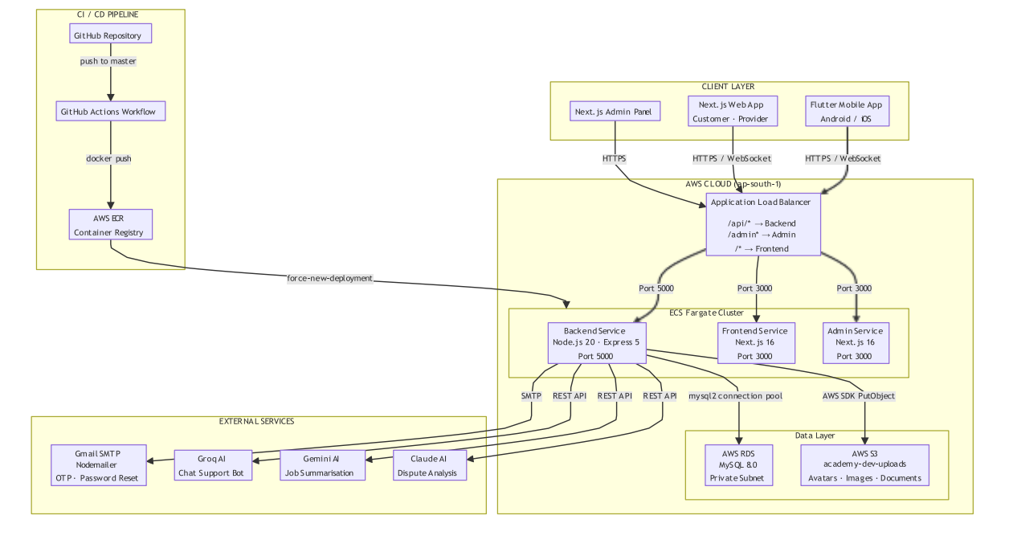

Figure 1.1 — Kaarkun System Architecture Diagram
3.3 Functional Requirements
The system requirements were divided into eight areas: authentication, job management, bidding, booking, communication, GPS tracking, reviews, notifications and administration. Twenty functional requirements were. Ranked as High or Medium depending on how important they were, to the main work of the Kaarkun platform.
Table 3.3 — Kaarkun Functional Requirements
ID | Module | Requirement Description | Priority
FR-01 | Authentication | System shall allow customers/providers to register with name, email, phone, password, and role. | H
FR-02 | Authentication | System shall authenticate users with email and password, returning a signed JWT valid for 24 hours. | H
FR-03 | Authentication | Service providers shall submit identity documents for admin review before appearing publicly. | H
FR-04 | Job Management | Customers shall post a job request specifying title, description, category, date, and GPS location. | H
FR-05 | Job Management | System shall display open jobs to providers filtered by category and sorted by proximity. | H
FR-06 | Job Management | Customers shall view the status of all posted jobs: open, booked, completed, or cancelled. | M
FR-07 | Bidding | Service providers shall submit a bid specifying a quoted price and explanatory message. | H
FR-08 | Bidding | Customers shall view all bids and accept exactly one, transitioning the job to booked status. | H
FR-09 | Booking | Upon bid acceptance, system shall auto-generate a unique QR code delivered to the customer. | H
FR-10 | Booking | Provider shall scan the customer QR code on arrival (check-in) and again on completion (check-out). | H
FR-11 | Booking | System shall record timestamped check-in and check-out events visible to both parties. | M
FR-12 | Communication | System shall provide real-time in-app messaging via Socket.io between customer and provider. | H
FR-13 | Communication | Mobile app shall provide a rule-based AI chatbot accessible from the home screen. | M
FR-14 | GPS Tracking | Customer shall view provider real-time GPS location on a map after booking confirmation. | H
FR-15 | GPS Tracking | Provider app shall broadcast GPS coordinates via Socket.io at configurable intervals. | H
FR-16 | Reviews | After service completion, customer shall submit a star rating (1-5) and optional review. | H
FR-17 | Reviews | Provider public profile shall display average rating and five most recent written reviews. | M
FR-18 | Notifications | System shall create in-app notifications for: new bid, bid accepted, booking confirmed, service started, completed. | H
FR-19 | Admin | Admin panel shall allow administrators to view, search, activate, or deactivate any user account. | H
FR-20 | Admin | Admin panel shall display a dashboard of platform totals: users, providers, bookings, and open reports. | M
3.4 Use Case Analysis
Figure 1.2 shows how the Customer actor works with the Kaarkun system. Figure 1.3 shows how the Service Provider actor works with the Kaarkun system. The Administrator actor works through the Next.js admin panel. The Administrator actor takes responsibility for all user account management activities. The Administrator actor grants approval for provider credentials during the verification process. The Administrator actor actively monitors all platform operations which occur on this system. The Administrator actor controls all report management activities.

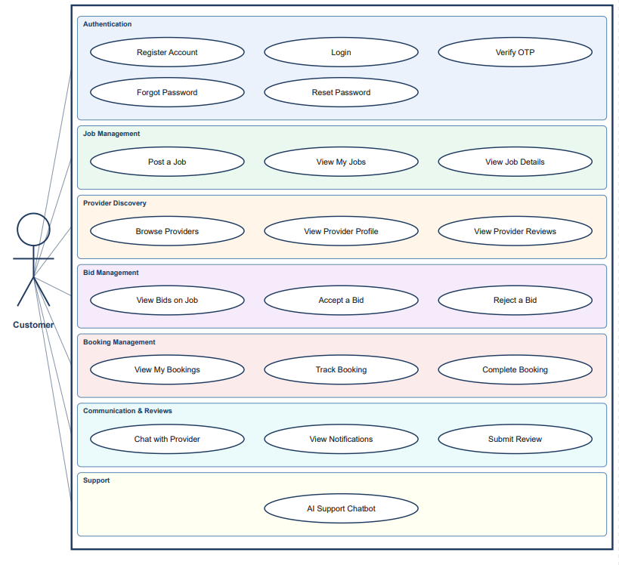

Figure 1.2 — Use Case Diagram: Customer Actor

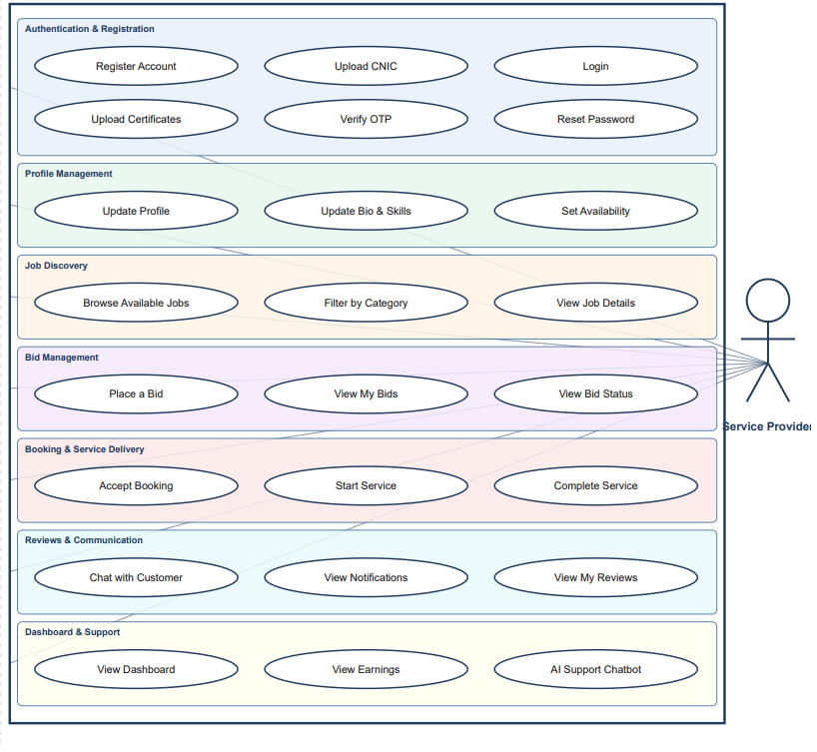

Figure 1.3 — Use Case Diagram: Service Provider Actor
3.5 Database Design (ERD Diagram)
I built the Kaarkun database using MySQL 8.0. The database contains eleven tables which I designed according to Third Normal Form (3NF) standards. I did this to make sure the Kaarkun database does not have data and keeps all links between tables strong. The users table serves as the main structure which forms the base of the Kaarkun database. The users table maintains two types of accounts which include customer accounts and service provider accounts. I used a role column to tell them apart. The provider profiles table I created serves as a dedicated storage system for service provider specific information. The Kaarkun database allows users to place multiple bids for every available job position. The Kaarkun database system generates a bookings record when someone accepts a bid. The bookings record contains a unique QR code together with scheduled check-in times and check-out times. Users who complete their work assignments can write reviews which link back to the original bookings record. I also made sure the Kaarkun database saves all messages so people can see their chat history. The notifications table helps keep the platform running. You can see the Entity-Relationship Diagram in Figure 1.4.

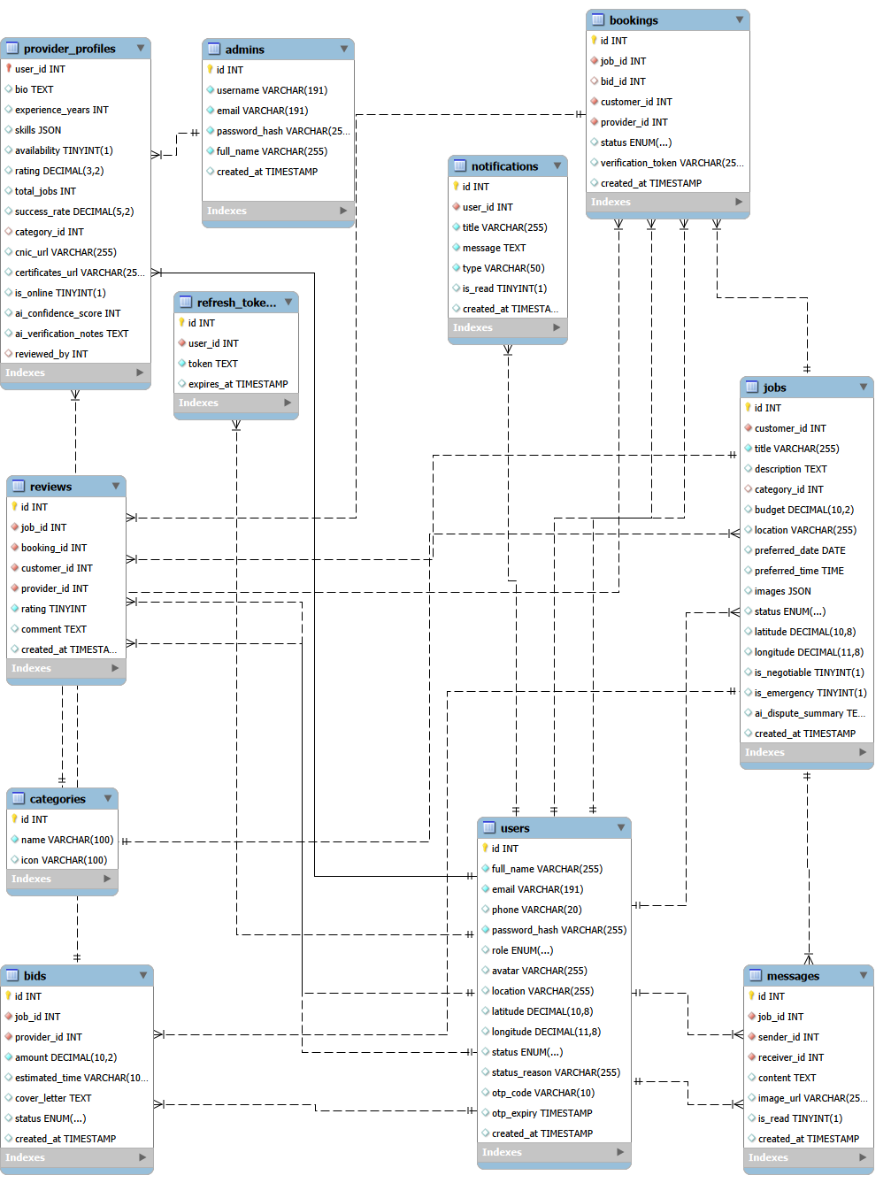
Figure 1.4 — Entity-Relationship Diagram: Kaarkun Database (11 Tables)
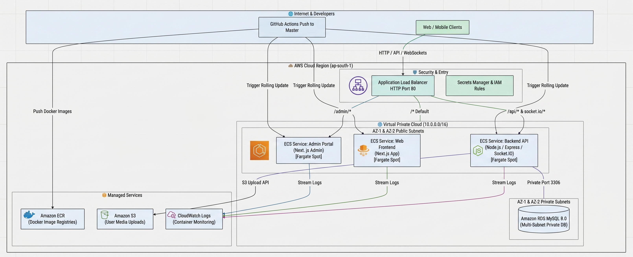
Figure 1.5 — Cloud Infrastructure

3.6 Implementation Features
3.6.1 Authentication and Authorization
User registration is processed by a POST /api/auth/register endpoint that validates inputs, hashes passwords using bcrypt (salt factor 10), and creates the user record. Login via POST /api/auth/login verifies the password hash and returns a signed JWT encoded with the user's ID, role and email, set to expire after 24 hours. All protected API routes validate the JWT through Express middleware. Service provider registration additionally requires document upload pending administrator approval. Only verified providers appear in the public job feed.
3.6.2 Job Posting, Bidding and Booking
Customers start by making a job request. When a customer makes a job request they include a title, a description, a category ID, a preferred date and GPS coordinates, from the Flutter geolocator package. Once the jobs are live verified providers find work by using GET /api/jobs. Providers can filter these jobs by category. How close they are. After looking at the jobs providers submit bids using POST /api/bids. The customer then picks one bid by using PATCH /api/bids/:id/accept. This single step is very important because it marks the chosen bid as accepted and rejects all the bids at the same time. This action also changes the job status to booked and tells the system to create a QR code.
3.6.3 QR Code Verification
When the bid accepts the server creates a booking token using Node.js crypto.randomUUID() and turns it into a QR image with the qrcode npm package. When the customer arrives the provider scans the customer’s QR code. Posts the decoded booking token to POST /api/bookings/:id/checkin. That endpoint checks the booking token and logs a check‑in event. When the stay ends the scan triggers POST /api/bookings/:id/checkout, which records the checkout timestamp marks the booking as completed and unlocks the review submission interface, for the customer.
3.6.4 Real-Time Messaging and GPS Tracking
In-app chat uses Socket.io rooms keyed by booking ID. Both parties join the room when booking confirmation is emitted. Messages are persisted to the messages table. Broadcast to the other party. GPS tracking is activated upon check‑in. The provider Flutter app emits location_update Socket.io events every fifteen seconds. The server directs all events directly to their respective customers. The customer’s Flutter screen tracks Google Maps marker position changes which occur in real time. The system operates at a high level of efficiency which produces prompt reactions.
3.6.5 AI Chatbot
The Kaarkun chatbot operates as an in-device engine which Flutter application contains. This engine performs word matches through its established rule system. An intent library takes normalised user input. The system converts user input into specific answer categories which handle typical platform questions. The Kaarkun chatbot gives a scripted response when a keyword match has the confidence and when input does not match any keyword the Kaarkun chatbot uses a graceful fallback. No network connection is. The Kaarkun chatbot provides immediate answers to users.
3.6.6 Administration Panel
The Next.js admin panel gives logged-in admins access, to four management tools. The system provides four management tools which include User Management and Document Verification and Booking Monitor and Dashboard (which displays platform totals in real time). Every admin API route needs a JWT with role = admin. Our server middleware checks the JWT to make sure everything is safe.
3.6.7 Wallet and Transaction System
Kaarkun has added a wallet that is managed by the platform. I see that Kaarkun’s digital wallet lets customers keep a pre‑funded balance so that they can pay service providers and it lets providers receive earnings automatically once a booking is finished. Kaarkun’s wallet works on the Flutter app and on the Next.js web site and it is supported by a set of dedicated REST API calls that run on the Node.js backend.
Kaarkun’s wallet records two balances, for each user: a balance that shows money that can be withdrawn and an escrow balance that holds money until a booking is complete. When a customer accepts a provider’s bid Kaarkun moves the agreed amount into escrow. When the booking is finished Kaarkun releases the money into the provider’s available balance giving a clear payment trail that is linked to the same booking record used by the QR attendance system.
The following wallet operations are available through the platform.
Top-up: Customers can load their wallet with money in amounts ranging from PKR 100 to PKR 50,000 each time. The top-up screen shows four select options (PKR 500 1,000 2,000 5,000) and also a field where Customers can type any amount they wish. The top-up process sends a POST request to /api/wallet/topup. Then gives back the new balance.
Withdrawal: Both customers and providers can withdraw funds from their balance using three payment methods: Bank Transfer, JazzCash and EasyPaisa. A minimum Withdrawal of PKR 500 is enforced by the server. The operation calls POST /api/wallet/withdraw with the requested amount and chosen method and returns the balance. Withdrawal requests are sent to the chosen payment channel and final settlement happens according to the channels processing schedule.
Provider earnings. I want to explain that service provider wallets receive money automatically when a booking is marked as completed. Providers do not put money into the wallet; they only remove the money that has accumulated. Because of this the top‑up option is hidden on the wallet screen when it does not apply. This keeps the interface free, from a workflow that would not make sense.
Transaction history: All wallet events such as top‑ups, withdrawals, payments, refunds and earnings are saved as transaction records. Each record is marked as either credit or debit and further labelled with a sub‑type, like top‑up, withdrawal, payment, refund or earning. The transaction list is divided into pages of ten records each. To get a given page of the transaction list, you make a call to GET /api/wallet/transactions?limit=10&amp;offset=N, where N is the number of records to skip over before returning the next ten transactions. Each transaction record includes the balance that was available after that transaction was recorded, creating an audit trail for the wallet.
On the wallet UI, the main balance and the escrow balance are displayed on a gradient balance card at the top of the screen. If there is any escrow amount (meaning some funds are currently locked in the escrow), an information strip will display the escrow amount. This strip only appears when there is an escrow amount to show, keeping the wallet UI clean of unnecessary information. Notifications for success or error messages as the user performs operations on the wallet are displayed as toast messages on the wallet screen itself, so the user does not have to leave the wallet page to see these notifications.
3.6.8 Multilingual and Multi-Currency Interface
The Kaarkun target market in Khyber Pakhtunkhwa speaks multiple languages so we developed the Flutter application to support both English and Urdu languages. I built a tool called LanguageProvider using the Flutter ChangeNotifier pattern to handle these language needs easily. The system maintains all user-interface text through core/l10n/translations.dart which serves as the central repository. I have two lists: enTranslations for English and urTranslations for Urdu. The lists maintain their structure through dot-notation keys which look like 'wallet.topUpTitle' and 'auth.login.title' in their organization system. The LanguageProvider.t(key) method activates to find words through its translation map whenever the app needs to retrieve words. The app shows the key itself when it fails to find the path through the LanguageProvider.t(key) method. The system prevents application crashes because it handles any missing translation content. I also wanted to make sure the app remembers what language a person likes. The SharedPreferences package lets me store the language selection as a value which I assign to the kaarkun_lang key. The system keeps your preferred language active throughout all app sessions which start after you close the app. The LanguageProvider functions as a primary ChangeNotifier provider which triggers all app components to update when users select different languages. The app immediately switches to a different screen when users change their language selection without needing to restart the application. I established a system which shows different money types through a CurrencyProvider that I developed. Our database stores all financial data through Pakistani Rupees (PKR) which functions as the core currency. The CurrencyProvider then turns those PKR amounts into the currency the user wants to see. We use fixed exchange rates to do this. The application now supports six different currencies which include PKR (₨) USD ($) AED (د.إ) SAR (﷼) EUR (€) and GBP (£). I set the conversion rates based on how many PKR equal one unit, like USD: 278.0 or GBP: 352.0. The app displays monetary values by first showing the currency code followed by the amount which appears as USD 18.01. For the base currency it. The display presents the entire sum through a single integer which shows as ₨ 5,000.
The users currency selection is stored in SharedPreferences under the selected_currency and is loaded again when the app starts with CurrencyProvider.loadCurrency(). The Settings screen shows both a language selector (English / Urdu dropdown) and a currency selector (six‑currency in one preferences panel so users can change both settings in one place. When either currency or language setting changes all screens update away thanks to the ChangeNotifier listener pattern.
I notice that the web frontend uses a parallel language context through a useLanguage() React hook that exposes an at(key) translation function ensuring that the customer and provider web interfaces display text consistently, with the mobile application.
3.7 Project Screenshots
These images show screenshots of the Kaarkun mobile application and the administration panel. The images illustrate the user interface, across the user flows.
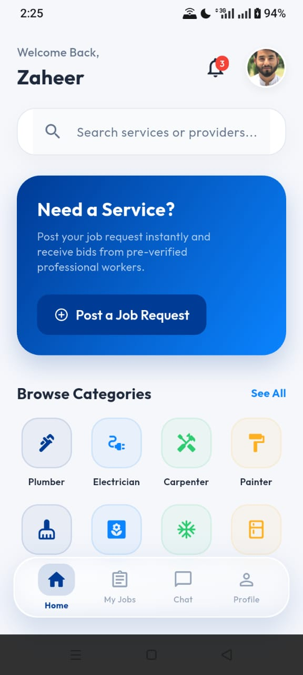
Image 2.1 Kaarkun App: Customer Home Screen

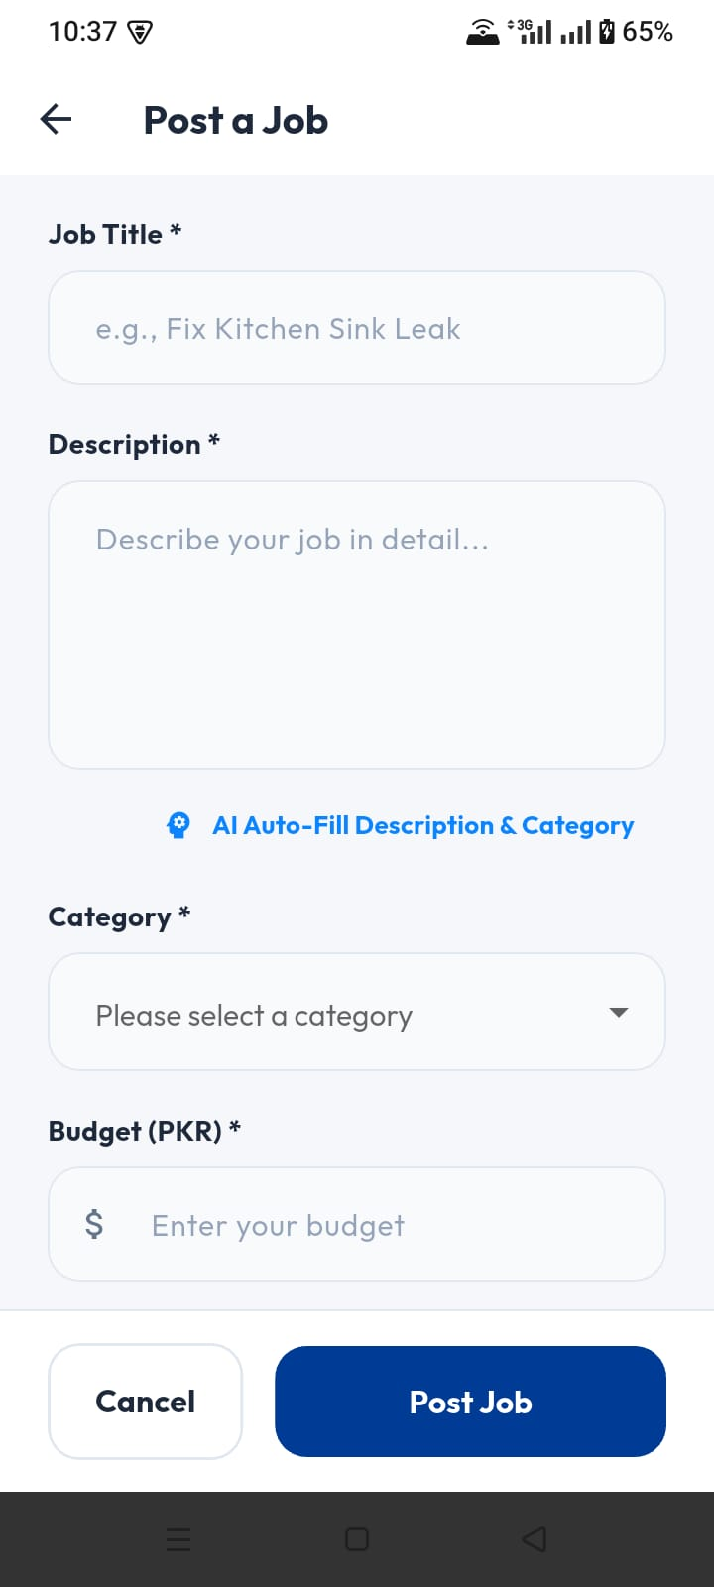

Image 2.2 Kaarkun App: Post a Job Screen
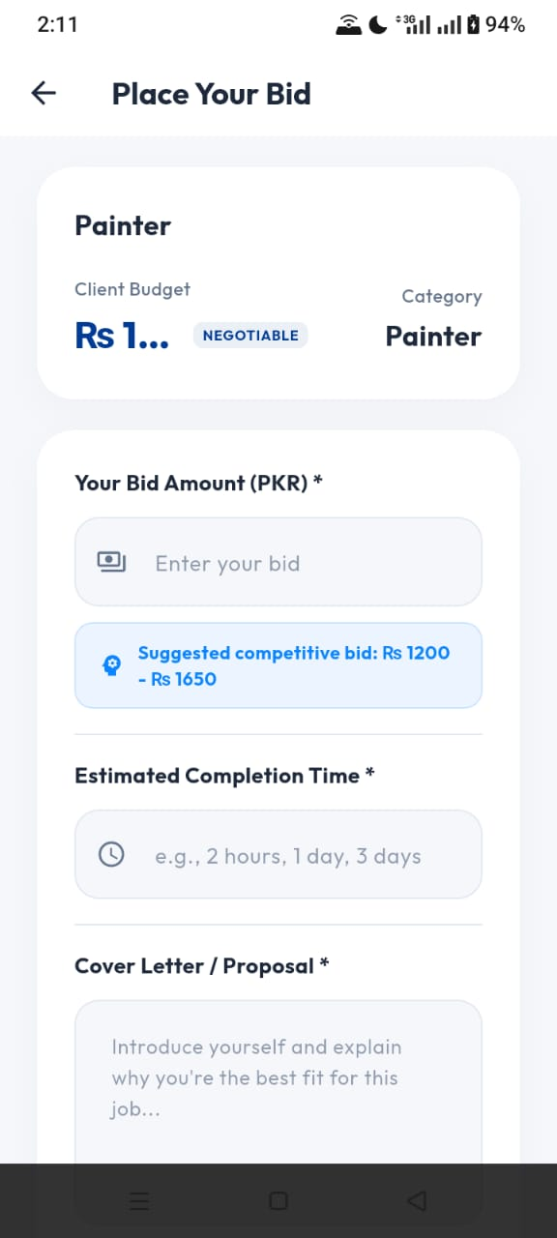
Image 2.3 Kaarkun App: Provider Bid Screen

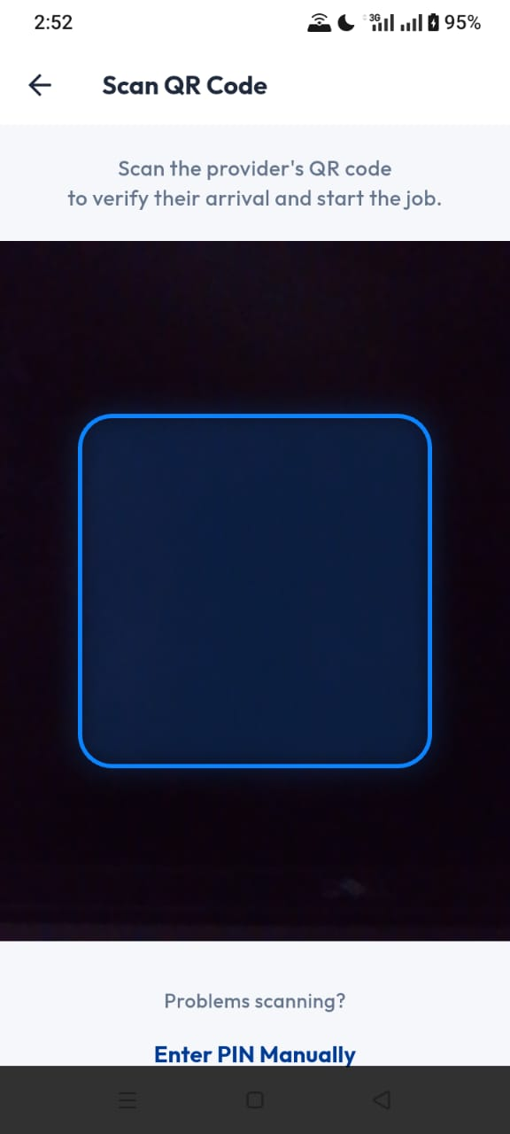
Image 2.4 Kaarkun App: QR Code Verificatoin Screen
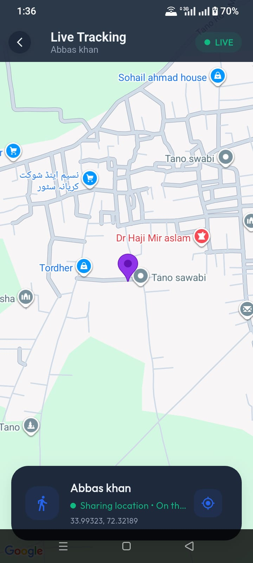
Image 2.5 Kaarkun App: Real-Time GPS Tracking Screen
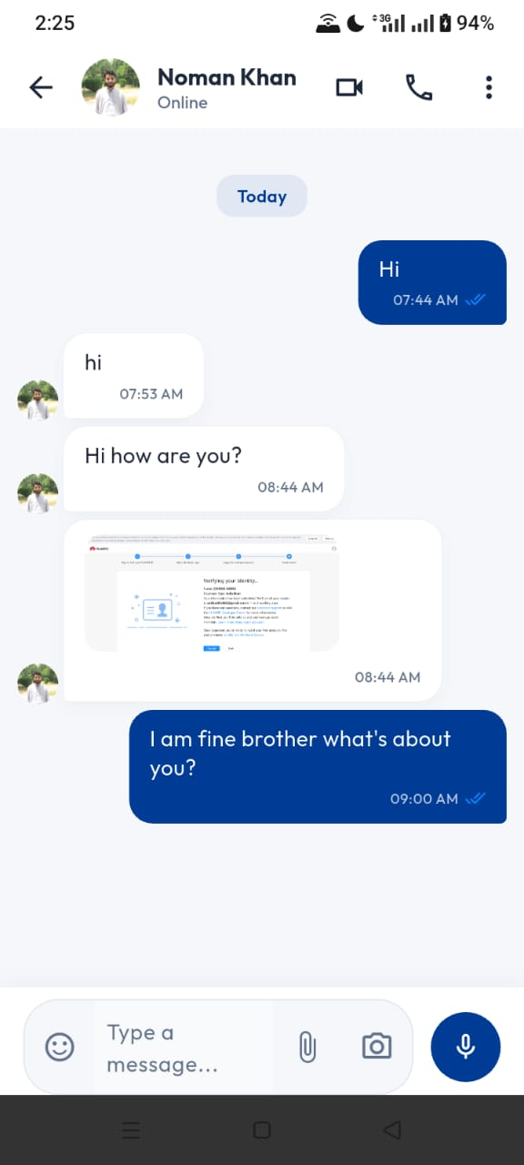
Image 2.6 Kaarkun App : In-App Chat Screen
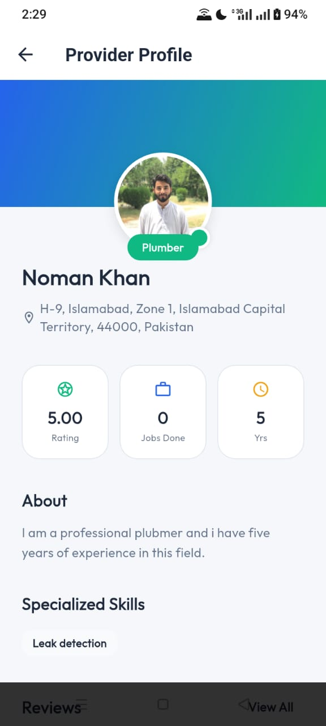
Image 2.7 Kaarkun App : Provider Profile Screen

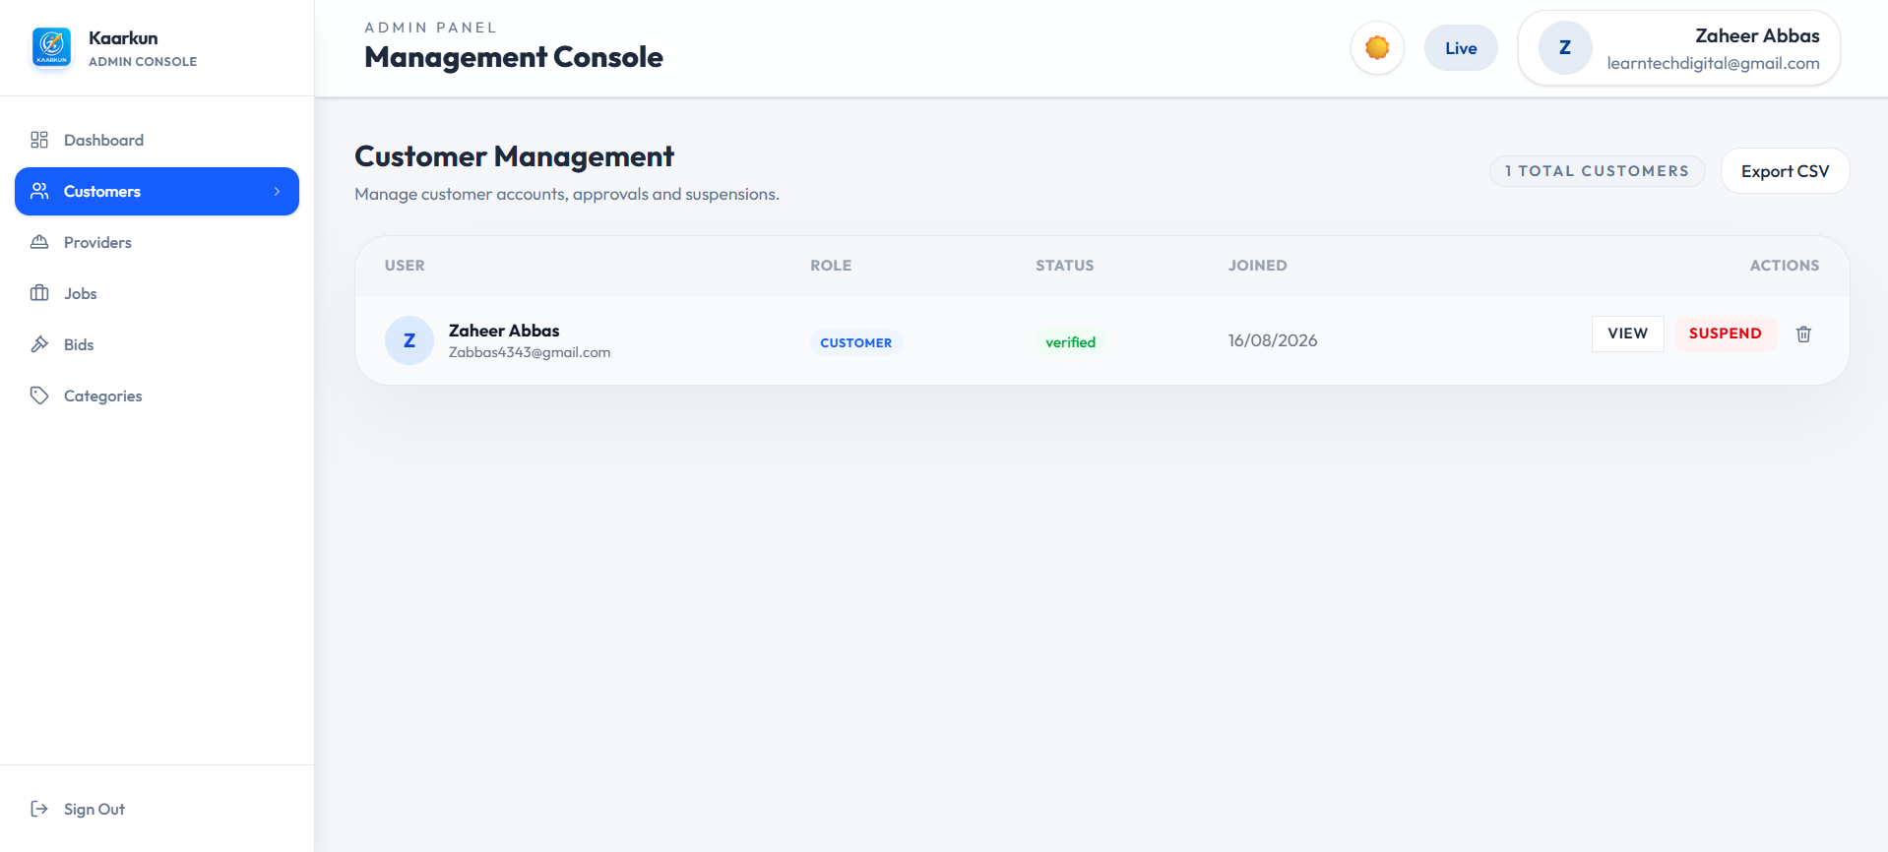

Image 2.8 Kaarkun Admin Panel : User Management

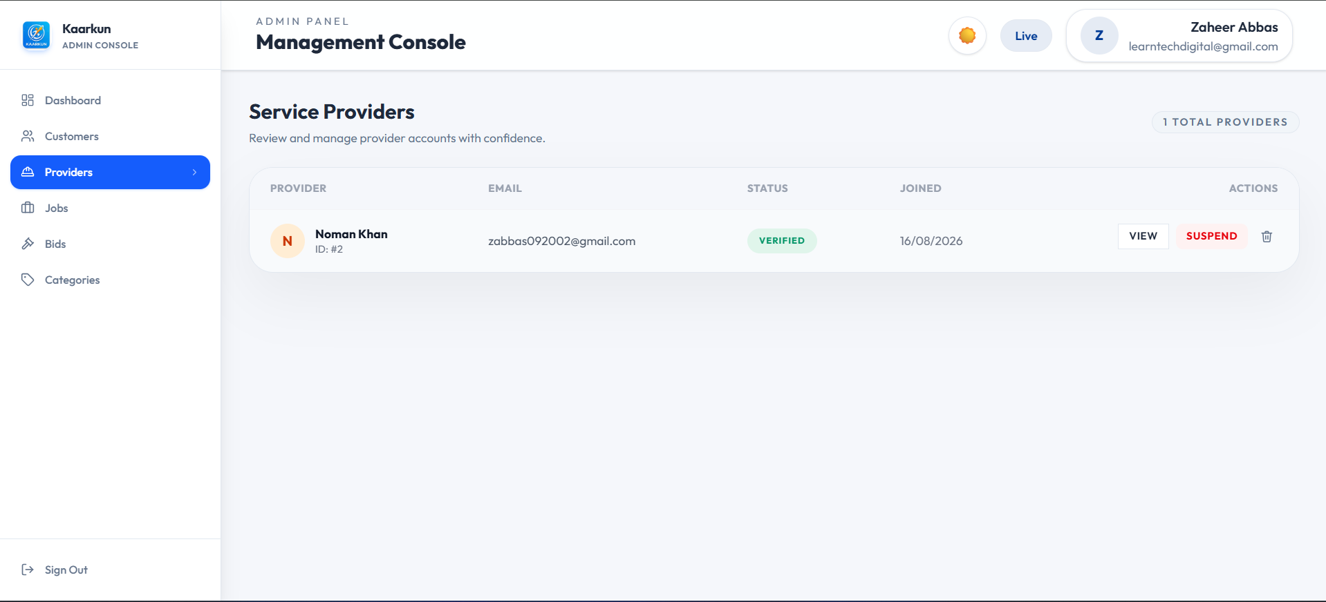

Image 2.9 Kaarkun Admin Panel : Provider Verification
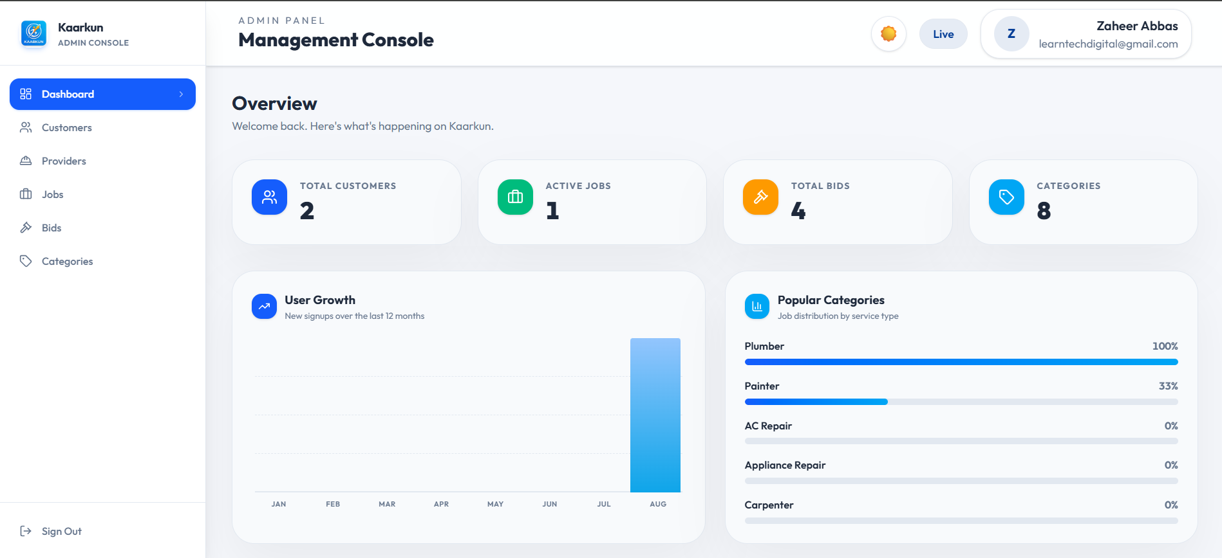

Image 2.10 Kaarkun Admin Panel : Dashboard Overview

3.8 Security Design
Table 3.4 shows the security measures that I have implemented for the Kaarkun system. These security measures guard user authentication, passwords, database operations, API access, input data and uploaded files.
Table 3.4 Security Measures by System Layer
Layer | Measure | Technology
Authentication | JWT-based authentication is used to protect authenticated routes. Tokens have a configured expiration period. | jsonwebtoken
Password storage | Passwords are securely hashed with bcrypt and are never stored in plaintext. | bcrypt
Database queries | Parameterised queries are used to reduce the risk of SQL injection attacks. | mysql2
API access control | CORS restricts requests to approved application origins. Role-based middleware also limits access to authorised users. | cors, custom Express middleware
Input validation | I want to make sure that Server‑side validation checks required fields. I also want to make sure that Server‑side validation checks user roles, OTP values, booking data and other request inputs. I also want to make sure that Client‑side form validation is also used in the application. | Express middleware, Flutter validators
File uploads  Rate Limiting | Uploaded files are restricted by file type and size limits before being stored or processed.  Login and OTP verification requests are rate-limited to reduce brute-force and credential-stuffing attempts. | Multer  express-rate-limit
Real-Time Security | Socket.IO connections require a valid JWT during the connection handshake. | socket.io, jsonwebtoken
3.9 Deployment Architecture and DevOps Pipeline
The Kaarkun platform is set up on Amazon Web Services (AWS) in the ap-south-1 (Mumbai) region putting the system into an environment that is ready, for real use. All the parts of the system that make up the infrastructure are described using code with Terraform and putting the system into action happens automatically using a GitHub Actions CI/CD pipeline. This part of the document explains the way the system is put together how containers are used, the cloud. How secrets are kept safe.
3.9.1 Continuous Integration and Delivery (CI/CD)
A GitHub Actions workflow that is defined in.github/workflows/deploy-aws.yml runs every time there is a push to the master branch. The workflow carries out the following steps one after another.
1. Repository checkout using actions/checkout@v4.
2. AWS credential configuration from GitHub repository secrets (AWS_ACCESS_KEY_ID and AWS_SECRET_ACCESS_KEY) using aws-actions/configure-aws-credentials@v4.
3. Authenticated login to Amazon Elastic Container Registry (ECR) using aws-actions/amazon-ecr-login@v2 which allows Docker push access.
4. Docker image. Push for each of the three applications: the Node.js backend (from./backend) the Next.js customer web frontend (from./web/kaarkun) and the Next.js admin panel (from./admin). The frontend and admin images get the NEXT_PUBLIC_API_URL and NEXT_PUBLIC_WS_URL build arguments so that the compiled JavaScript bundles point to the ALB endpoint at build time.
5. ECS service update via aws ecs update-service --force-deployment for each of the three ECS services telling ECS to get the new image and restart running tasks, with zero-downtime rolling replacement.
This pipeline removes deployment steps makes sure that the live environment always matches the master branch and creates a deterministic repeatable deployment process.
3.9.2 Docker Container Architecture
Every application is made into its Docker image. The build uses stages to keep the image small and reduce the chance of security problems. All Docker images start from alpine. Docker images run with a non‑root USER node to harden security.
Backend container (backend/Dockerfile): This Dockerfile uses a two‑stage build. In the deps stage production Node.js dependencies are installed. In the stage the dependencies and source code are copied. Backend container opens port 5000. Runs node app.js at start.
Frontend container (web/kaarkun/Dockerfile): This Dockerfile also uses a two stage build. The first stage installs all dependencies. The first stage compiles the Next.js application. The second stage copies the production output and node_modules. The second stage exposes port 3000. Starts with npm start.
Admin panel container (admin/Dockerfile) builds in three stages. First a deps stage gathers all dependencies. Second a build stage compiles the Next.js admin application. Third a runner stage runs the application. The Admin panel container exposes port 3000. Starts by running node server.js.
When I work locally I use a file. That file connects the four services: MySQL database, backend, frontend and admin. All of them share a Docker network. The MySQL database service has a health check. This health check makes the backend container wait for MySQL to finish initializing before it accepts connections.
3.9.3 AWS Cloud Infrastructure
The following AWS services form the production infrastructure for the Kaarkun platform.
Amazon Elastic Container Registry (ECR): Three private repositories store the versioned Docker images for backend, frontend and admin respectively.
Amazon Elastic Container Service (ECS) with Fargate: Serverless container orchestration. One ECS cluster (academy‑dev‑cluster) hosts three ECS services: academy‑dev‑frontend and academy‑dev‑admin. Each service runs a Fargate task definition with 512 CPU units and 1,024 MB of memory. Tasks run in subnets and do not hold public IP addresses limiting the attack surface.
Application Load Balancer (ALB): The public entry point for all HTTP traffic. The ALB listens on port 80 and applies path‑based routing rules: requests matching /api/* are forwarded to the backend service requests matching /admin or /admin/* are forwarded to the admin panel service and all other requests are forwarded to the frontend service.
Amazon RDS (MySQL 8.0): A managed relational database instance runs in subnets. The database is not internet‑accessible; only ECS tasks within the VPC security group can connect on the MySQL port (3306).
Amazon CloudWatch Logs: All ECS container output streams to CloudWatch log groups enabling log inspection and monitoring without SSH access, to containers.
AWS Identity and Access Management (IAM): An ECS task execution role grants the minimum permissions required for containers to pull images from ECR and write logs to CloudWatch.
3.9.4 Network Architecture and Security Groups
The VPC is split into two subnets and two private subnets spread over two Availability Zones. Within the subnets sits the NAT Gateway, which allows private resources to reach the internet while keeping them hidden from inbound traffic. The Internet Gateway supplies connectivity to the subnets. ECS task containers and the RDS database instance operate within the subnets and do not have public IP addresses.

Three security groups uphold the principle of privilege. The ALB security group permits HTTP traffic from any source (0.0.0.0/0). The ECS security group accepts traffic from the ALB security group. The RDS security group accepts MySQL traffic from the ECS security group. This layered boundary stops internet access to the application containers or, to the database.
3.9.5 Infrastructure as Code (Terraform)
I have defined all the AWS resources mentioned above using HashiCorp Terraform inside the terraform/ directory. The provider.tf file uses a variable to set the AWS provider region. In the variables.tf file I declare all the settings you might want to change, such as aws_region, project_name, environment, vpc_cidr and container ports. After you run the code the outputs.tf file will show you details like the ALB DNS name, ECR repository URLs and the RDS endpoint. I make sure the database password stays safe by using a random_password resource during the process. Because I marked the database password as sensitive in the Terraform outputs the database password will never be saved as text, in any version-controlled files. You can set up the Infrastructure by running this command: terraform apply -var-file=terraform.tfvars -var-file=secrets.tfvars -auto-approve I use a file to make sure the secrets.tfvars file, which holds all the private credential values stays out of version control. I also included a secrets.tfvars.example template so you can see which variables you need to fill in without seeing any secret values.
3.9.6 Secret Management
I manage deployment secrets at two levels. First I use GitHub repository secrets like AWS_ACCESS_KEY_ID and AWS_SECRET_ACCESS_KEY. The workflow puts these GitHub repository secrets into the GitHub Actions runner as environment variables. This way the AWS API can authenticate without me having to hardcode the AWS_ACCESS_KEY_ID or AWS_SECRET_ACCESS_KEY directly into the workflow file. Second I handle application runtime secrets such as EMAIL_USER, EMAIL_PASS, JWT_SECRET and DB_PASSWORD. These application runtime secrets get injected into the ECS containers as environment variables, through the task definition that Terraform manages. For my local work I keep local development secrets stored in backend/.env. I make sure that backend/.env is always excluded from version control so those local development secrets stay safe.
3.9.7 Deployment Flow Summary
The full process of taking code from when its written and making it available for users to use happens in seven steps.
1. A developer sends code to the master branch of the GitHub repository.
2. GitHub Actions starts the deployment process automatically.
3. The workflow connects to AWS using the information set up in GitHub.
4. Docker images for the backend, frontend and admin panel are created on the GitHub Actions runner.
5. The three images are sent to their ECR repositories and marked as the latest version.
6. Each ECS service is changed to start a deployment, which makes ECS get the newest image and replace the running tasks one by one.
7. The ALB keeps sending traffic to the tasks that are still working during the update so users never notice any downtime.
After the first version was built and tested some changes were made to the user interface in the administration panel the Flutter app and the Next.js web page. Using the changes will improve the ease of use of the software and make it look the same across all platforms. The features of each individual will be easy to see, but these changes do not alter the way in which the business operates. The rules that govern the business and its applications remain unchanged.
3.10 User Interface Design Refinements
3.10.1 Administration Panel Enhancements
The administration panel dashboard was improved to make the information clearer and the overall interface more consistent and user-friendly.
Dashboard analytics chart: A User Growth bar chart was added to show the number of user registrations for each month from January up to the current month. Each bar is placed with bottom-anchored CSS inside a container that has a relative height fixing a rendering problem where child elements with percentage heights inside flex containers collapsed to zero. When you hover over a bar a tooltip shows the number of signups.
Statistic card icon visibility: The four dashboard statistic cards – Total Customers, Active Jobs, Total Bids and Categories – were updated to use solid‑colour icon backgrounds. The backgrounds are blue‑600, emerald‑500 amber‑500 and sky‑500. The icons are white. This change replaces the light‑background design that had poor contrast when the interface is in light mode.
Sidebar brand icon: The placeholder icon in the administration panel sidebar was replaced by the Kaarkun application icon (icon.png). A plain HTML img element is used of the Next.js Image component because the Next.js image optimisation endpoint (/_next/image) does not route through the ALB configuration, for the admin panel.
Card hover border: The colour of the card hover border was changed. In mode it now uses subtle blue‑200 (#BFDBFE) instead of dark primary navy (#003B95). In mode it uses a semi‑transparent blue‑500. This reduces harshness when hovering over cards.
Content layout alignment: The left padding of the content area was fixed. It was changed from 288 px (pl‑72) to 256 px (pl‑64). This makes the padding match the fixed sidebar width so the background gap strip disappears.
3.10.2 Flutter Mobile Application Refinements
Four refinements were applied to the Flutter application.
The Wallet screen now shows currency amounts as whole numbers instead of displaying two decimal places which used to show PKR 5,000.00 as PKR 5,000. The _fmt helper method now uses Dart's num.round().toString() instead of toStringAsFixed(2) because the PKR currency system does not need decimal point precision below one rupee.
Role-based wallet top-up visibility: The wallet top-up button is now hidden for service provider accounts. Providers receive earnings automatically when a booking is completed and have no requirement to deposit funds; displaying a top-up control for providers introduced a confusing and inapplicable workflow. An AuthService role check (role == 'provider') conditionally removes the top-up button and its associated spacing from the balance card.
Browse Jobs filter modal dialogs: The Category and Sort By selection controls on the Browse Jobs screen were converted from slide-up bottom sheets (showModalBottomSheet) to centred modal dialog boxes (showDialog with a custom Dialog widget). The redesigned dialogs display a scrollable list of options with icon badges per category and a checkmark indicator on the currently selected item, improving discoverability on larger-screen devices.
Settings screen simplification: The Payment Methods settings entry was removed from the Settings screen. Because the platform does not currently use a third‑party payment gateway the Payment Methods settings entry was a placeholder that led to an incomplete workflow; removing it lowers the mental effort, for users navigating the Settings screen menu.
3.10.3 Web Frontend Navigation Refinements
I made two changes to how people move around the Next.js customer and provider web frontend.

Authentication page isolation: I added the Forgot Password page (/forgot-password) to the PUBLIC_ROUTES list in the AppShell component. When a page is on the public routes list it shows the page content without the sidebar or navigation bar for users who are not logged in. Before this change the Forgot Password page showed the authenticated navigation shell because it was not on the public route list. As a result, users who were not logged in found the interface difficult to understand and navigate.
Landing page brand icon: I replaced the placeholder Sparkles icon in the LandingNavbar component with the Kaarkun application icon (icon.png). I used an img element to make sure it works well with the ALB routing configuration. Now the branding, on the landing page looks just like the administration panel and the mobile application.

CHAPTER- IV
RESULTS AND DISCUSSION
4.1 Testing Approach
I carried out the system evaluation in two phases. The first phase comprised functional black-box testing of all twenty functional requirements. Each requirement was formulated as one or more discrete test cases executed by a simulated user operating the Flutter mobile application or Next.js web application against a locally running Node.js/Express.js server. Test outcomes were recorded as Pass or Fail based on whether the system response exactly matched the expected output. The second phase comprised integration testing of five critical cross-module workflows. All tests were performed on a Windows 11 development machine with MySQL 8.0 and Node.js 20-alpine running locally. The Flutter app was tested on Android Emulator API level 33 and on a physical Android device.
4.2 Functional Testing Results
Table 3.5 shows the testing done for the Kaarkun platform. A total of 25 test cases were used to check the 20 requirements. All 25 test cases passed, giving a pass rate of 100%. These results show that the features that were built worked as expected under the conditions that were tested.
Table 3.5 — Functional Test Case Results
TC-ID | FR | Test Case Description | Expected Result | Actual | Status
TC-01 | FR-01 | Register new customer with valid inputs | User created; success response returned | As expected | PASS
TC-02 | FR-01 | Attempt registration with duplicate email | HTTP 409 conflict error returned | As expected | PASS
TC-03 | FR-02 | Login with correct credentials | JWT token returned in response body | As expected | PASS
TC-04 | FR-02 | Login with wrong password | HTTP 401 unauthorised error | As expected | PASS
TC-05 | FR-03 | Provider uploads identity documents | Files saved; account set to pending | As expected | PASS
TC-06 | FR-04 | Customer posts a job with all required fields | Job created with status = open | As expected | PASS
TC-07 | FR-05 | Verified provider views open job list | Jobs returned, sorted by proximity | As expected | PASS
TC-08 | FR-06 | Customer views own posted jobs | All jobs with correct statuses returned | As expected | PASS
TC-09 | FR-07 | Provider submits bid on an open job | Bid record created with status = pending | As expected | PASS
TC-10 | FR-07 | Provider submits second bid on same job | HTTP 409 duplicate bid rejected | As expected | PASS
TC-11 | FR-08 | The job is not changed to booked; implementation changes it to active. | “Bid accepted; booking created; job status changed to active; other bids rejected.” | As expected | PASS
TC-12 | FR-09 | The verification PIN is not generated during bid acceptance, and the database field is not qr_code. | “Provider requests handshake PIN; a six-digit PIN is generated and stored in verification_token.” | As expected | PASS
TC-13 | FR-10 | The provider does not scan the QR code. The provider generates the PIN, while the customer verifies it. | “Provider generates an arrival PIN; customer verifies it.” Expected result: verification_token generated successfully.in-progress | As expected | PASS
TC-14 | FR-11 | There is no second QR scan for completion. The same handshake only changes the booking to in_progress. | Replace with a booking-status test, such as: “Provider marks the booking as awaiting confirmation.” | As expected | PASS
TC-15 | FR-12 | Customer sends message to provider | Message persisted; received via Socket.io | As expected | PASS
TC-16 | FR-13 | User types "how to post a job" in chatbot | Scripted response returned within 100 ms | As expected | PASS
TC-17 | FR-14 | Customer opens tracking screen during booking | Google Maps shows provider marker | As expected | PASS
TC-18 | FR-15 | Provider app emits GPS location event | Customer map marker moves to new location | As expected | PASS
TC-19 | FR-16 | Customer submits 4-star review after completion | Review saved; provider avg_rating updated | As expected | PASS
TC-20 | FR-17 | View provider public profile | Shows avg rating and 5 most-recent reviews | As expected | PASS
TC-21 | FR-18 | Check notification on bid acceptance | Provider notification created, correct type | As expected | PASS
TC-22 | FR-18 | Customer receives notification on booking confirmed | Customer notification created, correct type | As expected | PASS
TC-23 | FR-19 | The system does not use is_active; it uses the status field. | “Admin changes user status to blocked; blocked user login is rejected.” | As expected | PASS
TC-24 | FR-19 | The system does not use is_verified in the current schema. | “Admin changes provider status to verified; verified provider becomes publicly visible.” | As expected | PASS
TC-25 | FR-20 | Admin views dashboard statistics | Platform totals correctly returned | As expected | PASS
4.3 Integration Testing Results
Table 3.6 shows five integration test scenarios. These scenarios were used to check communication, between the parts of the Kaarkun platform. All five scenarios worked correctly during testing. This proves that the connected parts of the platform functioned together as planned.
Table 3.6 — Integration Test Scenarios
IT-ID | Scenario | Modules Involved | Status
IT-01 | Complete booking lifecycle: job posting -> bid submission -> bid acceptance -> PIN generation -> customer verification -> booking completion → review | Job Management, Bidding, Booking, PIN Verification, Reviews, Notifications | PASS
IT-02 | Real-time tracking: provider sends GPS coordinates -> server relays the location -> customer’s map updates | GPS Module, Socket.IO Server, Flutter Maps | PASS
IT-03 | Complete chat exchange: customer sends a message -> message is stored -> provider receives and replies | Chat Module, Socket.IO, Messages Database Table | PASS
IT-04 | Admin approves a provider -> provider logs in -> provider becomes visible to customers | Admin Panel, Authentication Module, Provider Directory | PASS
IT-05 | Chatbot interaction: user submits a query -> system attempts an AI response -> rule-based fallback handles unavailable or unmatched responses | Chatbot Interface, Backend AI Service, LLM Services, Offline Fallback | PASS
4.4 Requirements Compliance Matrix
Table 3.7 connects each research objective to the system features built to solve them, as well as the integration test cases used to check the features. I managed to meet all five research objectives during the testing phase. However, I did not include real-world validation, production-grade load testing or formal security testing in this project.
Table 3.7 — Research Objectives Compliance Matrix
Obj. | Research Objective | Addressing Feature(s) | Verified By | Status
O1 | Design and implement a multi-platform service marketplace | Android Flutter app, Next.js web application, REST API, and MySQL database | TC-01 to TC-25 | MET
O2 | Implement transparent competitive bidding | Job posting, bid submission, bid comparison, bid acceptance, and automatic rejection of other bids | TC-06 to TC-11 | MET
O3 | Provide real-time communication and GPS tracking | Socket.io chat, GPS location events, Google Maps tracking | TC-15, TC-17, TC-18, IT-02, IT-03 | MET
O4 | Integrate an AI-assisted support chatbot | Backend AI service with LLM providers and an offline rule-based fallback | TC-16, IT-05 | MET
O5 | Establish trust through identity verification, arrival verification, and peer reviews | Provider document verification, six-digit PIN-based arrival verification, and customer reviews | TC-05, TC-12, TC-13, TC-19, TC-20, TC-24 | MET
4.5 Discussion
The results of the testing phase of the Kaarkun platform indicate that we have finished all five research goals and finished all twenty requirements that we planned during the design phase of the project. All of the functional and integration tests that were performed passed perfectly, indicating that the requirements, the build, and the testing all work together. These tests were performed in a controlled space, however, and it is not yet appropriate to claim that all aspects of the platform perform perfectly in the world outside of controlled conditions.
One of the big things that makes the Kaarkun platform special is its arrival-verification mechanism. Instead of using QR codes to check in and out, Kaarkun uses a six-digit PIN that the provider creates, and the customer uses this PIN to verify that the provider has arrived. I believe this arrival-verification mechanism helps to build trust and makes people more accountable, as it confirms when a booking actually starts. Still, we should not call this an audit trail unless the Kaarkun platform saves separate times for checking in and checking out.
Another feature that helps make prices clear is the competitive bidding feature. This feature allows many verified providers to send offers for a customer’s job. Customers can look at the prices and messages before they pick a provider. I also added real-time GPS tracking to make the service better. This feature lets customers see where the provider is while the provider is driving to the job. We used Socket.IO to make sure both the live chat and the location updates work smoothly in the system.
Even though our tests showed a 100% pass rate, those tests only occurred within our development environment. When we launch the Kaarkun platform for the first time, we could encounter new problems. We might experience issues related to the internet, too many people using the app at once, different types of phones, or users that are not good with technology. Because of these possible issues, I think the next steps for the platform should be to conduct heavy load testing, real security tests, and small pilot tests with customers and providers. We should discuss these gaps in the project limitations section of the report rather than claiming that everything is totally fixed.

CHAPTER-V
SUMMARY
This study examined the markets for home and skilled trade services in Pakistan, especially in the Khyber Pakhtunkhwa province. People usually rely on asking friends to help with these jobs. There is no information about the workers or the prices of the services. It is difficult for customers to find the help they need and for workers to find new jobs. I have created Kaarkun, a digital platform, to fix these problems and make it easier for the two groups to connect with each other.
I built the system using the Design Science Research (DSR) method from Hevner et al. (2004). Followed the six-phase process from Peffers et al. (2007). I worked in two-week sprints to build and improve Kaarkun. I created twenty requirements which I used to direct my development process for Kaarkun main components and their testing activities.
The system operates through three different platforms which include an Android Flutter app and two Next.js web applications for customers and providers and administrators. The system components exchange data through a REST API which Node.js and Express.js power to access MySQL database information. Users can receive instant messages and notifications and GPS tracking through the Socket.IO system which I implemented. The MySQL database organizes its data through tables which serve as both organizational structures and security mechanisms. The mapping system operated through Google Maps while users could find addresses through OpenStreetMap Nominatim search functionality.
The Kaarkun platform performs a variety of important functions. Customers can post jobs to the platform. Verified providers can then submit bids for those jobs. Customers can view the bids for their jobs and select the best provider for the job. To ensure that the provider arrives at the customer’s location, the provider creates a six-digit PIN. The customer checks the PIN, which can also be displayed as a QR code within the application. Customers can also track the providers’ locations, message the providers, receive notifications, and leave reviews for the providers. The platform’s admin can manage the users, documents, jobs, and categories for the application. An AI chatbot has also been added to the platform. If the AI chatbot is down, simple rules are used to keep the chatbot functionality operational.

To keep the platform secure, JWT-based authentication was implemented for the API. Passwords for the users were hashed using bcrypt. SQL queries for the API were parameterized to prevent SQL injection. Additional security features include CORS restrictions, file-upload validations, rate limiting, and other server-side security checks. Access tokens are valid for seven days by default. A bcrypt cost factor of 12 was used for securing passwords. Twenty-five tests were conducted for the platform’s defined requirements. Five tests were conducted to evaluate how different components of the platform interact. All tests passed, resulting in a 100% pass rate for the platform. This indicates that the platform’s features work as they were planned. However, this was not a real-world test of the application. Features such as the provider PIN arrival check and GPS tracking are critical features of the platform, as they help to establish trust between the customers and the providers. However, tests such as user studies in Khyber Pakhtunkhwa, heavy load testing, and security hacking tests were not performed for this project.
CHAPTER-VI
CONCLUSION AND RECOMMENDATIONS
I worked on developing a marketplace for local workers and home service providers in Khyber Pakhtunkhwa, Pakistan. To develop this marketplace, I created the Kaarkun platform. The Kaarkun platform consists of an Android app built using Flutter, a Next.js web app for customers and providers, and a Next.js admin panel. For the backend, I developed a REST API using Node.js and Express.js, and used a MySQL database. I also integrated Socket.IO into the platform to enable real-time communication between users, notifications, and live GPS updates.
The Kaarkun platform allows customers to post jobs and browse through bids from verified workers. I added features like document verification for providers, a PIN system to check when a provider arrives at the job, GPS tracking of the provider, and a chat system between customers and providers. Customers can also leave reviews for the providers. To make sure a provider actually shows up, the provider creates a six-digit PIN, and the customer uses that PIN when the provider arrives. On the app, this PIN might show up as a QR code, but I did not build a separate QR check-in system or a special timestamped attendance log for this. I also included a chatbot that uses AI to help people. It falls back to simple rules if the AI service stops working.
To test that everything worked properly after finishing development of the Kaarkun platform, I ran 25 tests that covered 20 individual requirements and five integration scenarios. All 25 tests passed, which showed that the features of the Kaarkun platform performed as expected. Though, those tests did not examine how the platform would work in the real world with thousands of users. I compared Kaarkun to other similar platforms like Urban Company, TaskRabbit and Rozgar.pk and found that Kaarkun stands out due to its bidding system, PIN-based arrival verification and GPS tracking features. I did not include user studies within Khyber Pakhtunkhwa, heavy load testing or security testing in this project. Therefore, the Kaarkun platform will require further testing with real users and on a much larger scale before I can definitively say how well it performs for all users.
  - Recommendations
Based on the limitations and experiences gained during the development and testing of Section 1.4, several suggestions can be made regarding the Kaarkun platform.
- Enhance the AI Chatbot:
Presently, the Kaarkun platform uses an AI-assisted chatbot with a rule-based fallback. To improve upon this existing feature, the Kaarkun chatbot should be made much better at talking to people. This can be achieved by making the chatbot understand contexts better and adding different languages to the chatbot. Additionally, the chatbot can be made to give service-specific recommendations by integrating tools like Google Gemini or Anthropic Claude into the chatbot.
- Integrate a Local Payment Gateway:
Currently, the wallet module in the app does not handle actual money and only works within the app. If we add JazzCash or Easypaisa to the app, we can make the app much better. Adding JazzCash or Easypaisa to the app would allow users to add money to their wallet, pay for the things they want to purchase from the store, and allow the providers to take out their funds. It would also make sure that the automated settlement between users and providers happens without any trouble.
- Conduct a Formal User Study:
A usability study needs to be conducted in a structured manner. This study should include both the people who avail of the services and those who provide the services in different parts of Khyber Pakhtunkhwa. Such a study will help in identifying any usability problems with the platform. It will also help to determine if the platform meets the needs of the people it is intended to serve.
- Perform Production Load and Scalability Testing:
While the system can be deployed on AWS, it has not yet undergone production-grade load testing. I believe that future work should test users API response times, database performance, Socket.IO. System behaviour, under heavy traffic.
- Add Push Notification Support:
Firebase Cloud Messaging should be added so that notifications can be sent when the mobile app is not open or is running in the background. This will make sure that important alerts about bids, bookings, messages and service updates are received on time. Adding Firebase Cloud Messaging will help keep users informed and improve the experience. The focus is, on making sure that Firebase Cloud Messaging works properly and delivers all the messages. The goal is to have a way to send notifications. The same applies to all types of messages including ones. Making sure that Firebase Cloud Messaging is correctly set up is important. The same process should be followed for all notification types. The main idea is to ensure that Firebase Cloud Messaging is used effectively.
- Introduce Pashto Language Support:
The application must be fully internationalised to support Pashto language. All parts of the application such as interface text, validation messages, notifications and chatbot responses should be translated into Pashto language. This change will help users, with English proficiency to use the application more easily.
- Improve Provider Discovery and Matching:
The provider-matching algorithm must grow to include verified ratings, successful job-completion rates, response time, availability, distance and previous experience, in the service category. The provider-matching algorithm can be improved with a weighted scoring model that gives accurate recommendations and pushes higher service quality.

LITERATURE CITED
Ahmad, S., & Hussain, M. (2022). Digital labour platforms and informal sector employment in Pakistan: Opportunities and structural barriers. Pakistan Journal of Social Sciences, 42(1), 45-61.
Ahmed, N., Rehman, A., & Shah, S. A. (2021). Mobile commerce adoption in developing economies: Evidence from Khyber Pakhtunkhwa, Pakistan. Journal of Information Technology & Development, 27(3), 112-129.
Beck, K., Beedle, M., van Bennekum, A., Cockburn, A., Cunningham, W., Fowler, M., Grenning, J., Highsmith, J., Hunt, A., Jeffries, R., Kern, J., Marick, B., Martin, R. C., Mellor, S., Schwaber, K., Sutherland, J., & Thomas, D. (2001). Manifesto for agile software development. Agile Alliance.
Choudary, S. P. (2015). Platform scale: How an emerging business model helps startups build large empires with minimum investment. Platform Thinking Labs.
De Reuver, M., Sorensen, C., & Basole, R. C. (2018). The digital platform: A research agenda. Journal of Information Technology, 33(2), 124-135.
Evans, D. S., & Schmalensee, R. (2016). Matchmakers: The new economics of multisided platforms. Harvard Business Review Press.
Farhan, M., & Baig, U. (2020). An analysis of freelancing platforms and gig economy growth in Pakistan. Proceedings of the International Conference on Computing and Information Technology, 23-29.
Google LLC. (2024). Google Maps Platform documentation: Geocoding API.
Hagiu, A., & Wright, J. (2015). Multi-sided platforms. International Journal of Industrial Organization, 43, 162-174.
Hevner, A. R., March, S. T., Park, J., & Ram, S. (2004). Design science in information systems research. MIS Quarterly, 28(1), 75-105.
International Labour Organization (ILO). (2022). World employment and social outlook: The role of digital labour platforms in transforming the world of work. ILO.
Khan, Z., & Qureshi, J. A. (2021). Trust mechanisms in peer-to-peer service platforms: A review of design strategies. Telematics and Informatics, 58, 101530.
Lim, W. M., Kumar, S., & Ali, F. (2022). Advancing knowledge through literature reviews: What, why, and how to contribute. The Service Industries Journal, 42(7-8), 481-513.
Malik, A., & Khan, S. (2020). Platform economy and service market transformation in South Asian cities. Asian Development Review, 37(2), 134-158.
MySQL Community Edition. (2024). MySQL 8.0 reference manual. Oracle Corporation.
Parker, G., Van Alstyne, M., & Choudary, S. P. (2016). Platform revolution: How networked markets are transforming the economy and how to make them work for you. W. W. Norton & Company.
Peffers, K., Tuunanen, T., Rothenberger, M. A., & Chatterjee, S. (2007). A design science research methodology for information systems research. Journal of Management Information Systems, 24(3), 45-77.
Rahman, F., & Ali, M. (2019). E-commerce growth in Pakistan: Opportunities and challenges in the informal economy. South Asian Studies, 34(2), 89-104.
Rochet, J.-C., & Tirole, J. (2003). Platform competition in two-sided markets. Journal of the European Economic Association, 1(4), 990-1029.
Royce, W. W. (1970). Managing the development of large software systems. Proceedings of IEEE WESCON, 26, 1-9.
Socket.IO. (2024). Socket.IO documentation: Introduction to WebSockets.
Stucke, M. E., & Grunes, A. P. (2016). Big data and competition policy. Oxford University Press.
Sutherland, J., & Schwaber, K. (2020). The Scrum guide: The definitive guide to Scrum: The rules of the game. Scrum.org.
Yin, R. K. (2018). Case study research and applications: Design and methods (6th ed.). SAGE Publications.

SHORT BIOGRAPHY OF THE SCHOLAR
Zaheer Abbas completed his Secondary School Certificate in 2018 and then completed his Higher Secondary School Certificate from the Board of Intermediate and Secondary Education, Mardan in 2020. He obtained his Bachelor's degree in Computer Science from The University of Swabi which he completed in 2026.
The student developed Kaarkun during his final year project which Professor Hammad supervised as an AI-based service marketplace operating across multiple platforms. The main focus of his work involved building complete application solutions which included both web-based and mobile-based systems. He worked with Flutter, Next.js, Node.js, MySQL, Socket.IO, RESTful APIs, and GPS integration. The project offered him real-world experience through its frontend and backend development work which included database management and real-time communication systems and API integration. Abbas concentrates on full-stack web development and mobile application development and backend engineering and database systems and software engineering and artificial intelligence. He wants to become a Full Stack Developer who creates software solutions that solve actual problems through scalable and reliable systems.
SHORT BIOGRAPHY OF THE SCHOLAR
Muhammad Dawood achieved his Secondary School Certificate in 2020 and then completed his Higher Secondary School Certificate from the Board of Intermediate and Secondary Education, Mardan in 2022. He then pursued a Bachelor's degree in Computer Science from The University of Swabi and graduated in 2026.
For his final year project, under the supervision of Professor Hammad, Dawood worked on the Kaarkun platform. His main focus for this project was on infrastructure engineering, automating the deployment processes for the platform, and setting up continuous integration and continuous delivery pipelines. He used Terraform to define the infrastructure for the platform as code, automated the deployment of the platform using GitHub Actions, and configured several AWS services such as AWS ECS Fargate, Application Load Balancers, Amazon RDS, Amazon S3, and AWS Secrets Manager. With this educational and project experience, Dawood aims to pursue a career in cloud computing and DevOps engineering.
SHORT BIOGRAPHY OF THE SCHOLAR
Ismail Khan completed his Secondary School Certificate in 2020 and Higher Secondary School Certificate from the Board of Intermediate and Secondary Education, Mardan in 2022. He also has a Diploma in Information Technology from the Board of Intermediate and Secondary Education, Peshawar in 2024. He completed his Bachelor's degree in Computer Science from The University of Swabi in 2026.
For his final year project, under the guidance of Professor Hammad, he worked on Kaarkun, an AI-based multi-platform service marketplace. His role in the project was to focus on the frontend development of the web and mobile applications. He contributed to the designing and implementation of the user interfaces, testing the mobile application, web application, and admin panel, as well as supporting the overall implementation of the system. The project gave him practical experience in frontend development, application testing, documentation, and project coordination. Ismail Khan is interested in frontend development, user interface design, web technologies, mobile application development, software testing, and software engineering. He wants to pursue a career as a Frontend Developer, focusing on building software applications that are modern, responsive, and user-friendly.

