1. Missing Database Driver

Error generated by not having mysql driver jar file in the library. Fixe by include the jar file in the library

Error Message: "Problem getting driver:com.mysql.jdbc.Driver"

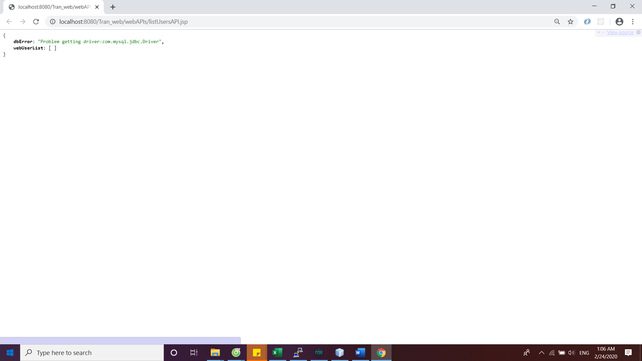

1. Database Unreachable

Error generated by not connecting to a SSH software to get to external mysql server. Fixe by connect with PuTTY

Error Message: "Problem getting connection:Communications link failure The last packet sent successfully to the server was 0 milliseconds ago. The driver has not received any packets from the server."

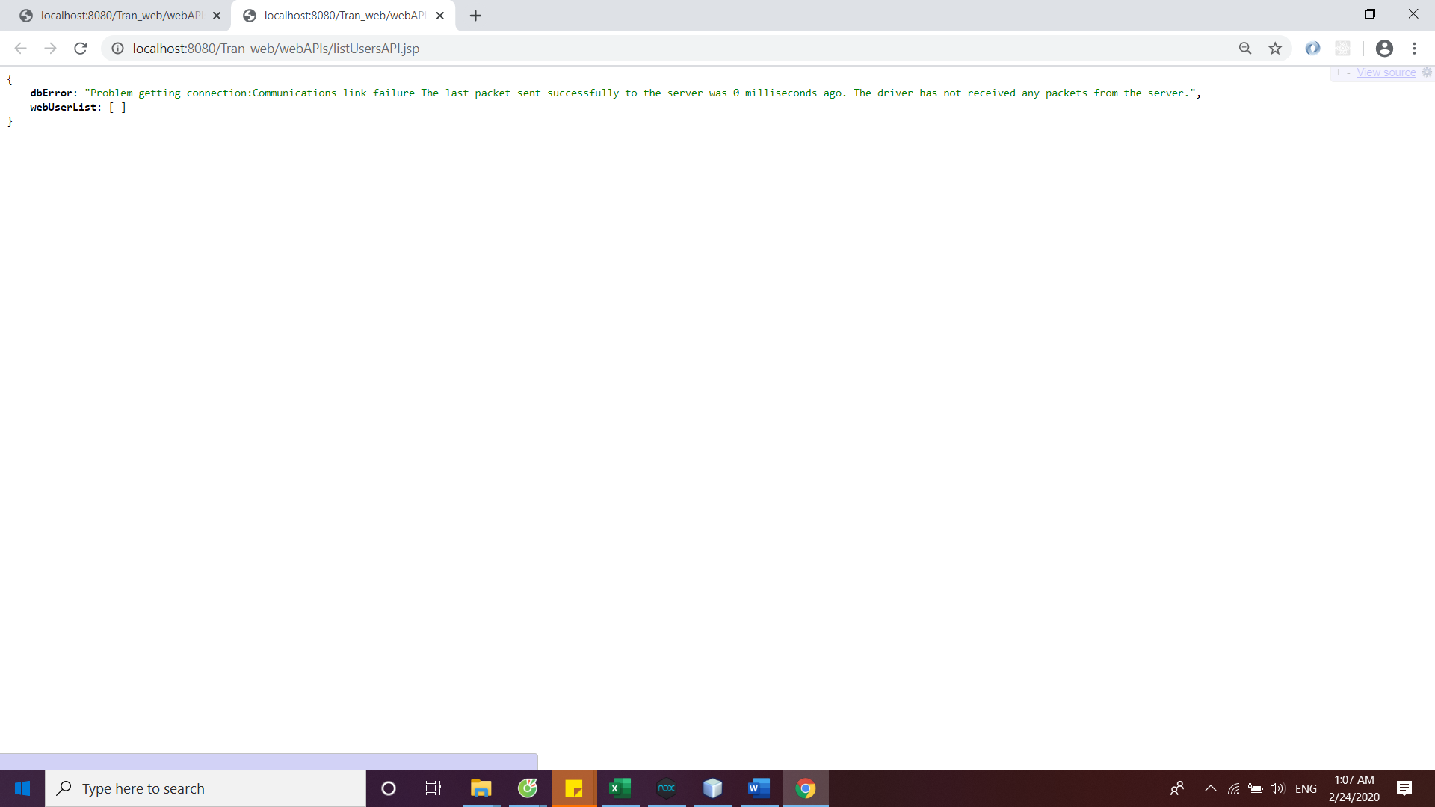

1. Database Not Authorized

Error generated by wrongly type the user name or password when trying to connect to the external mysql server. Fixed by entering the correct password and user name.

Error Message: "Problem getting connection:Access denied for user 'tug70814'@'cis-linux2-priv.temple.edu' (using password: YES)"

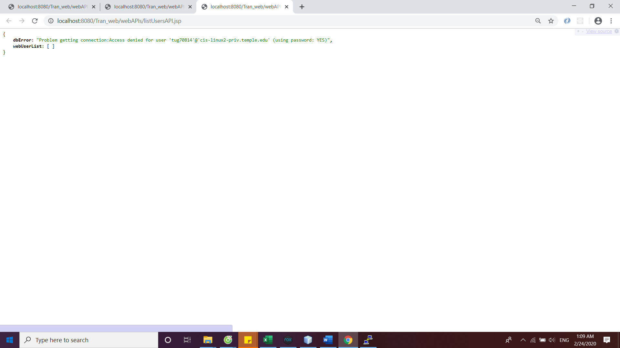

1. Syntax error in SQL Statement

Error generated by making a mistake in the SQL statement. Fixed by correctly input the syntax of the SQL statement

Error Message: "Exception thrown in WebUserView.allUsersAPI(): You have an error in your SQL syntax; check the manual that corresponds to your MySQL server version for the right syntax to use near 'web_user, user_role where web_user.user_role_id = user_role.user_role_id ORDER B' at line 1"

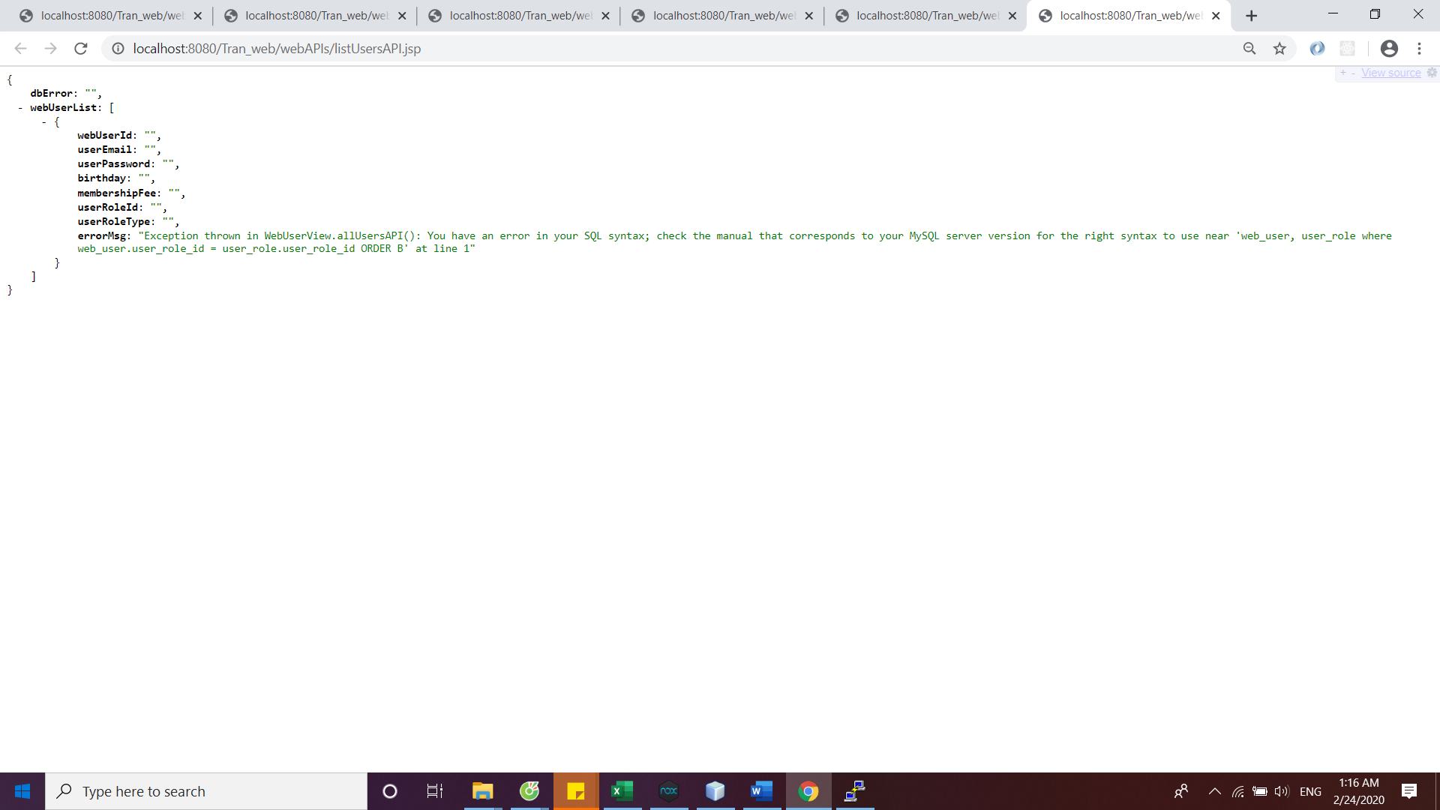

1. Error Extracting Data from Result Set (bad column name)

Error generated by entering the non existed column name within the declaration inside StringData file. Fixed this by enter an existed column name in mysql database

Error Message: "Exception thrown in model.webUser.StringData (the constructor that takes a ResultSet): Column 'user_email2' not found."

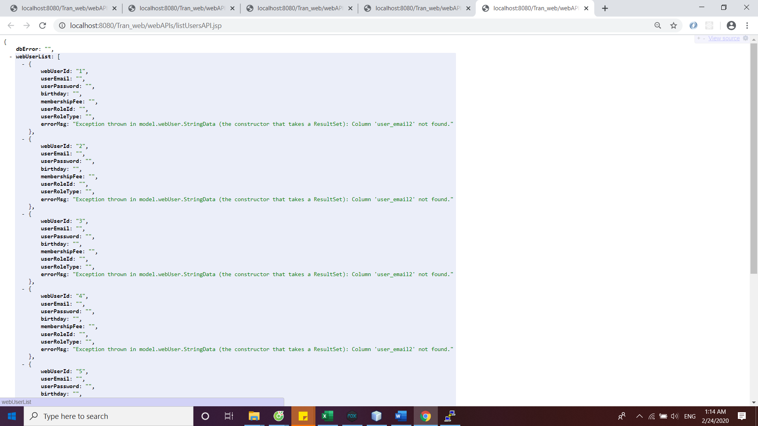

1. Error Extracting Data from Result Set (wrong data type)

Error generated by having the converting the wrong data type from the database to web format in StringData file. Fixed this by assign the correct data type for conversion

Error Message: "bad Integer in FormatUtils:123@ho.ho Error:java.lang.String cannot be cast to java.lang.Integer"

