Minh Tran

Functionality

It’s an MMO-RPG game site that allow player to register and play an online multiplayer game. The web application provide ability to register, log on-off, delete account in the user table and play a game embedded in the site. The “other table” is prefixed so the user cannot alter that table in anyway. The user can change the associate table by inserting and deleting records within the table.

Marketing Material

As the game is the main selling point for people to access the site, the game will be the main part that get marketed on. With over 400 classes and a rich storyline, the game provides an interesting experience on RPG gaming and encourage people to try out different classes. With a different way of implementation, player can register with more than one class without creating new account.

Possible lines:

The official website for the hot new multiplayer rpg game, Symphony at Dawn. Participate in the ongoing project and start your adventure with more than 400 classes!!! What are you going to be? ~

Symphony at Dawn is developed as a fan lore of the songs from the American production company Two Steps from Hell. With epicness in their track, Two Steps from Hell has inspired a crazy amount of human to break out from their comfort zone and achieve the impossible. With this model in mind, the game developer hope to bring an impossible gaming experience to the audience.

Data model:

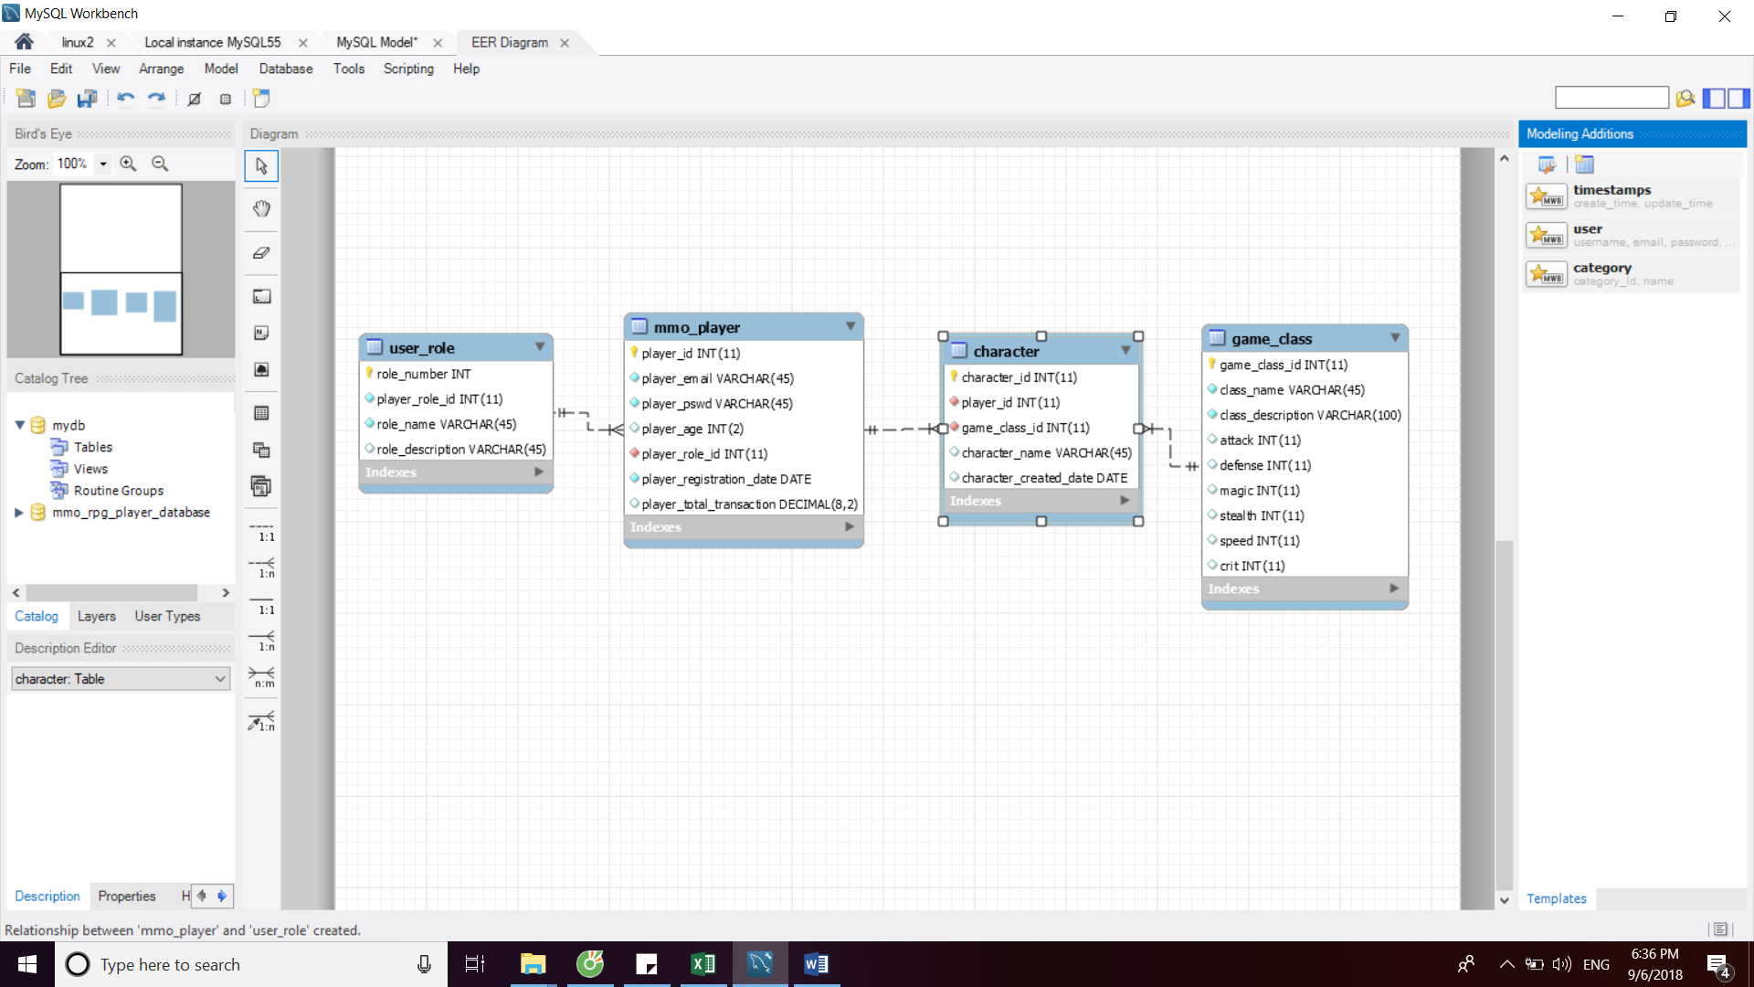

Table Design

User table and its foreign key

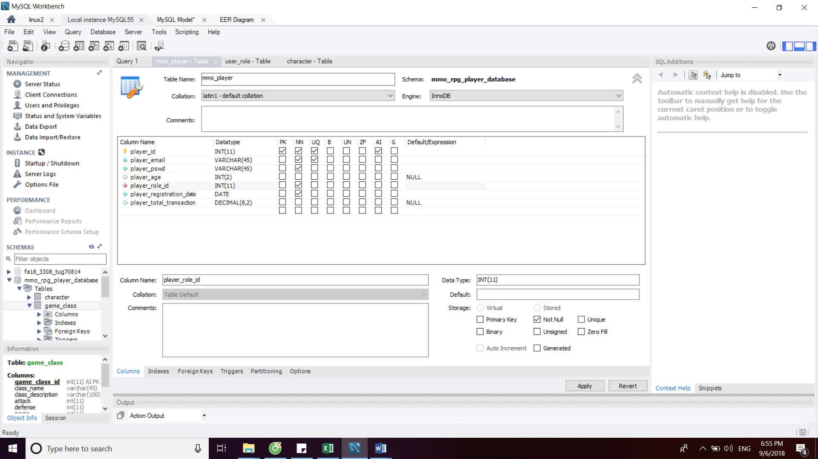

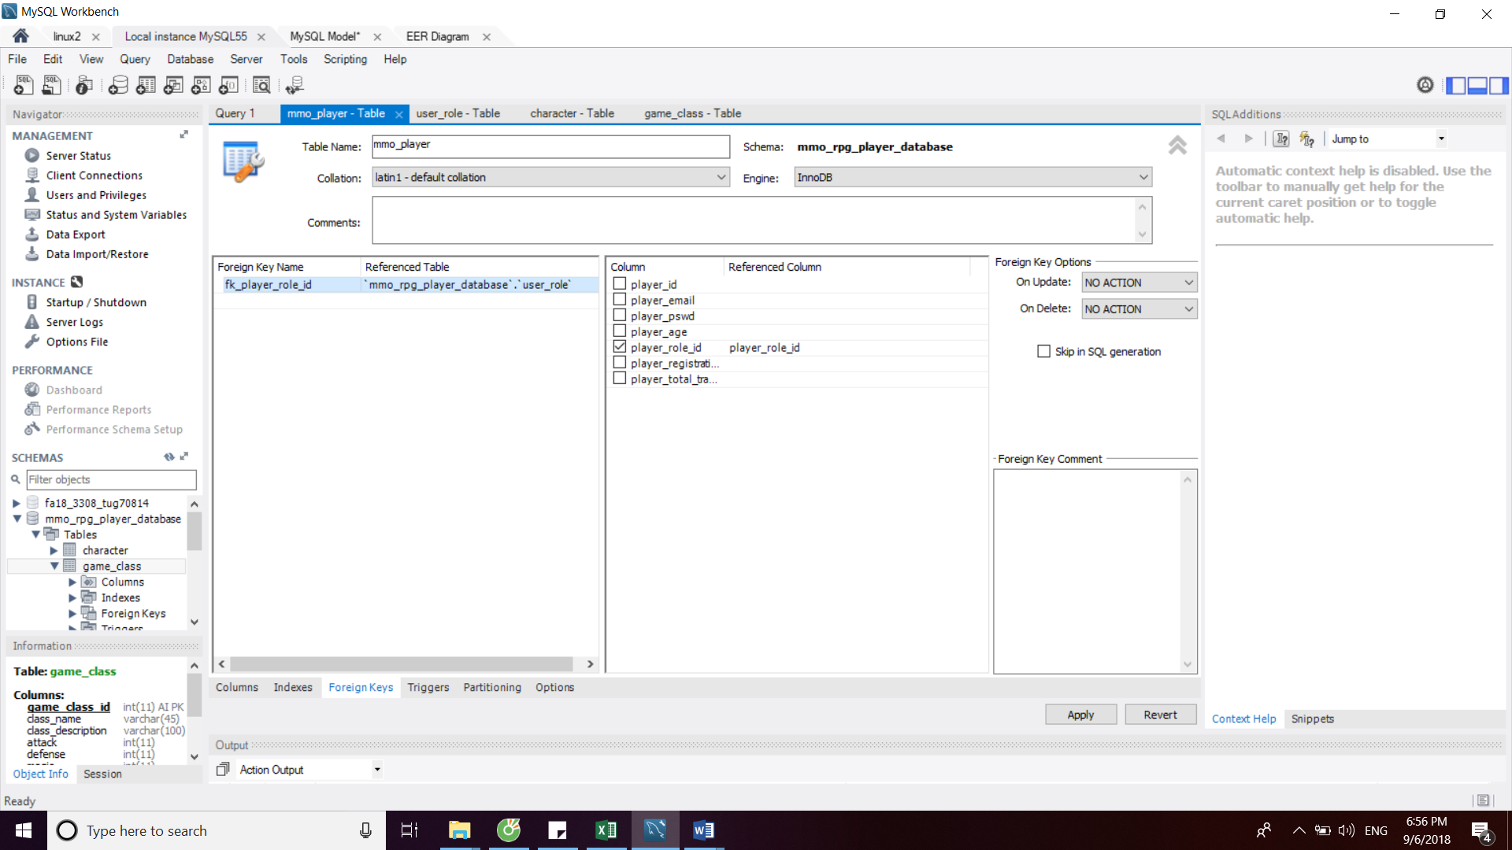

Other table:

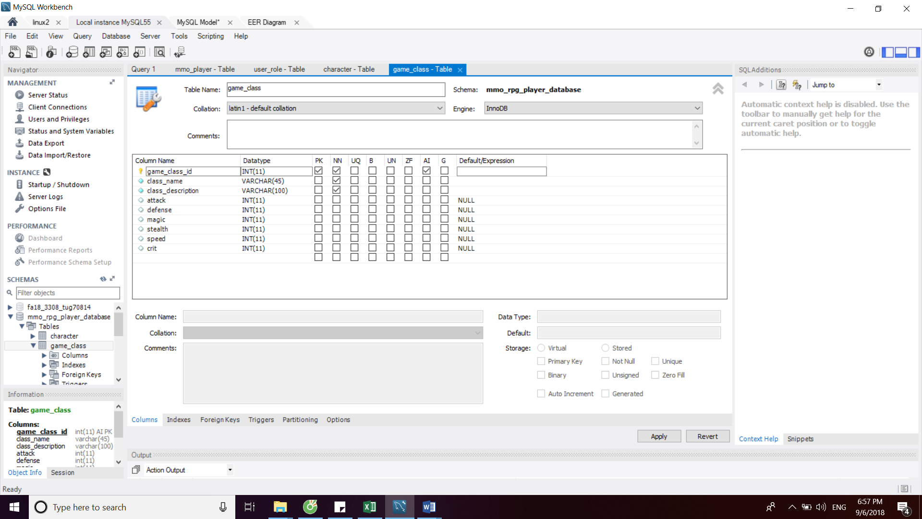

Associate table and its foreign key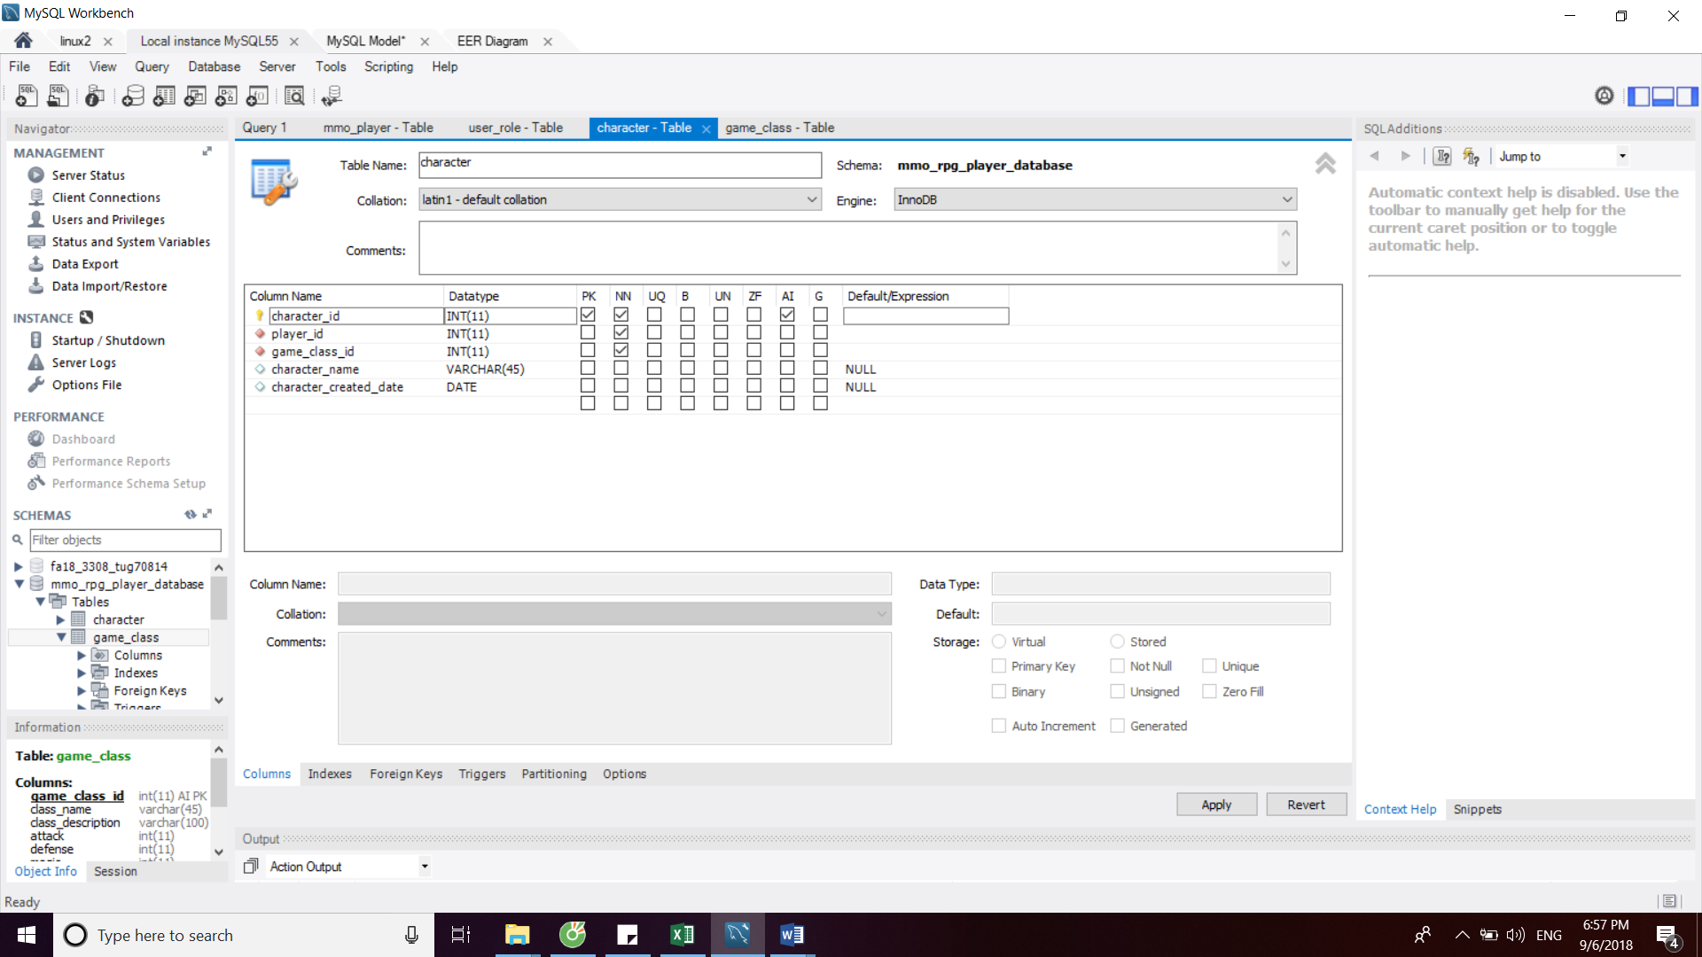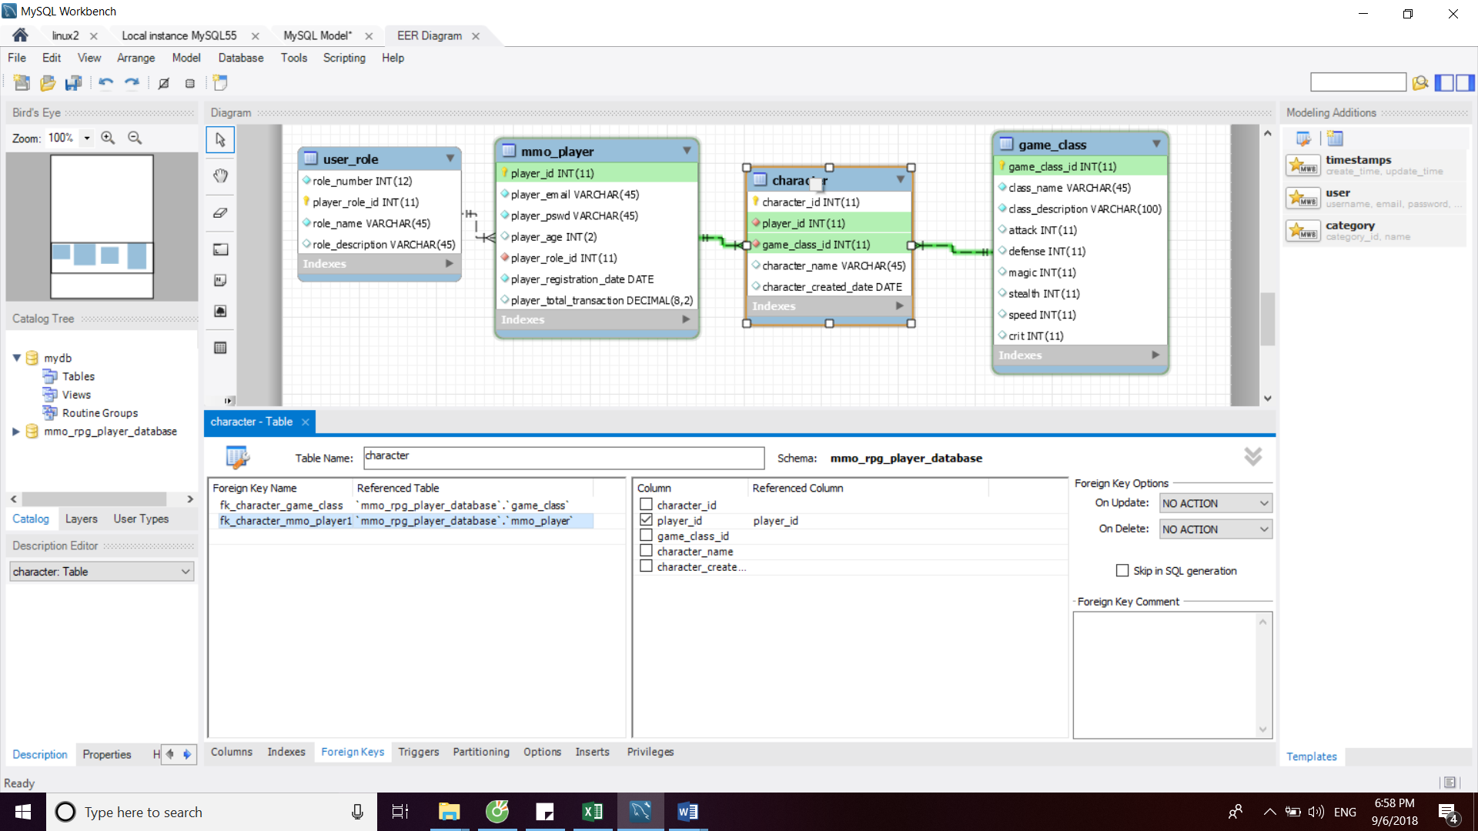

Select Statement 