1. Problem: **Missing Database Driver;**

Error in DbConn. Problem getting driver:com.mysql.jdbc.Driver

The error happens as jar file for connecting database to html and jsp file is not presented. This can be fixed by adding the JAR file in

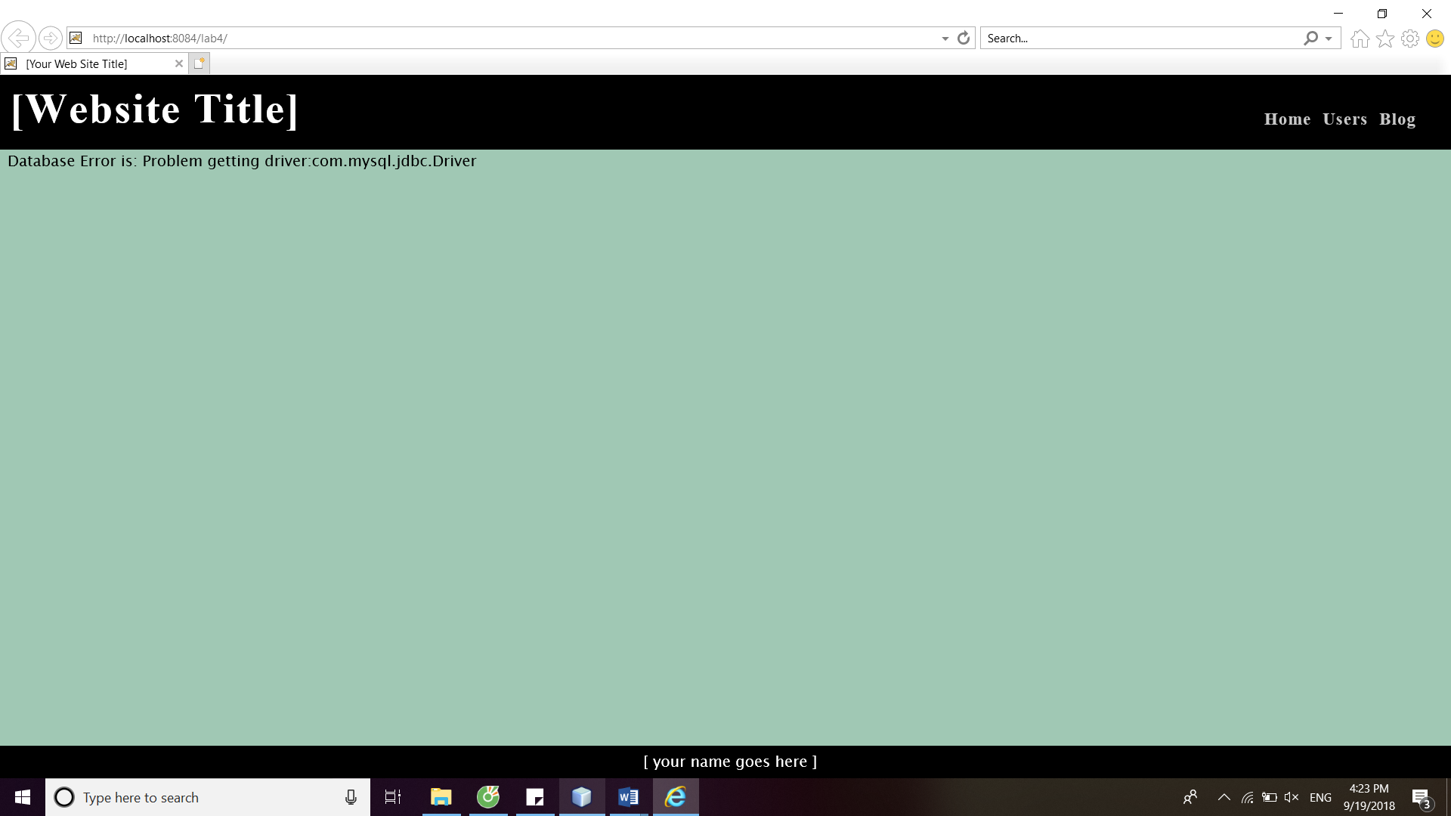

1. Error: Database unreachable

Database Error is: Problem getting connection:Communications link failure The last packet sent successfully to the server was 0 milliseconds ago. The driver has not received any packets from the server.

The error happens as the website was not tunneled for the cis-linux2 server. Use Putty and other tunneling program to connect to the server to fix the error.

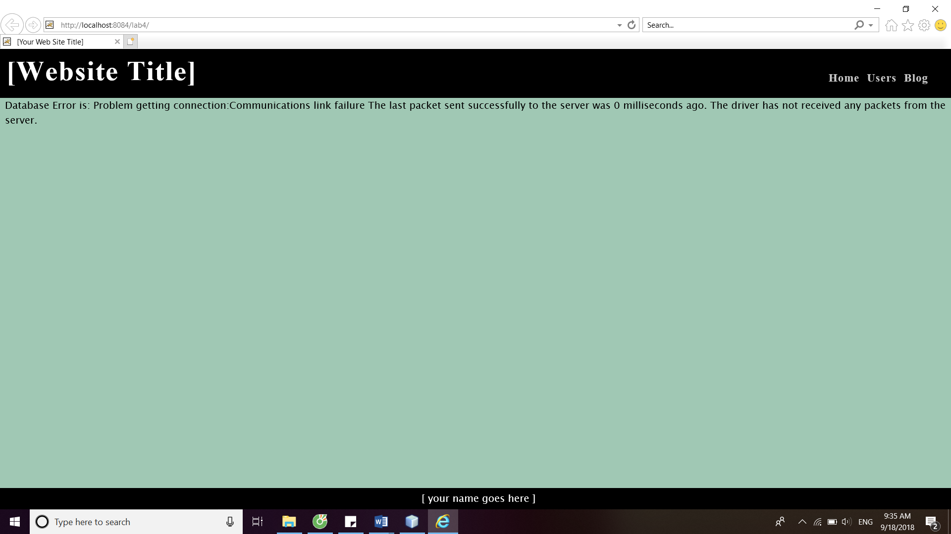

1. Error: Database Not Authorized

Database Error is: Problem getting connection: Access denied for user 'tug70814'@'cis-linux2-priv.temple.edu' (using password: YES)

The error happens as the password was entered incorrectly. Reenter the correct password in the DBConn.java will solve the problem

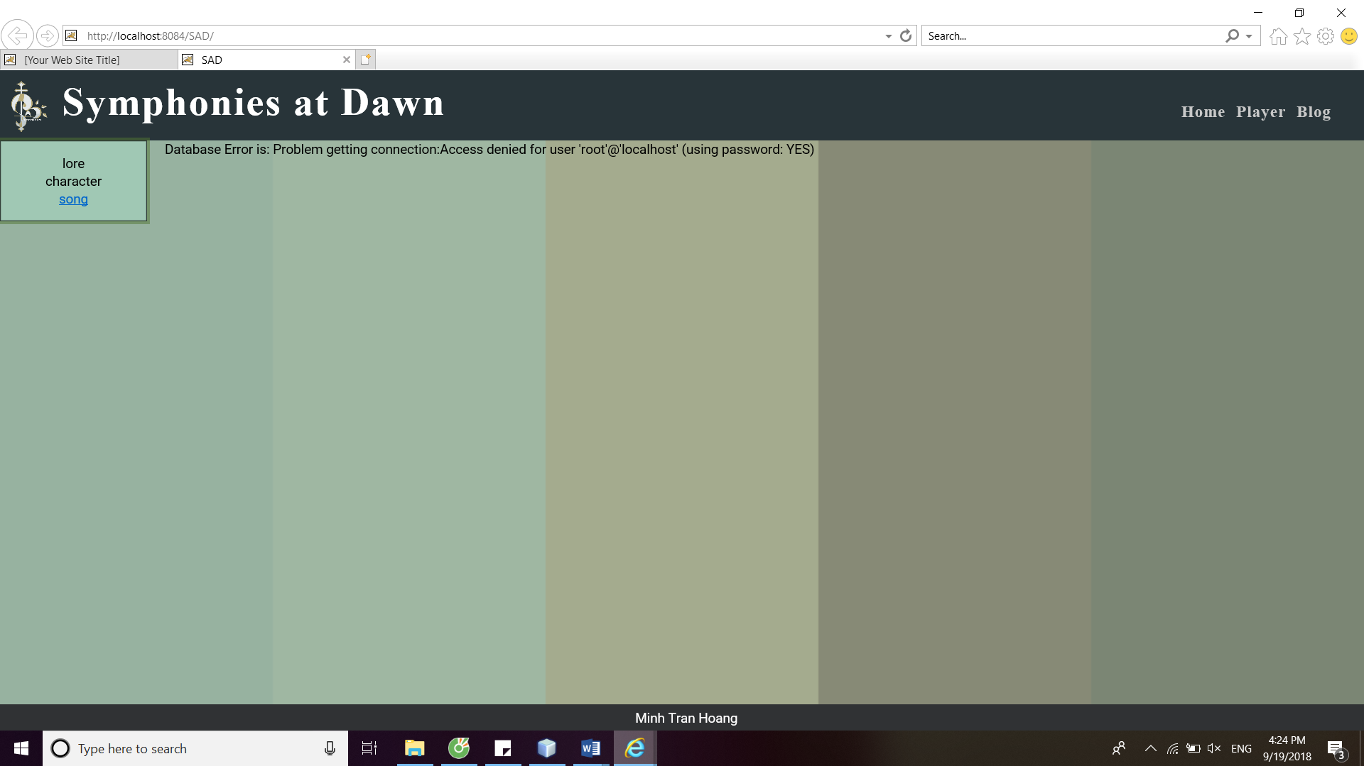

1. Error: Error Extracting Data from Result Set (bad column name)

Exception thrown in WebUserView.allUsersAPI(): Unknown column 'user_role_id' in 'field list'

Error happens when enter column name that doesn’t exist in the database or not include the table that the column is in at WebUserView.java. Change the wrong column name in WebUserView.java and other View.java class into the correct column name or include the table will solve the problem

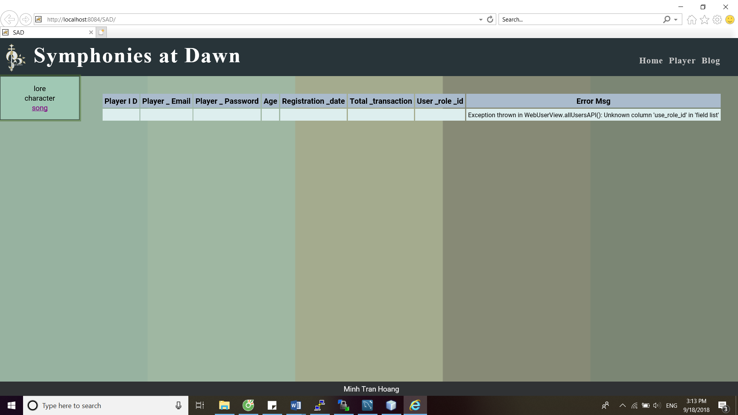

1. Error Extracting Data from Result Set (wrong data type)

Exception thrown in WebUser StringData (the constructor that take a ResultSet) java.sql.Date cannot be cast to java.math.BigDecimal

Error happen when the data type for transformation was not correct. Changing the casting data type to the expected data type in StringData.java and similar java class will solve the problem

