**Render my_s1_index.html locally** in your browser

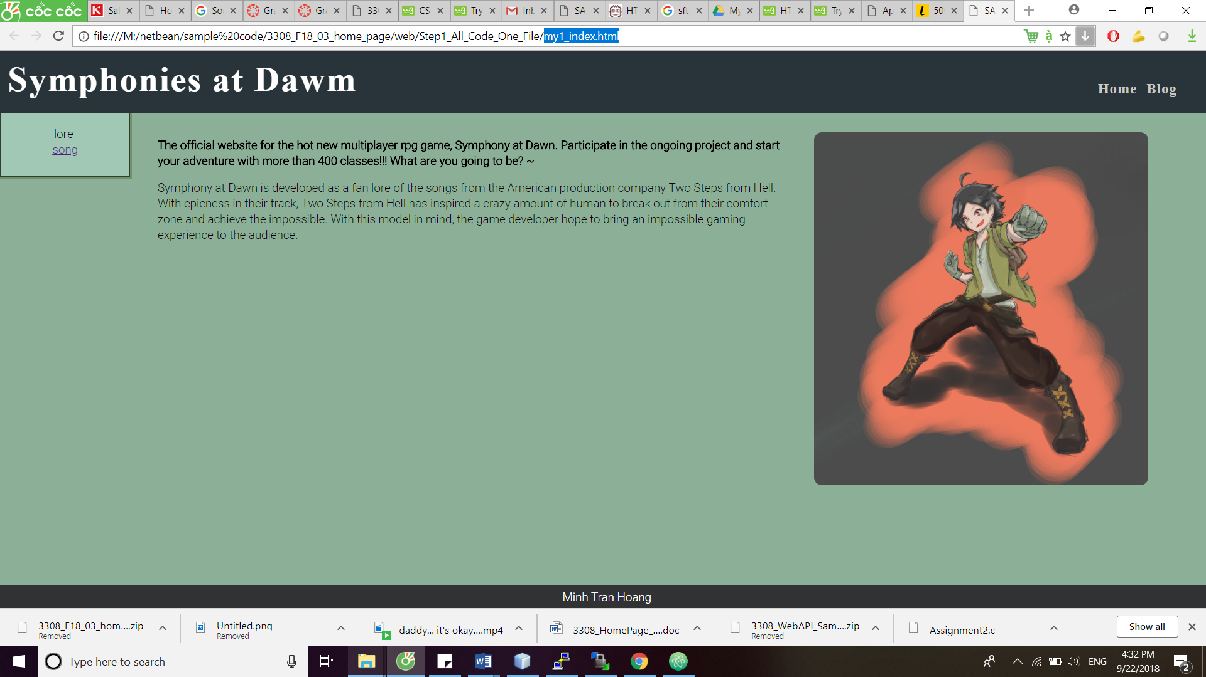

**Render my_s1_index.html remotely** from the web server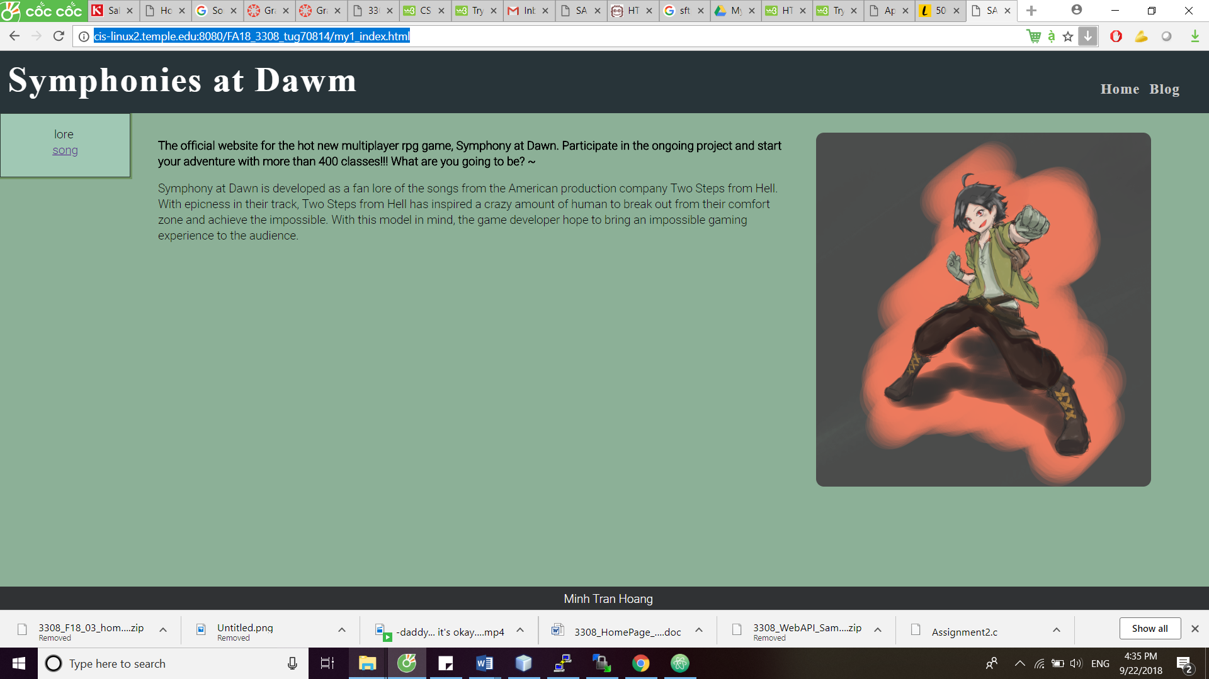

**Render my_s2_index.html locally**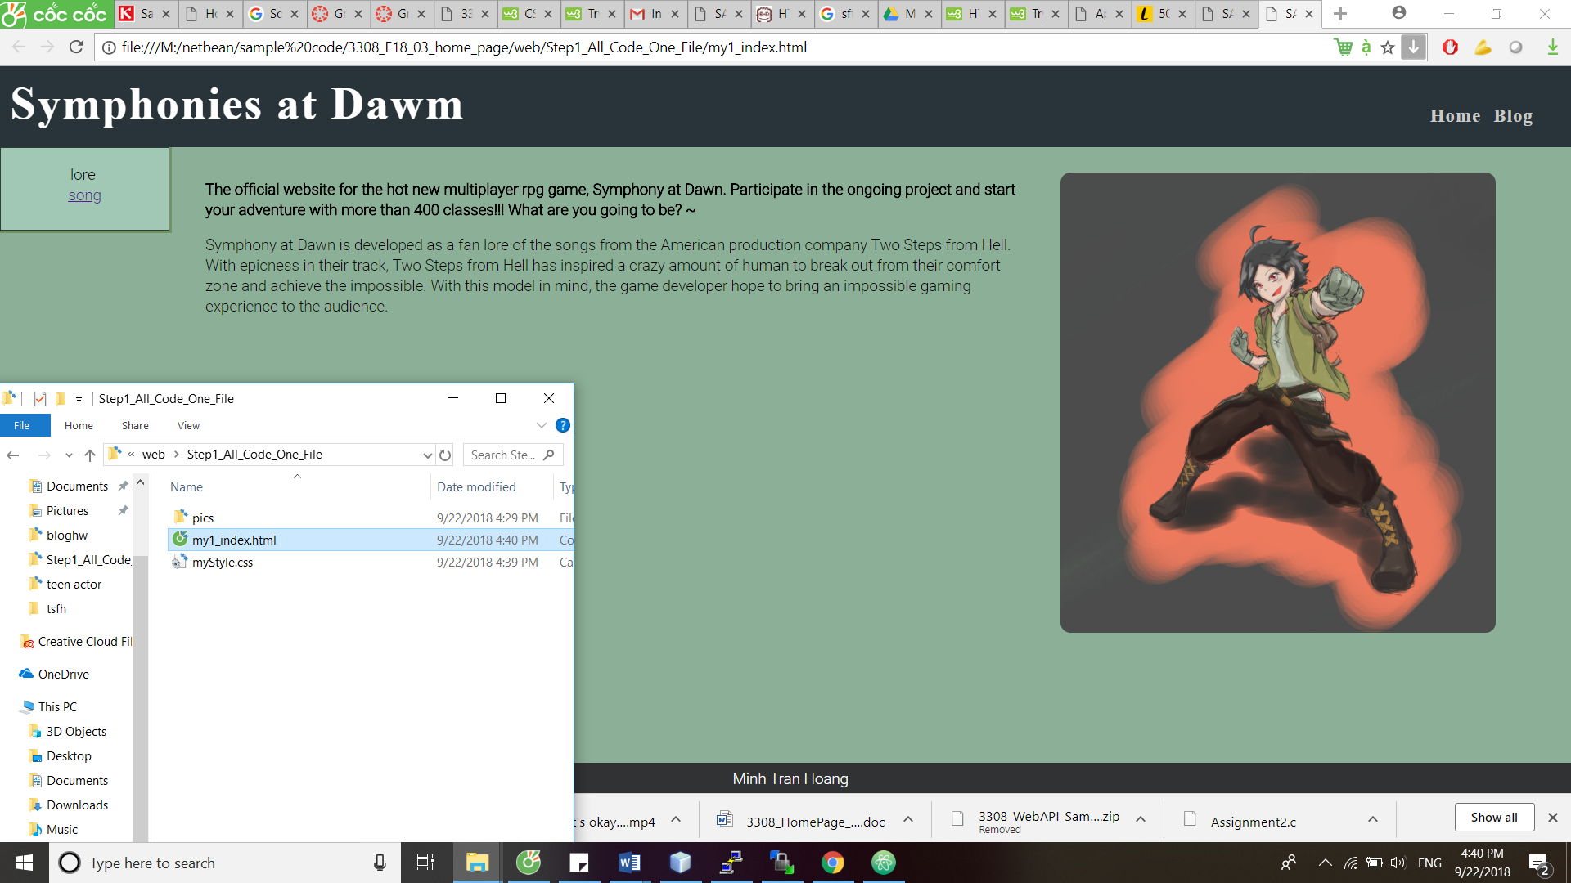 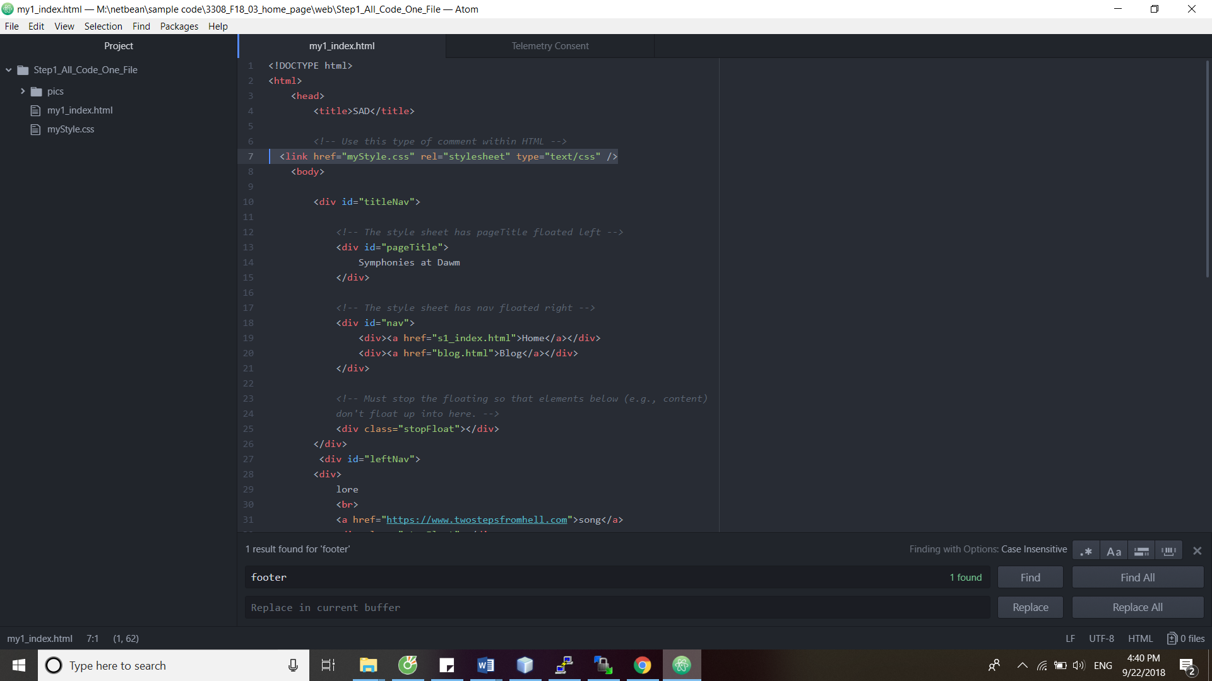

**Render my_s3_index.html locally**