1. What is the title of your web application?

2. Who will be users of your web application? • What attributes will you store for each of your users?

3. What “other” table will be part of your database? • What attributes will be stored for each record of this table?

4. What information will be stored in your associative table (the table that implements a "many to many" relationship between your "other table" and your user table)?

5. Explain how there is a many to many relationship between your user table and your “other” table.

6. What functionality will your web application provide? Your application will provide the following at a very "mechanical" level, but functionally, how will users benefit from your web app? • Users will be able to register, log on, and log off. • Users will be able to insert (edit and delete) "other" records (whatever you decided to keep in your "other" table. • Users will be able to insert (edit/delete) associative records. 7. Write 1-2 paragraphs of “marketing material” that attempts to entice people to become registered users and/or viewers of your web site. This will become the basis for the content area of your home page. In your paragraphs, do not explain to me what your web site will be able to do, write text that will entice users to visit your site.

1. A forlorn symphony at dawn
2. User will be the online player. Its attribute will contain information about the player like id, email, password, age, role, registration date and total transaction that the player made up until the latest date.
3. Other table will be the fantasy class(occupation) in the game. Other’s attribute contains the class id, class name, description, attack, defense, magic, stealth, speed, crit. The attack, defense, magic, stealth, speed, crit are different and can possibly left NULL for some classes.
4. Associative table will store information about player’s character. As the player registers in the website, they also will register a class and create a new online persona or their own character. The character table also contain a file_id column in case player want to keep choose a new class
5. A user can register for more than one class, one class can have many player choosing the class.
6. -It’s an MMO-RPG game site that allow player to register and play an online multiplayer game. The web application provide ability to register, log on-off, delete account in the user table and play a game embedded in the site. The “other table” is prefixed so the user cannot alter that table in anyway. The user can change the associate table by inserting and deleting records within the table.
7. As the game is the main selling point for people to access the site, the game will be the main part that get marketed on. With over 400 classes and a rich storyline, the game provides an interesting experience on RPG gaming and encourage people to try out different classes. With a different way of implementation, player can register with more than one class without creating new account.

Data model:

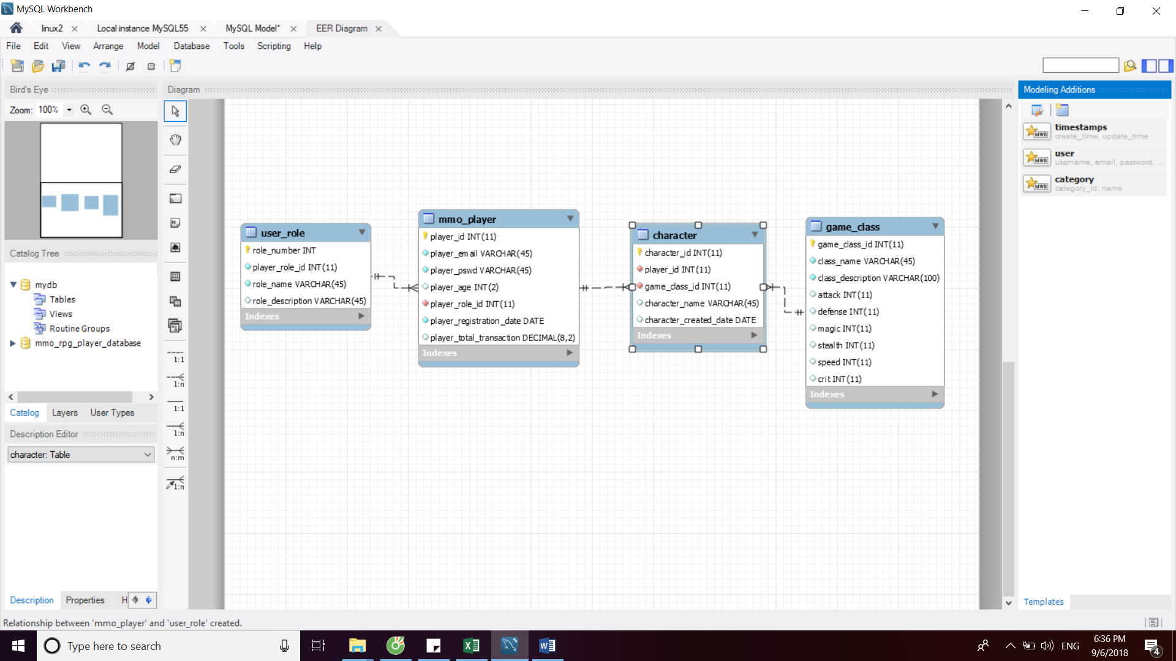

User table and its foreign key

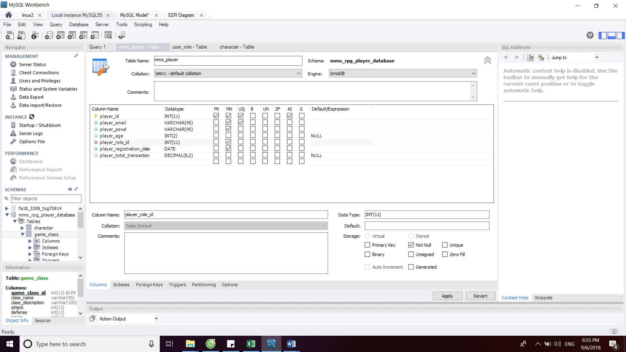

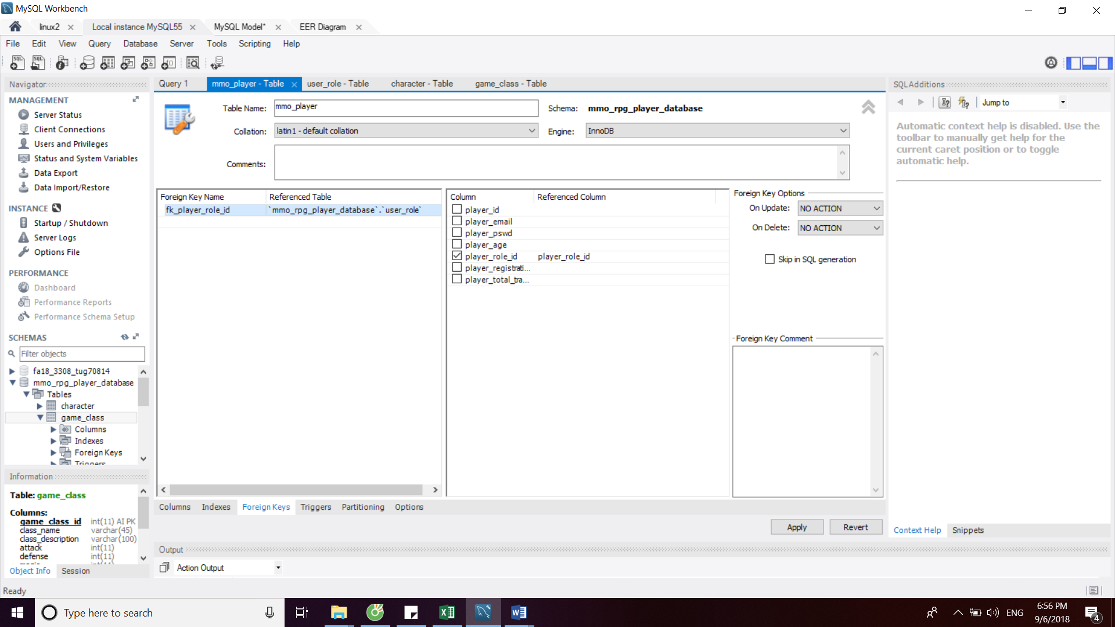

Other table:

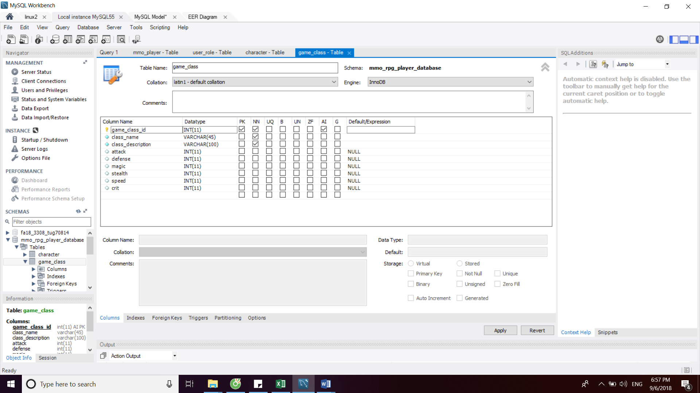

Associate table and its foreign key

