From Software Requirements Specifications to Agile User Stories Using Large Language Models: A Structured Critical Review and Proposed Evaluation Framework
Zaher Fadhil Raham¹,² · Sura Salah³
¹ College of Computing & Informatics, Universiti Tenaga Nasional (UNITEN), Malaysia | ² Al-Nahrain University, Baghdad, Iraq
³ Presidency of Al-Nahrain University, Baghdad, Iraq

Abstract
Background: Large language models (LLMs) can transform software requirements specifications (SRSs) and related requirements artifacts into Agile user stories and acceptance criteria, yet fluent outputs do not necessarily preserve source obligations. Objective: This structured critical review examines selected, source-verifiable contributions to requirements-to-story generation, prompt engineering, story quality, acceptance-test readiness, and traceability, and develops a practical evaluation framework. Methods: Relevant publications were purposively selected and critically appraised by one reviewer on the basis of task relevance, accessible source evidence, study context, and measurement methods. Direct SRS-to-story studies were distinguished from adjacent transformations, quality assessment, and conceptual work. The accompanying bibliographic landscape map is described in Appendix A and is not a systematic-study inclusion flow. Findings: The selected literature supports the feasibility of LLM-assisted story generation, while reported performance depends on the task, source artifact, prompt, evaluation criterion, and human judgment. High textual quality or local semantic similarity alone cannot establish complete source coverage or freedom from unsupported additions. Contribution: Section 6 proposes a source-grounded assessment framework integrating atomic obligation coverage, claim support, bidirectional traceability, QUS/INVEST-aligned quality, acceptance-test readiness, robustness, and human revision effort. Conclusion: The framework provides an operational basis for future controlled evaluation; the proposed protocol is not presented as an empirically validated model.
Keywords: structured critical review; software requirements specification; Agile user stories; large language models; prompt engineering; evaluation framework; coverage; traceability.

1. Introduction
Software requirements specifications (SRSs) describe what a system is expected to do and the conditions under which it must operate. They may contain functional requirements, non-functional requirements, data constraints, interfaces, security rules, user roles and dependencies. In Agile development, the same project may be organized through shorter user stories and acceptance criteria. These artifacts have different purposes: an SRS is often intended to preserve an agreed body of requirements, whereas a user story supports negotiation, planning and incremental delivery. Transforming one into the other is therefore not simply summarizing a document.
Large language models (LLMs) offer an attractive interface for this conversion. A model can read natural-language requirements and produce role-oriented statements, typically in the form “As a [role], I want [capability], so that [benefit].” A model may also propose acceptance criteria, priorities, test scenarios or backlog items. Yet the fact that an output looks like a user story does not establish that it is correct. A fluent story could lose an important restriction, assign an unauthorized role, merge multiple actions, or add a plausible but undocumented feature. These errors have practical consequences because downstream developers may treat generated stories as approved work items.
The user-story literature provides an established conceptual foundation. The Quality User Story (QUS) framework separates syntactic, semantic and pragmatic quality concerns; a syntactically valid statement may still be non-atomic, incomplete or inconsistent with its context [1]. User stories also support communication between stakeholder groups and act as boundary objects, so quality includes usefulness for shared understanding rather than only grammatical conformity [2]. Broader reviews of generative AI and software requirements engineering document expanding coverage of elicitation, analysis, validation, specification and traceability [3,4]. A prompt-engineering review similarly identifies many techniques, but warns that reproducibility and comparability remain limited [5].
Several primary studies now address different parts of this workflow. GeneUS investigates automated generation of user stories from requirements documents [8]. An industrial Agile model-driven development (MDD) study evaluates generated stories and related artifacts in real projects [10]. A study of interview-based generation and assessment directly examines whether LLMs can produce and judge user stories [9]. Other work assesses user-story refinement [15], generates acceptance criteria [12], or recovers requirements trace links [16]. A conceptual risk follows: results from interview-derived stories, goal-derived stories, story-to-task decomposition or issue-title-to-requirement generation are not interchangeable with tests of complete SRS-to-story transformation.
This structured critical review critically compares task-specific evidence and offers a proposed, reproducible evaluation framework. It separates direct SRS-to-story conversion from related generation and assessment tasks and specifies how future studies should jointly test source-obligation coverage, unsupported additions, and traceability. The proposed framework, rather than an exhaustive systematic-study count, is the article’s methodological contribution.

2. Review Aim and Research Questions
The review asks what is known about LLM-assisted translation from existing software requirements artifacts to Agile user stories, and how confidently that knowledge can support practical adoption. It addresses five questions:
- RQ1. What source artifacts, LLM models and workflows have been used for requirements-to-user-story generation?
- RQ2. Which prompt-engineering strategies have been compared, and are their effects consistent across evaluation criteria?
- RQ3. How are user-story quality, source requirement coverage, claim faithfulness, acceptance criteria and traceability measured?
- RQ4. How have the studies designed datasets, comparators, human assessments and reproducibility procedures?
- RQ5. What evaluation protocol and research agenda would make future SRS-grounded transformation experiments reproducible and more trustworthy?

3. Structured Critical Review Method

3.1 Review design and purpose
This article is a structured critical review with a proposed evaluation framework. It is not presented as a completed systematic literature review, PRISMA 2020 review, or exhaustive survey. Publications were selected purposively to illustrate relevant research tasks and contrasting forms of evidence: direct requirements-to-story generation (E1), adjacent requirements transformations (E2), quality and traceability evaluation (E3), and foundational or secondary context (E4). The selection and critical synthesis were conducted by a single reviewer; model-assisted bibliographic organization did not constitute an independent second reviewer. The analytical focus is the applicability and limitations of reported methods, not an estimate of how many studies exist or a pooled treatment effect.

3.2 Source selection and scope
Studies were selected for their relevance to the review questions, identifiable source-to-output task, inspectable methods or reported findings, and usefulness in developing an SRS-grounded assessment framework. Available full reports and verifiable bibliographic records were preferred for detailed claims; adjacent work was discussed only within its original input/output setting. The selection was purposive and undertaken by one reviewer, without independent duplicate screening, formal consensus adjudication, or an exhaustively completed full-text eligibility flow. Consequently, numerical bibliographic search coverage is not used to infer the number of eligible or included studies. A descriptive map of the broader literature landscape and its deduplicated metadata appears separately in Appendix A.
Evidence for the main synthesis was chosen by analytical relevance, not by treating every record in a bibliographic export as an included study. The wider identification archive contributes contextual information about the literature landscape; its source collections and counts are documented in Appendix A. The ScienceDirect citation collection is reported as a collection, not represented as a separately audited native database search.

3.3 Evidence roles and analytical boundaries
Primary studies were interpreted according to the actual direction of transformation. E1 addresses requirements documents or explicit requirements material transformed into Agile user stories; E2 covers different inputs or outputs, including interviews, goals, issue titles, refinement, and acceptance-criteria generation; E3 addresses evaluation, quality assessment, traceability, or source grounding; and E4 comprises conceptual and secondary studies used as context. Work on adjacent tasks informs the proposed framework but is not treated as direct empirical evidence of complete SRS-to-story fidelity. Closely related publications and preprints were checked to avoid treating the same research program as independent confirmations.
This coding is an analytical typology for critical comparison, not a formal pooled study-inclusion denominator. Reported results are attributed to their source studies, with sample sizes, denominators, and task conditions kept distinct. Source-derived abstracts or publisher metadata support identification and context, not unverified claims about detailed methods or outcomes.

3.4 Critical extraction and synthesis
For the selected works, the critical comparison records bibliographic identity; input artifact; generated output; study design and dataset; model, model version, and prompting strategy; evaluation units and metrics; human assessment; reported numerical results; and methodological limits. Findings are organized by evaluation construct rather than combined as pooled estimates because tasks, reference standards, and outcome measures differ. Any numerical claim is tied to the corresponding reported task and denominator; proposed procedures and fictional examples are distinguished from completed experiments.
A source and provenance register supports the analysis, including DOI/title matching and source links. Bibliographic retrieval assistance, source summaries, and single-reviewer critical judgments are recorded as different activities. This source-focused approach supports transparency without implying that a dual-reviewer systematic selection procedure occurred.
The companion public repository provides the non-copyrighted bibliographic index, source-provenance links, validation scripts, and research artifacts. It does not redistribute licensed publisher abstracts or full texts, and its candidate-record index is not a roster of included empirical studies.
3.5 Single-reviewer appraisal and interpretation
Single-reviewer appraisal was applied to task relevance, source identifiability, outcome validity, comparator quality, and reproducibility. No inter-rater agreement statistic is claimed. Ambiguous or adjacent studies were used conservatively to inform the evaluation dimensions, without being counted as direct confirmations of SRS-to-story generation. Claims and metrics in the main text remain traceable to the cited research. The broader bibliographic map in Appendix A is descriptive scoping of the literature landscape, not a PRISMA identification-to-inclusion diagram.

3.6 Analytical classification of the selected evidence
The review groups selected works into E1 (requirements-document-to-story experiments), E2 (related generation or transformation), E3 (quality measurement, traceability, acceptance criteria, and validation), and E4 (conceptual or secondary foundations). This framework allows comparison without conflating tasks or counting secondary reviews as independent empirical experiments. The labels describe evidence roles, not inclusion decisions made by two independent human screeners.
Critical appraisal considers each study’s source artifact, LLM contribution, output type, reference standard, evaluation method, and reported constraints. A comparison is treated as directly relevant only where the original study’s input and output genuinely correspond to the SRS-to-story setting. Results from interview-to-story, story-to-test, or story-to-model work may guide method design but cannot establish complete SRS fidelity.
The synthesis draws on a purposively selected group of source-verifiable reports and organizes them by research task and evaluation construct. Figure 1 presents this task-aware critical synthesis workflow. Study-level examples are provided to clarify strengths, trade-offs, and limits of applying reported findings to SRS-grounded story generation.
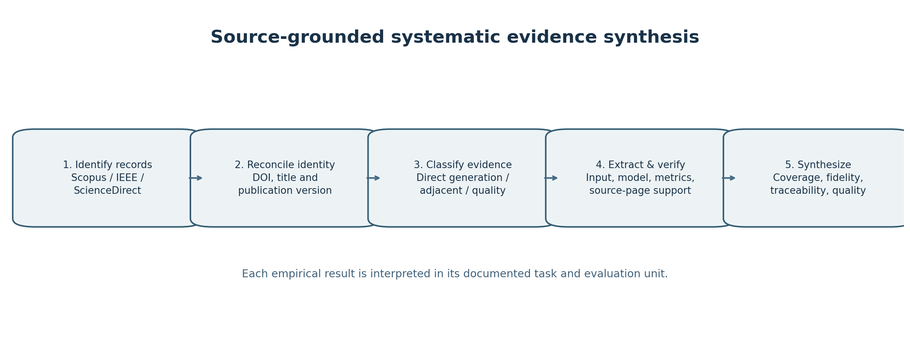
Figure 1. Task-aware evidence selection, critical extraction, and synthesis workflow.

4. Conceptual Background: From Source Obligations to Agile Stories

4.1 Artifact semantics
SRS statements commonly vary in granularity. A single paragraph may define several functional operations, a performance threshold, an access-control rule and an exception path. The generation task should first identify atomic obligations—indivisible normative requirements that can be tested or checked—and then decide whether each obligation should become a story, an acceptance criterion, an explicit constraint, or a deferred item. A one-to-one mapping is not necessarily correct; one requirement may support several stories, and one story may consolidate multiple compatible requirements. The scientific task is to make those transformations inspectable.
A user story is not merely a shorter SRS sentence. Its role and benefit fields introduce assumptions that must be traced or explicitly marked as proposed. Acceptance criteria often carry the more precise boundary conditions required for testing. Security, privacy, performance, interoperability and regulatory obligations should not disappear because the output schema favors functional statements. In particular, non-functional requirements may attach to multiple stories and require a separate constraint registry.

4.2 Quality of a story versus faithfulness to the source
The QUS framework [1] provides criteria for well-formedness, atomicity, minimality and related qualities. The INVEST rubric used in practice has a different emphasis: Independent, Negotiable, Valuable, Estimable, Small and Testable. Both are relevant for whether a story is useful, but neither alone establishes that the story matches its originating source. A story can be clear and testable while introducing an invented reporting function. Conversely, a source-faithful story can still be too large or unclear. These outcomes must be measured separately to avoid hiding unsafe transformations behind average quality scores.
Traceability methods distinguish source identifiers from downstream artifact links. Pre-specification traceability research [7] and recent LLM-based link-recovery work [16] demonstrate that candidate relationships can be proposed automatically. A link prediction score is not the same construct as generation accuracy: a generated story may contain a correct cited source ID and still omit a separate required obligation, while a textually similar story may be unsupported by its cited source span.

5. Synthesis of the Research Evidence

5.1 Direct requirements-to-story generation
Rahman et al. introduced an automated approach to generating user stories from requirements material, known as GeneUS [8]. The workflow demonstrates how LLMs can produce structured user stories for downstream software-engineering use. Its findings are more nuanced than the statement that a particular prompt consistently “wins.” The source audit found that a Refine-and-Thought approach performed better in several settings but not uniformly across measured criteria. For a reported user-story AlignScore comparison, a best-case normalized score favored that approach (0.99 versus 0.91 for the baseline), whereas a worst-case comparison favored the baseline (0.29 versus 0.40). Such extrema are not pooled means and cannot support universal ranking of prompts. The study also reports a developer questionnaire involving 76 participants; subjective developer assessments should be read alongside artifact-level accuracy rather than treated as an independent measure of complete requirements coverage.
Maha’s thesis [24] extends the document-to-story line of work and is useful for describing staged and iterative prompting. Because it is a graduate thesis and overlaps conceptually with the GeneUS research program, it should be presented as contextual evidence rather than automatically counted as an independent peer-reviewed confirmation. The existing studies establish technical feasibility, but robust evidence that all original obligations are preserved across diverse SRS documents remains more limited than evidence that plausible stories can be generated.

5.2 Industrial relevance and out-of-scope content
Spijkman et al. investigated LLM-supported requirements engineering in Agile model-driven development and obtained practitioner evaluations in four industrial projects [10]. The generation tasks included stories, acceptance criteria and data models. Practitioners often appreciated the generated artifacts, but the source-based audit recorded that 25% of generated user stories were judged out of scope overall, reaching 40% for one project. The same paper reported a 74.6% macro-average positive response across two user-story validation statements. These observations are not contradictory: perceived usefulness and source conformity are separate properties. For SRS-to-story adoption, a positive satisfaction rating cannot remove the need for a requirement-level audit of unsupported additions.
The industrial setting is valuable because it exposes project context, vocabulary and stakeholder judgments that artificial benchmarks may omit. However, observed results from four projects in one organizational methodology should not be generalized to all requirements domains. A rigorous follow-up should record each document’s length, requirement structure, role taxonomy, language, confidentiality requirements and accepted story granularity, and then evaluate whether gains persist on independent projects.

5.3 Story generation and assessment from other inputs
Quattrocchi et al. studied whether ten LLMs could elicit user stories through simulated customer interviews and assess story quality [9]. This work is a direct counterexample to any novelty claim that LLM-based user-story quality assessment has never been examined. Its central input is interaction-derived requirements rather than an authoritative complete SRS, so it does not by itself measure preservation of every obligation in a supplied source document. The study illustrates an important evaluator issue: grammatically sound stories and acceptance criteria do not guarantee diversity or complete stakeholder intent capture.
Hernández-Agüero et al. evaluated and refined 60 existing Spanish-language user stories against INVEST dimensions, comparing three human experts with GPT-5.1 in interface and API conditions [15]. The authors explicitly caution that their observational comparisons do not establish causal superiority or equivalence with expert judgment. This is relevant to evaluator calibration and repeated model runs, not a direct test of SRS-to-story source coverage. In the same way, SimAC explores collaborative LLM generation of acceptance criteria from user stories [12]; acceptance-criteria elaboration is a downstream activity that may improve testability while preserving the danger of adding unsupported details.
Other adjacent work reverses the direction of transformation, such as code-to-story generation, or decomposes stories into implementation tasks. These studies may contribute ideas for prompts, ranking and human feedback, but their input evidence differs substantially from natural-language SRS. Scores obtained on code snippets or issue titles should never be presented as estimates of how completely an LLM translates a requirements specification.

5.4 Missing-requirement identification and the coverage problem
Kabadi et al. tested whether LLMs can identify missing requirements from production-derived user-story sets [14]. Their three-domain comparisons reported higher recall for LLM-generated story sets than the original analyst sets in all evaluated domains. However, F1 did not favor the LLM across all domains: in the Trawelli case the analyst F1 was 84.2%, compared with 79.2% for the LLM. This is an example of a coverage–precision trade-off. It also exposes a reference-standard problem: a production-derived backlog can contain plausible additions not present in an initial requirements document, so matching the backlog may reward inference beyond a fixed source rather than strict preservation of that source.
An SRS-to-story study should therefore report at least two different outcomes. Source coverage asks how many original normative obligations are represented by supported generated items. Unsupported-addition risk asks how much generated content has no license in the provided source. These measures have different denominators and can move in opposite directions. Increasing coverage by creating more stories is not necessarily beneficial if it also produces many unsupported claims.

5.5 Source-grounded intermediate artifacts and reconstructability
ReqGenX [13] provides an important related example of controlling transformation provenance. It decomposes seven PURE requirements documents into source-grounded atoms, regenerates pre-SRS artifacts and reconstructs SRS content. The published abstract reports typical median atomic AlignScore values of 0.96–0.99, and downstream artifact values typically around 0.80–0.94. These are ranges for the authors’ studied components, not a direct benchmark of generated Agile user stories. The study also shows variation in source coverage across documents and configurations despite high grounding scores for individual atoms. Thus, high local support does not prove that every source obligation has been retained.
The importance of ReqGenX for the present review is methodological: intermediate atomic statements and explicit provenance can make otherwise opaque transformations auditable. The PURE corpus itself is a public collection of real requirements documents [21]; it can support SRS-level experiments, but a separate collection of user stories cannot be treated as a matched ground-truth output unless the source-to-story pairing is independently established.

5.6 Prompt engineering and requirements-traceability methods
Prompt engineering in requirements engineering has been synthesized by Huang et al., who screened 867 records and included 35 primary studies [5]. Their taxonomy links prompting patterns to RE tasks and supports more explicit and repeatable prompt design. Yet task-level heterogeneity limits any claim that one technique dominates in all settings. Paiva et al. compared two models and three prompting styles over 150 feature-request issue titles, yielding 900 generated requirements [11]. Their results show criterion-specific trade-offs: few-shot prompting increased mean singularity scores for both models, whereas an expert-style prompt was strong on verifiability. These were issue-title-to-requirement transformations, not complete SRS-to-story conversions. Prompt choice should therefore be treated as an empirical factor, not a guarantee of better source fidelity.
TraceLLM [16] evaluates prompt-guided trace-link recovery across four benchmark datasets and eight models. It reports benefits of demonstration selection and prompt refinement for requirements-to-downstream-artifact links. That evidence establishes that links can be recovered more effectively under certain configurations, not that a generated story has preserved every source obligation. Similarly, REQINONE [17] and consulting-company applications [18] show how LLMs can draft or reorganize requirements specifications, but their principal targets are not a complete controlled comparison of SRS-to-story coverage. These works remain important as evidence about constraints, context and requirements-document structure.

5.7 Convergent evidence across task families
Three conclusions are supported by the available heterogeneous studies. First, LLMs can generate plausible, often useful user stories and related requirements artifacts. Second, prompt effects and evaluator ratings depend on the chosen task, criterion, document and execution conditions. Third, local text quality and semantic similarity do not constitute an adequate proxy for preservation of all source obligations. These findings support a methodological contribution—a multidimensional evaluation protocol—rather than a claim that source-grounded transformation has never been studied.

5.8 Extracted characteristics of the principal studies
Table 1 summarizes representative, purposively selected studies that clarify direct generation, adjacent transformations, and measurement constructs. It is an explanatory evidence map and does not claim to enumerate all eligible published studies.
Table 1. Characteristics of representative studies: source artifact, dataset, model/prompt, evaluation, and interpretation boundary.
Study | Input and output | Dataset | Model / prompt | Metrics | Human evaluation / boundary
GeneUS [8] | Requirements documents → user stories | Requirements material (number of independent SRSs not confirmed) | LLM; direct vs reasoning/structured prompting (RaT) | Normalized AlignScore; RUST evaluation | Developer-based evaluation reported by the study; task and sample scope require citation-specific interpretation
Spijkman et al. [10] | Industrial requirements → user stories/criteria/models | Four low-code warehouse-management projects | LLM with engineered reusable prompts; model version NR | Reported scope relevance and out-of-scope outputs; project-dependent | Project team practitioner ratings; Adjacent industrial setting
Quattrocchi et al. [9] | Simulated interviews → user stories / story-quality judgments | Emulated customer interviews | 10 LLMs; evaluation guidance varies | Story quality, coverage/style/diversity, acceptance criteria | Expert / student comparisons, human assessment; Not a fixed SRS input
ReqGenX [13] | Legacy SRS → grounded atoms → pre-SRS artifacts → reconstructed SRS | Seven PURE SRS documents | Multi-LLM pipeline; constrained prompts, iterative refinement | AlignScore; Prometheus; information retention | Model-judge components; human protocol not confirmed here; Not direct story generation
Kabadi et al. [14] | Production-derived stories → missing-requirement discovery | Three industry domains/projects | LLM-based elicitation; prompt version NR | Recall, precision and F1 vs analyst baseline | Production story reference; human annotation details NR; Higher recall not always higher F1
Paiva et al. [11] | Issue titles → generated requirements | 150 OSS feature-request titles; 900 generated requirements | Two LLMs × three prompting styles | Singularity, verifiability (quality framework) | Independent human validation NR in audit; Not user-story task
Hernández-Agüero et al. [15] | Existing Spanish user stories → assessment and refinement | 60 existing stories | GPT-5.1 via interface and API; prompts NR | INVEST / expert comparison | Three human expert reviewers; Not generation from SRS
TraceLLM [16] | Artifact links → recovered traceability | Four benchmark datasets | Eight LLMs, demonstration / prompt strategies | Trace-link precision/recall/F1 as applicable | Human adjudication details NR here; Different trace-link targets
Goal2Story (F07/F13) | Goals/context → stories | StorySeek >1,000 goal-linked stories | Multi-agent small LLM fleet, context-sensitive prompting | FHR; QuACE | Human validation scope NR here; Not SRS-grounded benchmark
Design science low-code (F01) | Minimal functional requirements → story suggestions | Three low-code applications | LLM-based agent design process | Practitioner consistency/relevance | Five practitioner interviews; Small qualitative setting

5.9 Study quality and risk-of-bias considerations
Risk appraisal uses a domain-based signalling rubric rather than an unvalidated total score. D: dataset/sample representativeness and potential selection bias; C: adequacy of comparators and control conditions; E: independence and validity of evaluation, including LLM-as-judge leakage; R: reproducibility and release of prompts, data and annotations. Flags below mean an issue needing source verification or careful inference, not proof that the study is biased. A definitive quality appraisal requires full-text re-extraction and independent human adjudication.
Table 2. Critical appraisal matrix of selected studies: study-specific methodological concerns and limits.
Study | Dataset / selection | Comparators | Evaluation / bias | Reproducibility | Interpretation limit
GeneUS [8] | Sample scope to verify | Prompt conditions vary | Developer assessments of story candidates; no universal benchmark baseline | Source-setting and evaluation materials should be interpreted according to the original article | Mixed comparisons; not universal prompt advantage
Spijkman [10] | Four similar domain projects | No external randomized control | Practitioner judgment is contextual; no randomized effect is inferred | Industrial source confidentiality | Limited transfer to heterogeneous SRS
Quattrocchi [9] | Interview simulation, not real SRS | Models / prompts may vary | Human vs LLM judge comparability | Public artifacts to verify | Do not infer SRS fidelity
ReqGenX [13] | Seven PURE docs | Multi-stage workflow | Judge-derived measures; reconstruction | Code/data release to verify | Not direct story-generation outcome
Kabadi [14] | Three domains; production gold | Analyst baseline | Recall/F1 depend on reference | Industry transfer and leakage to verify | Recall gains do not imply all-metric wins
Paiva [11] | 150 titles, not SRS | Two models × three prompts | Generated requirements quality judgments | Data/prompts availability to verify | Different input/output task
Hernández-Agüero [15] | 60 Spanish stories | No causal baseline claimed | Three experts, GPT-5.1 comparisons | API/interface settings differ | Existing-story refinement only
TraceLLM [16] | Four link datasets | Eight models / example selection | Trace link correctness differs by type | Prompt/sample reuse to verify | No direct SRS→story demonstration
Table 3. Task-aware map of representative studies and evidence limits.
Study | Input → output | Main evidence | Why it is not interchangeable with complete SRS coverage
GeneUS / Rahman et al. [8] | Requirements document → user stories | Prompt comparisons, structured output, developer feedback | Metrics vary by case; story completeness must be independently checked
Spijkman et al. [10] | Industrial RE context → stories / criteria / models | Four project teams; relevance and scope evaluation | Practitioner usefulness coexists with out-of-scope output
Quattrocchi et al. [9] | Simulated customer interviews → stories / evaluation | Ten-model generation and quality-assessment study | No fixed authoritative SRS obligation inventory
Hernández-Agüero et al. [15] | Existing stories → ratings / refinements | Expert–model comparison under INVEST | Measures evaluation/refinement, not source document coverage
SimAC [12] | User stories → acceptance criteria | Collaborative LLM elaboration | May introduce acceptance details absent from original source
Kabadi et al. [14] | Production story references → elicited stories | Recall/F1 across three domains | Missing-requirement detection reference differs from SRS ground truth
ReqGenX [13] | SRS → atoms → artifacts → reconstructed SRS | Source grounding, reconstruction, coverage analysis | Not a direct SRS → Agile story benchmark
Paiva et al. [11] | Issue titles → requirements | 900 outputs; prompt-criterion trade-offs | Input is short issue text rather than complete SRS
TraceLLM [16] | Requirements / design / tests → links | Prompt-guided traceability across benchmarks | Link prediction is not generative coverage or claim support

6. Proposed Source-Grounded Evaluation Framework: Main Contribution
The central contribution of this review is a proposed, operational, source-grounded evaluation framework for converting an SRS into Agile user stories. It is derived from the critical comparison in Section 5, not claimed as a newly tested algorithm or empirically validated measurement instrument. The framework has three design commitments: (i) treat atomic SRS obligations as the reference units; (ii) judge every generated claim against an identifiable source span; and (iii) score backlog usability separately from faithfulness to the source. The workflow combines source parsing, atomic obligation identification, story and acceptance-criterion generation, claim-level verification, bidirectional traceability, and human adjudication. Its intended output is an auditable transformation record that can be evaluated and corrected before adoption.
Figure 2. Proposed source-grounded generation and verification architecture (not empirically validated).
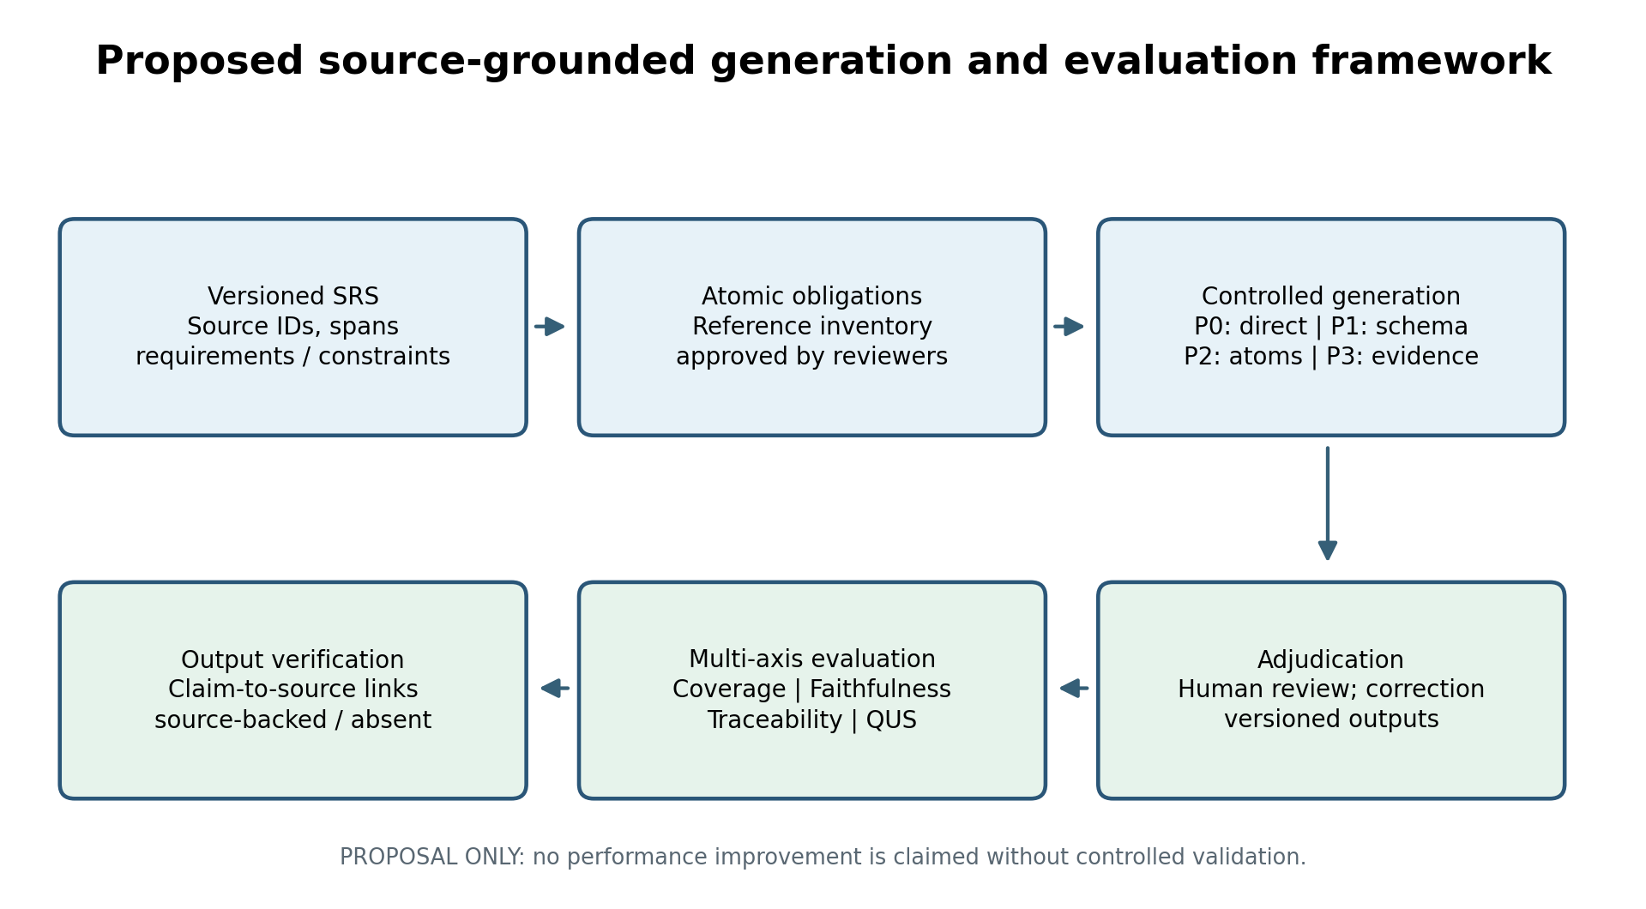
The generated artifact is a testable protocol; all quality claims require human adjudication.

6.1 Coverage and omissions
Let R denote the independently agreed set of applicable atomic source obligations and C the subset supported by at least one valid generated story or associated acceptance criterion. Source requirement coverage is |C|/|R|. This recall-like measure should separately identify functional obligations, non-functional constraints, exception paths and actor permissions. The denominator must be frozen before examining generated outputs, with a reasoned process for resolving ambiguous or overlapping source statements. A story that mentions a topic but omits its normative condition should not automatically count as coverage.

6.2 Source support and unsupported additions
Every generated story is segmented into auditable claims (actor, action, data entity, condition, benefit, constraint and acceptance-test statement). Reviewers judge each claim as supported, contradicted, not stated, or indeterminate, citing a specific source span and confidence rationale. Supported-claim proportion is the number of supported claims divided by the number adjudicated; unsupported-addition rate is the number judged “not stated” divided by the same denominator. Contradictions are reported separately because they represent a different risk from plausible additions. These are proposed measures and must not be confused with precision metrics used in earlier papers on different tasks.

6.3 Bidirectional traceability
A generated story may link to one or multiple source requirements. For each candidate link, an analyst records whether the linked source span genuinely supports the story claim. Trace-link precision, recall and F1 can be computed against a separately adjudicated reference link set, while requirement-level coverage checks whether each source obligation has at least one justified output link. A link is not considered valid solely because an LLM lists a requirement identifier; the cited passage and the assertion must agree. The framework also records one-to-many and many-to-one mappings and linked-source version IDs.

6.4 Story quality, testability and human correction
Story quality is independently scored with a prespecified QUS/INVEST-compatible rubric that covers role clarity, atomicity, ambiguity, negotiability, value, size and testability. Acceptance criteria are checked for observable conditions, boundary behavior and unsupported assumptions. At least two trained human reviewers independently assess a defined sample, then adjudicate disagreements. The evaluation reports agreement for the actual task and rating scale, along with expert editing minutes, number of rewritten claims, and post-edit acceptance decisions. Changes in fluency should not be described as improved fidelity without direct source checks.

6.5 Robustness and cost
Model/version, prompt text, decoding settings, output schema, context segmentation, retrieval sources, token budget and execution date must be preserved. Repeated runs are necessary because a single generated backlog can be unrepresentative. Comparisons should present distributions and uncertainty intervals of each criterion across documents and runs, rather than only a best example. Privacy and confidentiality constraints may prohibit uploading sensitive organizational SRS content to external systems; in these settings, local models or redacted inputs require separate performance reporting.

6.6 Worked example: an illustrative university inventory requirement
The following is a synthetic worked example for explaining the coding logic; the wording is not quoted from the PURE university inventory SRS, and the example is not an experimental test or case-study validation. Hypothetical source: R-INV-01 “An authorized inventory officer shall record an asset transfer between custodians”; R-INV-02 “Every transfer shall retain the old custodian, new custodian, transfer date and approving officer in an audit log.”
Table 4. Fictional worked example mapping SRS obligations to stories, acceptance criteria, and source links.
Stage | Illustrative content / adjudication
Source obligations | O1: authorized officer can record transfer (R-INV-01). O2: old/new custodian, date and approver are logged (R-INV-02).
Candidate generated story | US-01: As an inventory officer, I want to record an asset transfer between custodians so that the asset register remains up to date.
Acceptance criterion A1 | Given an authorized inventory officer, when an asset is transferred, then the new custodian is saved. (Supports O1.)
Acceptance criterion A2 | When the transfer is confirmed, then previous custodian, new custodian, date and approving officer are retained. (Supports O2.)
Traceability map | US-01 / A1 → R-INV-01. A2 → R-INV-02. Reviewers inspect the exact span, not the ID alone.
Unsupported addition flagged | “Automatically email both custodians” is NOT stated in either hypothetical source; mark as proposed/unsupported, not as an approved acceptance criterion.
Illustrative result | 2/2 example obligations have a justified mapping; this fraction is a pedagogical calculation, not a measured research result.
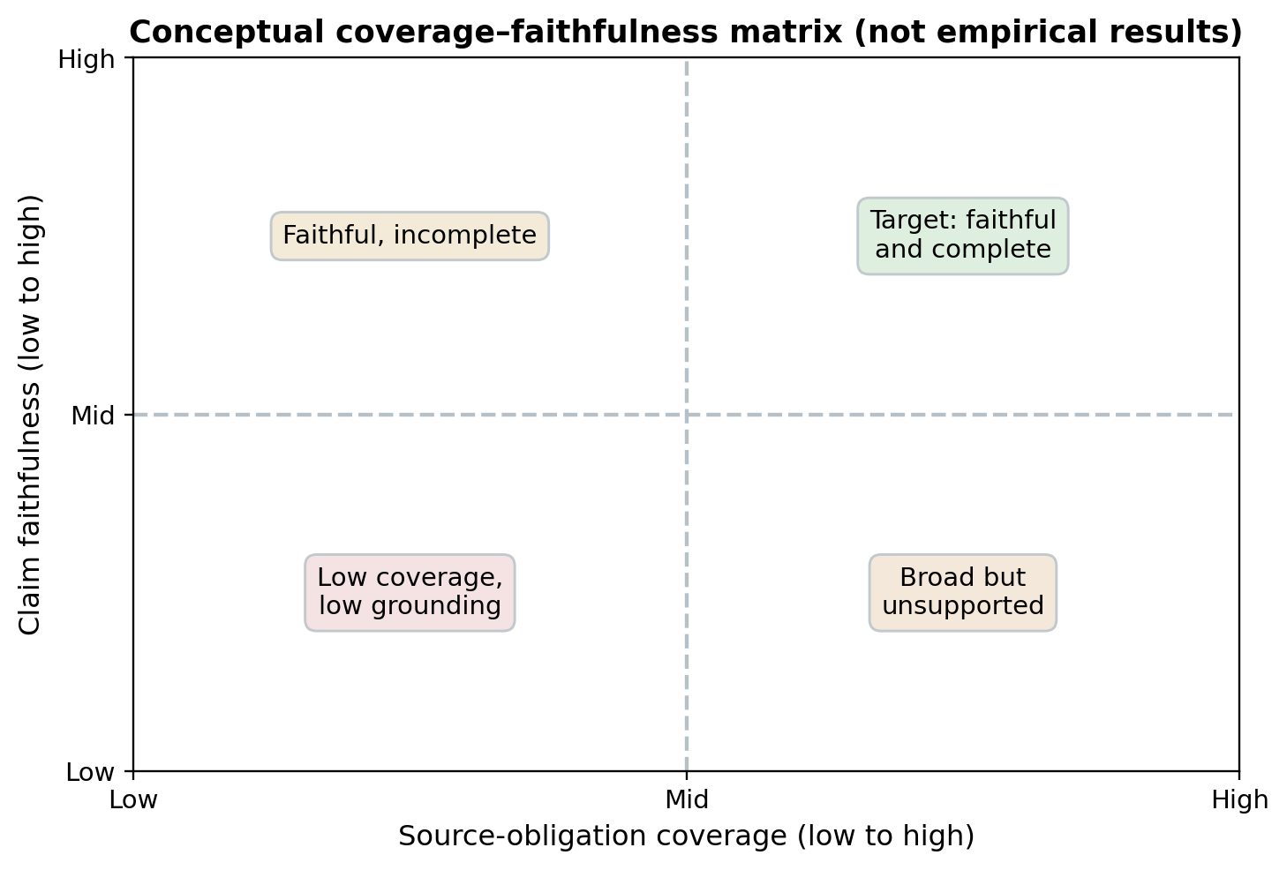
Figure 3. Theoretical coverage–faithfulness trade-off matrix; no experimental observations are plotted.
Table 5. Proposed operational measures for evaluating SRS-to-story transformations.
Construct | Unit | Proposed operational measure | Common invalid substitute
Source coverage | Atomic SRS obligation | Supported obligations represented / applicable obligations | Story count or topical similarity
Claim faithfulness | Atomic story claim | Supported, contradicted, not stated, indeterminate; source span | LLM self-declared confidence
Traceability | Source–story link | Expert-verified precision/recall/F1; missing links | Presence of an ID string
Story quality | User story | QUS/INVEST rubric, blinded expert rating | Correct “As a…” syntax alone
Testability | Acceptance criterion | Observable conditions, boundaries, constraint evidence | Generated test count
Stability | Model-prompt-document run | Variance and confidence interval across runs | Single best output
Human effort | Analyst correction | Minutes; accepted changes; disagreement frequency | Model response latency alone

6.7 What the framework contributes
The proposed contribution is not that an LLM can draft or grade a user story. Rather, it specifies a coherent evaluation unit (atomic source obligation), an explicit claim-to-source verification process, and separate measures for obligation omission and unsupported invention. This separation prevents improvements in story fluency, acceptance-criteria length, or model-judge similarity from being mistaken for evidence of complete requirements preservation. The framework also requires auditable provenance and human correction effort, enabling subsequent controlled comparisons of prompts, model versions, and document classes. These measures are proposed for future validation; no composite score, performance gain, or inter-rater statistic is asserted here.

7. Research Gaps and Testable Hypotheses

7.1 Joint optimization of coverage and faithfulness
A defensible open research problem is not whether LLMs can produce stories or score their style. It is whether a reproducible generation workflow can jointly increase valid coverage of original requirements and reduce unsupported additions. H1: under a fixed document, model and token budget, prompting with mandatory source-span evidence will lower the proportion of unsupported claims relative to a direct-generation baseline. H2: a decomposition-first pipeline will increase correctly covered atomic obligations, but may increase story count or editorial cost. Both hypotheses require direct expert adjudication of claims and requirements.

7.2 Effect of prompt structure without confounding
Many prompt studies compare techniques while changing additional contextual information, model settings or output constraints. Controlled SRS experiments should isolate the effect of prompt structure. A minimal factorial study could use the same SRS input, model family, token budget and reviewer protocol under: P0 direct prompt; P1 constrained structured output; P2 atomic requirement decomposition; and P3 source-span justification with a verification pass. Models should be repeated across multiple independent SRS documents and runs; “best prompt” should be reported per metric, not assumed universal.

7.2.1 Experimental specification for H1 and H2 (future research only)
The H1/H2 claims are hypotheses for a future experiment, not findings of this review. A minimum follow-up design will use at least three independent SRS documents from distinct applications (a university inventory document can be one pilot case), a preregistered obligation annotation guide, and the same model/version/decoding budget across four prompting conditions (P0–P3). For each document × prompt, use at least five independent stochastic generations and log seeds/settings when available. The primary endpoints will be expert-adjudicated claim unsupported-addition rate (H1) and obligation coverage proportion (H2); secondary endpoints will include trace-link F1, story count, human correction time and reviewer agreement. Compare within-document paired results, report uncertainty (e.g., bootstrap confidence intervals across documents), and treat document as a clustering unit; any Wilcoxon/paired test would be exploratory with only three documents. Do not infer causality from cross-paper comparisons; a confirmatory hypothesis test requires a prespecified sample-size/power analysis and more documents than this minimum pilot.
Table 6. Suggested experimental conditions for a future direct SRS-to-story benchmark.
Condition | Control/prompt change | Expected benefit to test | Potential cost or failure
P0: Direct | One-step baseline; story format only | Low latency and minimal setup | Omissions and unsupported features
P1: Structured | Schema, role list, constraints, explicit no-invention instruction | Cleaner outputs and stable extraction | Rigid templates may miss nuance
P2: Decompose | Atomic source obligations before story generation | Better obligation coverage | Errors in atomization propagate
P3: Cite & verify | Require source-span links and claim-level verification | Fewer unsupported claims; auditable links | Higher token use and correction effort

7.3 Human–LLM evaluator calibration
LLM-as-judge scoring can be convenient, but automatic ratings may be sensitive to the model, prompt and reference answer. Existing research already studies human–model agreement in story evaluation [9,15]. A stronger SRS-grounded study should calibrate model judgments separately for style, source support, link correctness and coverage. It should report sample sizes, blinded disagreements, reviewer training, adjudication and confidence intervals. The objective is not to replace expert judgment, but to define what can be screened automatically without concealing disagreements.

7.4 Generalization across documents, languages and institutions
A single university inventory SRS could support a detailed pilot but not a multi-case generalization claim. Replication should use at least three genuinely independent SRSs spanning domains, lengths, documentation quality and role structures. Public corpora such as PURE [21] can be used where license and versioning permit. The independently collected Dalpiaz user-story corpus can inform style and task distribution, but is not a ground-truth paired output for PURE documents. For cross-language systems, translation quality and role interpretation require dedicated assessment rather than reusing English-only quality rules without validation.

7.5 Reproducibility, data governance and release artifacts
A credible study should publish (where permitted) document IDs, extraction rules, source-atom annotations, story prompts, generation settings, run logs, versioned outputs, evaluated claim–source links and the reviewer adjudication record. Commercial SRS data may need secure, limited-access replication packages. Privacy, licensing and institutional approval should be discussed explicitly. Reproducibility includes negative and unsuccessful generations, not only accepted stories.

8. Discussion and Implications

8.1 What practitioners can conclude
LLMs can assist with a first backlog draft, story rewriting and preparation of acceptance criteria, especially when the input document is long and stakeholder review time is limited. Yet the evidence does not justify autonomous replacement of requirements approval. A safe workflow treats every generated story as a candidate artifact that requires review against its originating obligation and relevant non-functional constraints. An explicit “unsupported or proposed” label is more useful than silently incorporating plausible extensions as approved requirements.

8.2 What researchers should stop conflating
Three distinctions deserve particular attention. First, generation quality is not evaluator agreement: a model may provide fluent text that both humans and LLM judges like while losing an original constraint. Second, coverage is not correctness: a higher recall of candidate requirements can coincide with more unsupported additions, as indicated by the differing recall and F1 outcomes in missing-requirement studies [14]. Third, local grounding is not global document completeness: an atomic proposition can be supported by its cited passage even when a separate source obligation has been omitted [13]. Treating all three as “accuracy” destroys interpretability.

8.3 Implications for AI-assisted Agile practice
Teams should maintain version-controlled source IDs, a stable list of authorized roles and a clear process for approving features that the model infers rather than reads from the SRS. The model can be instructed to propose questions when a business rule is ambiguous, but proposed answers must not become accepted stories without stakeholder approval. A traceability dashboard that flags unlinked source requirements and unsupported output claims can support focused human review. For high-risk domains, non-functional constraints and audit trails deserve explicit checkpoints.

8.4 Contribution of the evidence synthesis
The scholarly contribution of this review is to organize existing evidence around the exact transformation unit and the evaluation construct, and to propose a falsifiable, operational protocol for source-grounded SRS-to-story work. It is not a new trained model, a benchmark performance claim or a pooled meta-analysis. The framework will acquire empirical status only after independent annotations, controlled multi-case comparisons and results are collected and analyzed.

9. Interpretation and Threats to Validity
The study corpus spans diverse source artifacts, target outputs, domains, prompt structures, and evaluation measures. This heterogeneity supports a structured comparison of evidence constructs rather than pooled effect estimation. Findings from simulated interviews, low-code development projects, issue titles, goal models, or story refinement must not be transferred directly to full-document SRS transformation without matching source and output definitions. Evaluations based on small, homogeneous samples or contextual practitioner feedback should be interpreted in relation to their original study settings.
Measurements of prose fluency, user-story quality, and evaluator agreement do not alone establish fidelity to the originating requirements. Stronger inferences require traceable source spans, explicit annotation units, and independent adjudication of omissions and unsupported additions. Accordingly, this review distinguishes demonstrations of feasibility from evidence of end-to-end obligation preservation, and treats secondary literature as conceptual support rather than an empirical replicate.
The proposed evaluation protocol is a methodological synthesis of reported work. Its metrics and hypotheses are intended to support future controlled empirical comparisons; the illustrative example is not presented as an executed experiment. The review preserves original denominators and avoids generalizing task-specific performance beyond the documented source studies.

10. Conclusion
Automated transformation of software requirements specifications into Agile user stories is feasible and practically attractive, but its reliability cannot be inferred from fluent text or positive ratings alone. The available research demonstrates useful document-to-story workflows, criterion-dependent prompting outcomes and promising human–LLM quality-assessment methods. It also shows that out-of-scope generation, missing obligations and imperfect evaluator agreement are real concerns. We therefore propose a source-grounded evaluation protocol that separately measures requirement coverage, claim faithfulness, bidirectional traceability, story quality, acceptance-test readiness, stability and human correction cost. Future studies should benchmark controlled prompts across independent SRS documents, use blinded expert annotation, publish linked provenance, and report both omissions and unsupported additions. These steps can turn plausible generated backlogs into auditable engineering artifacts.

Declarations and Supporting Materials
Authorship: Zaher Fadhil Raham and Sura Salah.
Data and materials availability: The public project repository provides curated, non-copyrighted bibliographic metadata, identification arithmetic, links to supporting sources, evidence-role definitions, and validation scripts: https://github.com/zaher1976/SRS-to-Agile-User-Stories-SLR. The wider 207-entry/181-candidate literature landscape record is documented in Appendix A. Bibliographic candidates are not a final included-study count. Third-party publisher full texts and licensed abstracts are not redistributed.
AI assistance disclosure: AI-supported tools assisted bibliographic organization, source retrieval and summarization, and manuscript editing. Interpretation, selection of studies for critical discussion, and responsibility for the accuracy of the synthesis remain with the authors. The review was not conducted as independent dual screening.
Reporting scope: This article is a structured critical review based on purposively selected source-verifiable studies, assessed by a single reviewer. It proposes, rather than empirically validates, an evaluation framework. Appendix A provides descriptive bibliographic landscape scoping only; it does not report a systematic review inclusion flow or support claims of exhaustive study capture.

Appendix A. Scoping of the Literature Landscape (Bibliographic Context)
For descriptive mapping of the research landscape, a companion index combined 93 Scopus entries (one search exported in parts of 50 and 43), 28 IEEE Xplore entries, and 86 entries from a ScienceDirect citation collection. The total was 207 imported bibliographic entries; identifier/title reconciliation detected 26 cross-source overlaps, leaving 181 distinct bibliographic candidates (93 Scopus, seven IEEE-only, and 81 ScienceDirect-only). This mapping provides a transparent starting context only. It was not used to claim an exhaustive search, a completed PRISMA selection procedure, or 181 included primary studies. Figure A1 and Table A1 describe the imported-record landscape, not a study-inclusion flow.
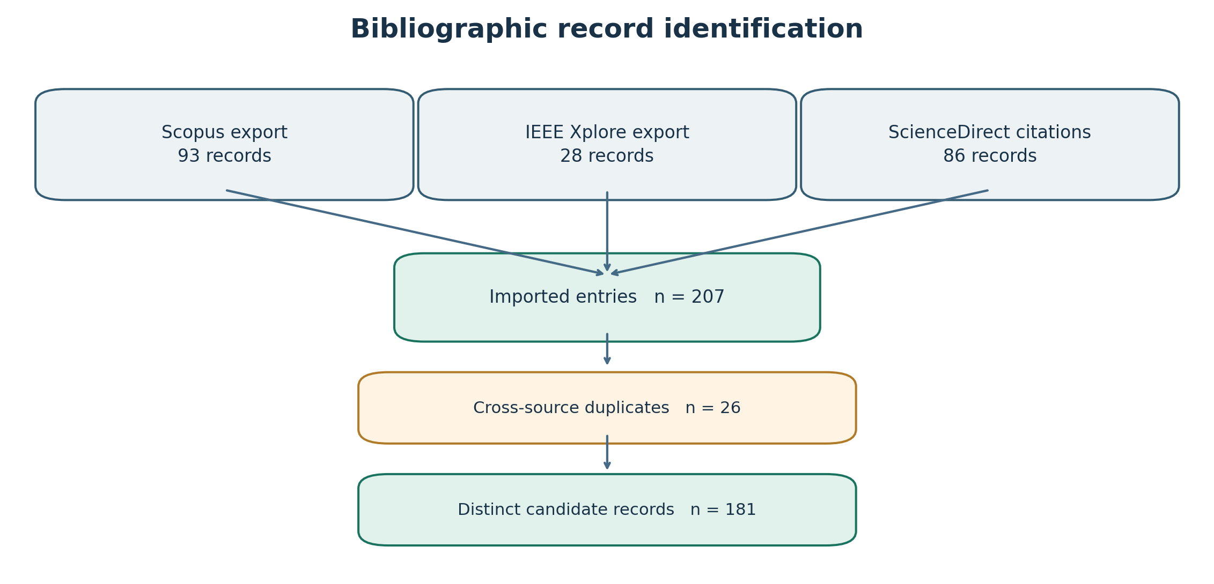
Figure A1. Bibliographic identification and duplicate reconciliation for scoping the literature landscape.
Table A1. Imported records and deduplication in the bibliographic landscape index.
Bibliographic identification element | Audited count | Documented source basis
Scopus export entries | 93 | Single Scopus search exported in two files (50 + 43)
IEEE Xplore export entries | 28 | 21 entries also appear in the Scopus source group
ScienceDirect citation-list entries | 86 | Source citation collection with publisher abstracts
Imported bibliographic entries | 207 | 93 + 28 + 86 imported bibliographic entries
Cross-source duplicate candidates | 26 | 21 IEEE/Scopus + five additional ScienceDirect overlaps
Deduplicated candidate records | 181 | 93 Scopus + seven IEEE-only + 81 ScienceDirect-only

Appendix B. Extraction form and reviewer decision rubric
Extraction domain | Required fields
Bibliographic identity | DOI; title; publication/online year; version lineage
Task direction | Source input → generated artifact; classify E1, E2, E3 or E4
Study design | Document count, domain, models, prompt templates, settings, comparator
Evaluation | Units, numerator/denominator, metrics, human raters, agreement
Source-grounding | Requirement IDs, obligation ledger, source spans, unsupported claim count
Risk / quality | Dataset/sample; comparator; reviewer independence; reproducibility
Reviewer decision | Include / Exclude / Unclear; exact exclusion reason; page-level evidence
Adjudication | R1 and R2 judgments independently entered, reconciled and time-stamped

References
[1] G. Lucassen, F. Dalpiaz, J. M. E. M. van der Werf, and S. Brinkkemper, “Improving agile requirements: The Quality User Story framework and tool,” Requirements Engineering, vol. 21, pp. 383–403, 2016. https://doi.org/10.1007/s00766-016-0250-x
[2] T. Sporsem, T. Dingsøyr, and K.-J. Stol, “User stories as boundary objects in agile requirements engineering: A theoretical literature review,” Journal of Systems and Software, vol. 233, art. 112693, 2026. https://doi.org/10.1016/j.jss.2025.112693
[3] H. Cheng et al., “Generative AI for Requirements Engineering: A Systematic Literature Review,” Software: Practice and Experience, vol. 56, no. 2, pp. 141–170, 2026. https://doi.org/10.1002/spe.70029
[4] A. Hemmat et al., “Research directions for using LLM in software requirement engineering: A systematic review,” Frontiers in Computer Science, vol. 7, art. 1519437, 2025. https://doi.org/10.3389/fcomp.2025.1519437
[5] K. Huang, F. Wang, Y. Huang, and C. Arora, “Prompt Engineering for Requirements Engineering: A Literature Review and Roadmap,” in 2025 IEEE International Requirements Engineering Conference Workshops, 2025. https://doi.org/10.1109/REW66121.2025.00081
[6] E. Wolf, A. Trendowicz, and J. Siebert, “Quality assessment of software requirements using artificial intelligence methods: A systematic literature review,” Information and Software Technology, vol. 191, art. 107979, 2026. https://doi.org/10.1016/j.infsof.2025.107979
[7] J. Mucha, A. Kaufmann, and D. Riehle, “A systematic literature review of pre-requirements specification traceability,” Requirements Engineering, vol. 29, pp. 119–141, 2024. https://doi.org/10.1007/s00766-023-00412-z
[8] T. Rahman, Y. Zhu, L. Maha, C. K. Roy, B. Roy, and K. Schneider, “Take Loads Off Your Developers: Automated User Story Generation Using Large Language Model,” in IEEE International Conference on Software Maintenance and Evolution (ICSME), 2024. https://doi.org/10.1109/ICSME58944.2024.00082
[9] G. Quattrocchi, L. Pasquale, P. Spoletini, and L. Baresi, “Can LLMs Generate User Stories and Assess Their Quality?,” IEEE Transactions on Software Engineering, vol. 52, no. 5, pp. 1773–1790, 2026. https://doi.org/10.1109/TSE.2026.3670612
[10] T. Spijkman, B. Molenkamp, S. Beudeker, S. Overbeek, and F. Dalpiaz, “LLM-Assisted Requirements Engineering in Agile MDD: Industry Insights and Validation,” in IEEE International Requirements Engineering Conference (RE), pp. 366–377, 2025. https://doi.org/10.1109/RE63999.2025.00043
[11] G. Paiva, E. D. Canedo, and G. P. Rocha Filho, “From issue titles to requirements: An empirical study of large language models and prompt engineering strategies,” Requirements Engineering, vol. 31, art. 7, 2026. https://doi.org/10.1007/s00766-026-00462-z
[12] Y. Li, J. W. Keung, Z. Yang, X. Ma, J. Zhang, and S. Liu, “SimAC: Simulating agile collaboration to generate acceptance criteria in user story elaboration,” Automated Software Engineering, vol. 31, art. 55, 2024. https://doi.org/10.1007/s10515-024-00448-7
[13] R. S. Ayon, R. Fahmi, S. Biswas, and S. Ahmed, “ReqGenX: An Empirical Study of Atomic Decomposition, Artifact Regeneration, and Reconstruction for Legacy SRS Documents,” in 20th International Symposium on Empirical Software Engineering and Measurement, LIPIcs, vol. 394, art. 35, 2026. https://doi.org/10.4230/LIPIcs.ESEM.2026.35
[14] V. Kabadi, A. Wuntakal, N. Gutha, L. Bellarykar, X. B. D. Le, P. Thongtanunam, and C. Treude, “Can LLMs Identify Missing Elements in Requirements Elicitation? An Empirical Evaluation Using Production-Derived User Stories in an Industry Setting,” in 20th International Symposium on Empirical Software Engineering and Measurement, LIPIcs, vol. 394, art. 82, 2026. https://doi.org/10.4230/LIPIcs.ESEM.2026.82
[15] E. Hernández-Agüero, C. Quesada-López, and J. P. Chaves-Sánchez, “Assessing and refining user stories using large language models: A replication study in a real-world organizational software-development setting,” Science of Computer Programming, art. 103575, online 2026. https://doi.org/10.1016/j.scico.2026.103575
[16] N. Alturayeif, I. Ahmad, and J. Hassine, “TraceLLM: Leveraging large language models with prompt engineering for enhanced requirements traceability,” Requirements Engineering, vol. 31, art. 6, 2026. https://doi.org/10.1007/s00766-026-00460-1
[17] T. Zhu, L. C. Cordeiro, and Y. Sun, “REQINONE: A Large Language Model-Based Agent for Software Requirements Specification Generation,” in IEEE International Requirements Engineering Conference (RE), 2025. https://doi.org/10.1109/RE63999.2025.00054
[18] L. Pasquale, A. Ragone, E. Piemontese, and A. A. Darban, “Exploring the Use of LLMs for Requirements Specification in an IT Consulting Company,” in IEEE International Requirements Engineering Conference (RE), 2025. https://doi.org/10.1109/RE63999.2025.00045
[19] A. C. Tricco et al., “PRISMA Extension for Scoping Reviews (PRISMA-ScR): Checklist and Explanation,” Annals of Internal Medicine, vol. 169, pp. 467–473, 2018. https://doi.org/10.7326/M18-0850
[20] M. L. Rethlefsen et al., “PRISMA-S: An extension to the PRISMA statement for reporting literature searches in systematic reviews,” Systematic Reviews, vol. 10, art. 39, 2021. https://doi.org/10.1186/s13643-020-01542-z
[21] A. Ferrari, G. O. Spagnolo, and S. Gnesi, “PURE: A Dataset of Public Requirements Documents,” in IEEE International Requirements Engineering Conference (RE), pp. 502–505, 2017. https://doi.org/10.1109/RE.2017.29
[22] N. D. Bandi and K. A. Demir, “Requirements Engineering with Generative AI: A Systematic Literature Review of Using AI Agents for Requirements Engineering Automation,” Automation, vol. 7, art. 169, 2026. https://doi.org/10.3390/automation7050169
[23] M. Ataei et al., “Elicitron: A large language model agent-based simulation framework for design requirements elicitation,” Journal of Computing and Information Science in Engineering, 2025. https://doi.org/10.1115/1.4067388
[24] L. T. Maha, “Large Language Models for Agile Software Engineering: From Textual Artifacts to Design Models,” Master’s thesis, University of Saskatchewan, 2026. https://harvest.usask.ca/items/d0652cc8-5f8d-45a4-997a-edacc504c7c1
[25] M. A. Zadenoori, J. Dąbrowski, W. Alhoshan, L. Zhao, and A. Ferrari, “Large Language Models (LLMs) for Requirements Engineering (RE): A Systematic Literature Review,” arXiv:2509.11446, 2025 (preprint). https://arxiv.org/abs/2509.11446
[26] M. J. Page et al., “The PRISMA 2020 statement: An updated guideline for reporting systematic reviews,” BMJ, vol. 372, n71, 2021. https://doi.org/10.1136/bmj.n71

