**(Group2**)’s **Software Evolution Project Final Report**

Group: 2  
Dr Adil Al-Yasiri  
Software Evolution   
University of Salford – 2018

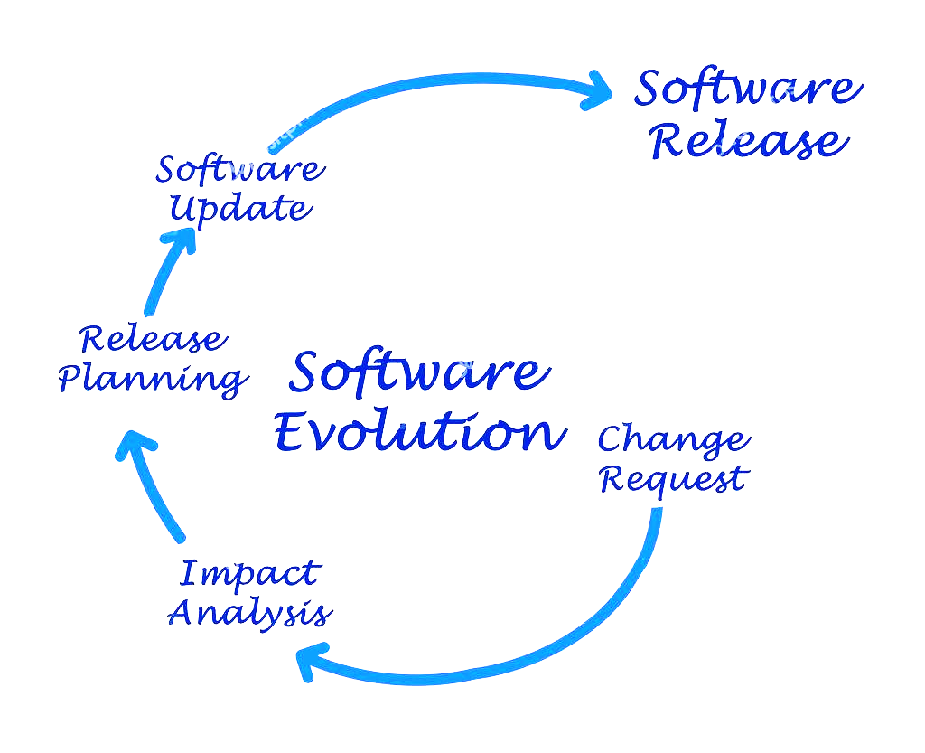

|  |
| --- |
| **Table of Content** |

**Table of Content 1**

**Group Members 2**

**Introduction 2**

**Project Planning 3**

**Sprint’s development processes 4**

**System Design 5**

**Appendices 7**

**User’s Guide 8**

**Solution implementation 8**

**Conclusions and Reflections 8**

**References 8**

|  |
| --- |
| **Group Members** |

|  |
| --- |
| Zahera Mohamad |
| Alweh Almohsin |
| Uddin Forhad |

|  |
| --- |
| **Introduction** |



|  |
| --- |
| **Project Planning** |

The group members did split the project into three sprints

* **Sprint 0**
* 1 day
* **Sprint 1, 2 and 3**
* 4 days
* **Final Report**
* Maximum of 10 days

|  |  |  |  |  |  |  |  |  |  |  |  |  |  |  |  |  |  |  |  |  |  |
| --- | --- | --- | --- | --- | --- | --- | --- | --- | --- | --- | --- | --- | --- | --- | --- | --- | --- | --- | --- | --- | --- |
| **April 2018** | | | | | | | | | | | | | | | | | | | | | |
| **Tu** | **We** | | **Th** | **Fr** | **Sa** | **Su** | **Mo** | **Tu** | **We** | | **Th** | **Fr** | **Sa** | **Su** | **Mo** | | **Tu** | | **We** | | **Tu** |
| 10  Start of the project  Sprint **0** | 11  Sprint **1** | | 12  Sprint **1** | 13  Sprint **1** | 14 | 15 | 16  Sprint **1** | 17  Sprint **2** | 18  Sprint **2** | | 19  Sprint **2** | 20  Sprint **2** | 21 | 22 | 23  Sprint **3** | | 24  Sprint **3** | | 25  Sprint **3** | | 26  Sprint **3** |
|  | | | | | | | | | | | | | | | | | | | | | |
| **Fr** | **Sa** | **Su** | **Mo** | **Tu** | **We** | | **Th** | **Fr** | **Sa** | **Su** | **Mo** | **Tu** | **We** | | | **Tu** | | **We** | |
| 27  Report | 28 | 29 | 30  Report | 1  Report | 2  Report | | 3  Report | 4  Report | 5 | 6 | 7  Report | 8  Report | 9  Report | | | 10  Report | | 11  End of the project | |

|  |
| --- |
| **Sprint’s development processes** |

* **The table below will illustrate the process of how each sprint was developed.**

|  |  |  |  |
| --- | --- | --- | --- |
| **Sprint 1** | | | |
| * Sprint goal |  | | |
| * Sprint backlog |  | | |
| * Sprint plan |  | | |
| * Sprint review meeting |  | | |
| * Sprint retrospective |  | | |
| **Sprint 2** | | **Sprint 3** | |
| * Sprint goal |  | * Sprint goal |  |
| * Sprint backlog |  | * Sprint backlog |  |
| * Sprint plan |  | * Sprint plan |  |
| * Sprint review meeting |  | * Sprint review meeting |  |
| * Sprint retrospective |  | * Sprint retrospective |  |

|  |
| --- |
| **System Design** |

Architecture Diagram (AFTER MODIFICATION)

A close up of a map

Description generated with high confidence

**Market Data**

Market Data Server

A screenshot of a cell phone

Description generated with very high confidenceA screenshot of a social media post

Description generated with very high confidence

Class Diagram (AFTER MODIFICATION)

**TRADES**

**UI**

A screenshot of a cell phone

Description generated with very high confidence

A screenshot of a cell phone

Description generated with very high confidence

A screenshot of a cell phone

Description generated with very high confidence

A screenshot of a cell phone

Description generated with very high confidence

A screenshot of a cell phone

Description generated with very high confidence

**SERVER**

A screenshot of a cell phone

Description generated with very high confidence

A screenshot of a cell phone

Description generated with high confidenceA screenshot of a cell phone

Description generated with very high confidence

A screenshot of a cell phone

Description generated with very high confidence

A screenshot of a cell phone

Description generated with high confidence

A screenshot of a cell phone

Description generated with high confidence

A picture containing screenshot

Description generated with very high confidence

**EXCEPTIONS**

Use Case Diagram (AFTER MODIFICATION)

**Security Trading Application**

A picture containing text, map

Description generated with very high confidence

|  |
| --- |
| **Appendices** |

|  |  |  |  |  |  |  |  |  |  |  |  |  |  |  |  |  |  |  |  |  |  |  |  |  |  |
| --- | --- | --- | --- | --- | --- | --- | --- | --- | --- | --- | --- | --- | --- | --- | --- | --- | --- | --- | --- | --- | --- | --- | --- | --- | --- |
| |  |  |  |  |  | | --- | --- | --- | --- | --- | | **Sprint 1** | | | | | |  | Day 1 | Day 2 | Day 3 | Day 4 | | Date | 2018-04-11 | 2018-04-12 | 2018-04-13 | 2018-04-16 | | Time | 10:00:00 | 10:30:00 | 10:15:00 | 10:00:00 | | Attendance | 3/3 | 3/3 | 3/3 | 3/3 | |

|  |  |  |  |  |  |  |  |  |  |  |  |  |  |  |  |  |  |  |  |  |  |  |  |  |  |
| --- | --- | --- | --- | --- | --- | --- | --- | --- | --- | --- | --- | --- | --- | --- | --- | --- | --- | --- | --- | --- | --- | --- | --- | --- | --- |
| |  |  |  |  |  | | --- | --- | --- | --- | --- | | **Sprint 2** | | | | | |  | Day 1 | Day 2 | Day 3 | Day 4 | | Date | 2018-04-17 | 2018-04-18 | 2018-04-19 | 2018-04-20 | | Time | 10:00:00 | 10:30:00 | 10:00:00 | 10:00:00 | | Attendance | 3/3 | 3/3 | 3/3 | 3/3 | |

|  |  |  |  |  |  |  |  |  |  |  |  |  |  |  |  |  |  |  |  |  |  |  |  |  |  |
| --- | --- | --- | --- | --- | --- | --- | --- | --- | --- | --- | --- | --- | --- | --- | --- | --- | --- | --- | --- | --- | --- | --- | --- | --- | --- |
| |  |  |  |  |  | | --- | --- | --- | --- | --- | | **Sprint 3** | | | | | |  | Day 1 | Day 2 | Day 3 | Day 3 | | Date | 2018-04-23 | 2018-04-24 | 2018-04-25 | 2018-04-26 | | Time | 11:00:00 | 10:30:00 | 10:00:00 | 10:00:00 | | Attendance | 3/3 | 3/3 | 3/3 | 3/3 | |

|  |
| --- |
| **User’s Guide** |

|  |
| --- |
| **Solution implementation** |

|  |
| --- |
| **Conclusions and Reflections** |

|  |
| --- |
| **References** |

* [2] V. T. Rajlich and K. H. Bennett. 2000. A stage model for the software life cycle. IEEE Computer, July, 2-8.
* Chapter 9 – software evolution. Retrieved from <http://csis.pace.edu/~marchese/CS389/L9/Ch9_summary.pdf>
* Models of Software Evolution. (july,1990). Retrieved from http://www.dtic.mil/dtic/tr/fulltext/u2/a227328.pdf
* [1] Lehman, M.M., and L. Belady. Program Evolution: Processes of Software Change. Academic Press, New York, 1985
* UML Activity Diagram Examples. (2009-2017). Retrieved from [www.uml-diagrams.org/activity-diagrams-examples.html](http://www.uml-diagrams.org/activity-diagrams-examples.html)
* The maintenance process. Retrieved from <http://rti.etf.bg.ac.rs/rti/ms1es/Literatura/Grubb_Takang-Software_Maintenance_Ch5.pdf>
* Priyadaeshi Tripathy and kshirasagar Naik (2015) “software evolution and maintenance: A Practitioner’s Approach”, John Wiley & Sons, Inc.
* Sommerville, I. (2015) “Software Engineering” 10th edition; Addison Wesley; ISBN 1292096136