
CORPORATE PROFILE · EDITION 2026
Trusted origins, curated for global markets.

An agricultural sourcing and export company connecting selected producers across Iran with international buyers.
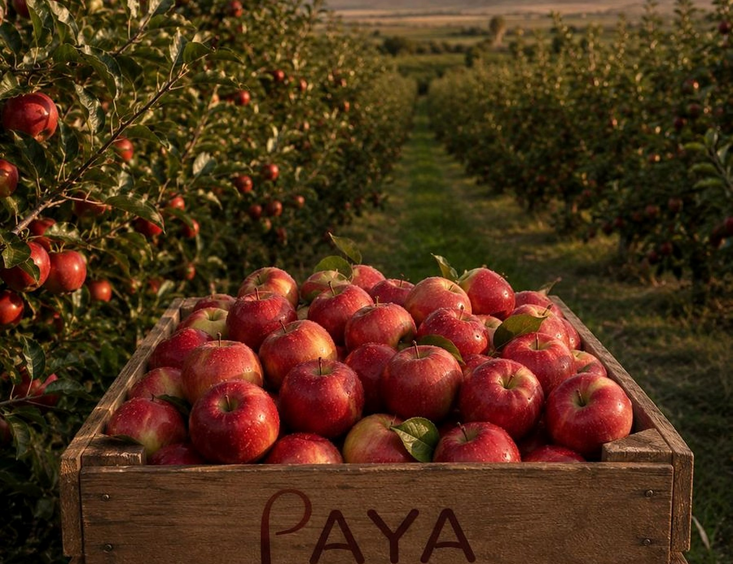
Apple harvest at a selected orchard. Iran, first light.

CONTENTS

What is in this document
Fields below update inside Word: select the table of contents, right-click and choose “Update Field” to refresh page numbers after editing.

01 — THE COMPANY

A single, accountable partner between Iranian farms and your business.
PAYA ORIGIN is an agricultural sourcing and export company. We identify producers across Iran's growing regions, verify what they grow, prepare it for its destination market, and ship it under one contract.
The company was built for export from the beginning rather than adapted to it. Our decisions start from a buyer's specification — product, grade, volume, packaging, destination — and work backwards to the orchard or field best able to meet it.
That order matters. It is the difference between offering a buyer what happens to be in a warehouse and building a supply chain that holds its shape across seasons.
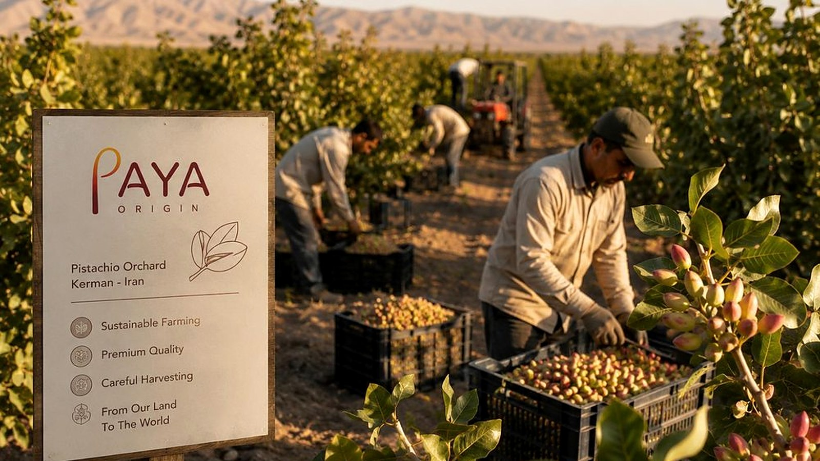
Fig. 01 — Pistachio harvest at a selected orchard, Kerman province. Producers are visited and assessed before they enter the network.
WHAT WE ARE  A sourcing, quality and export partner working on behalf of the buyer. | WHAT WE ARE NOT  A farm, a broker of anonymous stock, or a one-shipment trader.

02 — AT A GLANCE

A sourcing network built on experience, not guesswork.
15+ | Years in agricultural trade  Commercial experience across sourcing, quality control and export operations for Iranian agricultural products. | EXPERIENCE
05 | Sourcing regions across Iran  Kerman, Khorasan, Fars, Mazandaran and the Azerbaijan provinces — each selected for a specific crop, not for convenience. | ORIGIN
03 | Product categories  Dried fruits & nuts · fresh fruits · fresh vegetables — with packaging under our brand or your private label. | RANGE
04 | Priority export markets  Middle East · Russia & CIS · India · Europe. Commercial focus rather than an exhaustive list. | MARKETS
ONE | Point of accountability  A single contract and a single counterpart from producer selection through to delivered shipment. | STRUCTURE

Figures describe the company's commercial focus and sourcing footprint. Volumes, grades and lead times are confirmed per enquiry. Regions listed are those currently active in the sourcing network and expand according to buyer requirements.

03 — THE SOURCING PROBLEM

International sourcing is rarely a single transaction.
A buyer who wants ten tonnes of a specific grade, packed a specific way, arriving on a specific date, usually ends up coordinating four or five unrelated parties — and carrying the risk between them.
WITHOUT A COORDINATED PARTNER
Producers | Different standards, timelines and languages.
Inspectors | Quality verified inconsistently, if at all.
Packers | Packaging chosen for supply, not for the market.
Forwarders | Freight booked separately from production.
Documents | Certificates chased after the goods have moved.

WITH PAYA ORIGIN
One partner holds the whole chain — and the responsibility for it. Every hand-off removed is a point of failure removed. That is the entire commercial argument for how this company is structured.

WHAT FRAGMENTATION COSTS
QUALITY DRIFTS  When no single party owns the standard, each lot is judged against a slightly different one. | SCHEDULES SLIP  Production, packing and freight planned separately rarely meet on the date the buyer needs. | NOBODY ANSWERS  When something goes wrong across five counterparties, the buyer absorbs it. That is the real cost.

04 — OUR MODEL

From complexity to confidence.
One workflow, five stages, a single counterpart. Each stage produces something the next stage depends on — which is why we refuse to run them in parallel with different companies.
STAGE |  | WHAT HAPPENS | WHAT IT PRODUCES
01 | Requirement | Product, grade, volume, packaging, destination and delivery window are fixed in writing before anything is sourced. | Written specification
02 | Sourcing | The region is chosen for the crop; the producer is chosen for the specification. Alternatives are proposed, not assumed. | Origin proposal
03 | Verification | Quality is checked at supplier assessment, during procurement, and again before the shipment is sealed. | Inspection record
04 | Preparation | Cleaning, sorting, grading, packing and labelling to the destination market's requirements. | Packing & label spec
05 | Delivery | Documentation, customs and freight handled inside the same contract that started at the requirement. | Document set

PRINCIPLE  The requirement defines the sourcing strategy — never the other way round. | PRINCIPLE  Producers are selected and re-assessed. Being nearby is not a qualification. | PRINCIPLE  One coordinated partner replaces a chain of disconnected suppliers.

05 — SCOPE OF RESPONSIBILITY

What we take responsibility for — and what we deliberately do not.
A clear boundary is more useful to a buyer than a long list of capabilities. This is ours.
WE DO | WE DO NOT
— Procurement against a written specification. Grade, calibre, moisture, packing and tolerance agreed before sourcing begins.  — Producer identification and assessment. Farms and processors evaluated across Iran's growing regions.  — Quality verification at three points. Supplier assessment, procurement, pre-shipment.  — Packaging development. PAYA ORIGIN brand or your private label, built for the destination market.  — Export documentation and freight. Certificates, customs and shipment inside one contract.  — Season-over-season supply planning. Continuity treated as the product, not the by-product. | × Operate farms. We select and supervise producers; we do not compete with them.  × Sell anonymous commodity stock. Every lot has a named region and a named producer behind it.  × Depend on a single producer or region. Alternatives are maintained for every active line.  × Treat a shipment as the finish line. A first order that does not repeat is a failed order.  × Quote what we cannot verify. If a specification cannot be met honestly, we say so.  × Sell certification we do not hold. Required certificates are arranged and named explicitly per shipment.

“Rather than selling available inventory, we build supply around the customer's requirement.”

06 — HOW WE WORK

From requirement to reliable supply.
Five stages, each with a photograph of what it actually looks like. Every stage is designed to remove a specific uncertainty.
 | 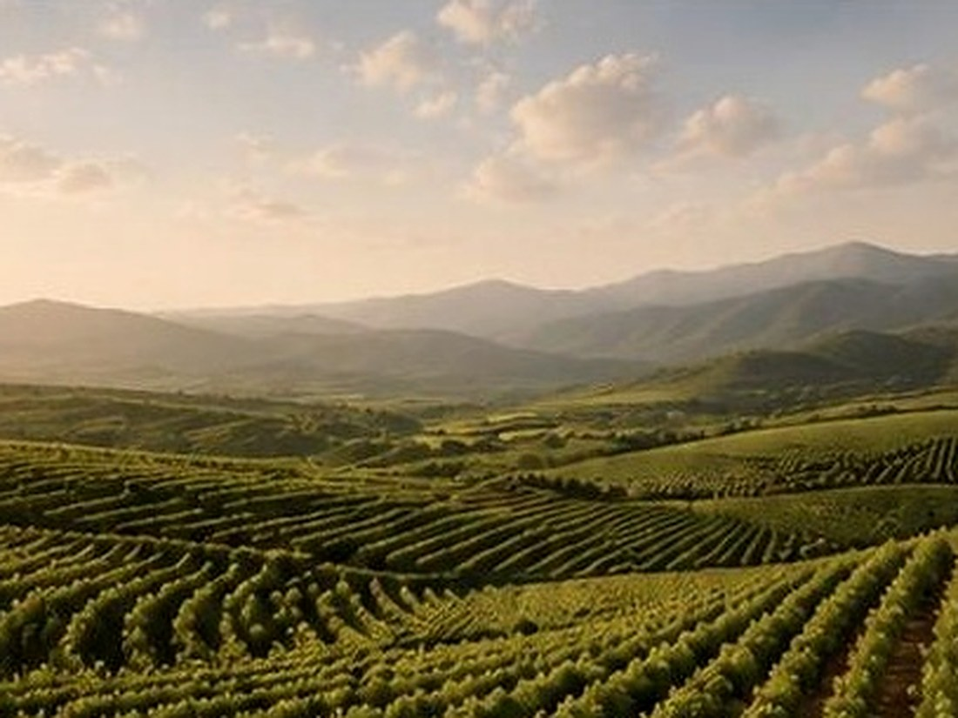 | 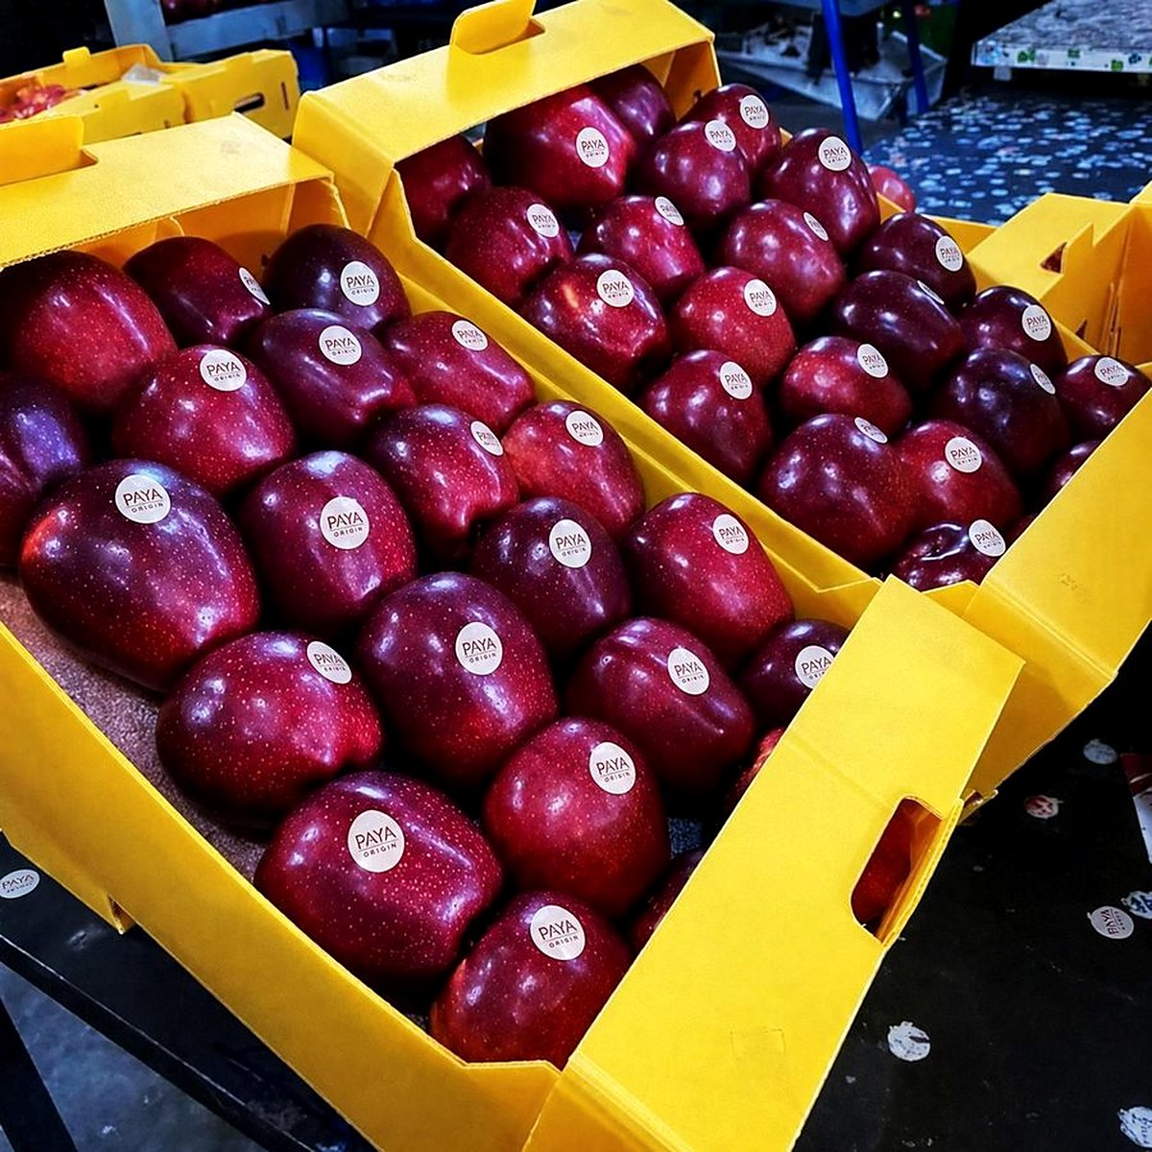 | 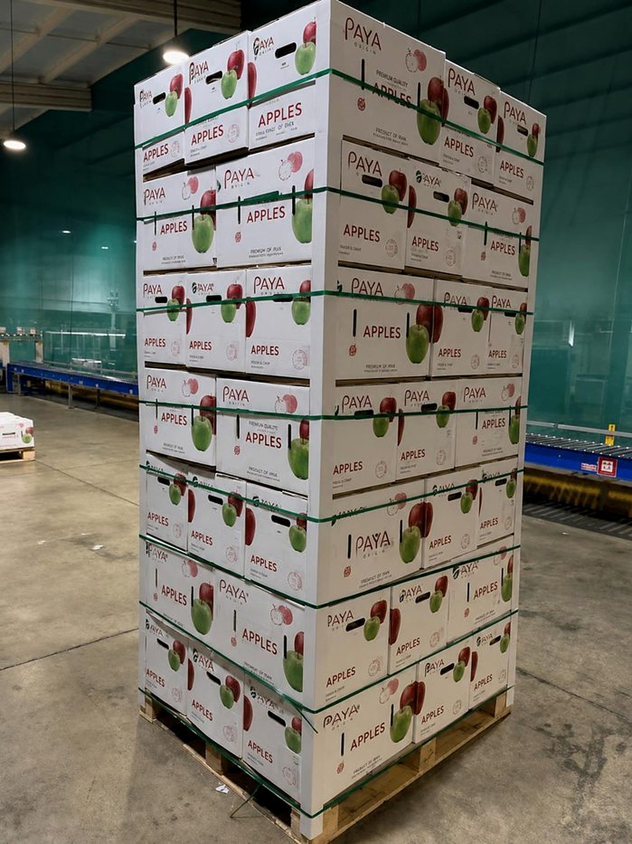 | 
01  Understand  Product, grade, quantity, destination market and delivery window recorded as a specification. | 02  Curate  Region matched to crop, producer matched to specification — with a second option held in reserve. | 03  Verify  Checked at supplier assessment, again during procurement, and again before loading. | 04  Prepare  Cleaned, sorted, packed, labelled and palletised for the destination market's rules. | 05  Deliver  Documentation, customs and freight coordinated under the same contract.

WHAT THE BUYER RECEIVES  A written specification, named origin, and an agreed delivery window before any commitment. | WHAT WE HOLD  Producer relationships, quality records and the freight plan — in one place. | WHAT CHANGES EACH SEASON  Origins and harvest windows. The process around them does not.

07 — QUALITY VERIFICATION

Quality is not a final inspection.
A single check before loading can only reject a problem. Checking at three points prevents it — which is considerably cheaper for everyone involved.
CHECKPOINT 01  Before procurement | The producer is assessed — growing region, handling practice, processing capability and past consistency. A producer who cannot meet the specification is not asked to try.
CHECKPOINT 02  During sourcing | Lots are checked against the agreed grade as they are collected and processed — so a deviation is caught while it can still be corrected, not after packing.
CHECKPOINT 03  Before shipment | Pre-shipment inspection against the same written specification the order started with, together with the documentation the destination market requires.

  Fig. 02 — Assessment recorded against the written specification, in the field. | TYPICALLY ACCOMPANIES A SHIPMENT  Commercial invoice  Packing list  Certificate of origin  Phytosanitary certificate  Bill of lading or CMR  Inspection report, where agreed  Exact document set depends on product, destination and the buyer's import requirements.

08 — ORIGINS ACROSS IRAN

Iran is not one origin. It is a set of them.
Climate, altitude and harvest window change completely between provinces. We source each crop from the region that grows it best — which is why the map matters more than the country name.
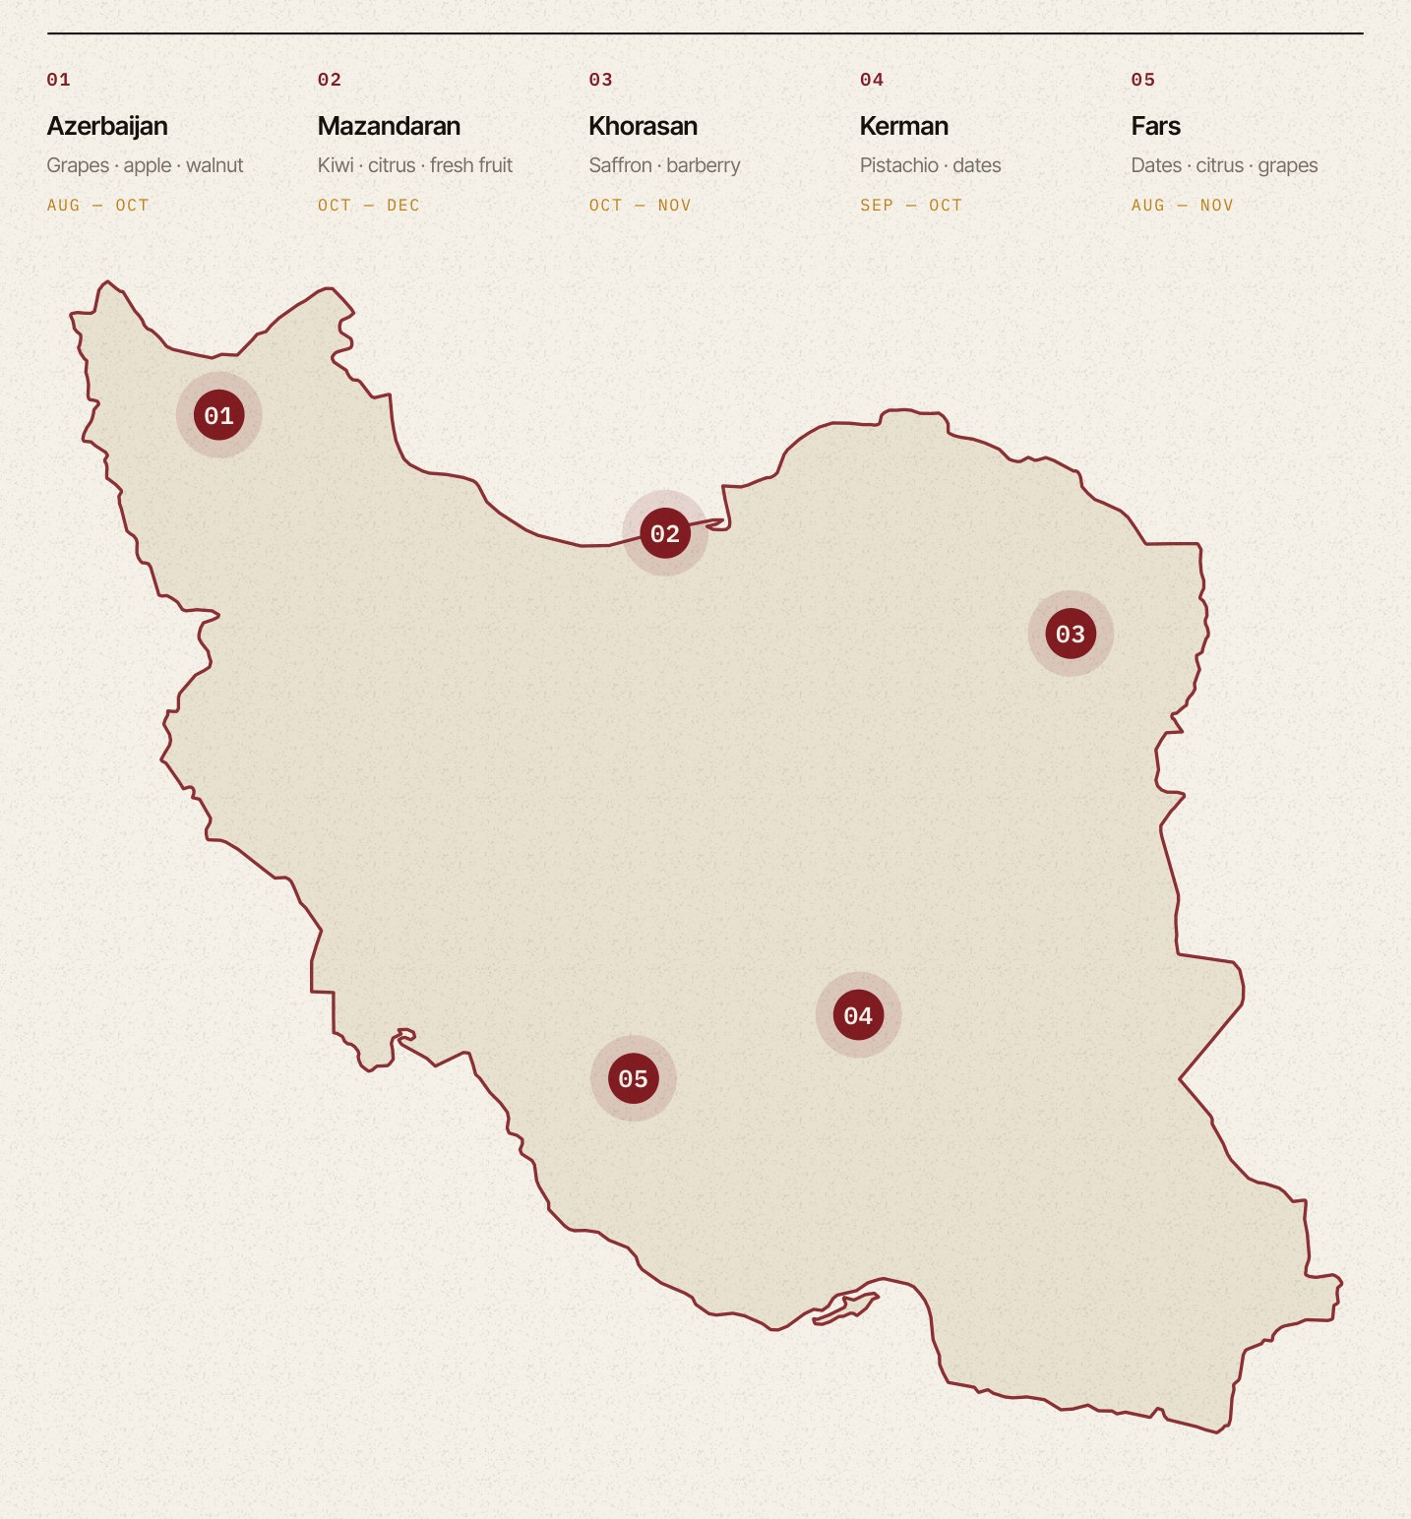
Fig. 03 — Selected agricultural origins. Positions are provincial reference points, not producer locations.

08 — ORIGINS ACROSS IRAN

Why each region, and what it is good for.
REGION | PRIMARY CROPS | GROWING CONDITION | HARVEST
Azerbaijan  East & West provinces | Grapes, apple, walnut | Cool continental highland; long, bright autumns that concentrate sugars before harvest. | Aug — Oct
Mazandaran  Caspian belt | Kiwi, citrus, fresh fruit | Humid subtropical strip between the Alborz range and the Caspian; the country's late-season fruit basket. | Oct — Dec
Khorasan  Razavi & South | Saffron, barberry | Semi-arid highland with cold winters and dry autumns — the conditions saffron requires and few places offer. | Oct — Nov
Kerman  Rafsanjan & Sirjan | Pistachio, dates | Arid high plateau with a wide day-to-night temperature range; the origin behind Iran's signature nut export. | Sep — Oct
Fars  Southern valleys | Dates, citrus, grapes | Warm temperate valleys with a long growing season, supporting both stone fruit and date production. | Aug — Nov

ORIGIN IS A DECISION  Two orchards in the same province do not produce the same lot. The producer is chosen after the region. | SEASONS ARE HONEST  Harvest windows shift year to year with weather. We commit to dates we can actually hold. | COVERAGE EXPANDS  New regions enter the network when a specification justifies the assessment work behind them.

09 — HARVEST CALENDAR

When each product is actually available.
Sourcing conversations are easier when both sides are looking at the same calendar. These are the windows we plan against.
 | Harvest |  | Available from storage |  | Year-round (protected cultivation)

 | J | F | M | A | M | J | J | A | S | O | N | D
DRIED FRUITS & NUTS
Pistachio
Saffron
Dates
Walnut
Raisin
Dried fig
FRESH FRUITS
Grape
Pomegranate
Kiwi
Apple
Peach
Melon
FRESH VEGETABLES
Bell pepper
Tomato

CONTRACT AHEAD OF HARVEST  Capacity at the better producers is committed early. Peak-season volumes are best agreed before the harvest opens, not during it. | TWO CALENDARS, NOT ONE  The harvest window and your selling season rarely align. Variety choice, storage and switching origin are how we bridge the gap. | STORAGE IS NOT NEUTRAL  Product supplied from storage is available, but it is not identical to a fresh-harvest lot. We tell you which one you are buying.

Indicative windows for Iranian production, subject to season, region and variety. Greenhouse-grown vegetables are available year-round with seasonal peaks. Confirmed per enquiry.

10 — PRODUCTS · CATEGORY 01 OF 03

Dried fruits & nuts
The category Iran is known for. Long harvest-to-export experience, established processing capacity, and grading conventions that international buyers already recognise.
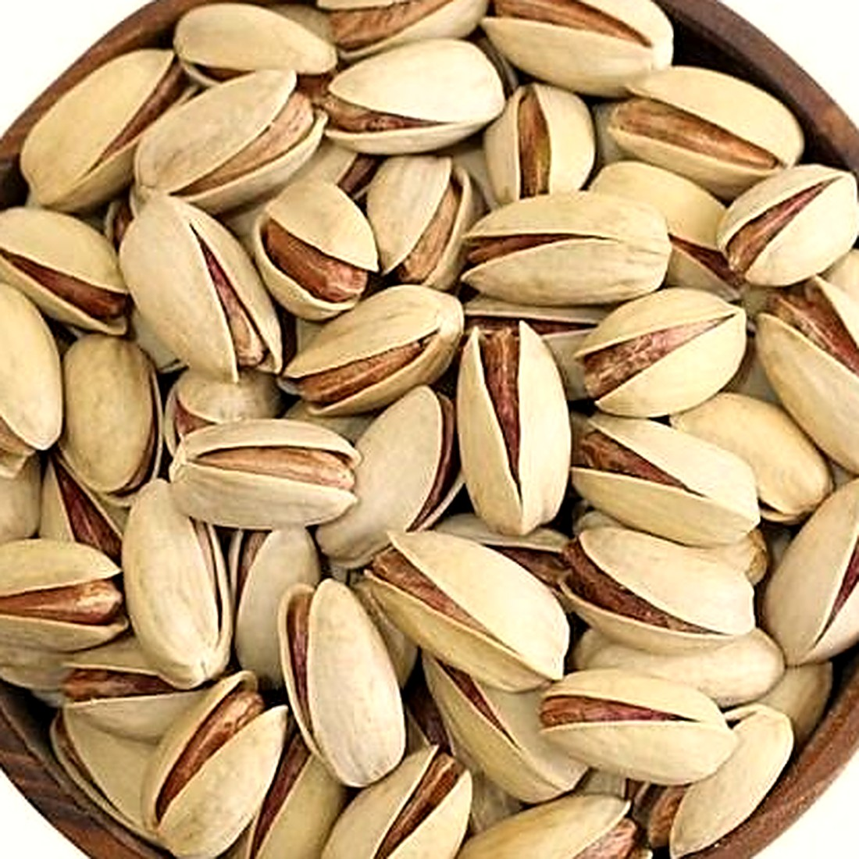 | 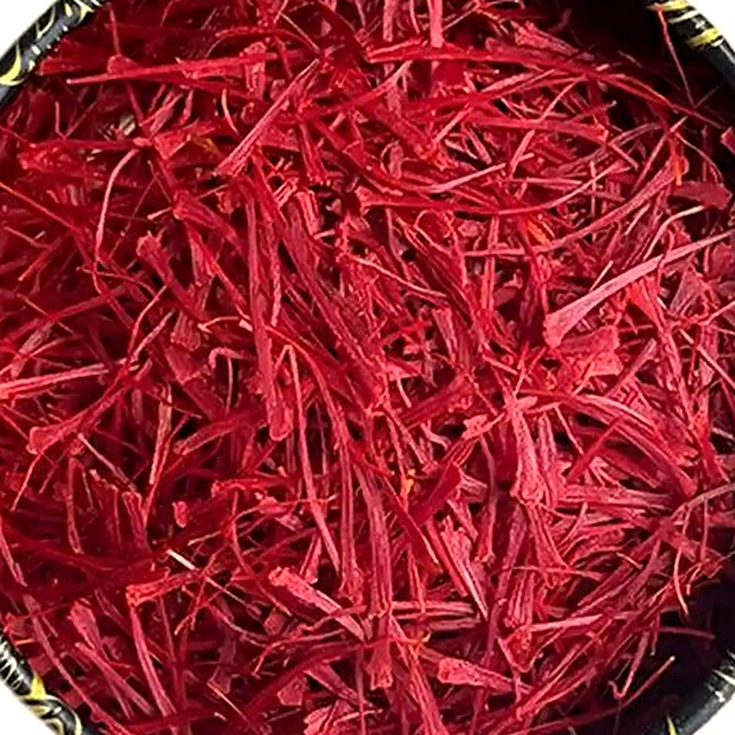 | 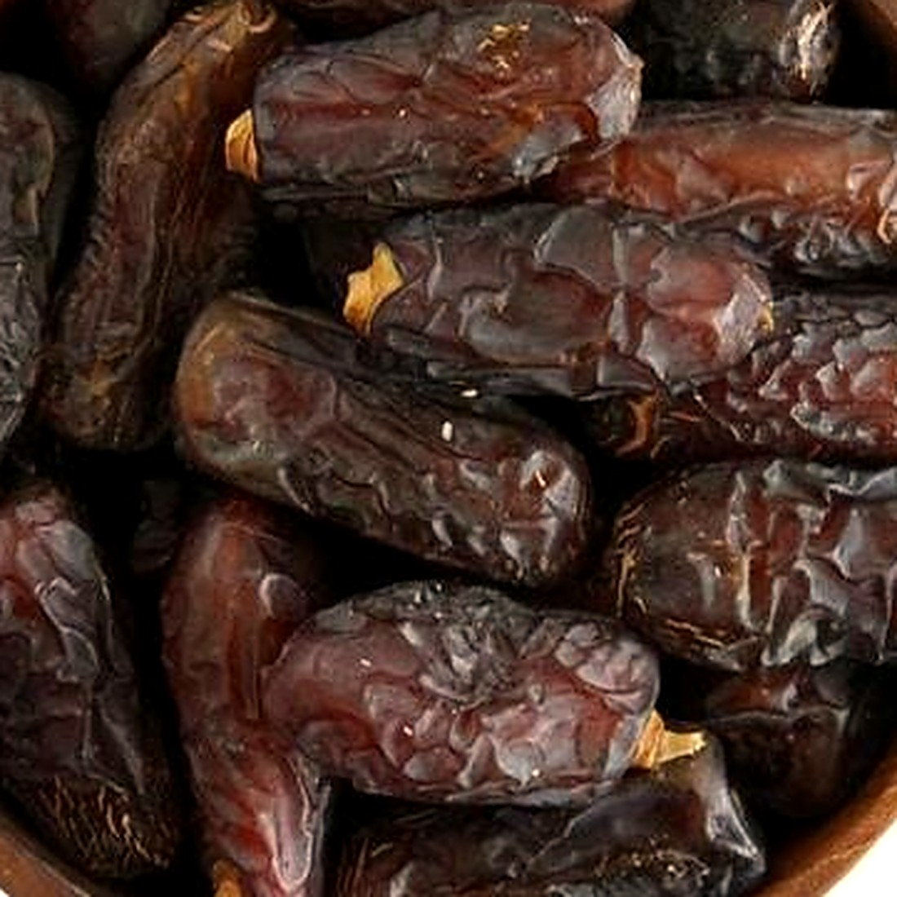
Pistachio  KERMAN · SEP–OCT | Saffron  KHORASAN · OCT–NOV | Dates  FARS · KERMAN · AUG–OCT
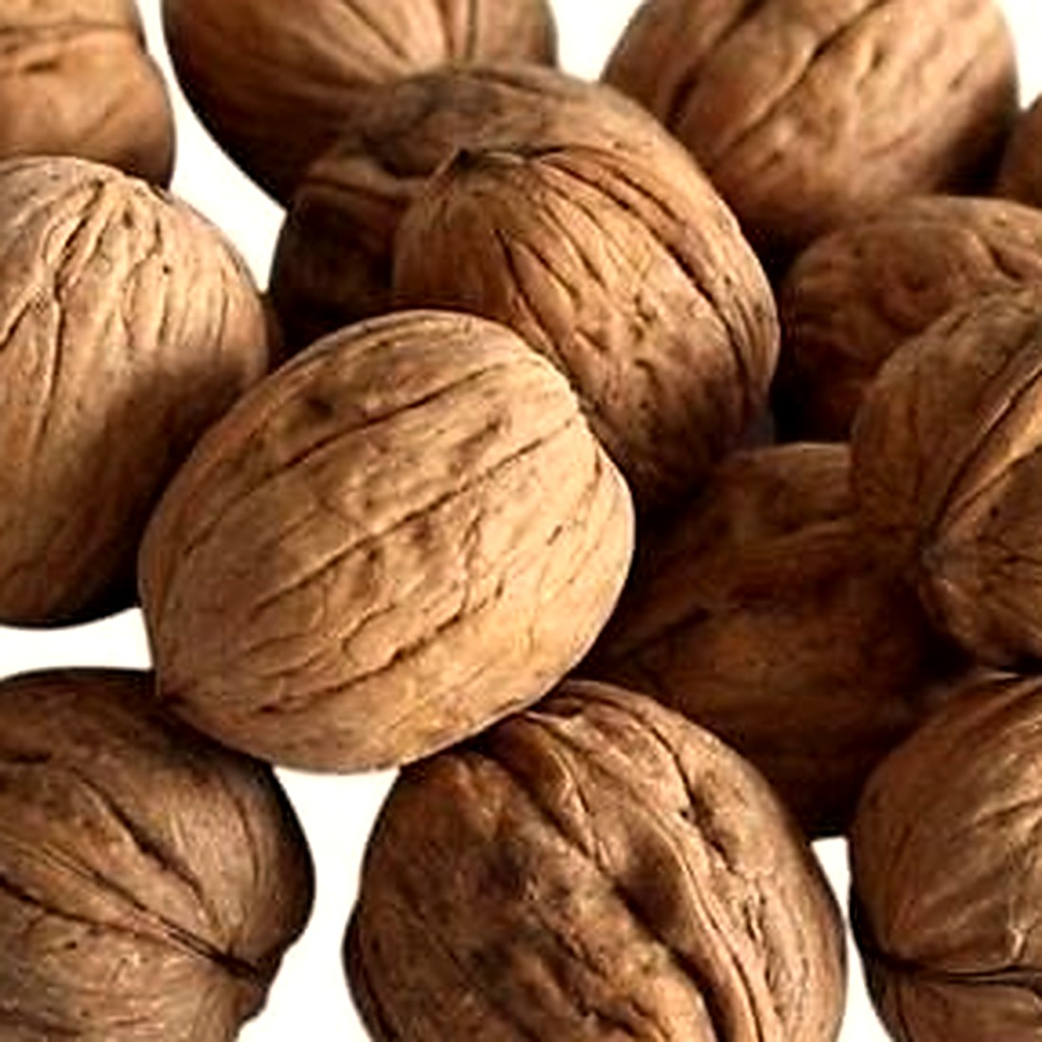 | 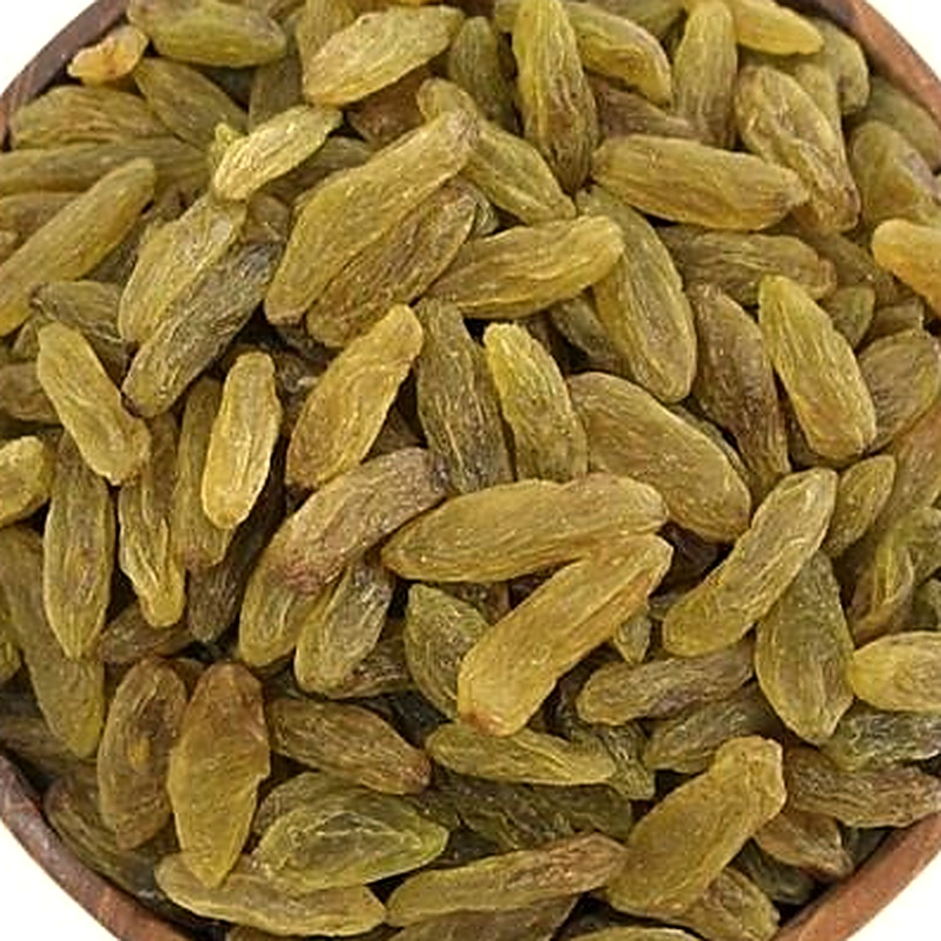
Walnut  AZERBAIJAN · SEP–OCT | Raisin  AZERBAIJAN · FARS · AUG–OCT
Pistachio is grown on the arid Kerman plateau, where the day-to-night temperature swing drives shell split and kernel fill. Supplied by variety and calibre — Akbari, Ahmad Aghaei, Kaleh Ghouchi, Fandoghi — in-shell or kernel.
ALSO SOURCED  Dried fig · peanut · dried mulberry · sunflower seed · watermelon seed · dried plum. | SPECIFIED BY  Variety, calibre or size grade, moisture, defect tolerance and treatment. | PACKED AS  Bulk cartons and sacks for processors; retail units under our brand or your private label.

11 — PRODUCTS · CATEGORY 02 OF 03

Fresh fruits
Iran's climate range means the fresh-fruit season does not close in autumn. Between the Caspian belt and the southern valleys, the country supplies across most of the calendar.
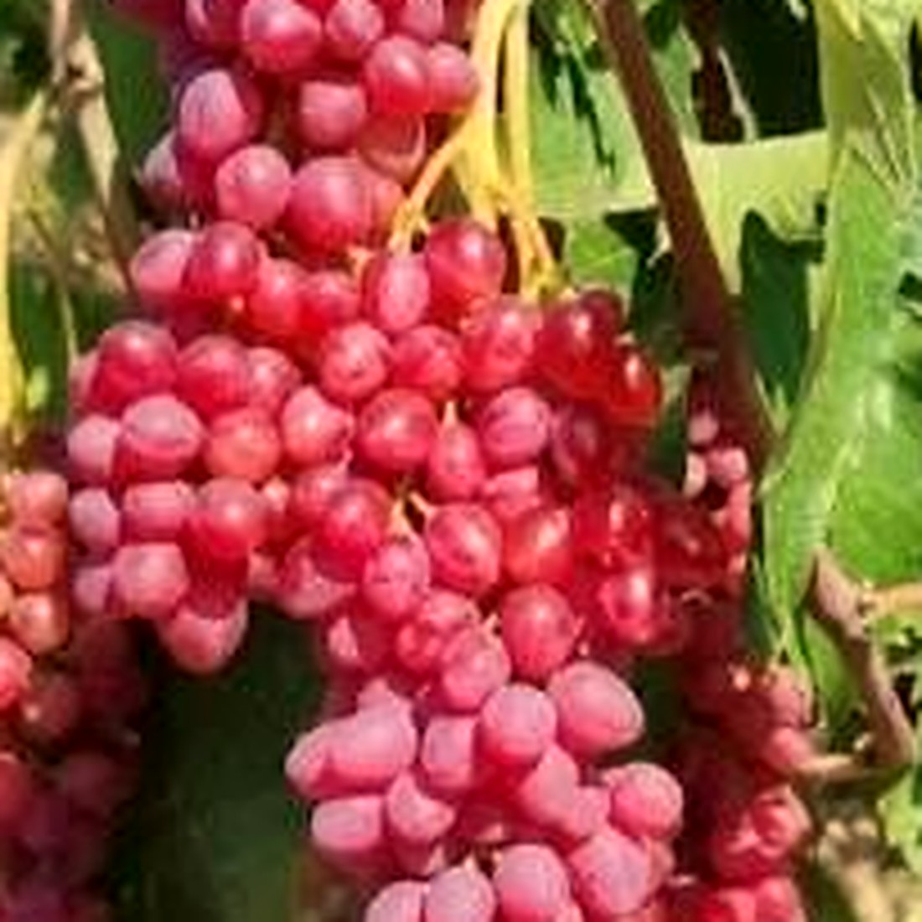 | 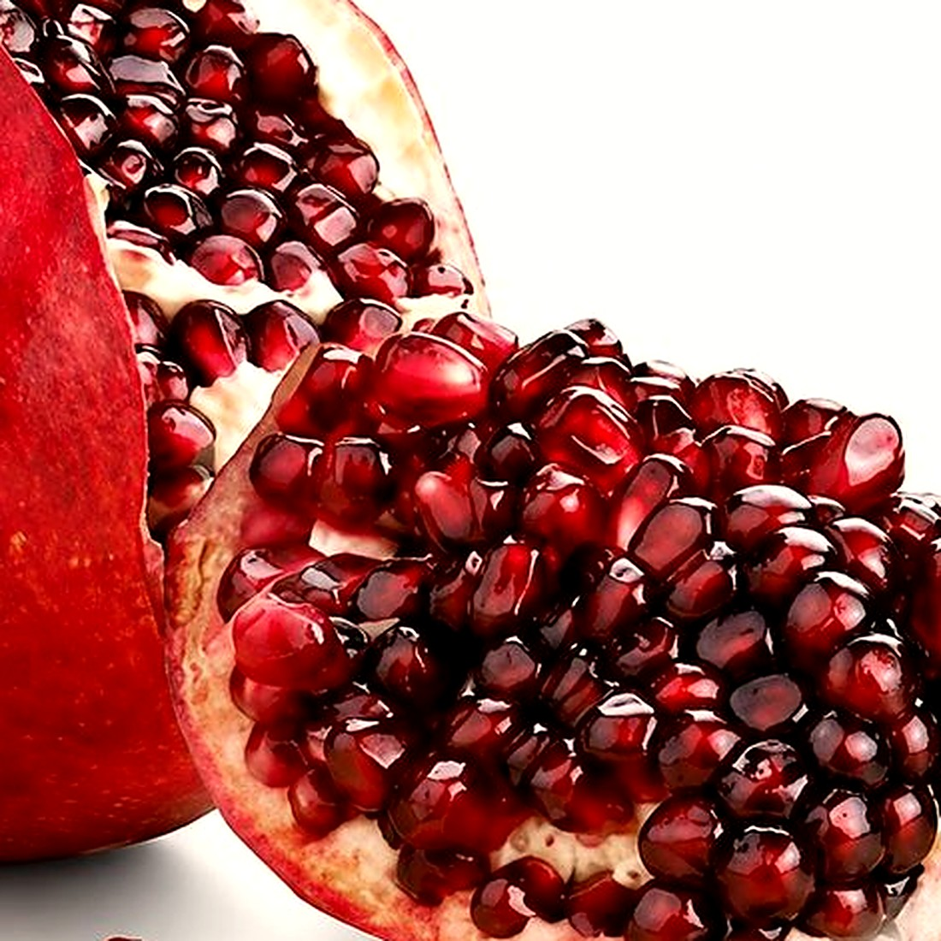 | 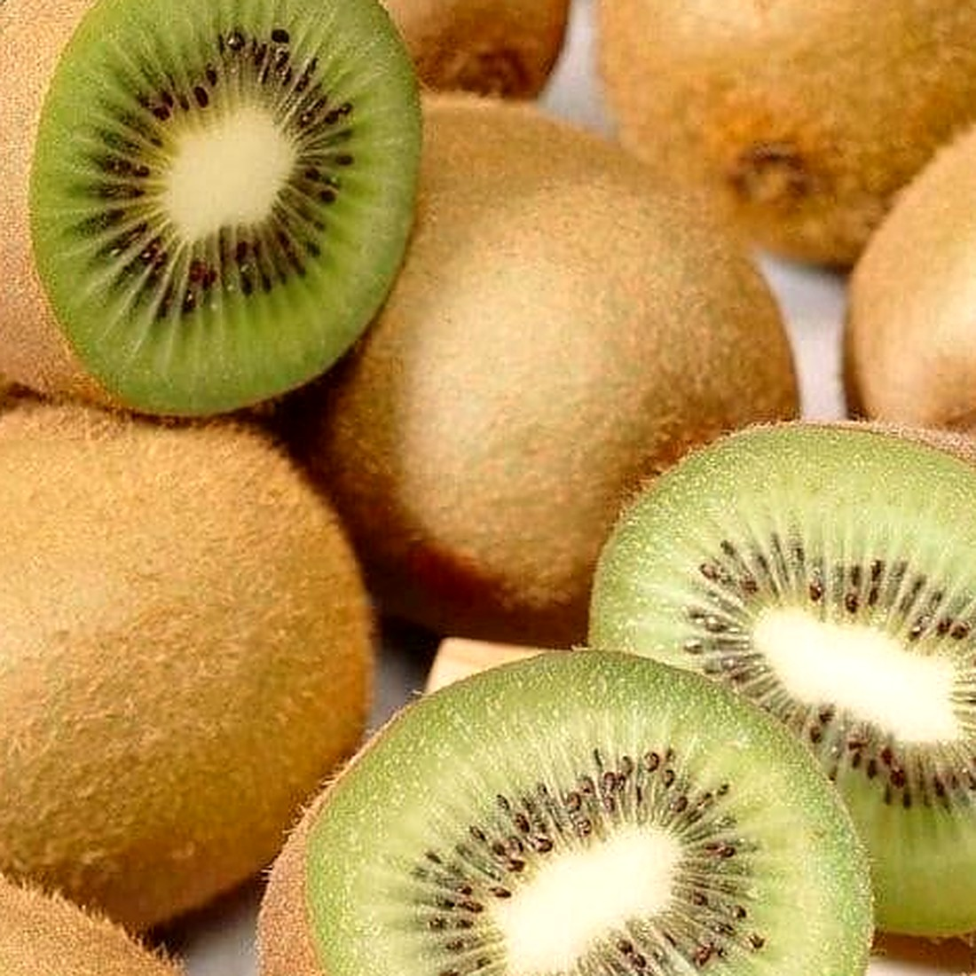
Grape  AZERBAIJAN · JUL–OCT | Pomegranate  FARS · SEP–NOV | Kiwi  MAZANDARAN · OCT–DEC
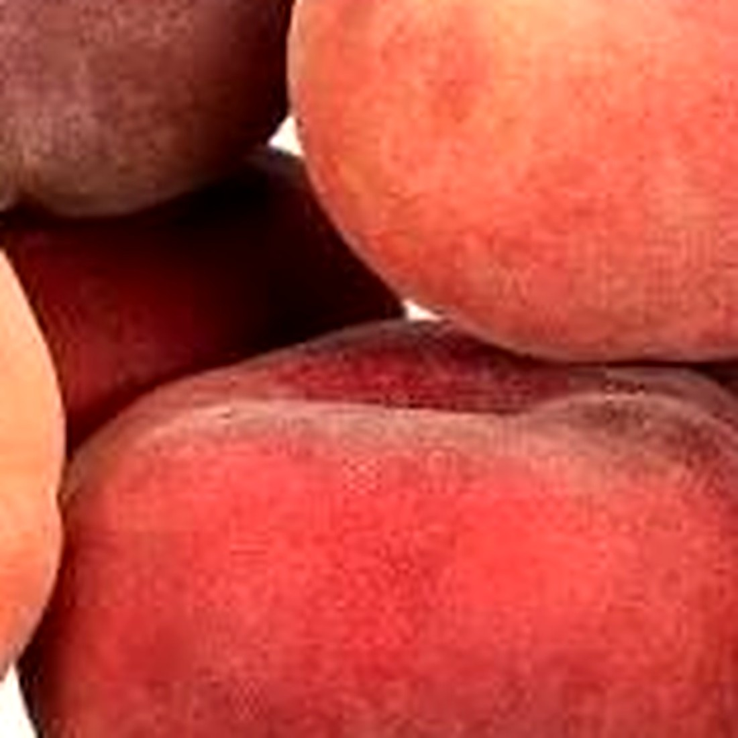 | 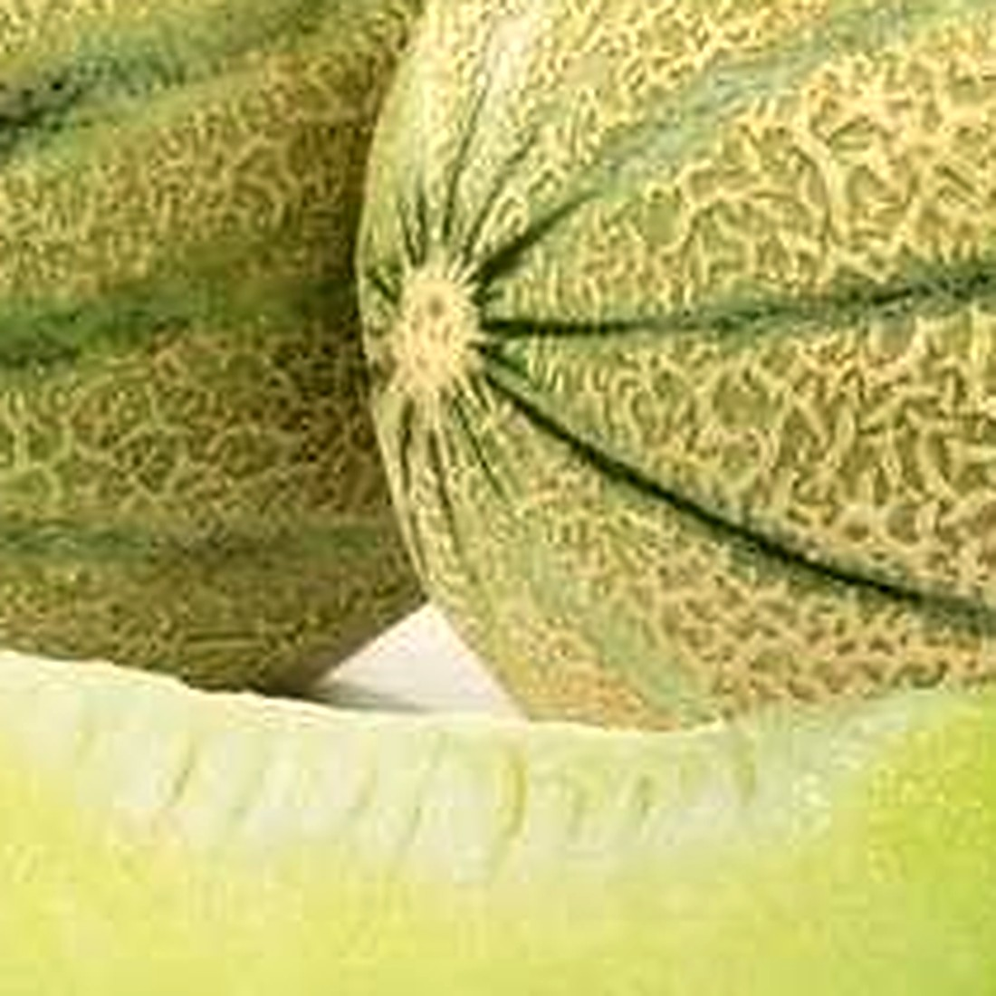
Peach  FARS · JUN–AUG | Melon  CENTRAL IRAN · JUN–SEP
ALSO SOURCED  Apple · watermelon · plum · citrus · seasonal varieties by harvest calendar. | SPECIFIED BY  Variety, size and colour grade, brix where relevant, and pack count. | HANDLED AS  Cold-chain from packhouse to port; carton and tray formats matched to the market.

12 — PRODUCTS · CATEGORY 03 OF 03

Fresh vegetables
Protected cultivation has changed what Iran can offer in vegetables. Greenhouse production runs through the year, which makes vegetables the category where continuity — not season — is the commercial point.
01 | Bell pepper | Greenhouse-grown across colour grades. Available year-round with a cooler-season peak, sized and packed to the buyer's count per carton.
02 | Tomato | Greenhouse and open-field production by variety and grade, including formats intended for onward processing.
03 | Seasonal produce | Cucumber, aubergine, courgette and others sourced against the harvest calendar and the destination market's requirements.
04 | Cold chain & programme | Vegetables are contracted as a rolling programme with agreed weekly or monthly volumes, and moved under temperature control from packhouse to port.

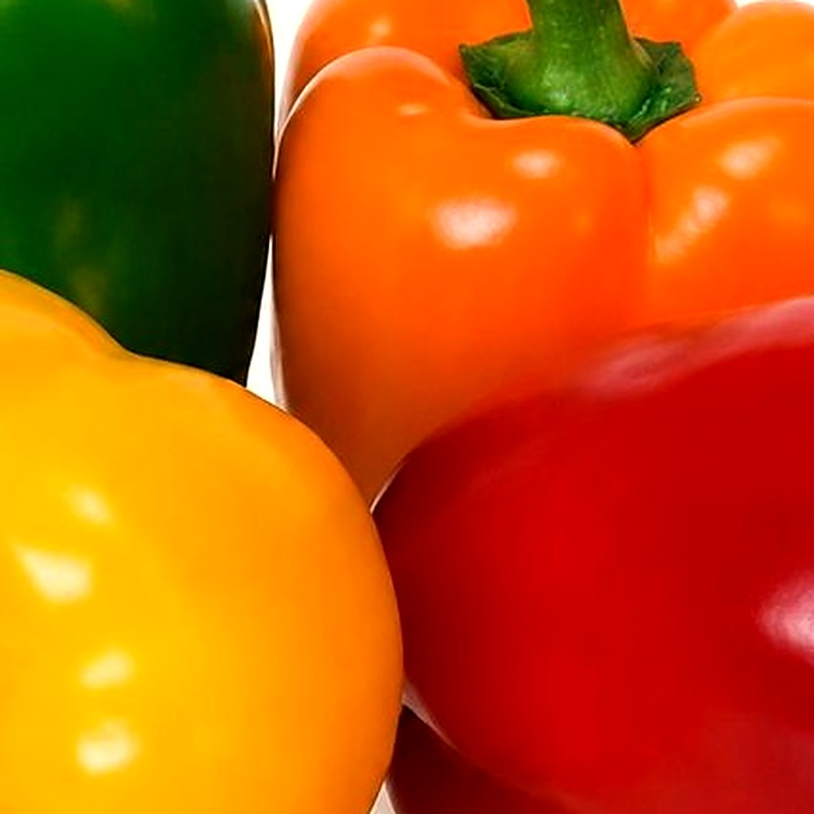
Fig. 04 — Bell pepper, sorted by colour grade before packing.
WHY VEGETABLES BEHAVE DIFFERENTLY
With protected cultivation the constraint moves from the season to the cold chain. Planning is agreed as a rolling programme rather than a single shipment — which is how most of our vegetable buyers work with us.

Full specifications, grades, packing formats and availability are set out in the Product Catalogue, available on enquiry.

13 — PACKAGING & PRIVATE LABEL

Packed for the market it is going to.
Packaging is a commercial decision, not a finishing touch. Format, count, labelling language and compliance marks change by destination — so they are agreed with the specification, not after it.
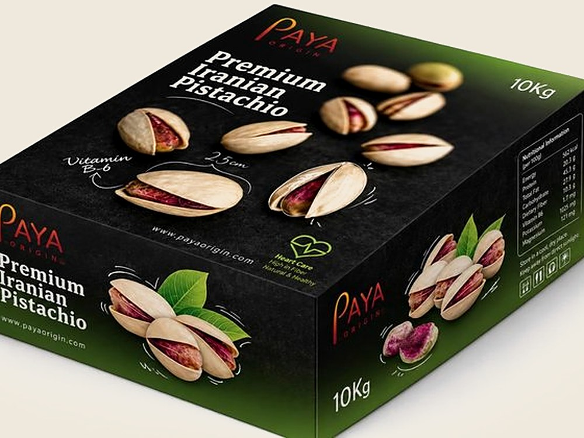 | 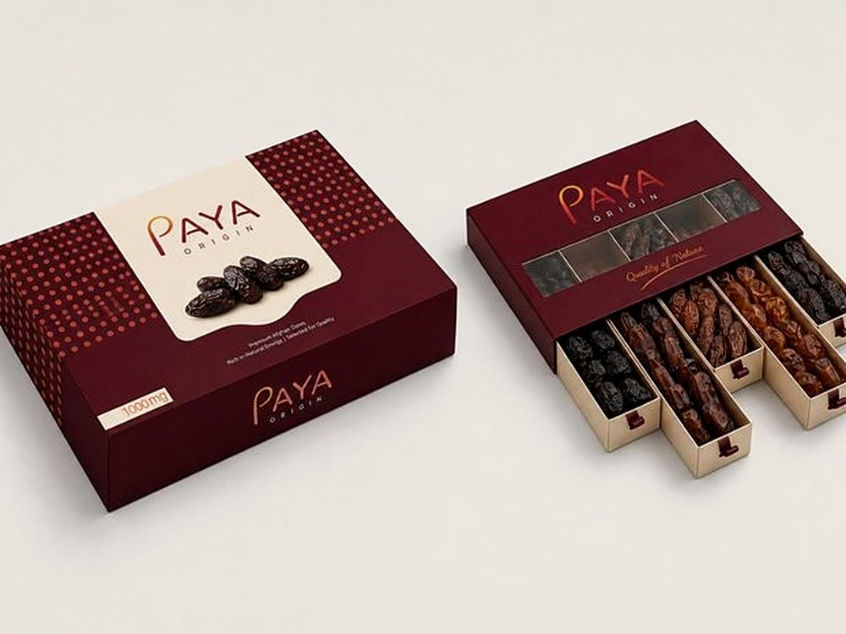 | 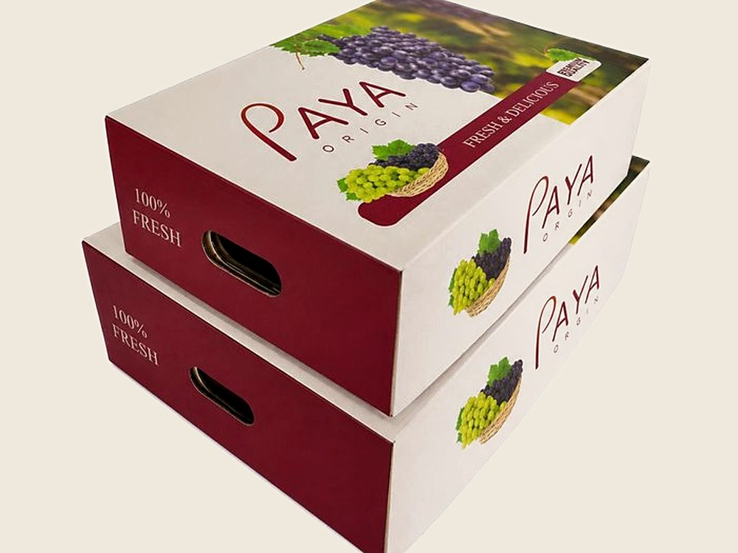 | 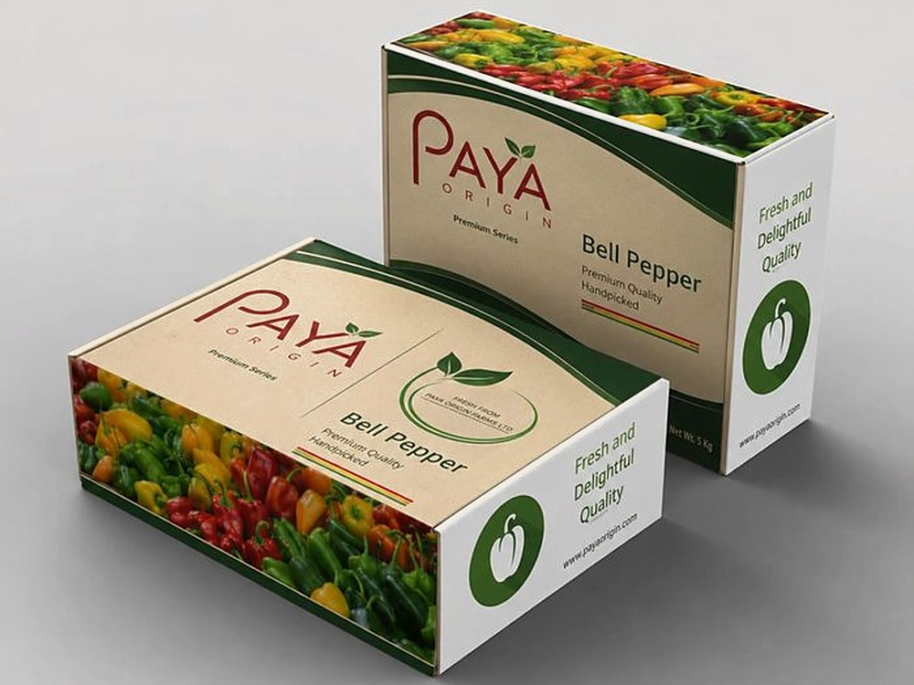
Bulk export carton  NUTS & DRIED FRUIT | Retail presentation  SAFFRON & PREMIUM LINES | Ventilated fruit carton  FRESH FRUIT · COLD CHAIN | Vegetable carton  GREENHOUSE PRODUCE

A | PAYA ORIGIN brand | Our own labelling, used where the buyer wants an origin-marked product without developing packaging of their own.
B | Private label | Your brand, your artwork, your market's language and compliance marks — produced to your specification.
C | Bulk & industrial | Unbranded bulk formats for processors and re-packers, specified by net weight and pallet configuration.

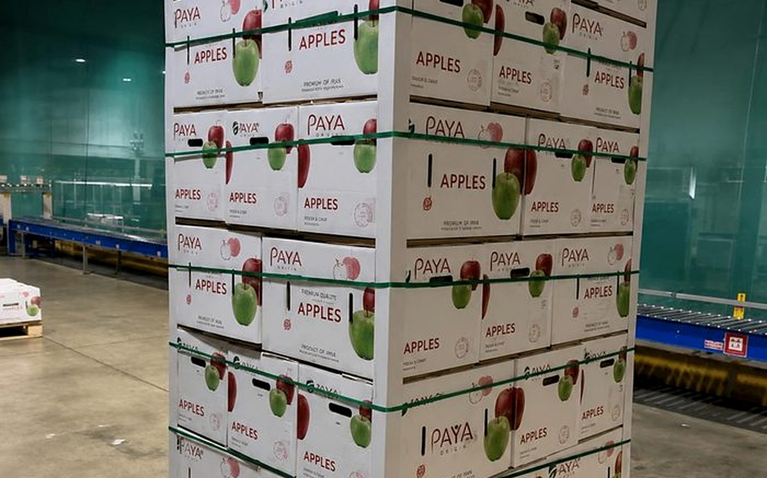
Fig. 05 — Palletised cartons staged for loading. Pallet configuration is agreed with the packing format, not improvised at the warehouse.

14 — MARKETS

Four markets we are built to serve.
Our commercial focus is deliberately narrow. These are the markets whose requirements, routes and buying patterns we know well enough to commit to.
01 | Middle East | GCC states and neighbouring markets. Short transit favours fresh fruit and vegetables where condition on arrival is the deciding factor. | Fresh fruit · vegetables · dates
02 | Russia & CIS | Established demand for Iranian fresh produce, with volume concentrated in the months when local supply is out of season. | Fresh fruit · vegetables · dried fruit
03 | India | A long-standing destination for Iranian dates, saffron and dried fruit, bought on specification and grade. | Dates · saffron · dried fruit
04 | Europe | Sea-freighted shelf-stable categories, where documentation, traceability and consistent grading matter as much as price. | Nuts · dried fruit · saffron

HOW A MARKET IS ADDED  A new destination enters the list once we understand its import requirements, have a route we can hold, and have buyers whose specifications we can meet repeatedly. Until then it is an enquiry we will answer honestly, not a market we claim. | 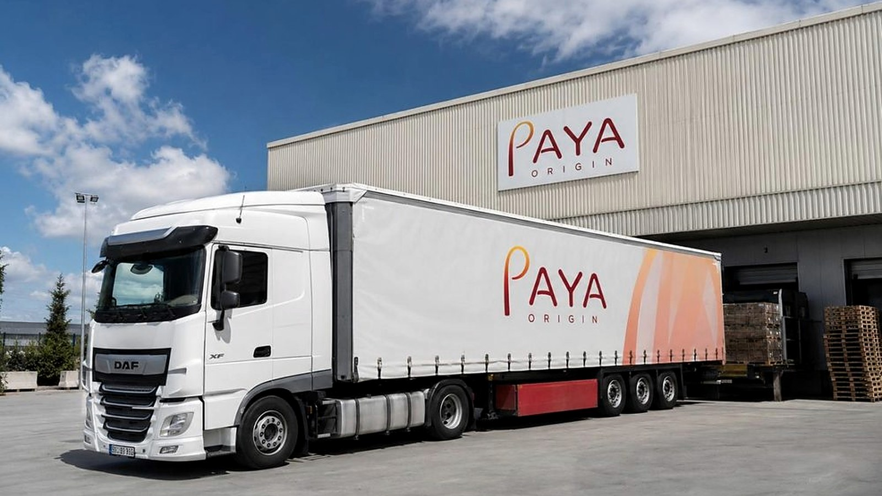  Fig. 06 — Dispatch. Freight is booked against a production plan, not after it.

15 — WORKING WITH US

What happens after you send an enquiry.
01 | Enquiry | Product, grade, volume, packaging preference, destination port and target delivery window — as much as you have.
02 | Sourcing proposal | Origin options with the trade-offs stated: what each region gives you on quality, timing and cost.
03 | Sample & approval | Representative samples against the specification, so the standard is agreed on the product rather than on paper.
04 | Contract & planning | Terms, schedule and packing fixed. Production is planned against the harvest window, not against optimism.
05 | Inspection & documents | Pre-shipment inspection and the document set your import process requires, prepared before the container moves.
06 | Shipment & follow-up | Delivery tracked to arrival, then reviewed — because the next season's programme is built on what this one taught us.

COMMERCIAL TERMS  FOB, CFR, CIF and DAP quoted on request, according to product, destination and the route being used. | LEAD TIME  Driven by harvest window, processing and packing format. Confirmed per order rather than promised in general. | FIRST ORDER  Trial volumes are welcome. Most long relationships here started as one container that arrived as described.

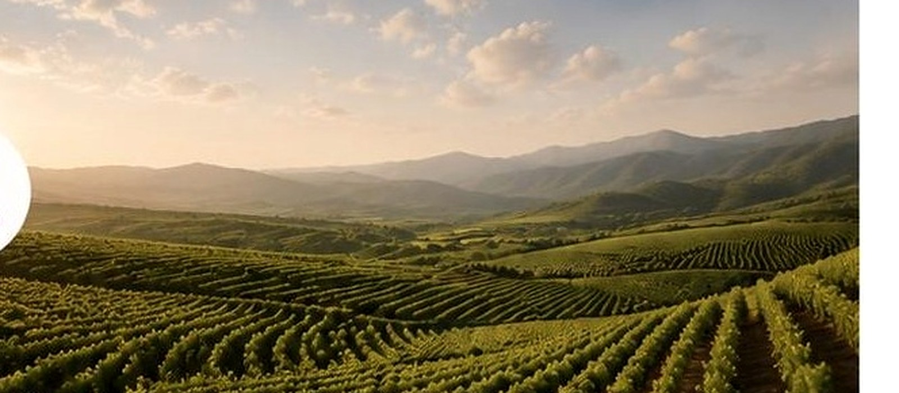
Trust is not created by words. It is created by disciplined decisions and consistent delivery.

Send us a specification, a target market and a delivery window — or simply ask what a region can realistically supply this season. We will answer with what is true, including when the answer is no.

EMAIL  sale@payaorigin.com | PHONE & WHATSAPP  +98 912 410 7606 | OFFICE  Valiasr Street, Tehran, Iran


© 2026 PAYA ORIGIN · payaorigin.com

