The models proposed in this report are described below. We are proposing 3 models namely in table 1. NB_Dist, NB_sqrt_dist and MM. The other models are from TMRs ffunctional forms for the Fifa world cup games.
Table 1: Model Description Table
Models with Embedded Colors
Model | Description | Color
NB_dist | Negative Binomial: Distance, Population and Income | blue
NB_sqrt_dist | Negative Binomial: Square Root Distance, Population and Income | cyan
NB-RE | Negative Nibomial Random Effects Model on Venue:Square Root Distance, Population and Income | lightblue
TMR_ff1 | Population x Income | denom = Square Root Distance | purple
TMR_ff2 | Population | denom = Square Root Distance | lavender
TMR_ff3 | Population x Income +Employment | denom = Square Root Distance | maroon
TMR_ff4 | Population x Income Dep C | denom = Square Root Distance | hotpink
TMR_ff5 | Population | denom = Distance | pink

The models were fitted on the Gold Coast 2018 data to explain the relationship between distance and predicted tickets to the venue. The cumulative plot of all the models can be seen below.

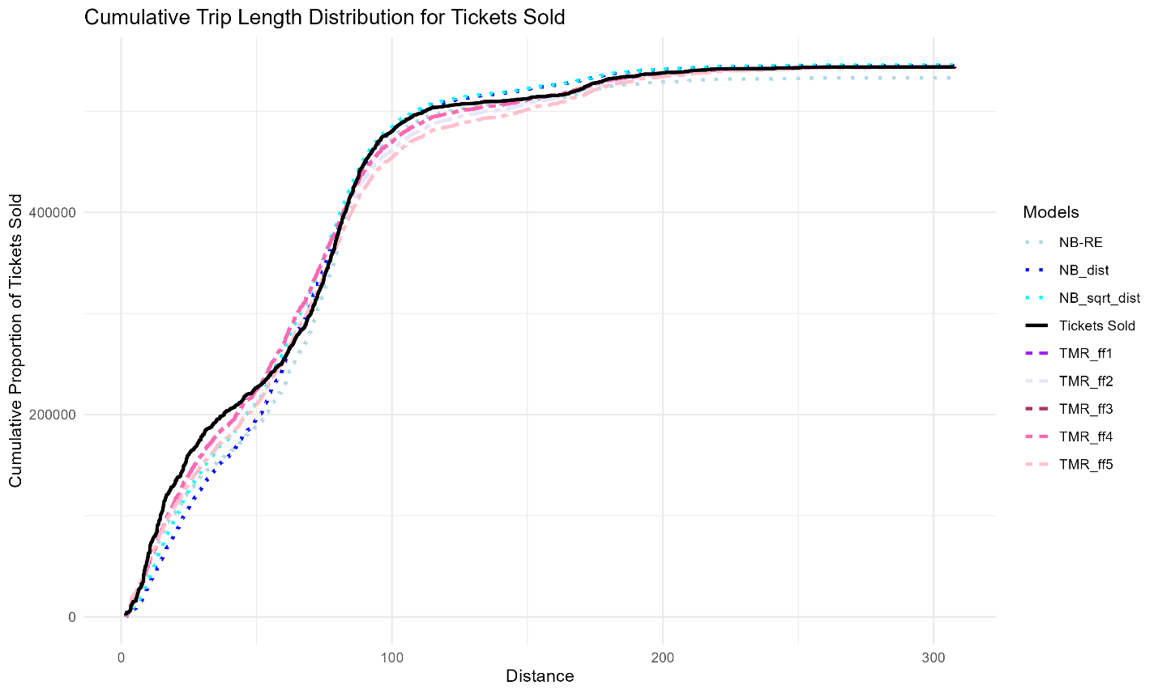
According to the plot, all models demonstrate a clear relationship between distance and ticket sales, indicating that the models are generally effective at capturing this trend. However, this approach has limitations. Specifically, it does not fully account for the variability in individual data points, meaning the models may not entirely capture the underlying processes driving ticket purchases.

Instead consider the plot below which shows the predicted tickets vs the actual tickets for each origin of zone area to destination venue.

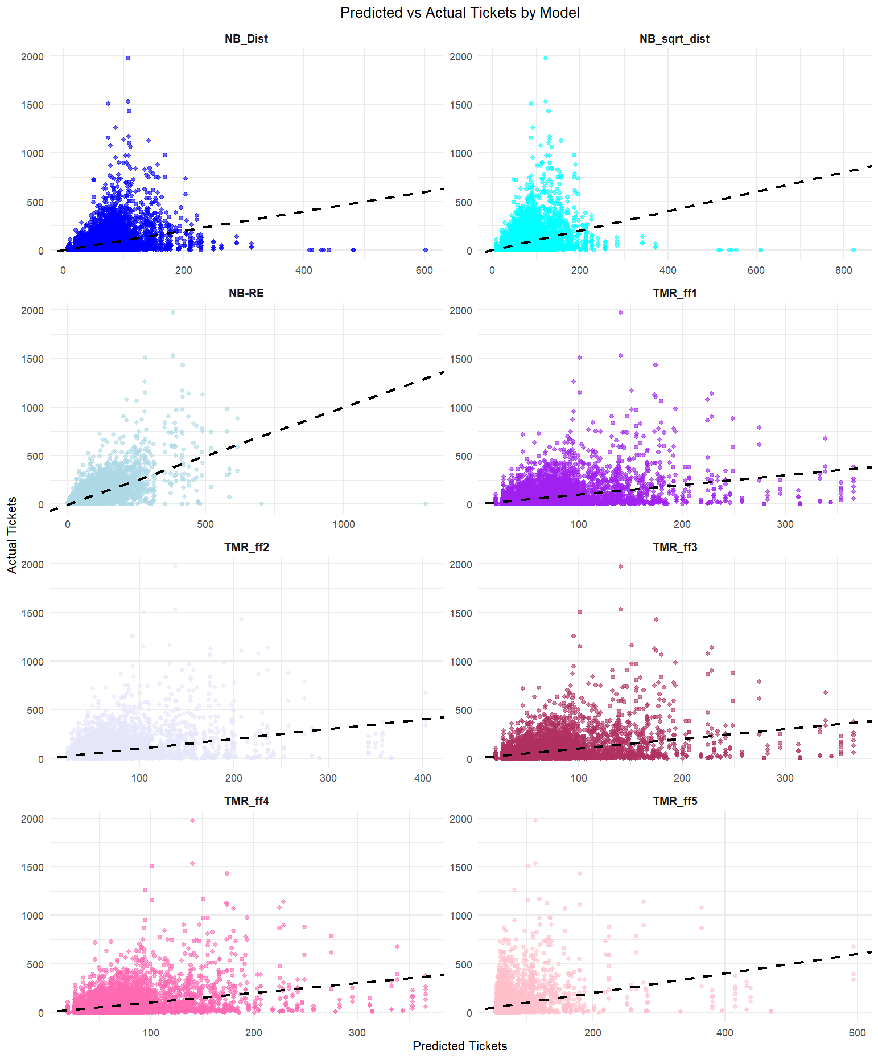

From the plots, we can observe that, on average, the TMR models struggle to predict higher ticket counts accurately. This is evident from the x-axis, where the highest predicted ticket count for TMR_ff5 is around 600 tickets. Additionally, TMR_ff5 makes a substantial number of predictions close to 0, even when the actual ticket values are significantly larger.
By examining the axes and trends across the plots, it becomes clear that the NB-RE model provides better predictions overall, particularly for higher ticket counts.

Here are the plots one by one:

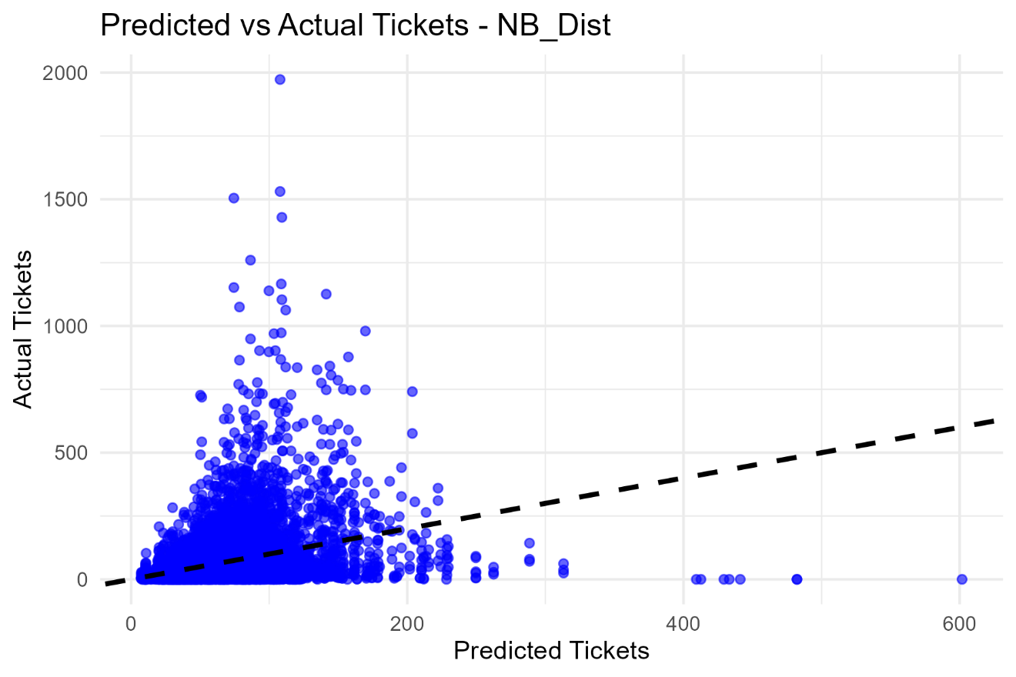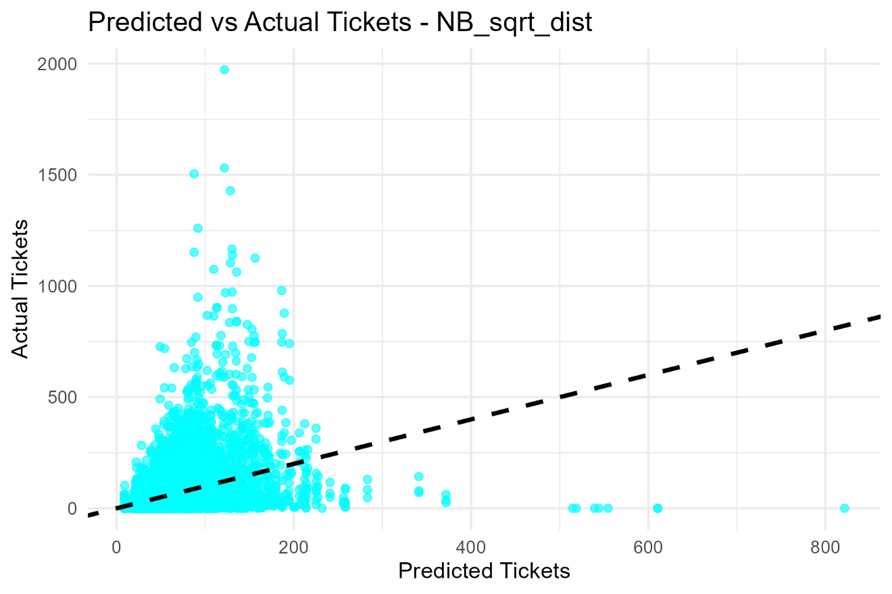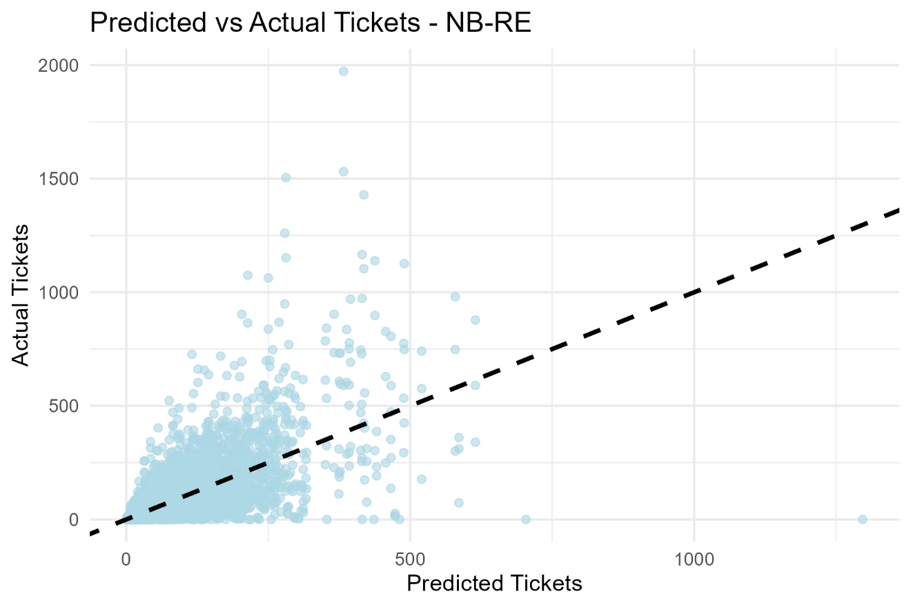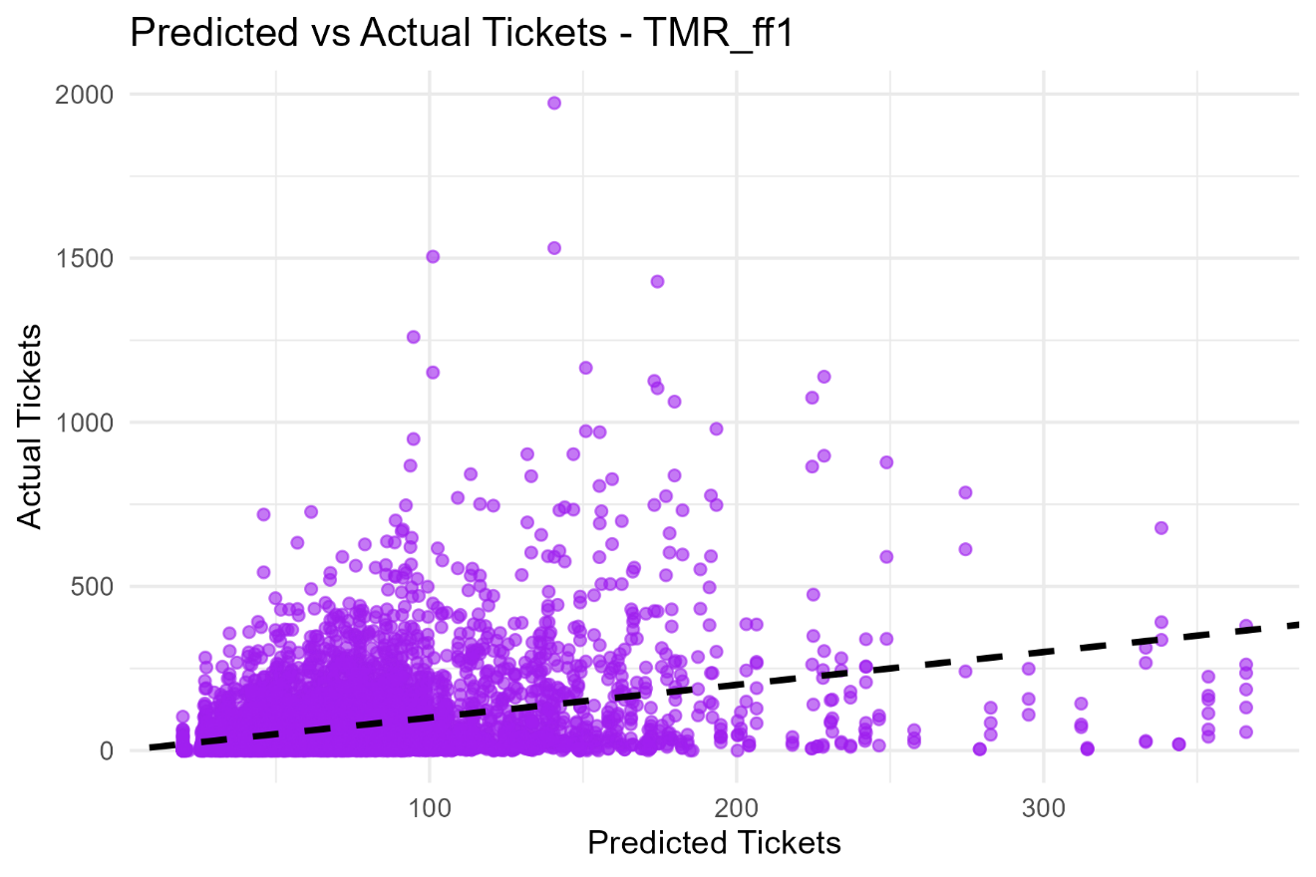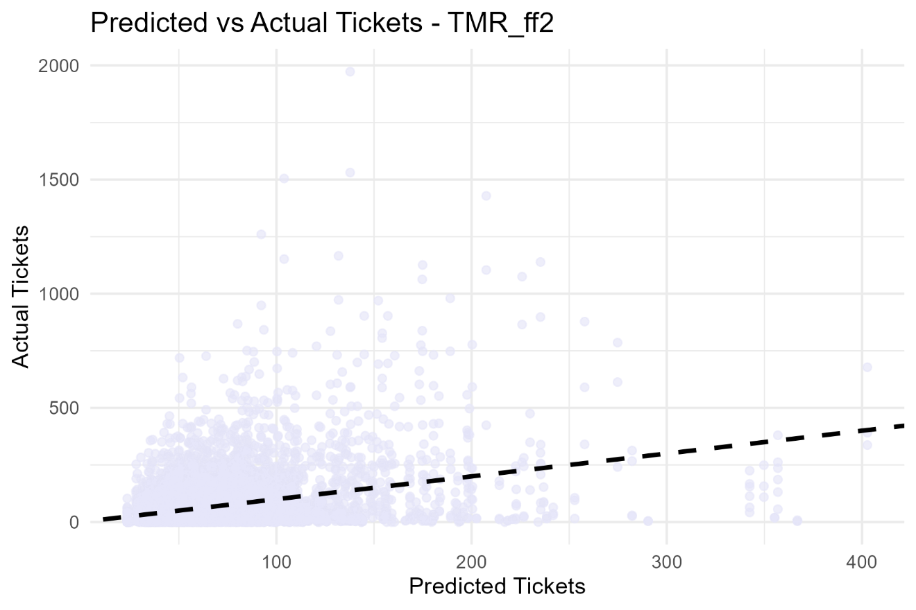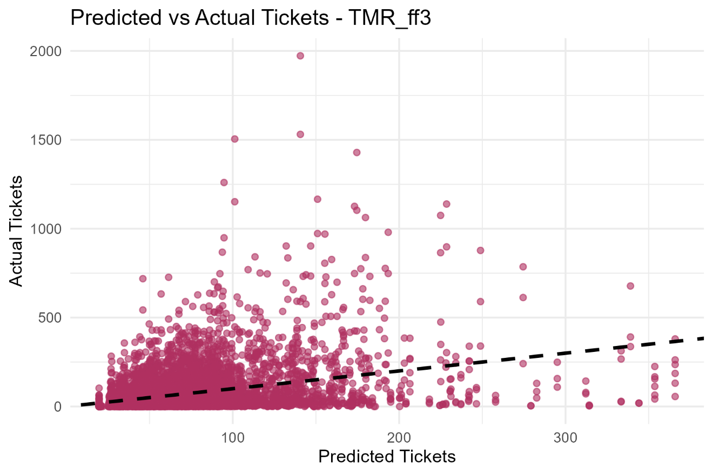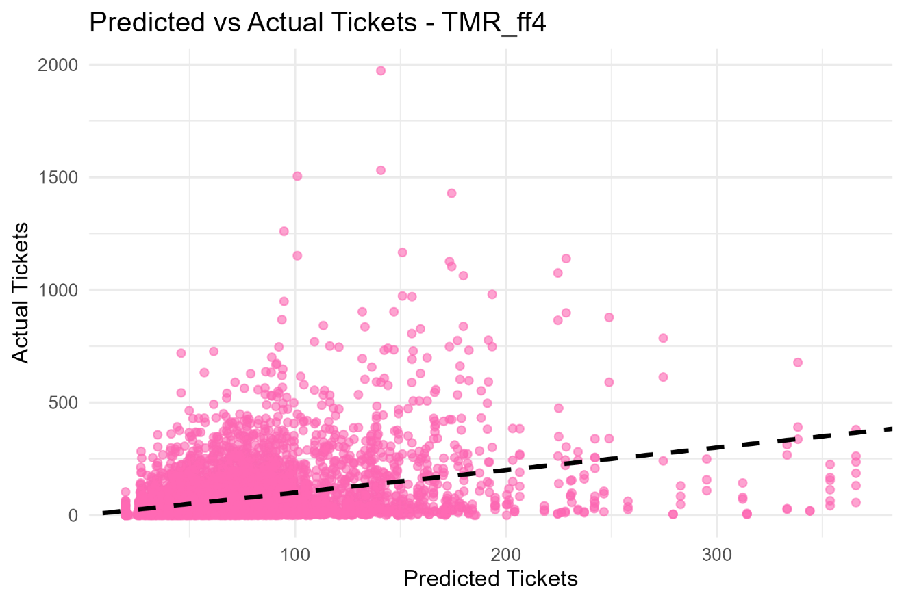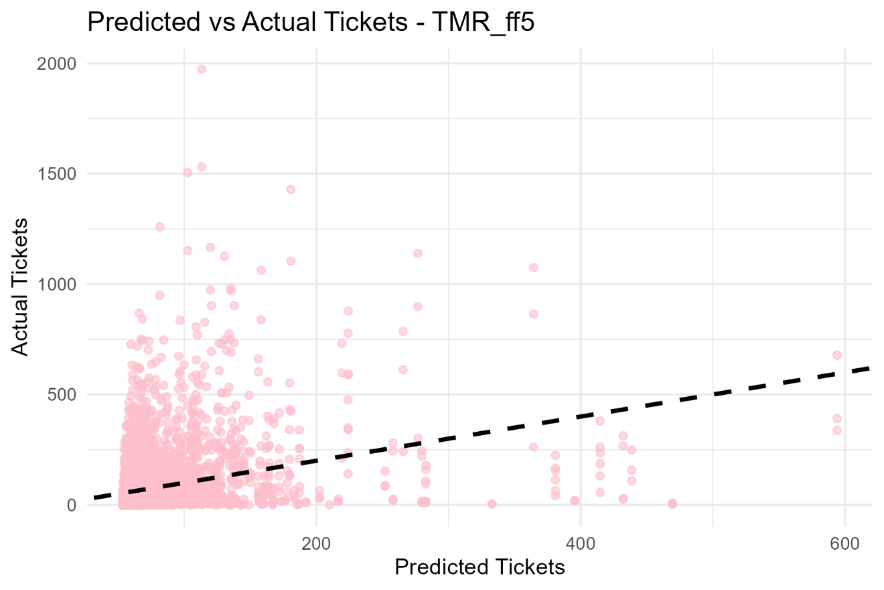

The fitted models exhibit distinct characteristics, with their coefficients presented in Table 2. A notable feature is the standard deviation of the venue-level random effect (sd(venue)) used in the random effects model (MM). This model accounts for unobserved heterogeneity across venues, recognizing that certain venues consistently attract more demand than others. By incorporating this random effect, the model captures variation in ticket sales that would otherwise require modeling each venue individually.
As a result, the random effects model outperforms the others in terms of predictive accuracy, as reflected in the lowest RMSE and highest log-likelihood values shown in Table 3. This suggests that the model generalizes well and avoids overfitting, lending credibility to the coefficient estimates reported.

Table 2: Comparison of Models
Proposed Models vs Report Models
Term | NB_dist | NB_sqrt_dist | NB-RE | TMR_ff1 | TMR_ff2 | TMR_ff3 | TMR_ff4 | TMR_ff5
(Intercept) | 2.84 | 3.21 | 3.00 | 1.97 × 10^1 | 2.36 × 10^1 | 1.96 × 10^1 | 1.97 × 10^1 | 5.36 × 10^1
Income | 1.26 × 10^-3 | 1.39 × 10^-3 | 1.35 × 10^-3 | NA | NA | NA | NA | NA
Distance | -5.93 × 10^-3 | NA | NA | NA | NA | NA | NA | NA
Pop | 6.07 × 10^-5 | 5.94 × 10^-5 | 5.89 × 10^-5 | NA | NA | NA | NA | NA
Functional form | NA | NA | NA | 3.81 × 10^-5 | 3.01 × 10^-2 | 3.81 × 10^-5 | 3.81 × 10^-5 | 6.00 × 10^-2
sd (Venue) | NA | NA | 1.10 | NA | NA | NA | NA | NA
sqrt(Distance) | NA | -1.15 × 10^-1 | -1.46 × 10^-1 | NA | NA | NA | NA | NA
Table 3: Model Metrics Table
Models Compared
Model | LogLik | RMSE
NB_Ddst | -39105.05 | 111.61829
NB_sqrt_dist | -39018.66 | 111.37609
NB-RE | -36433.64 | 85.69404
TMR_ff1 | -46546.91 | 108.19913
TMR_ff2 | -46596.07 | 108.89885
TMR_ff3 | -46546.75 | 108.19686
TMR_ff4 | -46546.75 | 108.19870
TMR_ff5 | -46687.36 | 110.21005

