**Elie Haouchan 220561**

Software Requirements Specification (SRS) document for the "Fitness App with Workout Diet & Motivation."

**1. Scope**

The fitness app "GoFit", is designed to provide users with a comprehensive platform for managing their fitness routines, nutrition plans, and motivation. It aims to help individuals of various fitness levels and goals track their progress, maintain a healthy diet, and stay motivated to achieve their fitness objectives.

**2. General Description**

**a. Target Audience**

GoFit is intended for:

- Fitness enthusiasts

- Beginners looking to start a fitness journey

- Individuals seeking personalized workout routines

- Users interested in maintaining a balanced diet

- People in need of motivation and support

**b. Objectives**

The primary objectives of GoFit are:

- To provide users with personalized workout plans and diet recommendations based on their goals and preferences.

- To help users track their fitness progress through data logging and analytics.

- To motivate users through reminders, achievements, and motivational content.

- To create a user-friendly and visually appealing interface for a seamless fitness experience.

**c. Constraints**

- Platform Compatibility: GoFit will be available on both Android and iOS devices.

- Data Privacy: The app must comply with data protection regulations to ensure user privacy.

- Limited Initial Content: The app will start with a limited workout library and diet recommendations, with plans to expand over time.

**3. Functional Requirements**

GoFit will include the following functional features:

- User Registration and Profile Management

- Personalized Workout Plans

- Nutrition Recommendations

- Progress Tracking

- Motivational Content

- Social Sharing

- Notifications and Reminders

- Feedback and Support

**4. Non-Functional Requirements**

Non-functional requirements include:

- Performance: The app should respond quickly to user interactions.

- Security: User data should be encrypted and protected.

- Usability: The interface should be intuitive and user-friendly.

- Availability: The app should be accessible 24/7 with minimal downtime.

- Scalability: The app should accommodate a growing user base and content library.

**5. Use Case Models (UML Diagrams)**

**Sequence Diagram (Login Case) :**

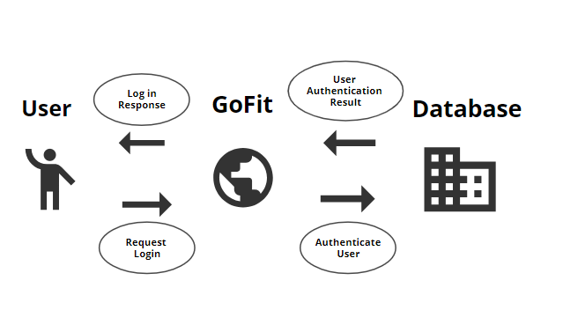

**Use Case Diagram :**

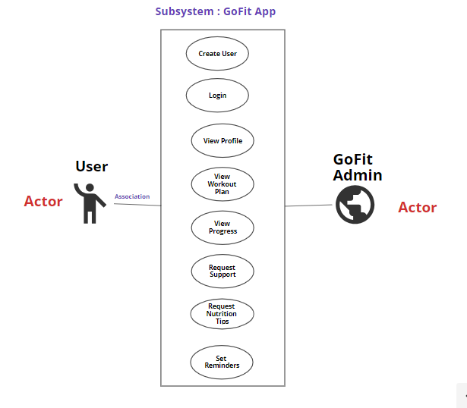

**6. Appendices**

**a. Definitions, Acronyms, Abbreviations**

-SRS: Software Requirements Specification

- UI: User Interface

- UX: User Experience

**b. References**

- [ISO/IEC 9126: Software Engineering - Product Quality](https://www.iso.org/standard/35733.html)

- [Data Protection Regulations](https://gdpr.eu/)

- [UML Documentation](https://www.omg.org/spec/UML/2.5/)