**Train Tracking and Arrival Time Prediction App - SRS Document**

**1. Scope**

This document outlines the requirements for the development of the "Train Tracking and Arrival Time Prediction" app. The app is designed to assist commuters in tracking train schedules and predicting arrival times at their designated stations.

**2. General Description**

**a. Target Audience**

The target audience for the app includes:

* Commuters who rely on trains for daily transportation.
* Train station staff responsible for managing train schedules.
* Travel enthusiasts interested in planning train journeys.

**b. Objectives**

The primary objectives of the app are as follows:

* Provide real-time train tracking information.
* Predict accurate train arrival times based on historical data and real-time updates.
* Offer a user-friendly interface for easy navigation and access to train information.
* Enhance the overall commuter experience by reducing uncertainty about train schedules.

**c. Constraints**

* Availability and accuracy of real-time train data from relevant authorities.
* Compatibility with various operating systems and mobile devices.
* Adherence to data privacy and security regulations.

**3. Functional Requirements**

The functional requirements of the app include:

* User registration and authentication.
* Search and selection of train routes and stations.
* Real-time tracking of trains on selected routes.
* Display of estimated train arrival times.
* Push notifications for delays or changes in train schedules.
* User feedback and rating system.
* Integration with external train data sources.

**4. Non-functional Requirements**

The non-functional requirements of the app include:

* Performance: The app should respond promptly and handle concurrent users efficiently.
* Security: User data and payment information should be encrypted and stored securely.
* Usability: The user interface should be intuitive and accessible to individuals with disabilities.
* Reliability: The app should maintain a high uptime and provide accurate information.
* Scalability: The system should be scalable to accommodate an increasing user base.
* Compatibility: The app should work seamlessly across various devices and platforms.

**5. Use Case Models**

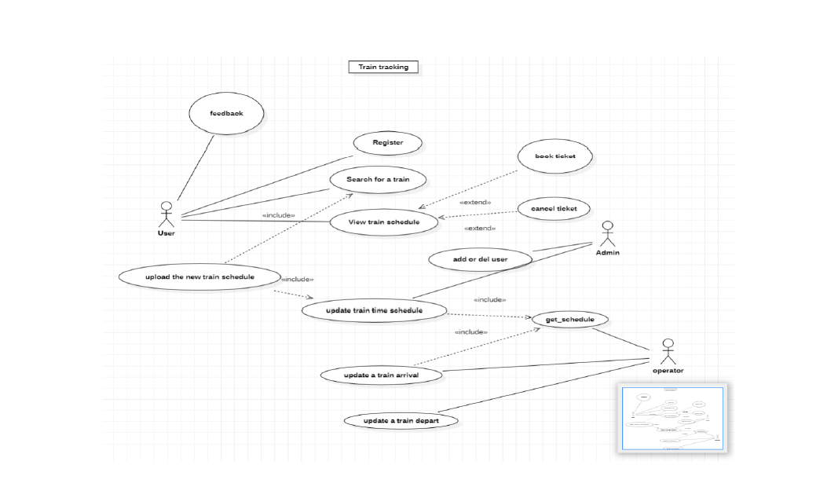

**6. Appendices**

**a. Definitions, Acronyms, Abbreviations**

* GPS: Global Positioning System
* API: Application Programming Interface
* UI: User Interface

**b. References**

* Train Authority API Documentation:

https://www.transitchicago.com/developers/ttdocs/

* Link to Data Privacy Policy:

https://engagerle.transitchicago.com/privacy