**Software Requirement Specification**

**Fitness App**

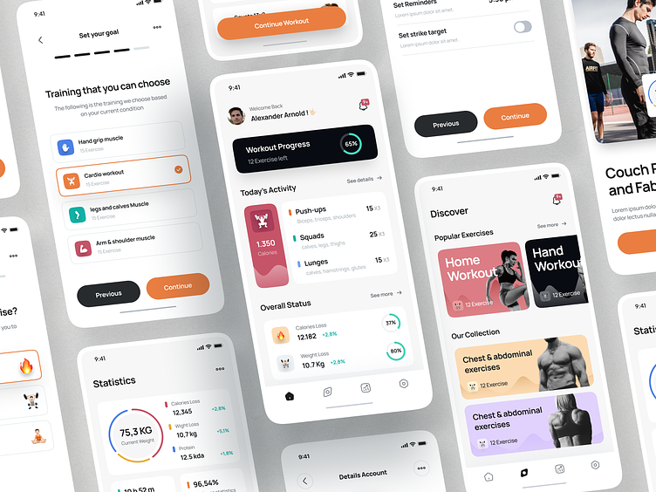

**Name:** Maria Hourani

**Matricule:** 222310

**Date:**22/09/2023

**Content:**

1. Scope

2. General description

a. Target audience

b. Objectives

c. Constraints

3. Functional requirements

4. Non-functional requirements

5. Use case models (diagrams using UML)

6. Appendices

a. Definitions, acronyms, abbreviations

b. References

**1.Scope :**

This Fitness App will provide a solution for individuals focused on enhancing their physical health and well-being. The app will primarily concentrates on workout training and tracking, Diet management and Motivation Features.

**2. General description:**

**a) Target audience:**

The target audience includes individuals seeking to improve their lifestyle and health, athletes and sport professionals

**b) Objectives:**

* Encourage Physical Activity, Motivate users to engage in regular physical activities, exercise routines, and workouts.
* Offer personalized workout plans based on the user’s goals
* Offer dietary recommendations and healthy recipes ideas.
* Facilitating users interaction by creating communities where users can discuss previous experiences and help each others.
* Helping beginners exercise by providing them instructional videos related to their specific workout routines

**c) Constraints:**

* The app must be compatible with iOS( version 12 and above) and Android(version 7 and above).
* Some features of the app requires Internet connectivity
* The app must integrate Google fit for health data syncing

**3. Functional requirements:**

* **User Authentication:** The users should be able to Login and Sign out whenever they want
* **User registration:** the user can sign up and will be asked to provide fitness goals and health information during sign up
* **Profile management:** Users should have the ability to edit their profiles, including fitness goals, personal details such as weight, their username and password
* **Search functionality:** Users should be able to search for specific exercises, recipes and communities
* **Notification:** The app should display notifications to remind users to complete workout plans, inform them about their progress or reminding them to add daily information such as calories count, exercises, or weight update
* **Workout and diet tracking section:** The app should have a progress tracking section allowing the user to add the exercises he did a day, the duration, number of sets, log meals and track calorie intake
* **Motivational feature section:** Containing athletes achievements, communities and motivational videos made by trainers I addition to daily motivational quotes
* **Workout plan and Diet plan suggestions:** The app should have a section for workout plans and diet suggestions based on the user’s interactions and user data

**4. Non Functional requirements:**

* **Availability :** The app must be available 24/7, whenever needed
* **Accessibility:** The UI must adhere to WCAG(web content accessibility guidelines) meaning it can be used by anyone even with people with disabilities including maintaining proper color contrast for color blind people with
* **Security:** Secure storage of user data and encrypted communication between users
* **Compability:** The app must be compatible with various mobile platforms, Android and IOS
* **Efficiency:** The app should provide smooth user interaction, quick load times and efficient use of system resources for optimal performance
* **Responsiveness:** The app should be fast loading, aiming for a maximum 2 seconds page load time after post-search and after clicking on app features
* **Failure transparency:** The app should ensure failure transparency by effectively managing errors and technical failures in a way users are not disrupted by these issues
* **Traceability:** Logging user interactions and errors for future improvement, If a failure occurs, the app should log these failures securely analysis so that the team can fix this error as soon as possible
* **Reliability:** Assurance of consistent and accurate system data including fitness plans and user information

**5.Use Case Models**

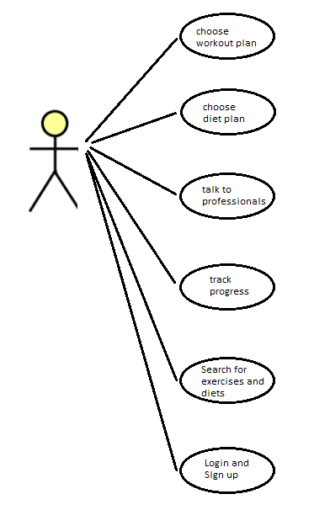

1. **Appendices**
   1. Definitions:

UI: User Interface

* 1. References:

Myfitnesspal app