|  |  |  |  |  |
| --- | --- | --- | --- | --- |
| MotivaFit | | | | |
|  |  | | |  |
| "Unleash Your Motivation, Ignite Your Fitness Journey!" | | | | |
|  | | SRS |  | |

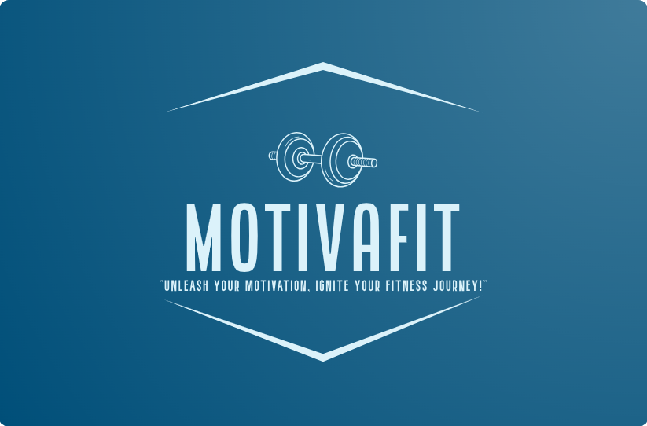

|  |  |  |
| --- | --- | --- |
| 7 Black Fitness Influencers You Should Be Following on Instagram - AskMen  The Difference Between Sculpting Male Abs vs. Female Abs  Woman Working Out at Gym Confronts Man Who Got Too Close in Video Viewed  Over 6M Times | |  | | --- | | TABLE OF CONTENTS |   1. Scope  2. General description   1. Target audience 2. Objectives 3. Constraints   3. Functional requirements  4. Non-functional requirements  5. Use case models  6 .Appendices   1. Definitions, acronyms, abbreviations 2. References |

|  |  |
| --- | --- |
| |  | | --- | | SCOPE | |



Motivafit is a mobile application designed to help users achieve their fitness goals in a healthy and personalized way. The app tracks weight, offers meal plans, calculates calorie intake, and provides a tailored fitness journey based on individual goals and body suitability. Additionally, Motivafit generates motivational quotes and messages to support users throughout their journey. The app can integrate with smart scales, and further features can be added. Key features of Motivafit include:

* Calendar: Users can set daily tasks and integrate workouts using the AI system's assistance.
* Meal Plans: Dietitian-created meal plans are provided based on goals and body measurements.
* Calorie Counter: The app calculates calorie intake based on entered meals.
* Body Composition Tracking: Users can track their progress with dietitians by recording body composition measurements obtained from smart scales.
* Motivational Cards: Users receive motivational notifications before meals or workouts, promoting self-love and personal growth.

Motivafit is available for both Android and iOS users.

|  |
| --- |
| GENERAL description |

1. **Target audience:**

Motivafit is designed for individuals from all fitness levels that have a comprehensive and personalized goals to achieve. It suits any plans including weight loss, maintenance, treating health issues (diabetes, hyper tension…). Whether users are beginners starting their fitness journey or experienced fitness enthusiasts looking to optimize their progress, Motivafit caters to their diverse needs.

1. **Objectives:**

The primary objective of Motivafit is to let the users embark on a sustainable fitness journey. By planning their meals and managing their workouts’ timings and quality, Motivafit makes fitness a part of the users’ every day lives. The application aims to provide a satisfactory fitness journey through the various features it offers: weight tracking, personalized meal planning, creating workout routines that correspond to the suitability of the user. Moreover Motivafit ensures to promote self-love, motivation and well-being in order to help the users achieve their fitness goals properly.

1. **Constraints:**

To ensure the app's usability, performance, and user experience, Motivafit runs within a set of technological and resource limitations. These restrictions might apply to features that need dependable internet connectivity, compatibility with mobile devices running the Android and iOS operating systems, and adherence to data privacy and security laws. A top-notch and user-friendly fitness app will be delivered by the development team while staying within the set budget and timeframe.

|  |
| --- |
| Functional requirements |

1. User registration:

* Users can create an account by providing necessary information like name, email, password.
* The app should validate and authenticate user credentials to ensure security.

1. Weight tracking:

* Users can track their weight by establishing a connection to compatible smart scales.
* The app should provide visual representation like charts, graphs and percentages.
* Users are able to see heir weight tracking over time in order to record their progress.

1. Meal plans:

* The app should offer personalized meal plans based on user goals and body measurements.
* Users can view and follow recommended meal plans made by featured dietitians, including recipes, ingredients, and portion sizes.

1. Calorie Counter:

* Users can enter their daily meals and the app should calculate and display the calorie intake.
* The app should have a comprehensive database of food items with nutritional information for accurate calorie calculations.

1. Fitness Workouts:

* The app should provide a library of workout routines and exercises for different fitness levels and goals.
* Users can select and follow workout plans, with detailed instructions and video demonstrations for each exercise.
* The app has integrated bots* that crawl though Instagram and YouTube to recommend personalized fitness-related content based on user preferences and goals.
* The app's AI* system should analyze the user's weekly schedule and provide recommendations for integrating workout days based on their availability and preferences

1. Motivational cards:

* Users will be able to get as a notification before a meal or a workout a motivational message in order to fulfill one of the main principles of Motivafit : well-being, motivation and self-love.

|  |
| --- |
| Non-functional requirements |

1. Performance:
   * The app should respond quickly to user interactions, minimizing loading times and delays.
   * It should handle a large number of users simultaneously without compromising performance.
   * The AI system should efficiently analyze the user's weekly schedule and provide timely recommendations for integrating workout days.
   * The app should ensure that the AI system's processing and response times are optimized to deliver recommendations in a prompt manner.
2. Usability:
   * The user interface should be intuitive, visually appealing, and easy to navigate.
   * The app should provide clear instructions and guidance to help users understand and utilize its features effectively.
3. Security:

* User data, including personal information and progress tracking, should be stored securely.
* The app should implement authentication and authorization mechanisms to protect user accounts.

1. Compatibility:
   * The app should be compatible with a wide range of mobile devices running Android and iOS operating systems.
   * It should adapt to different screen sizes and resolutions, providing a consistent user experience across devices.
2. Interoperability:
   * The app should demonstrate interoperability by integrating with popular platforms such as Instagram and YouTube.
   * It should seamlessly connect to these platforms, allowing users to access fitness-related content and resources from within the app.
   * The app should ensure smooth data exchange and interaction between the Motivafit app and the integrated platforms, providing a cohesive user experience.

|  |
| --- |
| Use case models |

use case model 1:

**Login / sign up to Motivafit**

user

**Navigate through workout plans and get added recommendation from Instagram and YouTube.**

**Set up everyday life schedule.(AI* system automatically integrates workouts)**

use case model 2:

**Login / sign up to Motivafit**

user

<<include>>

<<include>>

**Graphs and charts are generated related to the user’s body composition.**

<<include>>

**Automatic calorie intake calculation.**

**Checking history chart in order to track progress.**

**Entering goal and getting personalized meal plans.**

**Enter body measurements and gets on the scale.**

use case model 3:

user

**Login / sign up to Motivafit**

**Enters meal / ingredients.**

graphical

<<include>>

**Display remaining calorie intake for the day.**

<<include>>

**Calorie calculation and meal composition. (fat, proteins, carbs).**

Appendix:

|  |  |
| --- | --- |
| Word | Definition |
| AI | Artificial Intelligence |
| Bots | A bot is a computer program that can do things automatically without needing a person to control it. It can perform tasks, talk to users, or interact with other programs. Bots can be simple or smart, and they can work on different platforms like websites, messaging apps, or social media. |

References:

-<https://creately.com/diagram/example/iol4au2l1/fitness-tracker-use-case-diagram-simplified-classic>

-<https://opengeekslab.com/blog/create-a-fitness-app/>

-<https://online.visual-paradigm.com/diagrams/templates/use-case-diagram/fitness-tracking-app-/>

-https://enou.co/blog/how-to-create-a-fitness-app/