SRS-OES (Online Election System)

1. Scope:

This document outlines the requirements for the Online Election System (OES) app. The app aims to provide a secure and convenient platform for conducting elections online.

2. General Description:

a. Target Audience:

The OES app is designed for the following target audience:

Eligible voters.

Election administrators and officials.

Election candidates and campaign teams.

System administrators responsible for maintaining and securing the platform.

b. Objectives:

The main objectives of the OES app are as follows:

Enable eligible voters to cast their votes securely online.

Provide election administrators with tools for managing candidate registrations, voter rolls, and election processes.

Ensure the integrity, security, and transparency of the election process.

Enhance accessibility and convenience for voters.

c. Constraints:

Compliance with relevant election laws and regulations.

Security measures to prevent unauthorized access and tampering.

Scalability to handle a large number of voters and candidates.

3. Functional Requirements:

The OES app should include the following functionalities:

Voter registration and authentication.

Candidate registration and verification.

Ballot creation and management.

Secure online voting with authentication and encryption.

Real-time election monitoring and reporting.

Accessibility features for voters with disabilities.

Results tabulation and announcement.

4. Non-functional Requirements:

Security: The system must employ strong security measures to prevent fraud, tampering, and unauthorized access.

Scalability: The platform should handle a large number of concurrent users during peak voting times.

Usability: The user interface must be user-friendly and accessible to all voters.

Reliability: The system should be available and reliable throughout the election period.

Compliance: The system must adhere to election laws and regulations.

5. Use Case Models (Diagrams using UML):

Use Case Diagram:

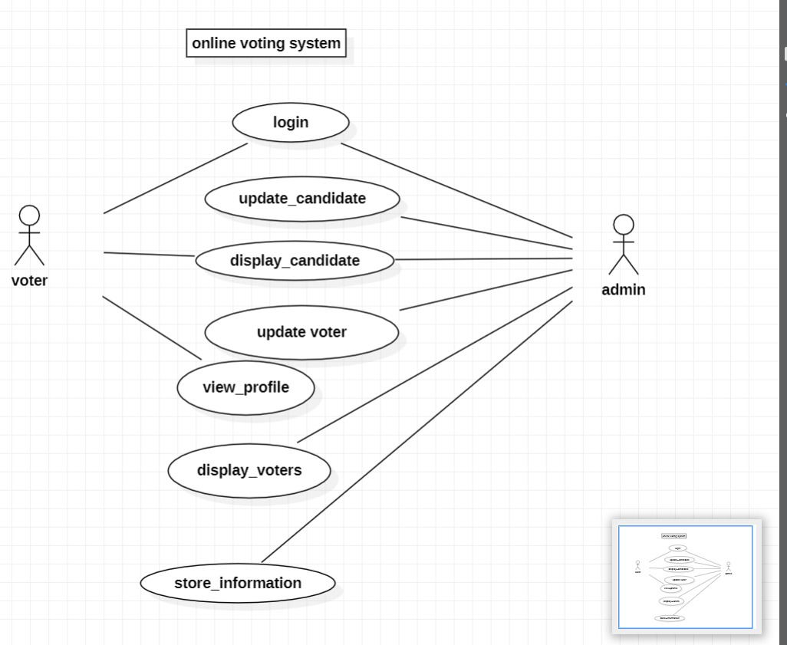

6. Appendices:

a. Definitions, Acronyms, Abbreviations:

OES: Online Election System

UML: Unified Modeling Language

b. References:

<https://www.bing.com/ck/a?!&&p=50d3223909ef4c62JmltdHM9MTY5NTUxMzYwMCZpZ3VpZD0yZTA4ZmE3YS0zNTljLTZmNmEtMmI2ZS1lODFiMzQ0MTZlN2ImaW5zaWQ9NTIyMw&ptn=3&hsh=3&fclid=2e08fa7a-359c-6f6a-2b6e-e81b34416e7b&psq=online+voting+system&u=a1aHR0cHM6Ly93d3cuZWJhbGxvdC5jb20vdm90ZXMtYW5kLWVsZWN0aW9ucy93aGF0LWlzLWFuLW9ubGluZS12b3Rpbmctc3lzdGVt&ntb=1>