**SRS Document: Hussein El Hajj:**

**1- Scope:**

This document outlines the requirements for the development of an Online Election System. The system aims to facilitate the process of conducting elections online, ensuring a secure, transparent, and efficient voting mechanism.

**2- General Description:**

**a. Target Audience:**

The target audience for this system includes election organizers, candidates, and eligible voters.

**b. Objectives:**

The main objectives of the system are:

* Enable secure online voting.
* Provide a transparent and auditable election process.
* Automate the tallying of votes.
* Generate real-time election results.

**c. Constraints:**

* The system will be developed as a mobile application using Flutter for the front-end.
* Firebase will be used for the backend and database services.
* The system should be accessible through Android and iOS devices.
* The system should be accessible through common web browsers like Chrome, Edge etc...

**3- Functional Requirements:**

**1- User Authentication:**

- Voters and election organizers should be able to log in with unique credentials.

**2- Voter Registration:**

- Eligible voters should be able to register for elections.

**3- Ballot Creation:**

-Election organizers should be able to create ballots with candidate names and positions.

**4- Voting:**

-Voters should be able to cast their votes securely.

**5- Vote Tallying:**

-The system should automatically tally votes and update them in real-time.

**6. Results Publication:**

-Publish election results after the voting period is over.

**7- Audit Trails:**

-Maintain a secure and transparent record of all voting activities.

**8. Notifications:**

-Send notifications to voters about election dates, voting status, and results.

**4-Non-Functional Requirements:**

**1- Performance**

The system should respond quickly to user interactions, even during high traffic.

**2- Security**

Implement robust security measures to protect sensitive voter data and ensure the integrity of the election.

**3- Usability**

The user interface (UI), built with Flutter, should be intuitive and user-friendly.

**4- Scalability**

The system should be scalable to accommodate a large number of voters and simultaneous elections.

**5- Reliability**

Ensure high uptime and data integrity.

**6- Compatibility**

The app should be compatible with both Android and iOS devices.

**7- Accessibility**

The system should be designed to be accessible to users with disabilities, complying with relevant accessibility standards such as the Web Content Accessibility Guidelines (WCAG). Features like screen reader support, high-contrast themes, and easy navigation should be incorporated.

**8- Auditability**

The system should maintain comprehensive logs and audit trails for all activities, including but not limited to voter registration, ballot creation, and vote tallying. This will facilitate any future investigations or audits and ensure the transparency and accountability of the electoral process.

**5- Use case models (diagrams using UML):**

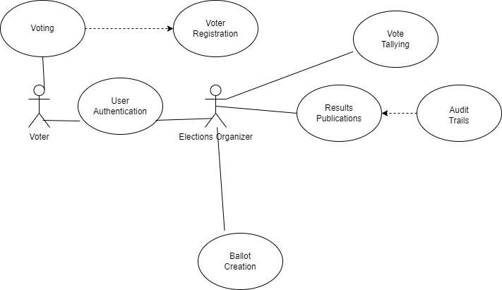

**6- Appendices:**

**a. Definitions, Acronyms, Abbreviations:**

1- SRS: Software Requirements Specification

2- UML: Unified Modeling Language

3- UI: User Interface

**b. References:**

1- Flutter: SDK used for building natively compiled applications.

2- Firebase: Backend and database service.

2- Draw.io: Diagramming and visual representation tool used for creating UML diagrams, which I used to make the diagram in this document.