**SRS Document: Jalal Harb:**

**1-Scope:**

The following document outlines the requirements for the development of a Restaurant Employees Tips Giver and Calculator system. The system aims to facilitate the calculation and distribution of tips among restaurant employees, making it hassle-free.

**2-General Description:**

**a. Target Audience**

The target audience for this system includes restaurant managers and staff members responsible for tip distribution.

**b. Objectives**

The main objectives of the system are as follows:

* Automate the calculation of tips based on predefined rules.
* Allow the manager to input tip-related data.
* Distribute tips among employees according to a fair and predefined distribution mechanism.
* Generate reports for tracking and auditing tip distributions.

**c. Constraints**

* The system will be developed as a web application using React for the front-end user interface.
* Next.js will be used for the backend of the web application.
* It will utilize a relational database which is PostgreSQL for secure storage of employee and tip-related data.
* The system should be accessible through common web browsers like Chrome, Edge etc...

**3-Functional Requirements:**

**The system should include the following functionalities:**

**1- User Authentication:**

Managers and staff members should be able to log in with unique credentials.

**2- Tip Calculation:**

Allow managers to input tip amounts and relevant data (e.g., sales figures).

Automatically calculate individual employee tips based on predefined rules (e.g., percentage of sales, hours worked).

**3- Tip Distribution:**

Implement a fair distribution mechanism to allocate tips among employees.

**4- Reporting:**

Generate reports showing tip calculations and distributions for auditing purposes.

**5- Data Storage:**

Store employee data securely in a relational database and maintain a record of all tip-related transactions.

**6- Employee Profile Management:**

Employees should be able to create and maintain their profiles, including personal information and contact details.

Managers should have the ability to edit employee profiles and assign roles and responsibilities.

**7- Tip Adjustment:**

Managers should be able to make manual adjustments to individual employee tips if necessary.

**8- Tip Distribution Notifications:**

The system should send notifications to employees when tips are distributed to their accounts.

Notifications should include the amount received and any adjustments made.

**4-Non-Functional Requirements:**

**1- Performance:**

The system, built with React and Next.js, should respond quickly to user requests, even during peak hours.

**2- Security:**

Implement proper security measures to protect sensitive employee and financial data.

**3- Usability:**

The user interface (UI), built with React, should be intuitive and user-friendly.

**4- Scalability:**

The system should be able to handle an increasing number of employees and transactions.

**5- Reliability:**

Ensure high uptime and data integrity.

**6- Compatibility:**

Support major web browsers and devices.

**4-Use case models (diagrams using UML):**

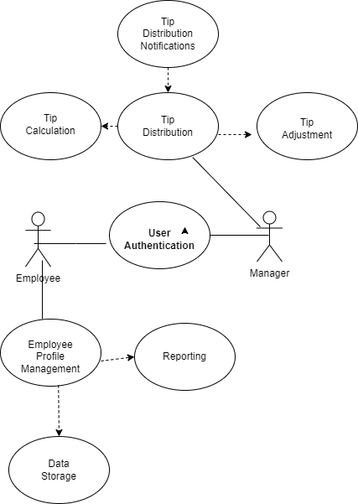

**6- Appendices:**

**Definitions, Acronyms, Abbreviations:**

SRS: Software Requirements Specification

UML: Unified Modeling Language

**References:**

Draw.io: Diagramming and visual representation tool used for creating UML diagrams and system illustrations.