# Fitness App with Workout, Diet & Motivation

## Table of Contents

1. Scope
2. General Description

a. Target Audience

b. Objectives

c. Constraints

1. Functional Requirements
2. Non-Functional Requirements
3. Use Case Models
4. Appendices

a. Definitions, Acronyms, Abbreviations

b. References

## 1. Scope

The purpose of this Software Requirements Specification (SRS) document is to present a detailed overview of the characteristics, functionalities, and specifications for a Fitness App created to serve as a comprehensive platform for individuals seeking to enhance their physical and mental health. The application will provide a diverse array of features, encompassing personalized exercise regimens, customized dietary plans based on individual nutritional requirements, and an inspirational content repository to encourage users in attaining their fitness objectives. The application is envisioned as a all-encompassing solution for fitness enthusiasts, offering a holistic approach to well-being by integrating physical activity, nutritional guidance, and mental motivation.

## 2. General Description

### a. Target Audience

* **Individuals aged 18-60**: This age group is often the most active and interested in fitness and well-being. The app aims to cater to both young adults who may be entering the fitness world for the first time, as well as older adults who are looking to maintain a healthy lifestyle.
* **Fitness enthusiasts**: These are individuals who already have a regular fitness routine and are looking to optimize their workouts and diets. The app will provide advanced features to meet their needs.
* **People looking to lose weight or gain muscle**: The app will offer specialized workout and diet plans aimed at weight loss or muscle gain, providing measurable goals and tracking to ensure progress.
* **Individuals seeking mental well-being**: In addition to physical fitness, the app will offer features like meditation guides, stress relief exercises, and motivational content to help improve mental health.

### b. Objectives

### To provide a variety of workout routines tailored to individual needs: The app will feature a wide range of workout routines that can be customized based on the user's fitness level, goals, and preferences. From cardio and strength training to yoga and Pilates, the app aims to offer something for everyone.

### To offer diet plans that complement the workout routines: Understanding that nutrition is a critical part of fitness, the app will provide diet plans that are designed to complement the user's workout routine. These plans will be customizable and will take into account dietary restrictions and nutritional needs.

### To deliver motivational content to keep users engaged: The app will feature a daily feed of motivational quotes, success stories, and tips to keep users inspired and focused on their fitness journey. The content will be curated to match the user's specific goals and interests.

### c. Constraints

* **Limited to mobile platforms (iOS and Android)**: The app is designed to be mobile-first, focusing on providing a seamless experience on smartphones. This constraint limits the app's availability to iOS and Android platforms, excluding desktop and web-based access.
* **Requires internet connectivity for some features**: While basic functionalities like tracking workouts and viewing diet plans can be accessed offline, certain features like updating progress, social sharing, and accessing the motivational content library will require an active internet connection.
* **Subject to app store policies**: The app must adhere to the guidelines and policies set forth by the respective app stores (Apple App Store for iOS and Google Play Store for Android). This may include limitations on content, user data handling, and in-app purchases.

## 3. Functional Requirements

1. User Authentication
   * Users must be able to sign in and sign out.
   * Support for social media login.
2. Profile Customization
   * Users should be able to set fitness goals.
   * Option to upload profile pictures.
3. Workout Routine Selection
   * Various categories of workouts.
   * Customizable workout plans.
4. Diet Plan Recommendations
   * Diet plans based on user's dietary restrictions.
   * Calorie tracking feature.
5. Motivational Content Feed
   * Daily motivational quotes.
   * Success stories from other users.
6. Progress Tracking
   * Track weight and other body measurements.
   * Graphical representation of progress.
7. Social Sharing
   * Share progress on social media platforms.

## 4. Non-Functional Requirements

1. User-friendly Interface
   * Easy navigation.
   * Quick access to all features.
2. Quick Load Time
   * App should load within 3 seconds.
3. Data Security
   * All user data must be encrypted.
4. Offline Availability for some features
   * Some features should be accessible offline.
5. Multi-language Support
   * Support for multiple languages.

## 5. Use Case Models

1. User Authentication

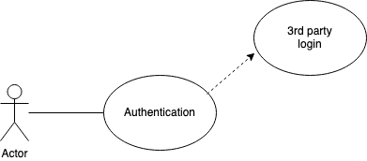

2. Profile Customization

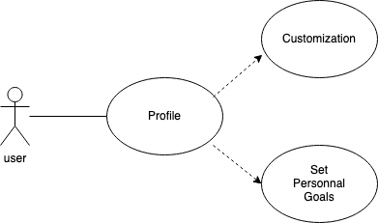

3. Workout Routine Selection

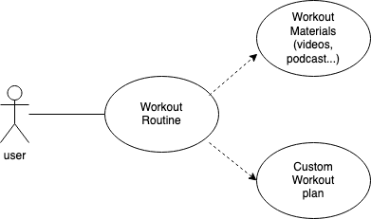

4. Diet Plan Recommendations

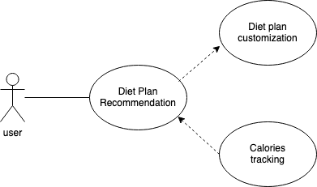

5. Motivational Content Feed

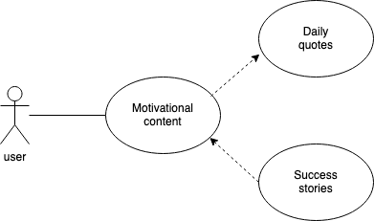

1. Progress Tracking

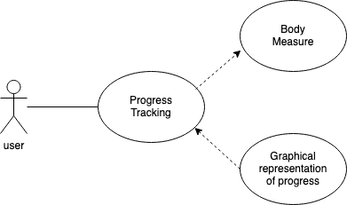

## 6. Appendices

### a. Definitions, Acronyms, Abbreviations

* UI: User Interface
* API: Application Programming Interface

### b. References

* [Fitness Guidelines by WHO](https://www.who.int/)
* [Nutritional Standards](https://www.fda.gov/)