**Open Shortest Path First (OSPF)**

**OSPF**

The **Open Shortest Path First (OSPF) protocol** is an intra-domain routing protocol based on link state routing. Its domain is also an autonomous system.

**Areas**

To handle routing efficiently and in a timely manner, OSPF divides an autonomous system into areas. An **area** is a collection of networks, hosts, and routers all contained within an autonomous system. An autonomous system can be divided into many different areas. All networks inside an area must be connected.

Routers inside an area flood the area with routing information. At the border of an area, special routers called **area border routers** summarize the information about the area and send it to other areas. Among the areas inside an autonomous system is a special area called the *backbone;* all of the areas inside an autonomous system must be connected to the backbone. In other words, the backbone serves as a primary area and the other areas as secondary areas. This does not mean that the routers within areas cannot be connected to each other, however. The routers inside the backbone are called the ***backbone routers*.** Note that a backbone router can also be an area border router.

If, because of some problem, the connectivity between a backbone and an area is broken, a **virtual link** between routers must be created by the administration to allow continuity of the functions of the backbone as the primary area. Each area has an area identification. The area identification of the backbone is zero. Figure 1 shows an autonomous system and its areas.

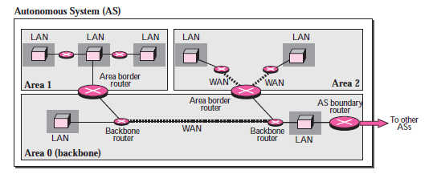

Figure -1

**Types of Links**

In OSPF terminology, a connection is called a *link*. Four types of links have been defined: point-to-point, transient, stub, and virtual

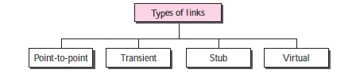

**Point-to-Point Link**

A **point-to-point link** connects two routers without any other host or router in between. In other words, the purpose of the link (network) is just to connect the two routers. An example of this type of link is two routers connected by a telephone line or a T-line. There is no need to assign a network address to this type of link. Graphically, the routers are represented by nodes, and the link is represented by a bidirectional edge connecting the nodes. The metrics, which are usually the same, are shown at the two ends, one for each direction. In other words, each router has only one neighbor at the other side of the link (fig-2)



Figure-2

**Transient Link**

A **transient link** is a network with several routers attached to it. The data can enter through any of the routers and leave through any router. All LANs and some WANs with two or more routers are of this type. In this case, each router has many neighbors. For example, consider the Ethernet in Figure 3a. Router A has routers B, C, D, and E as neighbors. Router B has routers A, C, D, and E as neighbors. If we want to show the neighborhood relationship in this situation, we have the graph shown in Figure 3.

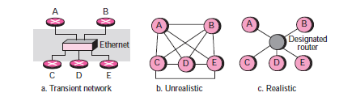

Figure -3

This is neither efficient nor realistic. It is not efficient because each router needs to advertise the neighborhood to four other routers, for a total of 20 advertisements. It is not realistic, because there is no single network (link) between each pair of routers; there is only one network that serves as a crossroad between all five routers.

To show that each router is connected to every other router through one single network, the network itself is represented by a node. However, because a network is not a machine, it cannot function as a router. One of the routers in the network takes this responsibility. It is assigned a dual purpose; it is a true router and a designated router. We can use the topology shown in Figure 3c to show the connections of a transient network.

Now each router has only one neighbor, the designated router (network). On the other hand, the designated router (the network) has five neighbors. We see that the number of neighbor announcements is reduced from 20 to 10. Still, the link is represented as a bidirectional edge between the nodes. However, while there is a metric from each node to the designated router, there is no metric from the designated router to any other node. The reason is that the designated router represents the network. We can only assign a cost to a packet that is passing through the network. We cannot charge for this twice. When a packet enters a network, we assign a cost; when a packet leaves the network to go to the router, there is no charge.

**Stub Link**

A **stub link** is a network that is connected to only one router. The data packets enter the network through this single router and leave the network through this same router. This is a special case of the transient network. We can show this situation using the router as a node and using the designated router for the network. However, the link is only one directional, from the router to the network (see Figure 4).

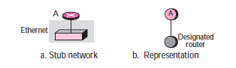

Figure-4

**Virtual Link**

When the link between two routers is broken, the administration may create a **virtual link** between them using a longer path that probably goes through several routers.

**OSPF Packets**

OSPF uses five different types of packets: *hello, database description, link state request, link state update,* and *link state acknowledgment* (fig 5). The most important one is the link state update that itself has five different kinds.

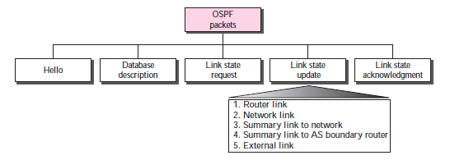

Figure -5

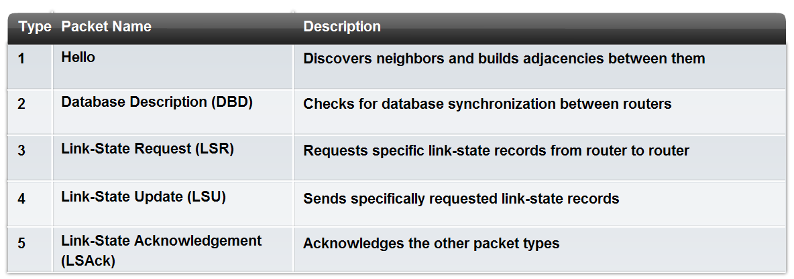

**OSPF Header**

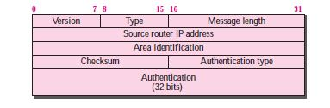

All OSPF packets have the same common header. Before studying the different types of packets, let us talk about this common header.

❑ **Version.** This 8-bit field defines the version of the OSPF protocol. It is currently version 2.

❑ **Type.** This 8-bit field defines the type of the packet. As we said before, we have five types, with values 1 to 5 defining the types.

❑ **Message length.** This 16-bit field defines the length of the total message including the header.

❑ **Source router IP address.** This 32-bit field defines the IP address of the router that sends the packet.

❑ **Area identification.** This 32-bit field defines the area within which the routing takes place.

❑ **Checksum.** This field is used for error detection on the entire packet excluding the authentication type and authentication data field.

❑ **Authentication type.** This 16-bit field defines the authentication protocol used in this area. At this time, two types of authentication are defined: 0 for none and 1 for password.

❑ **Authentication.** This 64-bit field is the actual value of the authentication data. In the future, when more authentication types are defined, this field will contain the result of the authentication calculation. For now, if the authentication type is 0, this field is filled with 0s. If the type is 1, this field carries an eight-character password.