Scenario

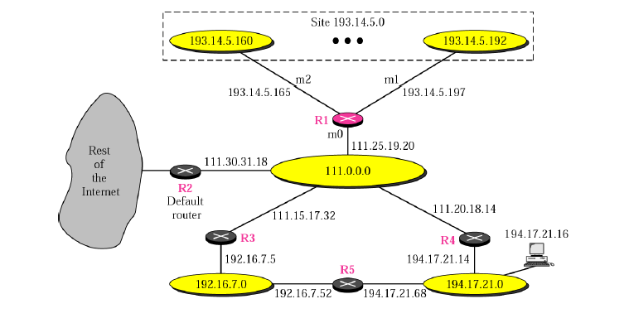

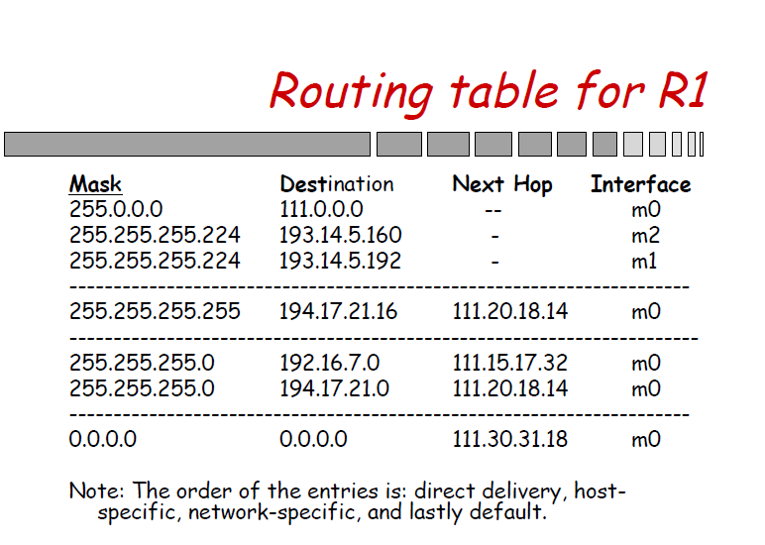

**Broadcast Domain**

A [broadcast](http://www.omnisecu.com/cisco-certified-network-associate-ccna/unicast-multicast-broadcast.php) domain consists of all the devices that will receive any broadcast packet originating from any device within the network segment.

Broadcast is a required type of communication and we cannot avoid Broadcasts, because many protocols (Example: [ARP](http://www.omnisecu.com/tcpip/address-resolution-protocol-arp.php) and [DHCP](http://www.omnisecu.com/tcpip/dhcp-dynamic-host-configuration-protocol-how-dhcp-works.php)) and applications are dependent on Broadcast to function.

**Collision Domain**

Collision domain is a section of a network where data packet can collide with each other when being sent on a sheared medium.

Collision domain occurs when more than one device attempts to send packet on a network segment at the same time.

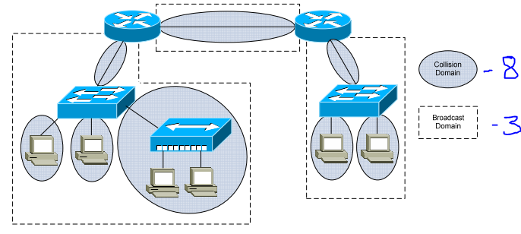

* Hub has only one collision domain
* Switch (24 ports) will have 24 collision domains
* Router- Each port of the router will be in different collision domain
* Hub has only one broadcast domain
* Switch has only one broadcast domain
* Router- Each port of the router will be in different broadcast domain