

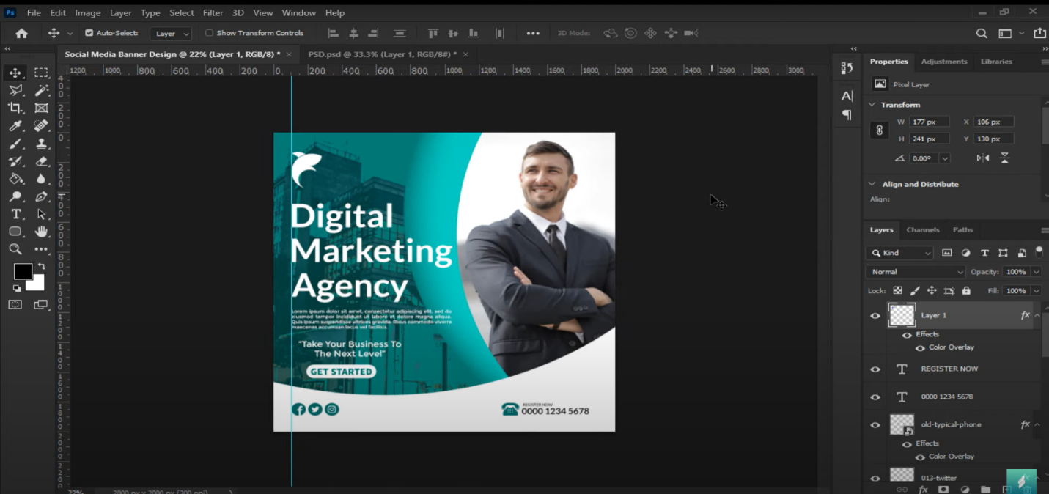

**Document Setup:**

* **Go to File > New and choose a magazine format size, typically A4 (8.27 x 11.69 inches).**
* **Set the resolution to 300 DPI for print quality.**
* **Ensure the color mode is set to CMYK for printing.**

**Adjust Layout:**

* **You can use the elements from your current design. Drag and resize them into the new A4 document.**
* **Ensure the design elements like the text, logo, and images are arranged in a way that suits a magazine layout, keeping margins for readability.**

**Typography:**

* **Consider adjusting the font size and line spacing for better readability in a magazine format. Headlines should be larger, and body text smaller, ensuring legibility.**

**Image Quality:**

* **Make sure the image of the man and any other graphics are high resolution to avoid pixelation when printed.**

**Additional Content:**

* **Depending on the magazine's length, you may need to add more text or images, especially for any articles or features.**

**Bleed and Margins:**

* **If you're printing the magazine, add a bleed area (usually 0.125 inches) to allow for trimming. Set this up when creating the new document or adjust it in Image > Canvas Size.**

**Export:**

* **Export the final design as a PDF for printing by going to File > Save As, and selecting PDF. Ensure to check the "Preserve Photoshop Editing Capabilities" box and embed fonts for the highest quality.**



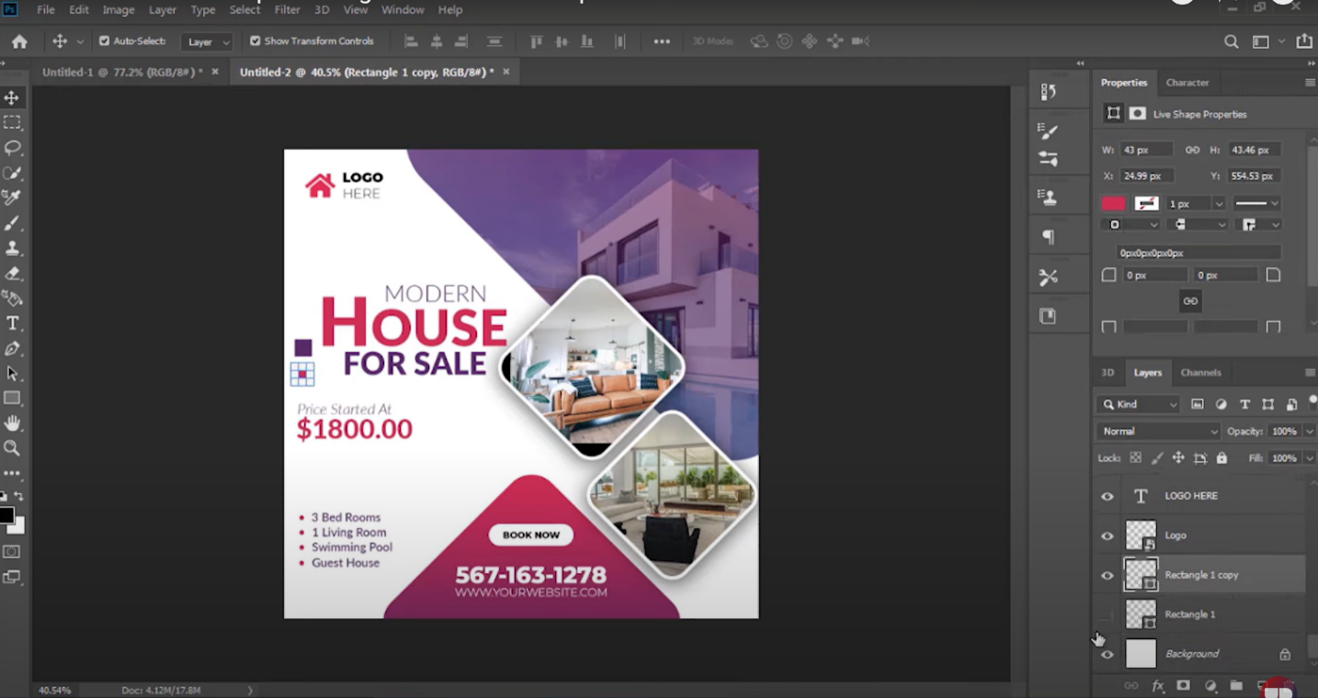

**Steps to Create a Magazine Layout from This Design:**

1. **Document Setup**:
   * Create a new document by going to File > New.
   * Choose **A4 size** (8.27 x 11.69 inches) or a custom magazine size as required.
   * Set the resolution to **300 DPI** for high-quality printing, and use **CMYK** color mode for print projects.
2. **Move Elements from Banner to Magazine**:
   * Open the current design in Photoshop and use the **Move Tool (V)** to drag the various layers (text, images, etc.) into your new magazine layout.
   * Adjust the elements so that they fit well into the new page layout. You might want to resize the images and text to fit the larger page.
3. **Layout Considerations**:
   * **Cover Page**: If this is for a magazine cover, the "House for Sale" design can be used as a main feature. Consider including additional information like the magazine's title, issue number, date, and other callout sections (e.g., "Latest Real Estate Trends").
   * **Interior Page**: If it's an interior page, you can expand the content. Add more images, property descriptions, or even testimonials. Break the content into sections for better readability.
4. **Typography**:
   * Adjust font sizes to fit a magazine format. Headlines and key points like "$1800.00" should be larger for emphasis, while body text can be smaller but clear.
   * For magazines, ensure there is enough **white space** around the text and images for a clean, professional look.
5. **Image Placement**:
   * The current images can be expanded or supplemented with more photos of the house.
   * Maintain image quality by ensuring they are high resolution (300 DPI).
   * Consider using full-page images as background visuals, which is common in real estate magazines.
6. **Additional Content**:
   * Add more **property features**, **location details**, or **real estate tips** to give readers more context. You can use bullet points or sidebars for additional text.
   * If you’re creating multiple pages, include articles or a feature story related to housing, real estate investments, etc.
7. **Bleed and Margins**:
   * If this is for print, include bleed in your design. Go to File > New, and when creating a new document, set a **0.125-inch bleed** to ensure the design extends to the edges after trimming.
   * Maintain margins (usually 0.25 inches) to avoid cutting off important content.
8. **Final Touches**:
   * Ensure that all layers are named and organized for easy navigation.
   * Review the **alignment** and spacing between elements. Use View > Show > Grid and View > Show > Rulers to align content.



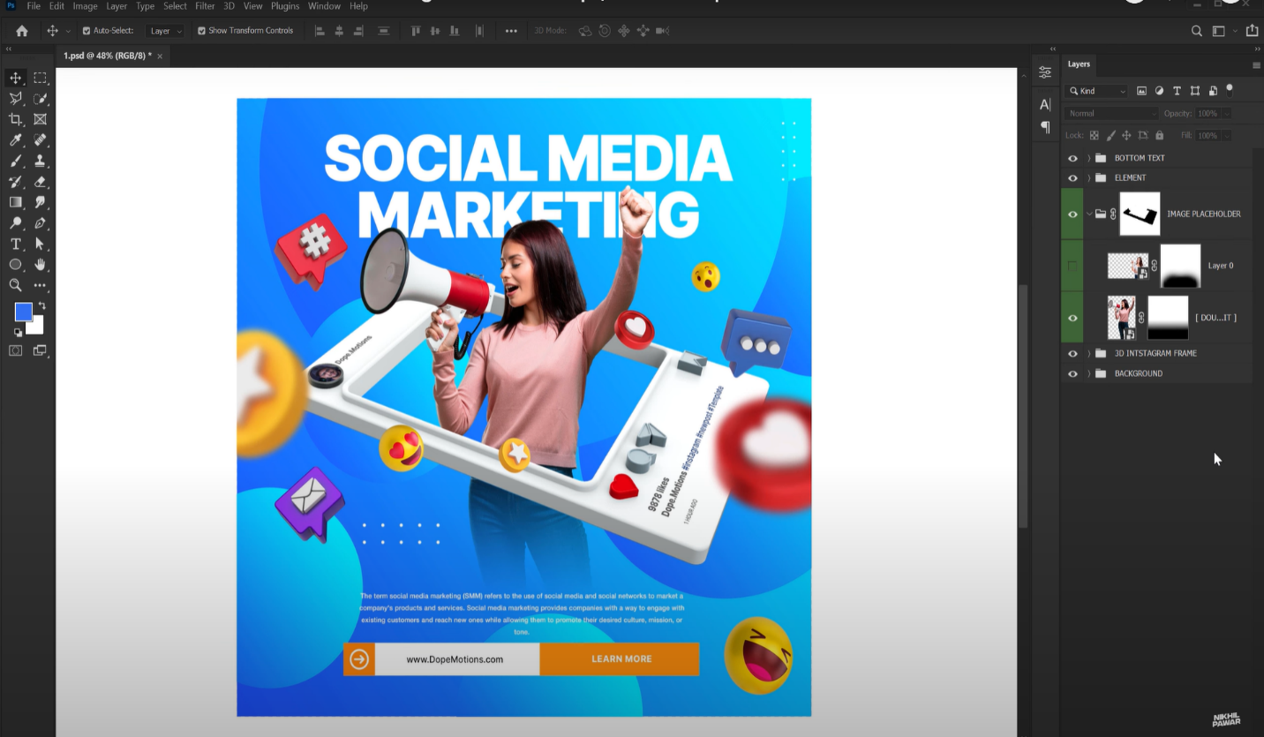

**Steps to Create a Magazine Layout from this Design:**

1. **Document Setup**:
   * Create a new document in Photoshop using File > New.
   * Select **A4 size** or any other preferred magazine size (8.27 x 11.69 inches).
   * Set the resolution to **300 DPI** and the color mode to **CMYK** for print.
2. **Transfer Design Elements**:
   * Open your current social media marketing design file.
   * Use the **Move Tool (V)** to transfer the elements (images, text, and graphics) from this design into the new document.
   * Resize and adjust the positioning to fit the magazine's proportions, as the layout for a page will differ from a social media banner.
3. **Layout Adjustments**:
   * Depending on whether you are using this as a **cover page** or an **interior page**, adjust the content accordingly.
     + For the **cover page**, you can keep the bold heading "Social Media Marketing" and add the name of the magazine, issue number, date, etc.
     + For the **interior page**, you can split the design into sections. Add extra text content, such as articles on social media strategies, case studies, or tips on digital marketing.
4. **Typography**:
   * For magazines, it's essential to maintain readable font sizes. Adjust the font sizes, especially for body text, and ensure there’s good contrast between text and background for readability.
   * Highlight the most important elements, such as the title or call-to-action (like “LEARN MORE”).
5. **Additional Content**:
   * Expand the design by including:
     + A **table of contents** or side sections for articles related to digital marketing.
     + A **section on the latest trends** in social media marketing.
     + **Graphs, charts**, or infographics to display statistics about the industry.
     + **Client testimonials**, quotes, or case studies showing successful campaigns.
6. **Image and Graphic Placement**:
   * Use the current images and graphics in the design but consider expanding them into full-page visuals or adding more elements like photos or icons related to marketing.
   * You could use **grid layouts** to organize content better and maintain structure, which is common in magazines.
7. **Page Flow**:
   * Create flow across pages by including:
     + Section headings.
     + Numbered pages with the magazine’s logo or other branding in the header or footer.
     + Clear **call-to-action** sections, like “Learn More” buttons, to direct readers to further reading or websites.

**8. White Space and Alignment**:

* + Maintain clean alignment and include enough white space between elements for a professional, non-cluttered look. Use Photoshop's grid and ruler tools for precise alignment.

**9.Bleed and Margins for Print**:

* + Set up margins and include bleed settings (usually 0.125 inches) to ensure the design extends to the edges when printed. This is crucial for a professional finish if the magazine is physically printed.

**10.Export**:

* + When the magazine design is ready, export it by going to File > Save As and selecting **PDF** for print. Ensure to choose **High Quality Print** with bleed and crop marks included.



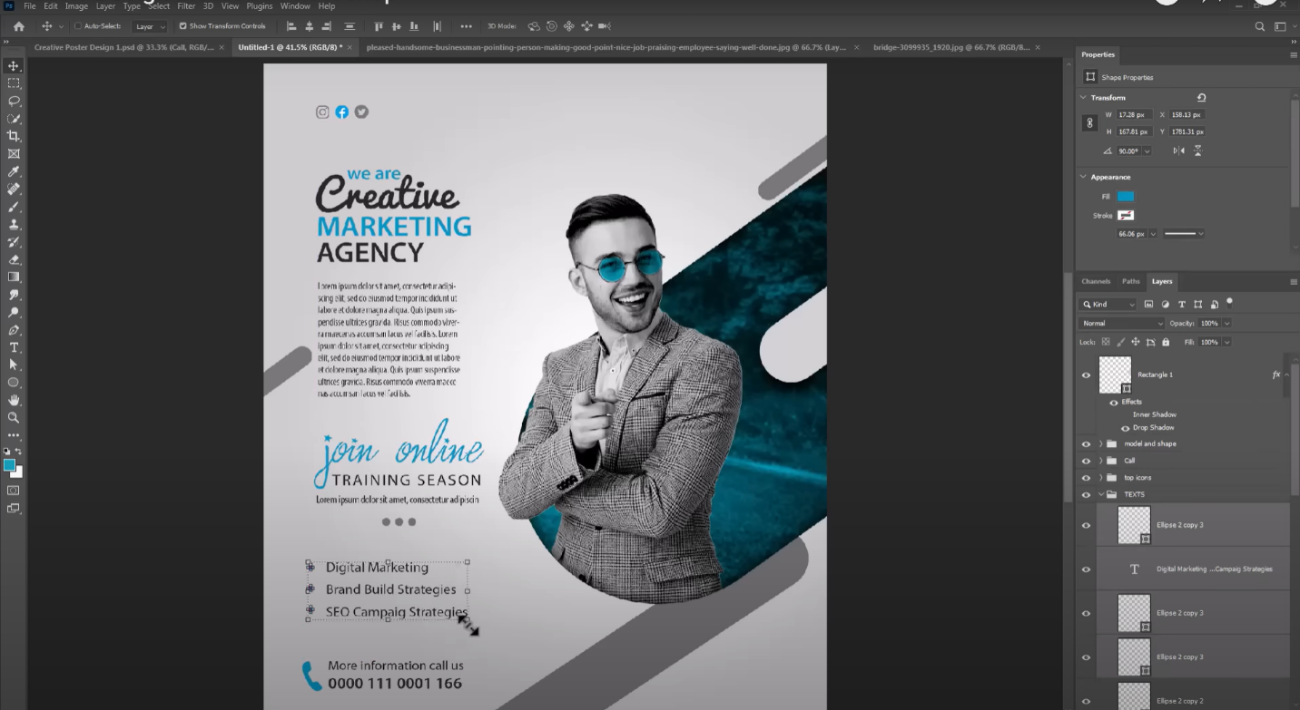

**1. Setup the Canvas:**

* **Size:** Set the dimensions of your flyer (e.g., A4 or any custom size). From your screenshot, the size looks like an A4 or a similar portrait format.
* **Resolution:** Use 300 DPI (dots per inch) for print quality designs.

**2. Background & Layout:**

* **Background:** Add a clean, subtle background, such as light gray or white, as it appears in the screenshot. The curved shape in blue can be created using the **Pen Tool** or shape layers.
* **Color Theme:** It appears you have a two-tone color theme, primarily using **blue accents** with grayscale tones, which gives a professional and modern look.
* **Guidelines:** Enable guides to help align text and shapes symmetrically.

**3. Add Visual Elements:**

* **Image Placement:** Insert a high-quality image of a person (as shown in the screenshot). Use the **Lasso Tool** or **Pen Tool** to cut out the subject from the background. Apply a **drop shadow** for added depth.
* **Shapes and Overlays:** Add dynamic geometric shapes behind or around the person to give the design a modern and energetic feel. The blue cut-out shape behind the subject adds depth and creativity.

**4. Typography:**

* **Title Text:** Use a large, bold, modern font for your headline text like "Creative Marketing Agency." Different weights of the font are used to highlight certain words (e.g., "Creative" being more playful and "Marketing Agency" being more formal).
* **Body Text:** Include smaller, less prominent fonts for filler text or a description of services. You can use **Lorem Ipsum** placeholders until the final copy is ready.
* **Call to Action (CTA):** Place your CTA ("Join Online Training Season") with a different font style or size to make it stand out. Use color contrast to make it eye-catching.
* **Bullet Points:** Add a list of services, such as "Digital Marketing," "SEO Campaign Strategies," and others, using icons beside the text to make them visually appealing.

**5. Icons & Decorative Elements:**

* Add social media icons at the top to show online presence, usually using **vector shapes** or downloaded icon packs.
* Additional small icons are placed next to service listings to enhance the readability and visual appeal.

**6. Contact Information:**

* At the bottom of the flyer, place contact details like phone numbers or emails using an easily readable font. You may also add a simple **icon next to the phone number** for clarity.

**7. Final Touches:**

* Apply finishing touches like **drop shadows**, **inner glows**, or **outer glows** to the shapes or text to make certain elements pop.
* Ensure all layers are well organized in groups such as "Texts," "Icons," "Model and Shape," and "Background."

**8. Exporting:**

* Once you’re satisfied with your design, export the flyer in high-resolution formats like **PDF** or **JPEG** for printing, making sure all
* the text remains clear.



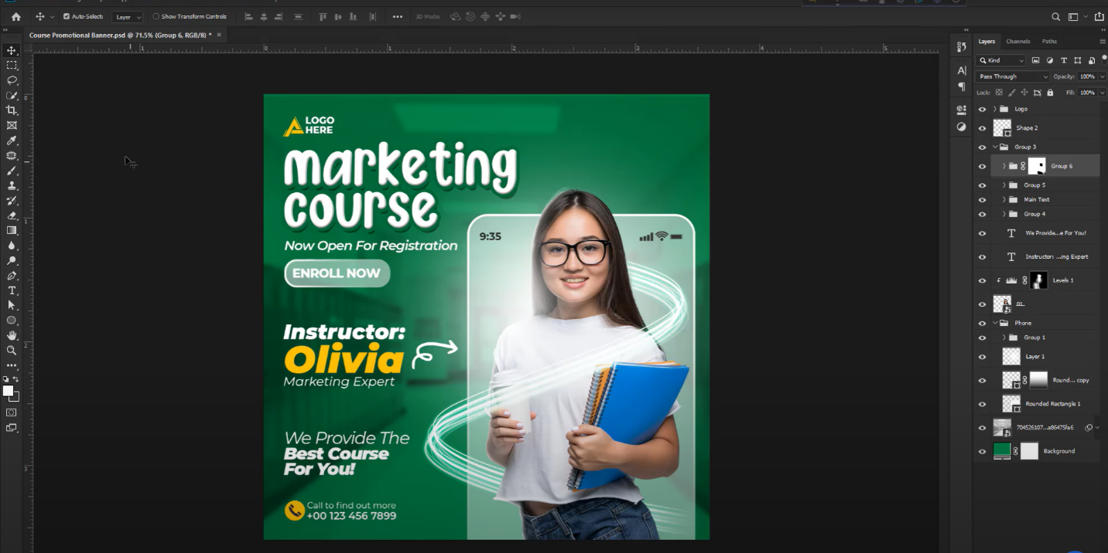

**Canvas Setup:**

* **Size:** Set up your canvas to the required dimensions. For banners, this could be in landscape or portrait mode depending on the platform (e.g., social media, web ads). In your screenshot, it seems to have a standard vertical orientation.
* **Resolution:** Use 72 DPI for digital display or 300 DPI if it's intended for print.

**2. Background Creation:**

* **Color:** Start by choosing a **green gradient background** as shown. You can create a smooth gradient using the **Gradient Tool** to add some depth.
* **Overlay Effects:** The design features subtle abstract light swirls, which you can create using the **Pen Tool** or by importing pre-made swirly shapes, adjusting their opacity, and blending modes.

**3. Adding the Image:**

* **Subject Placement:** The main subject (a person holding a notebook) should be cut out from its original background. Use tools like **Quick Selection** or **Pen Tool** for precise cut-outs.
* **Smartphone Mockup Effect:** Behind the subject, there’s a faint **phone mockup**. This effect is achieved by placing a rectangle or phone image behind the subject and reducing the opacity to create a glowing or transparent look.
* **Highlighting Effects:** The light swirls around the subject can be achieved using **custom brush strokes** or by importing vector swirl designs, then adjusting them to flow around the subject.

**4. Logo Placement:**

* In the top-left corner, place the **brand logo** or **placeholders** for where the logo should go. Ensure that it’s sized appropriately for visibility but not overwhelming the design.

**5. Typography:**

* **Main Header:** The title "Marketing Course" uses a playful, bold, and rounded font to attract attention. You can find similar fonts or use free fonts available on sites like **Google Fonts**.
* **Secondary Text:** Below the title, there’s a supporting line like "Now Open for Registration." Use a clean, sans-serif font to maintain readability and professionalism.
* **Call to Action Button:** Add a rounded rectangle for the "Enroll Now" button. Use white text on a green background to keep it aligned with the overall color theme.
* **Instructor Info:** Use a combination of bold and regular fonts to distinguish the instructor’s name (Olivia) from her title (Marketing Expert). Yellow color here creates contrast against the green background, making the text pop.
* **Additional Text:** At the bottom, the line "We Provide The Best Course For You" uses a smaller, readable font with a slight italic style for emphasis.

**6. Icons and Contact Information:**

* **Phone and Email Icons:** Add small, easily recognizable icons (phone, email, or other contact symbols) next to the contact information to improve clarity and provide visual cues.
* **Text Placement:** Keep the contact information visible and easy to read at the bottom, ensuring it doesn’t overpower the rest of the design.

**7. Effects and Enhancements:**

* **Shadows and Glows:** Apply **drop shadows** or **outer glows** to the text and images to give a 3D effect and help them stand out from the background.
* **Layer Organization:** Ensure all layers are neatly grouped and labeled (e.g., "Background," "Text," "Images"). This makes it easier to edit later on.

**8. Final Adjustments:**

* **Balance & Alignment:** Make sure all elements (images, text, buttons) are aligned properly, following design principles like **rule of thirds** or **grid alignment**.
* **Export:** Export the design in the required format (e.g., PNG or JPEG for digital, PDF for print). Ensure the resolution is optimized for where it will be displayed.