

Assignment: CBG

Submitted By: ZAHID HUSSAIN

Exercise 2.1: Create and format the following MS WORD document page:



Microsoft that allows users to organize, format and calculate data with formulas using a spreadsheet system. This software is part of the Microsoft Office suite and is compatible with other applications in the Office suite. Like other Microsoft Office products, Microsoft Excel can now be purchased through the cloud on a subscription basis through Office 365.

How to use excel

Creating a new spreadsheet from scratch.

Þ Executing basic computations in a spreadsheet, like adding, subtracting, multiplying, and dividing in a spreadsheet.

Þ Writing and formatting column text and titles.

Þ Excel's auto-fill features.

Þ Adding or deleting single columns, rows, and spreadsheets. Below, we'll get into how to add things like multiple columns and rows.

Þ Keeping column and row titles visible as you scroll past them in a spreadsheet, so that you know what data you're filling as you move further down the document.

Excel is a handy software that can be used to store and organize many data sets. Using its features and formulas, you can also use the tool to make sense of your data. For example, you could use a spreadsheet to track data.

Exercise 2.2: Create and format the following MS WORD document page:

A **video card** (also called a **graphics card**, **display card**, **graphics adapter**, or **display adapter**) is an [expansion card](https://en.m.wikipedia.org/wiki/Expansion_card) which generates a feed of output images to a [display device](https://en.m.wikipedia.org/wiki/Display_device) (such as a [computer monitor](https://en.m.wikipedia.org/wiki/Computer_monitor)). Frequently, these are advertised as discrete or dedicated graphics, emphasizing the distinction between these and [integrated graphics](https://en.m.wikipedia.org/wiki/Graphics_processing_unit#Integrated_graphics). At the core of both is the [graphics processing unit](https://en.m.wikipedia.org/wiki/Graphics_processing_unit) (GPU), which is the main part that does the actual computations, but should not be confused with the video card as a whole, although "GPU" is often used as a [metonymic](https://en.m.wikipedia.org/wiki/Metonymy) shorthand to refer to video cards

There are two **types of graphics cards**: integrated and dedicated. An integrated **graphics card**, usually by Intel to use in their computers, is bound to the motherboard and shares RAM(Random Access Memory) with the CPU, reducing the total amount of RAM available.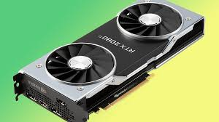

# RAM

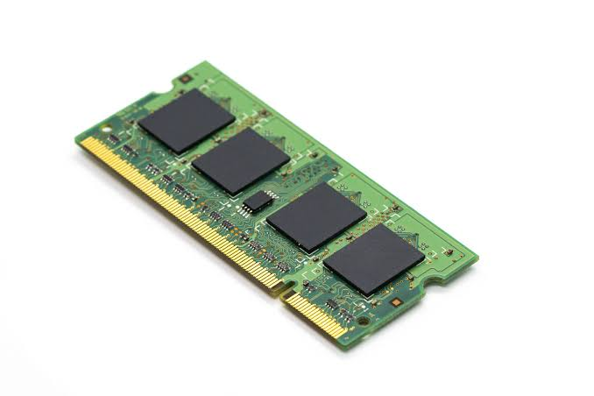  
Random-access memory is a form of computer memory that can be read and changed in any order, typically used to store working data and machine code. A random-access memory device allows data items to be read or written in almost the same amount of time irrespective of the physical location of data inside the memory.

**SOFT WORD .**

Exercise 2.4: Create and format the following MS WORD document page:

Classification of Computers

Þ On the basis of Purpose

Þ On the basis of Size

Þ On the basis of Working Mechanism

Classification of Computers (Purpose)

Þ General Purpose Þ Special Purpose

Classification of Computers (Size)

Þ Super Computers

Þ Mainframe Computers

Þ Mini Computers

Þ Micro Computers

Desktop Computers

Workstations

Notebook Computers

Tablet PCs

Handheld Computers

Smartphones

Classification of Computers (Working Mechanism)

Þ Analog Computers

Þ Digital Computers

Þ Hybrid Computers

## lab Manual Page 6 of 38

Exercise 3.1: Create the following table in MS Word:

|  |  |  |  |
| --- | --- | --- | --- |
| University Expenditure | | |  |
| Name:- ZAHID HUSSAIN | | |  |
| Roll No:- 20MTE001 | | |  |
| S.#. | Fees | Year/Semester | Amount |
| 1 | Admission Fees | Per Year | 12,000 |
| 2 | Tuition Fees | Per Semester | 28,000 |
| 3 | Hostel Fees | Per Semester | 8,200 |
| 4 | Monthly Expenditure | Per Year | 135,000 |
| 5 |  | Total Per Year(Net) | 214,200 |

Page

Exercise 3.2: Create the following smart art graphics in MS Word

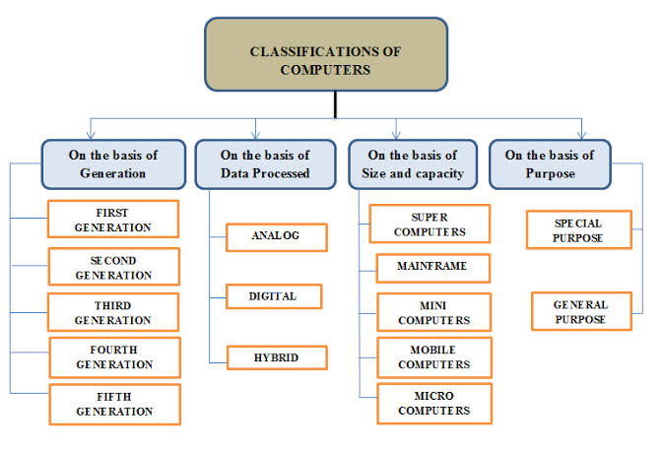



**Video Card Types**



**Vjay Card**



**Graphics Card**

Page

Exercise 3.3: Insert the following equations in MS Word document: x = 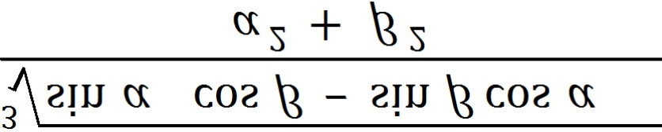

(a+b)n =an-kb

( ) =

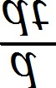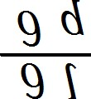

A (u) =

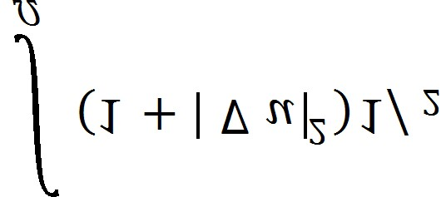

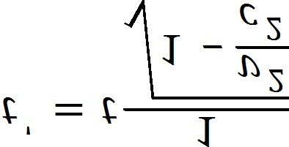



=

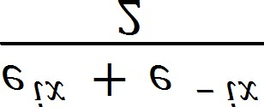

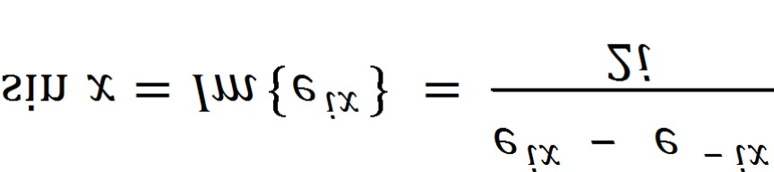

Page





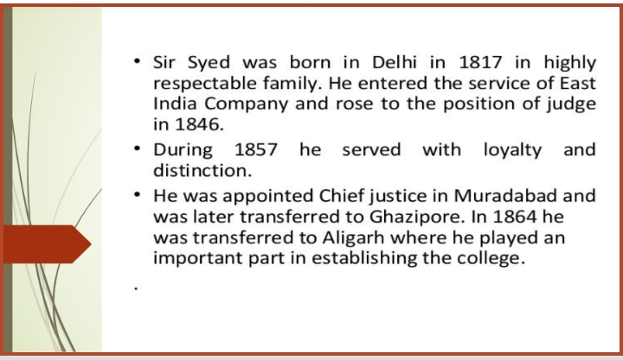

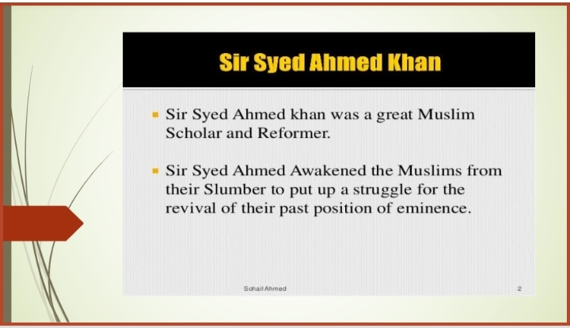



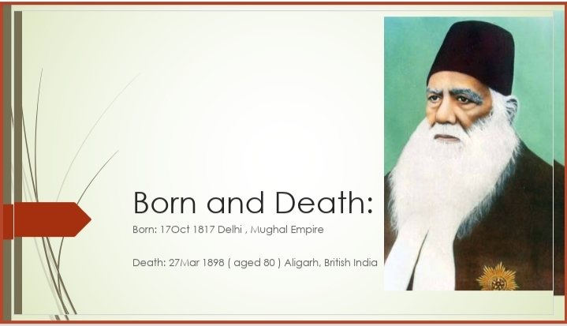

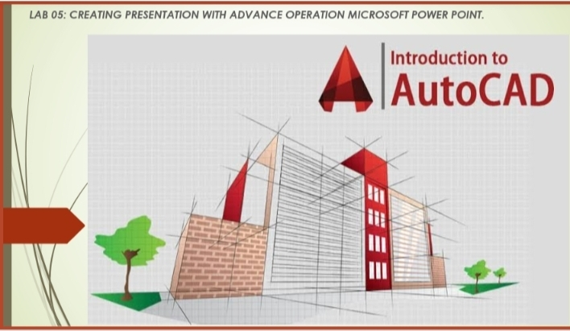



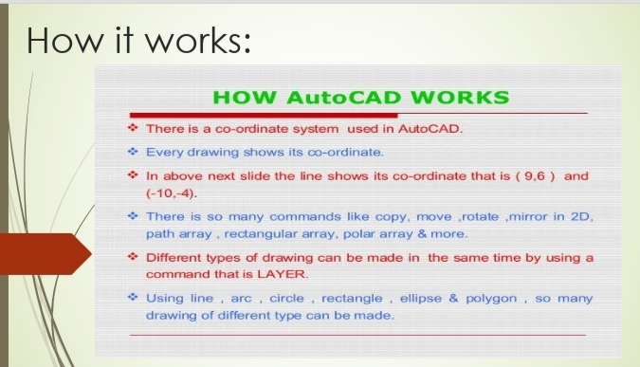

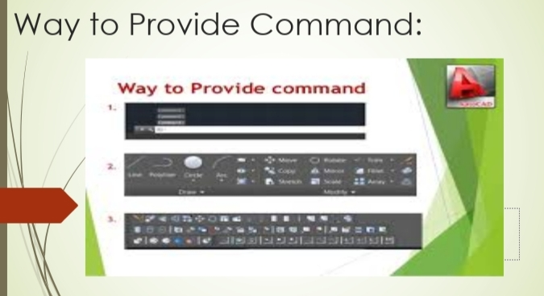

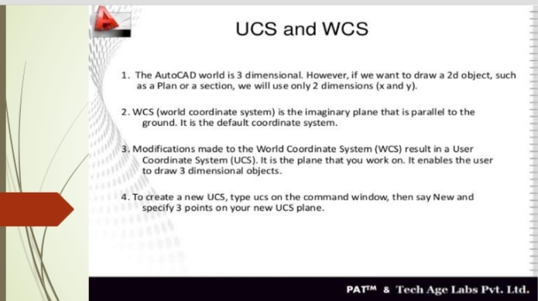

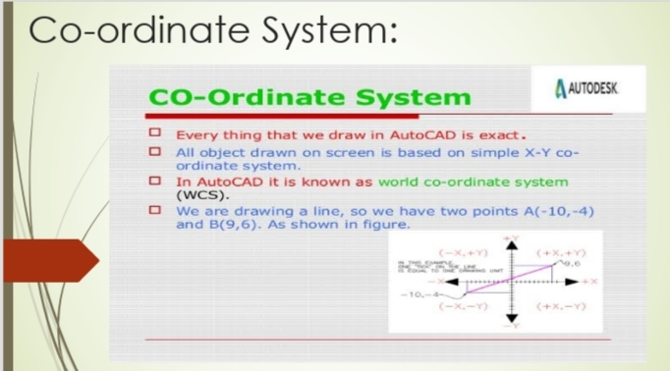

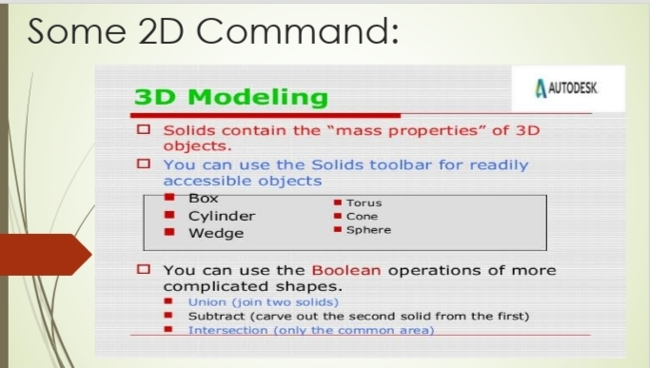

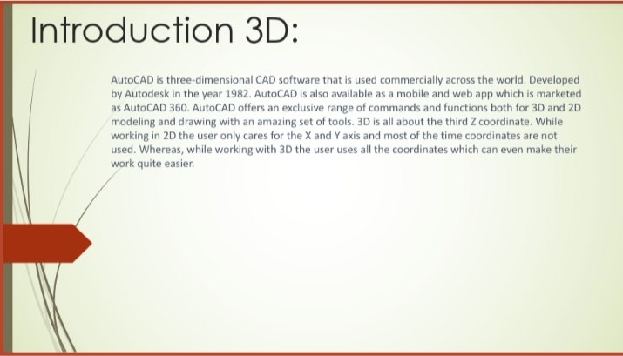

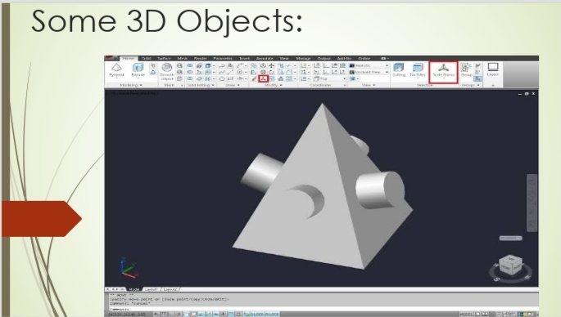

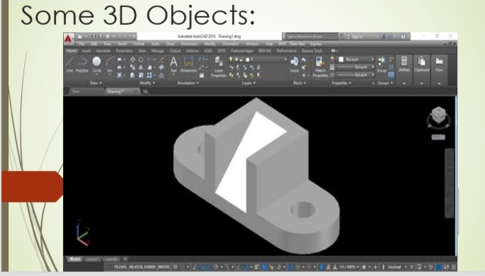

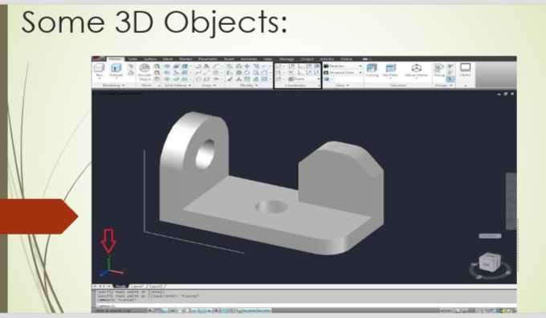



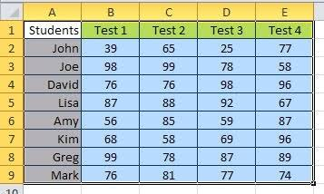**LAB 06: CREATING AND EDITING SPREADSHEETS WITH MICROSOFT EXCEL.**

Exercise 6.1 Create the following simple students test result worksheet in MS Excel: