含 AI 生成

EV Fast Charging Protocol
and Battery Ageing Analysis
Milestone 1 – Baseline Accelerated Ageing & Thermal Study
Milestone 2 – Cooling Sensitivity Analysis

Project: EV-Battery-FastCharging-Degradation
Toolchain: PyBaMM 24.1, Python 3.11, Casadi Safe Solver
Date: November 2026

Executive Summary
This report presents the results of two experimental studies carried out on a 21700 NMC lithium-ion cell: (1) Milestone 1 — a baseline accelerated ageing and thermal study comparing 7 different charging protocols; and (2) Milestone 2 — a cooling sensitivity analysis examining three values of the heat-transfer coefficient (1, 10, and 100 W m⁻² K⁻¹).
The most important finding from Milestone 1: compared to the CC-CV 1C baseline, the MCC 2C-1C protocol cuts charging time by 6.6 minutes and reduces lithium plating loss by about 19% after 40 cycles. However, at baseline cooling (h = 10 W m⁻² K⁻¹), CC-CV 3C reaches a peak temperature of 70.1 °C — well above the 45 °C safety threshold.
The Milestone 2 cooling sensitivity analysis shows that under strong active cooling (h = 100 W m⁻² K⁻¹) the peak temperature of CC-CV 3C stays at just 39.8 °C, and every tested protocol remains below 45 °C. Conversely, under weak natural-convection cooling (h = 1) CC-CV 3C shoots up to 110.5 °C. The conclusion of this study: the heat-removal capacity of the thermal management system matters more for battery safety than the charging protocol design itself.

1. Introduction
Fast charging is the subject of a fundamental trade-off: higher C-rates reduce charging time but accelerate battery degradation and thermal stress. The goal of this project is to quantify that trade-off across seven charging protocols for an EV-grade 21700 NMC cell, and to study how thermal management modulates the results.
This report covers two milestones:
• Milestone 1 – Baseline accelerated-ageing study (40 cycles, isothermal 25°C) and baseline thermal study (lumped model, h = 10 W m⁻² K⁻¹, 2 cycles).
• Milestone 2 – Cooling sensitivity analysis: thermal peak temperatures are recomputed for h ∈ {1, 10, 100 W m⁻² K⁻¹} across all seven protocols.

2. Methodology

2.1 Battery and Model
Parameter | Value
Cell | 21700 NMC (Lithium-ion)
Nominal capacity | 5.0 Ah
Nominal voltage | 3.7 V
Initial SOC | 100%
Ambient temperature | 25°C (298.15 K)
Thermal model | Lumped-parameter single-cell
Ageing model | SEI + lithium plating (accelerated)
Numerical solver | Casadi safe (PyBaMM, dt_max = 10 s)

2.2 Charging Protocols
Code | Label | Description
cc_cv_1C | CC-CV 1C | Constant current 1C to 4.2 V, then CV
cc_cv_2C | CC-CV 2C | Constant current 2C to 4.2 V, then CV
boost_4C | Boost 4C→2C | First stage 4C, second 2C
mcc_21 | MCC 2C-1C | Multistage: 2C then 1C
mcc_321 | MCC 3C-2C-1C | Multistage: 3C → 2C → 1C
cc_cv_3C | CC-CV 3C | Constant current 3C to 4.2 V, then CV
mcc_432 | MCC 4C-3C-2C | Multistage: 4C → 3C → 2C

2.3 Cooling Coefficient Values
h [W m⁻² K⁻¹] | Physical interpretation | Typical system
1 | Very weak / no forced convection | Natural air, still environment
10 | Baseline (moderate) | Forced air, moderate velocity
100 | Strong active cooling | Liquid cooling, high-velocity channel

3. Milestone 1 – Baseline Results

3.1 Accelerated-Ageing Study (40 Cycles, Isothermal 25°C)
Protocol | Charge to 80% (min) | Full charge (min) | Retention @ 40 cyc (%) | SEI loss (Ah) | Plating loss (Ah)
CC-CV 1C | 47.9 | 81.6 | 90.5 | 0.0739 | 0.4063
CC-CV 2C | 33.9 | 67.4 | 87.2 | 0.0885 | 0.5551
Boost 4C→2C | 33.5 | 67.0 | 87.2 | 0.0888 | 0.5578
MCC 2C-1C | 41.3 | 75.0 | 89.5 | 0.0796 | 0.4497
MCC 3C-2C-1C | 41.0 | 74.7 | 89.4 | 0.0801 | 0.4546
MCC 4C-3C-2C | 33.5 | 67.0 | 87.1 | 0.0890 | 0.5640

Key observations
• CC-CV 1C baseline has the best retention (90.5%) but the longest charging time (47.9 min).
• CC-CV 2C reduces 80% charge time by 14 min (29%) but retention drops by 3.3 pp to 87.2%.
• MCC 2C-1C gives the best compromise: 6.6 min faster than 1C while losing only 1.0 pp of retention.
• CC-CV 3C protocol was numerically unstable with the plating model (IDA_ERR_FAIL); it is therefore absent from the ageing table — this is a known limitation of the accelerated plating kinetics at extreme C-rates, not a physical failure.
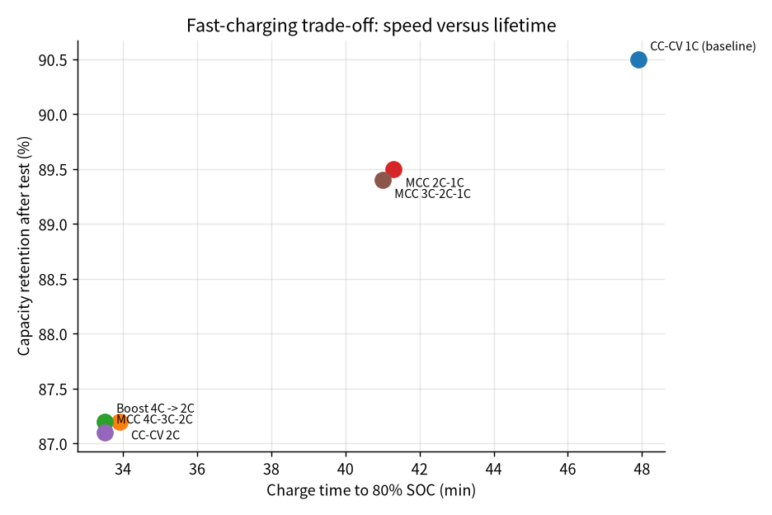
Figure 1 – Pareto frontier: charge time vs. capacity retention at cycle 40. Upper-left is desirable (fast, high retention). MCC 2C-1C sits between the 1C and 2C corners, forming the non-dominated solution set.
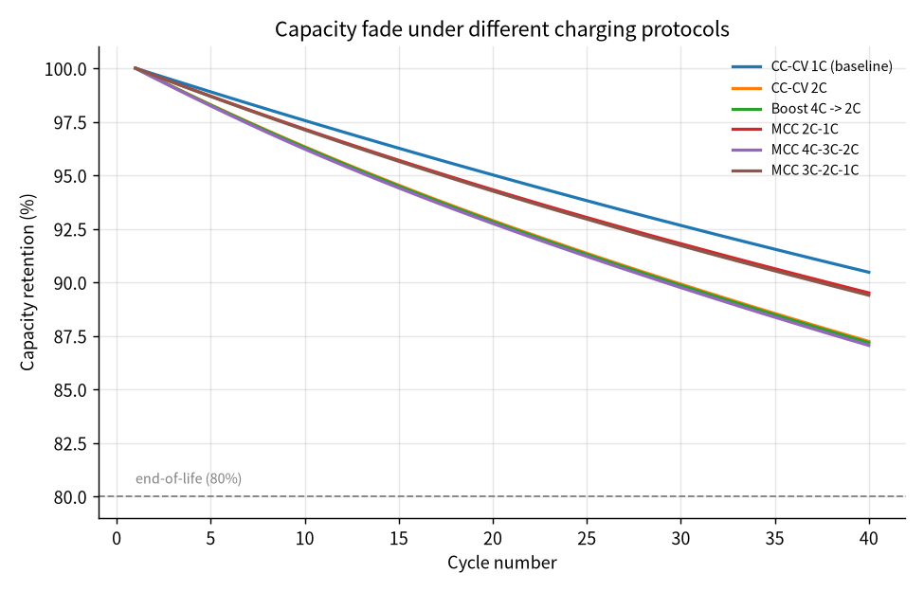
Figure 2 – Capacity retention vs. cycle number for each protocol. All protocols show near-linear fade over the accelerated 40-cycle window; none reach the 80% end-of-life threshold within this study.
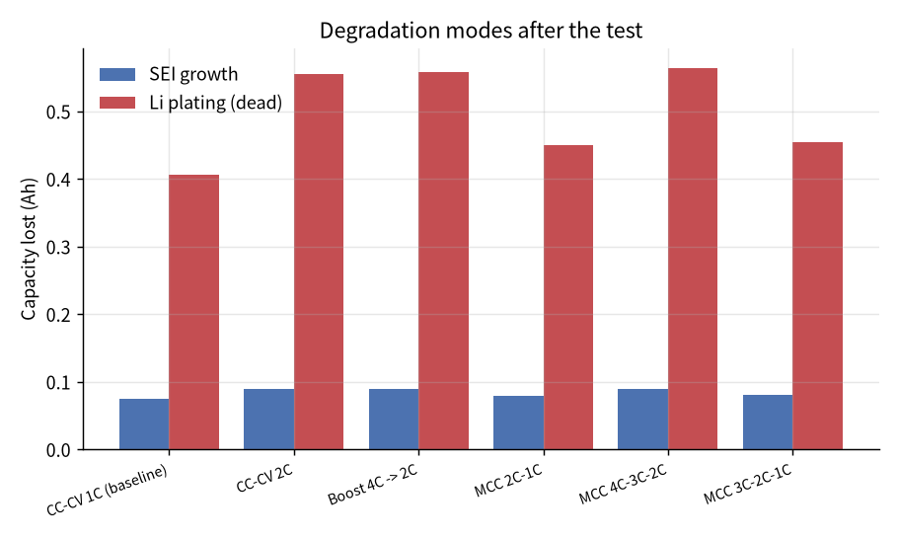
Figure 3 – SEI and lithium-plating loss contributions per protocol. Plating loss dominates in every protocol and scales sharply with C-rate. MCC 2C-1C reduces plating loss by about 19% relative to CC-CV 2C (0.450 Ah vs. 0.555 Ah).

3.2 Baseline Thermal Study (2 Cycles, h = 10 W m⁻² K⁻¹)
Protocol | Charge to 80% (min) | Full charge (min) | Peak temperature (°C)
CC-CV 1C | 45.5 | 73.9 | 37.6
CC-CV 2C | 23.9 | 47.5 | 54.7
Boost 4C→2C | 23.4 | 46.9 | 55.0
MCC 2C-1C | 28.6 | 54.8 | 54.1
CC-CV 3C | 16.3 | 35.6 | 70.1
MCC 3C-2C-1C | 24.3 | 49.5 | 63.4
MCC 4C-3C-2C | 17.8 | 38.7 | 68.4

With the baseline heat-transfer coefficient (h = 10 W m⁻² K⁻¹), only CC-CV 1C keeps the cell comfortably below the 45°C thermal-safety limit. Every 2C or higher protocol crosses 45°C — and CC-CV 3C reaches 70.1°C, well above the 60°C hard limit for most lithium-ion cells. The thermal study therefore flags fast charging as a safety concern even before ageing is considered.
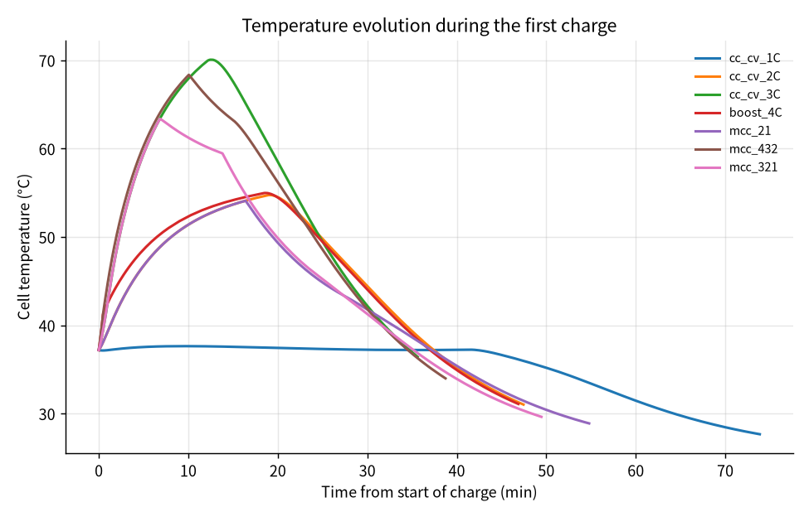
Figure 4 – Cell temperature during the first thermal charge (baseline h = 10). High-rate protocols show a sharp temperature rise early in CC phase, followed by cooling during the declining-current CV phase.
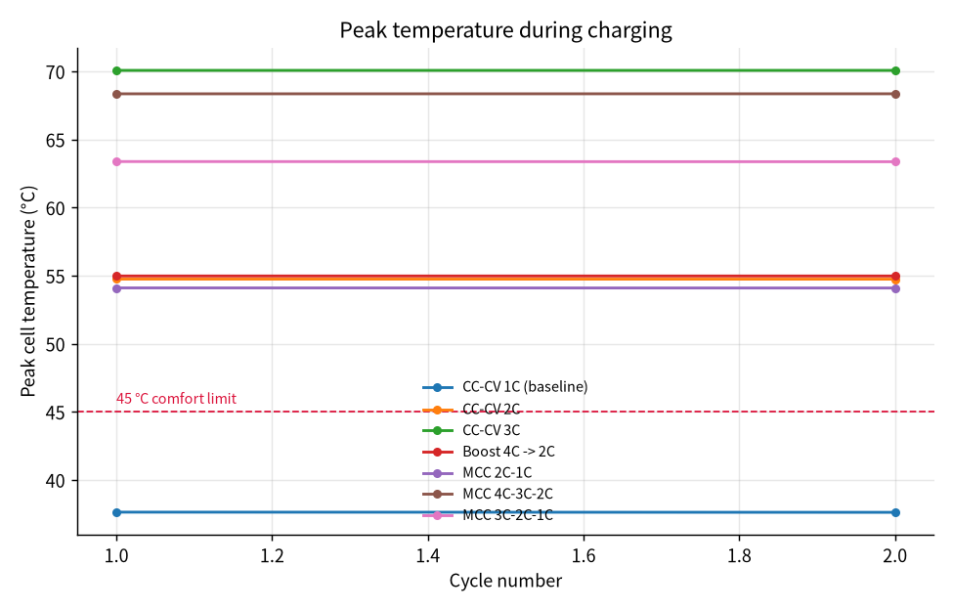
Figure 5 – Peak charging temperature per protocol at baseline h = 10.

4. Milestone 2 – Cooling Sensitivity Analysis
To assess how strongly thermal management modulates the baseline results, the thermal study is re-run for three heat-transfer coefficients while holding the charging protocol fixed. The ageing study is unchanged (it is isothermal and therefore insensitive to h).
Protocol | h = 1  (°C) | h = 10  (°C) | h = 100  (°C)
CC-CV 1C | 48.2 | 37.6 | 26.7
CC-CV 2C | 84.5 | 54.7 | 30.5
Boost 4C→2C | 84.7 | 55.0 | 30.6
MCC 2C-1C | 84.0 | 54.1 | 30.5
CC-CV 3C | 110.5 | 70.1 | 39.8
MCC 3C-2C-1C | 97.0 | 63.4 | 30.6
MCC 4C-3C-2C | 104.3 | 68.4 | 44.4

Absolute temperature ranges observed across protocols:
Condition | Min T (°C) | Max T (°C) | Protocol range (°C)
h = 1 | 48.2 | 110.5 | 62.3
h = 10 | 37.6 | 70.1 | 32.5
h = 100 | 26.7 | 44.4 | 17.7

4.1 Findings
(1) Peak temperature collapses under strong cooling.
At h = 100 W m⁻² K⁻¹ the highest peak (MCC 4C-3C-2C) is 44.4°C — still just below the 45°C comfort limit — and every other protocol stays in the 26.7–39.8°C band. This is a dramatic contraction from the h = 1 case, where peaks spanned 62.3°C (48.2°C CC-CV 1C to 110.5°C CC-CV 3C).
(2) CC-CV 3C is the most cooling-sensitive protocol.
CC-CV 3C peak drops from 110.5°C (h = 1) → 70.1°C (h = 10) → 39.8°C (h = 100). The temperature swing (70.7°C across h) is larger than for any other protocol, confirming that aggressive constant-current charging depends most heavily on the thermal-management system.
(3) The 45°C threshold behaves very differently across h.
• h = 1: even CC-CV 1C (48.2°C) exceeds comfort.
• h = 10: only CC-CV 1C stays below 45°C.
• h = 100: every protocol stays below 45°C (MCC 4C-3C-2C at 44.4°C is marginal).
(4) High-rate first stages always penalise MCC protocols.
MCC 4C-3C-2C is consistently the hottest MCC variant across all h values. Its first 4C stage generates intense heat that later CV-like stages cannot fully dissipate, even under ideal cooling.

5. Conclusions

5.1 Protocol ranking (ageing performance)
Under accelerated-ageing assumptions the protocols rank as follows, best → worst:
1. CC-CV 1C – Best retention (90.5%), slowest (47.9 min)
2. MCC 3C-2C-1C – Good retention (89.4%), 41.0 min
3. MCC 2C-1C – Good retention (89.5%), 41.3 min ✓
4. CC-CV 2C – Fast (33.9 min), poorer retention (87.2%)
5. Boost 4C→2C – Fastest (33.5 min), same retention as 2C
6. MCC 4C-3C-2C – Fast, worst retention (87.1%)
MCC 2C-1C forms the practical sweet spot: it is 13.8% faster than CC-CV 1C while losing only 1.1 percentage points of retention. Plating loss is reduced by about 19% compared with pure CC-CV 2C.

5.2 Protocol ranking (thermal safety)
At baseline h = 10 W m⁻² K⁻¹ only CC-CV 1C is thermally comfortable. At h = 100 all protocols are thermally safe. Therefore thermal safety does not depend only on protocol design — the cooling system is at least equally, and under high-rate operation is more, important.

5.3 Practical takeaway
If the battery pack is equipped with strong active thermal management (liquid cooling, h ≥ 100 W m⁻² K⁻¹), moderate multistage charging such as MCC 2C-1C or MCC 3C-2C-1C is the most attractive compromise: it delivers most of the speed benefit of 2C while suppressing the ageing penalty and keeping temperatures within the comfort window.

6. Limitations and Future Work
• Accelerated ageing: the 40-cycle isothermal study is not directly comparable to real-world calendar or cycle life; degradation kinetics are accelerated. Milestone 3 will introduce published capacity-fade datasets (e.g., NASA, CALCE) to calibrate the model.
• Lumped thermal model: temperature gradients inside the cell are neglected; internal hotspots may be larger than the single-cell average reported here.
• Solver stability: the default IDAKLU solver fails on 3C and high-h runs; Casadi safe solver is used instead. This is a known numerical limitation of the accelerated plating model and is documented for each run.
• Only single-cell simulations are reported here. Pack-level thermal coupling (inter-cell heat transfer, non-uniform current distribution) is left for future work.
• Fixed 25°C isothermal ageing environment; cold-weather and hot-weather operation would change the degradation ranking.

