EV Battery Fast-Charging and Degradation
Milestone 1: Results and Analysis
Baseline Reproduction and Results Analysis
This report presents the baseline results from a physics-based fast-charging simulation, five result figures, and their interpretation.

1. Scope of the Simulation
- Ageing study: 40 cycles, isothermal 25 °C. Accelerated degradation kinetics are used to rank the protocols comparatively.
- Thermal study: 2 cycles, lumped-cell cooling; ambient temperature 25 °C and heat-transfer coefficient h = 10 W m⁻² K⁻¹.
- The ageing and thermal studies are kept separate so that the temperature boundary condition does not influence the degradation ranking.

2. Ageing Study Results
Protocol | 80% charge (min) | Retention (%) | SEI loss (Ah) | Plating loss (Ah)
CC-CV 1C | 47.9 | 90.5 | 0.0740 | 0.4067
CC-CV 2C | 33.9 | 87.2 | 0.0885 | 0.5547
Boost 4C-2C | 33.5 | 87.2 | 0.0888 | 0.5574
MCC 2C-1C | 41.3 | 89.5 | 0.0796 | 0.4497
MCC 4C-3C-2C | 33.5 | 87.1 | 0.0890 | 0.5635
MCC 3C-2C-1C | 41.0 | 89.4 | 0.0801 | 0.4544
Retention is the percentage of initial capacity remaining after 40 cycles.

3. Thermal Study Results
Protocol | 80% charge (min) | Peak temperature (°C)
CC-CV 1C | 45.5 | 37.6
CC-CV 2C | 23.9 | 54.7
CC-CV 3C | 16.3 | 70.1
Boost 4C-2C | 23.4 | 55.0
MCC 2C-1C | 28.6 | 54.1
MCC 4C-3C-2C | 17.8 | 68.4
MCC 3C-2C-1C | 24.3 | 63.4
Charge times differ between the ageing and thermal studies because the two model configurations are not identical.

4. Figure 1: Speed–Lifetime Trade-off
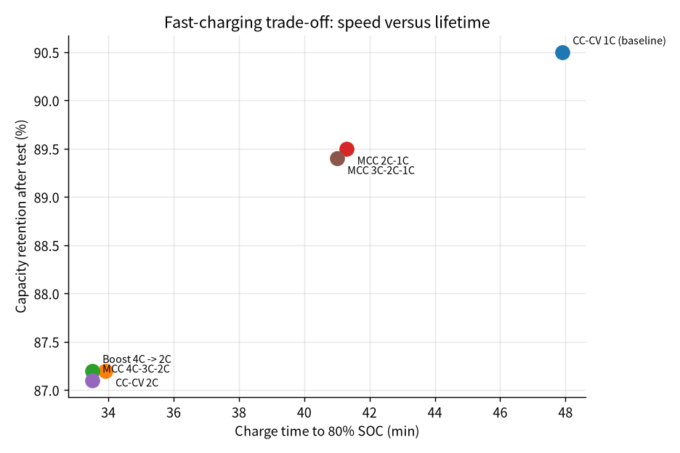
Figure 1: Charging time vs. capacity retention
- The upper-left corner of this plot is ideal — shorter charge time and higher retention.
- CC-CV 1C has the highest retention (90.5%) but is also the slowest (47.9 min).
- CC-CV 2C and Boost 4C-2C are faster, but retention is comparatively lower (~87.2%).
- MCC 2C-1C is the best-balanced point among the tested protocols (41.3 min, 89.5% retention).
- MCC 3C-2C-1C and MCC 4C-3C-2C are dominated by other protocols — the same or better outcome is available at a lower trade-off cost.

5. Figure 2: Capacity Retention over Cycles
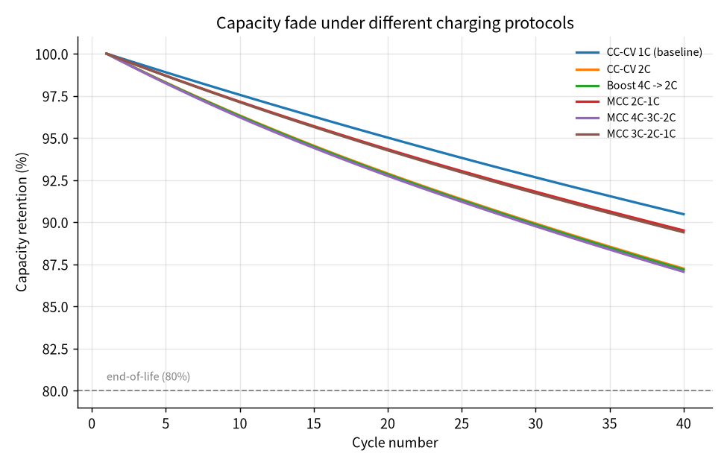
Figure 2: Capacity retention vs. cycle number
- Capacity decreases with cycle number for every protocol, but the fade rate is not the same for all.
- Fade is lowest at 1C; it is highest for 2C, Boost 4C-2C, and MCC 4C-3C-2C.
- MCC 2C-1C and MCC 3C-2C-1C show intermediate fade rates.
- No protocol has reached the 80 % end-of-life line within 40 cycles. Extrapolation of these curves to real-world cycle life is done in Milestone 3 (calibration).

6. Figure 3: Degradation Mechanisms
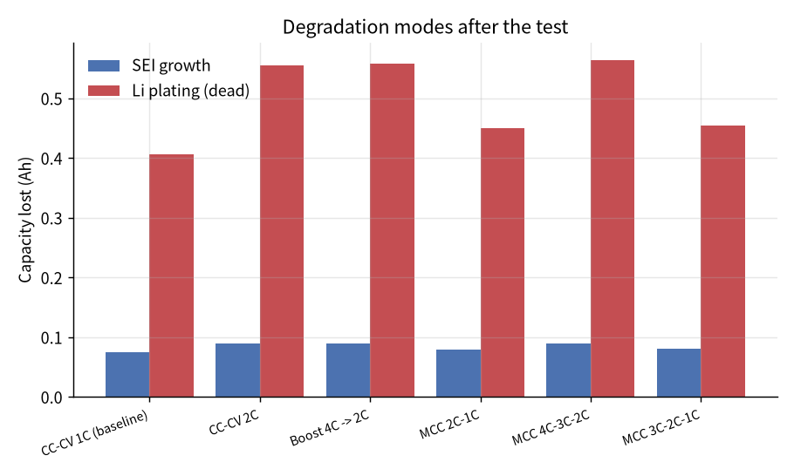
Figure 3: SEI growth and lithium-plating loss
- Lithium-plating loss dominates SEI loss across every protocol.
- Plating loss rises sharply with increasing C-rate.
- Plating loss in CC-CV 2C is about 0.555 Ah, whereas MCC 2C-1C brings it down to roughly 0.450 Ah — nearly 19 % lower.
- Reducing the current towards the end of charge is clearly helping to reduce plating exposure.

7. Figure 4: Temperature Profiles
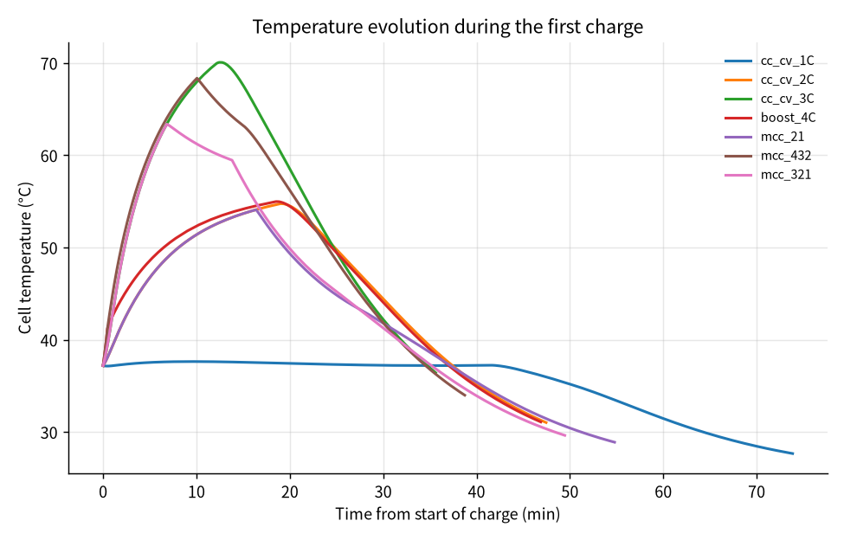
Figure 4: Temperature profile during the first charge
- High-rate protocols see a rapid temperature rise immediately after charging begins; CC-CV 3C reaches a maximum of 70.1 °C.
- Temperature peaks before the end of charge, not after.
- During the constant-voltage phase the current drops, heat generation falls, and temperature comes back down as cooling continues.
- The 1C profile stays comparatively flat and reaches a maximum of about 37.6 °C.

8. Figure 5: Peak Temperature Summary
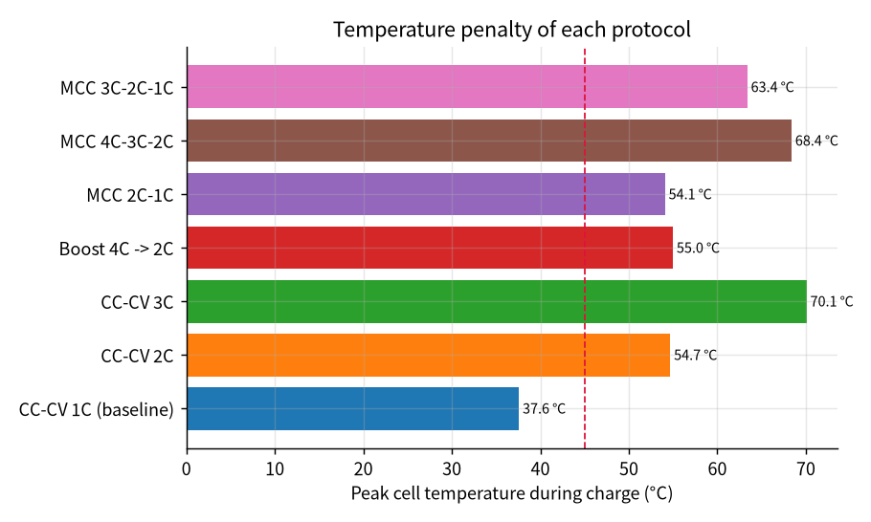
Figure 5: Peak temperature by protocol
- Under the current cooling assumption only CC-CV 1C stays below 45 °C.
- CC-CV 2C and every more aggressive protocol exceed 45 °C.
- MCC 2C-1C peaks at 54.1 °C, slightly below CC-CV 2C at 54.7 °C.
- CC-CV 3C, MCC 4C-3C-2C, and MCC 3C-2C-1C peak at 70.1 °C, 68.4 °C, and 63.4 °C respectively — these three carry the largest thermal penalty.

9. Main Conclusions
Going from 1C to 2C cuts the 80 % charge time from 47.9 min to 33.9 min — a 14 min or 29.2 % reduction. But 40-cycle retention drops from 90.5 % to 87.2 %.
MCC 2C-1C is 6.6 min faster than 1C with only 1.0 percentage point less retention. That is 2.3 percentage points better retention than plain 2C — a much better speed–lifetime trade-off.
Under the accelerated-ageing assumptions, moderate multistage charging reduced lithium-plating loss by approximately 19% relative to CC-CV 2C while retaining a practical charging-speed advantage over CC-CV 1C.

10. Limitations
- Degradation kinetics are accelerated; 40 simulated cycles do not correspond to a fixed real-world battery lifetime.
- The ageing study was run isothermally at 25 °C; thermal feedback is not coupled to ageing.
- SEI and plating kinetics have not yet been calibrated against published experimental data.
- When the plating model is active the pure CC-CV 3C protocol had to be excluded from the ageing study because of numerical instability.
- Conclusions about cooling are specific to this model and h = 10 W m⁻² K⁻¹; different cooling coefficients will produce different outcomes.

11. Next Steps
Milestone 2 will run thermal studies at h = 1, 10, and 100 W m⁻² K⁻¹ in sequence to see how much the 3C peak temperature can be brought down. Milestone 3 will calibrate the accelerated ageing model against NASA and CALCE datasets. Milestone 4 will extend the simulation to a 96-cell pack.

