Running VSCode from specific Location
D:\SOC_Training_monitoring\Advanced_Scripting>code .

Git--

PS C:\Users\ZAHID> git config --global user.name
zahid
PS C:\Users\ZAHID> git config --global user.email
zahid88@yahoo.com
PS C:\Users\ZAHID>
PS D:\> cd D:\SOC_Training_monitoring\Advanced_Scripting
PS D:\SOC_Training_monitoring\Advanced_Scripting> git init

PS D:\SOC_Training_monitoring\Advanced_Scripting> echo "Hellow">hello.txt
PS D:\SOC_Training_monitoring\Advanced_Scripting> cat hello.txt

Condi.sh
#!/bin/bash$
# Check if a number is positive, negative, or zero$
$
4 echo "Enter a number:"$
5 read num$
6 $
7 if [ $num -gt 0 ]; then$
8 echo "The number is positive."$
9 elif [ $num -lt 0 ]; then$
10 echo "The number is negative."$
11 else$
12 echo "The number is zero."$
13 fi$

https://crontab.guru/

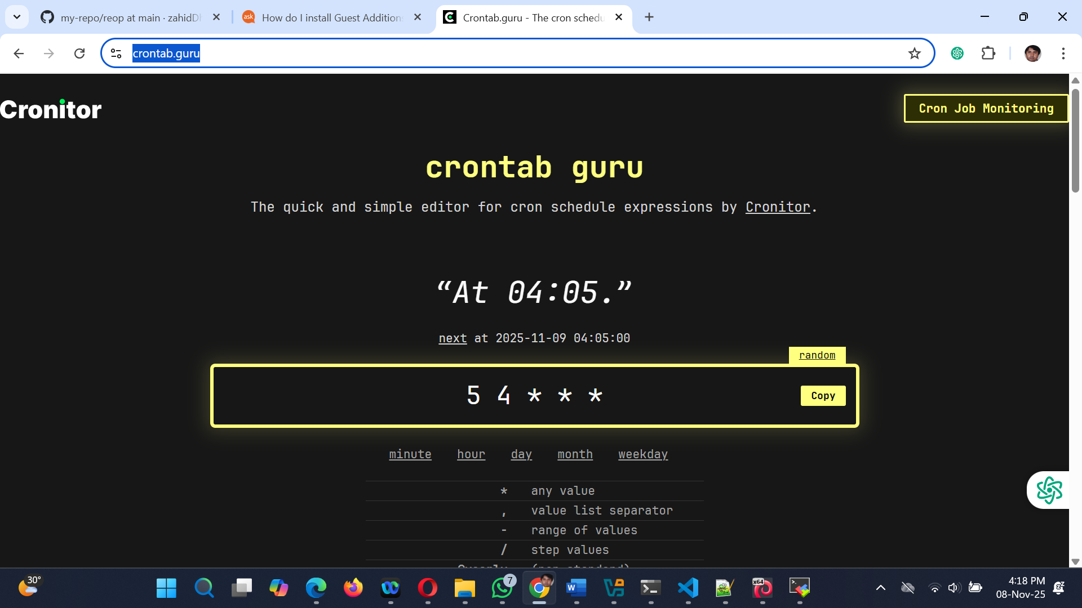

Powershell

PS C:\WINDOWS\system32> $psversiontable

Name Value
---- -----
PSVersion 5.1.26100.7019
PSEdition Desktop
PSCompatibleVersions {1.0, 2.0, 3.0, 4.0...}
BuildVersion 10.0.26100.7019
CLRVersion 4.0.30319.42000
WSManStackVersion 3.0
PSRemotingProtocolVersion 2.3
SerializationVersion 1.1.0.1

PS C:\WINDOWS\system32> pwsh
PowerShell 7.5.4
PS C:\Windows\System32>

Oracle Service: OracleServiceST

Get-Service | Where-Object {$_.Status -eq "Running"}
Get-Service | Where-Object {$_.Status -eq "Stopped"}
Get-Service | Where-Object {$_.Status -eq "Stopped"}
Get-Service -name “OracleServiceST” | Where-Object {$_.Status -eq "Stopped"} | Start-Service -Name “OracleServiceST”

PS D:\SOC_Training_monitoring\Advanced_Scripting> Get-Service -name "OracleServiceST" | Where-Object {$_.Status -eq "Stopped"}

Status Name DisplayName
------ ---- -----------
Stopped OracleServiceST OracleServiceST

Powershell path: C:\Program Files\PowerShell\7

// powershell configurations
"powershell.powerShellAdditionalExePaths": {
"homebrew": " C:\Program Files\PowerShell\7\pwsh.exe"
},
"powershell.powerShellDefaultVersion": "homebrew",
"[powershell]": {
"editor.defaultFormatter": "ms-vscode.powershell"
},
"workbench.editor.empty.hint": "hidden"

