Music Generation with LSTM

Experiment – 1:

### Hyperparameter setting and optimization ###

# Optimization parameters:
num_training_iterations = 2000 # Increase this to train longer
batch_size = 2 # Experiment between 1 and 64
seq_length = 50 # Experiment between 50 and 500
learning_rate = 5e-2 # Experiment between 1e-5 and 1e-1

# Model parameters:
vocab_size = len(vocab)
embedding_dim = 256
rnn_units = 500 # Experiment between 1 and 2048

# Checkpoint location:
checkpoint_dir = './training_checkpoints'
checkpoint_prefix = os.path.join(checkpoint_dir, "my_ckpt")
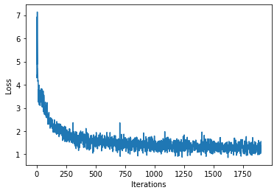

Result:
Found 9 songs in text

Experiment – 2:

### Hyperparameter setting and optimization ###

# Optimization parameters:
num_training_iterations = 2000 # Increase this to train longer
batch_size = 10 # Experiment between 1 and 64
seq_length = 100 # Experiment between 50 and 500
learning_rate = 5e-2 # Experiment between 1e-5 and 1e-1

# Model parameters:
vocab_size = len(vocab)
embedding_dim = 256
rnn_units = 1024 # Experiment between 1 and 2048

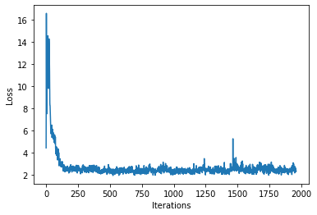

Result

Found 9 songs in text

Experiment 3:

### Hyperparameter setting and optimization ###

# Optimization parameters:
num_training_iterations = 2000 # Increase this to train longer
batch_size = 32 # Experiment between 1 and 64
seq_length = 200 # Experiment between 50 and 500
learning_rate = 5e-3 # Experiment between 1e-5 and 1e-1

# Model parameters:
vocab_size = len(vocab)
embedding_dim = 256
rnn_units = 1024 # Experiment between 1 and 2048

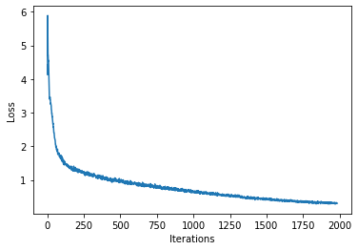

Result:
Found 4 songs in text

Experiment 4:

## Hyperparameter setting and optimization ###

# Optimization parameters:
num_training_iterations = 2000 # Increase this to train longer
batch_size = 64 # Experiment between 1 and 64
seq_length = 300 # Experiment between 50 and 500
learning_rate = 5e-4 # Experiment between 1e-5 and 1e-1

# Model parameters:
vocab_size = len(vocab)
embedding_dim = 256
rnn_units = 1500 #1024 # Experiment between 1 and 2048

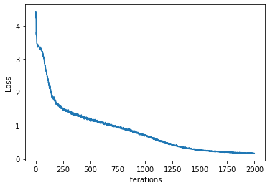

Result:
Found 0 songs in text

Experiment 5:

### Hyperparameter setting and optimization ###

# Optimization parameters:
num_training_iterations = 2000 # Increase this to train longer
batch_size = 64 # Experiment between 1 and 64
seq_length = 400 # Experiment between 50 and 500
learning_rate = 1e-5 # Experiment between 1e-5 and 1e-1

# Model parameters:
vocab_size = len(vocab)
embedding_dim = 256
rnn_units = 2048 # Experiment between 1 and 2048

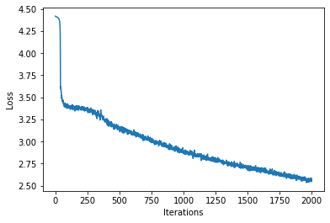

Result:
Found 0 songs in text

