**Git**

Advantages

1. Keeps track of changes in the files and folders
2. Keeps track of the changes made by each individual in collaborative development environment

Version control systems

* SVN and GIT

Git is version control systems. It can work without servers. We can create git repository in local computer.

*How to configure GIT*?

For windows

* Download git from <https://git-scm.com/download/win>
* Install using default settings.
* Check install
  + After install choose open git bash. You should see a window like:

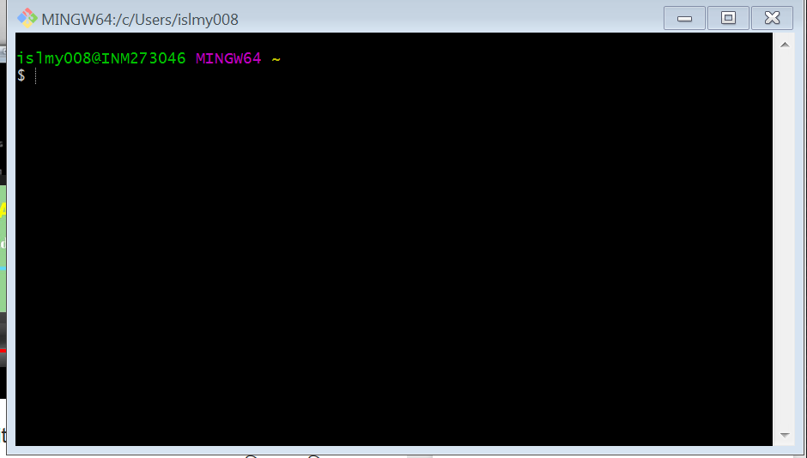

* + Write git in the CLI and press enter. That will show a list of git commands

----

*How to use GIT in local computers*?

-- create a folder for your project

-- click right button inside your folder and start git bash

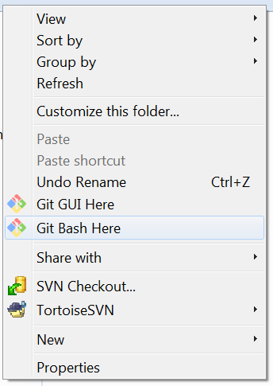

We installed git, now we need to instruct git to start version controlling of our desired project.

-- in the bash write $git init to initialize git and show a message that an empty git repository is created in the desired folder. This command creates some hidden folders in the directory/folder. If we write the command $ls –al it will show us the hidden folders.

**Adding files to repository:**

-- create or copy a file in your repository. Now write the command:

$git add filename

If we make changes and want to save the changes in the file we do a commit

If we make more changes and commit again we create two check points for the same file.

-- git commit creates history of a files

GIT Commands

Git status: shows the list of tracked and untracked files in the directory

*How to use GIT in remote servers*?

How to setup GIT for collaborative development?

* How to create branch
* How to resolve conflicts