**Report on Project_2**

1. Noisy Image Generation

F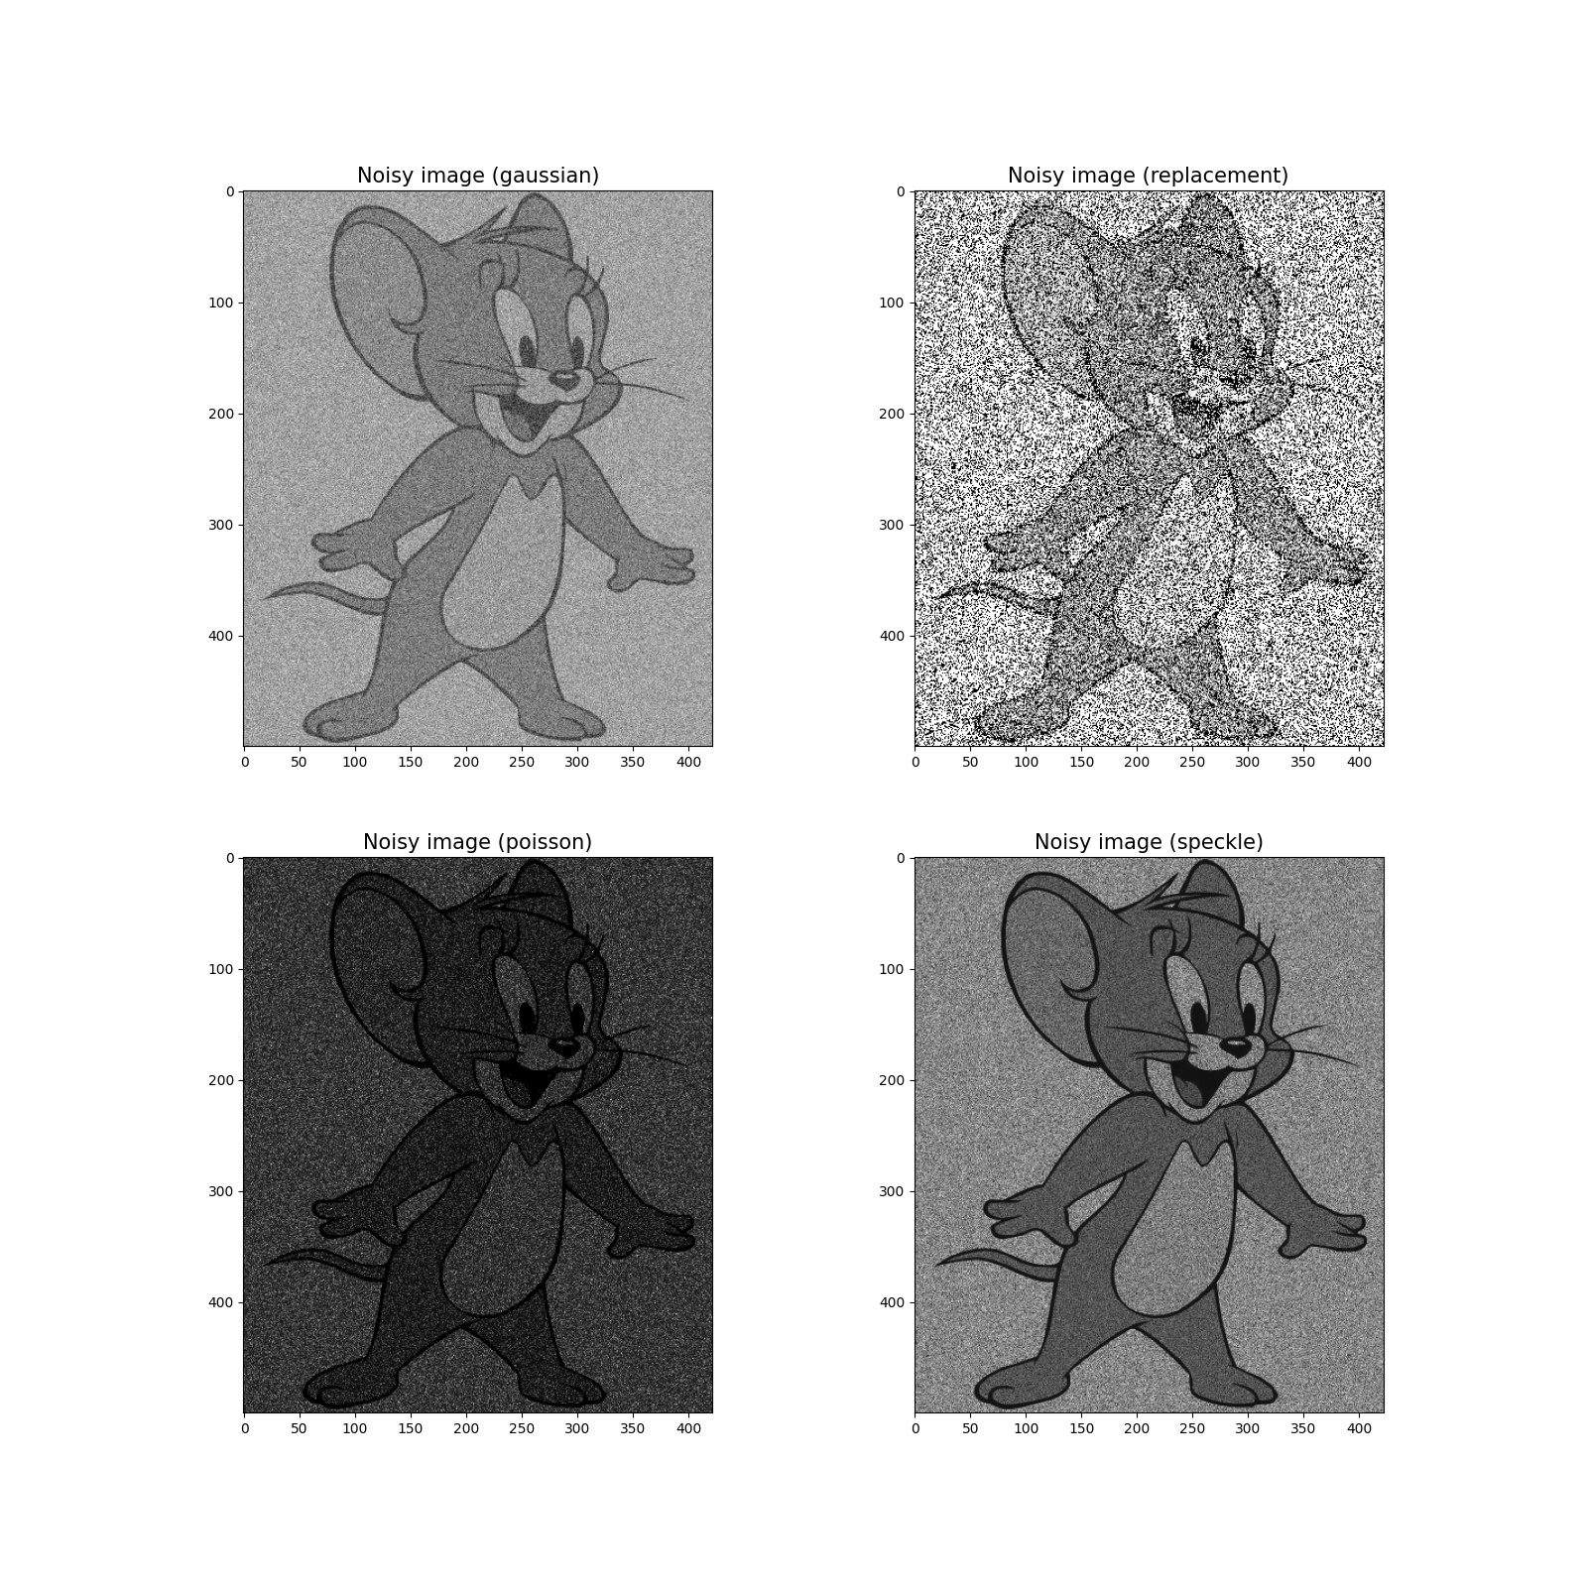or this question, I have used four types of noises: gaussian, replacement(salt and peper), speckle and poisson. Here are some of the output images:

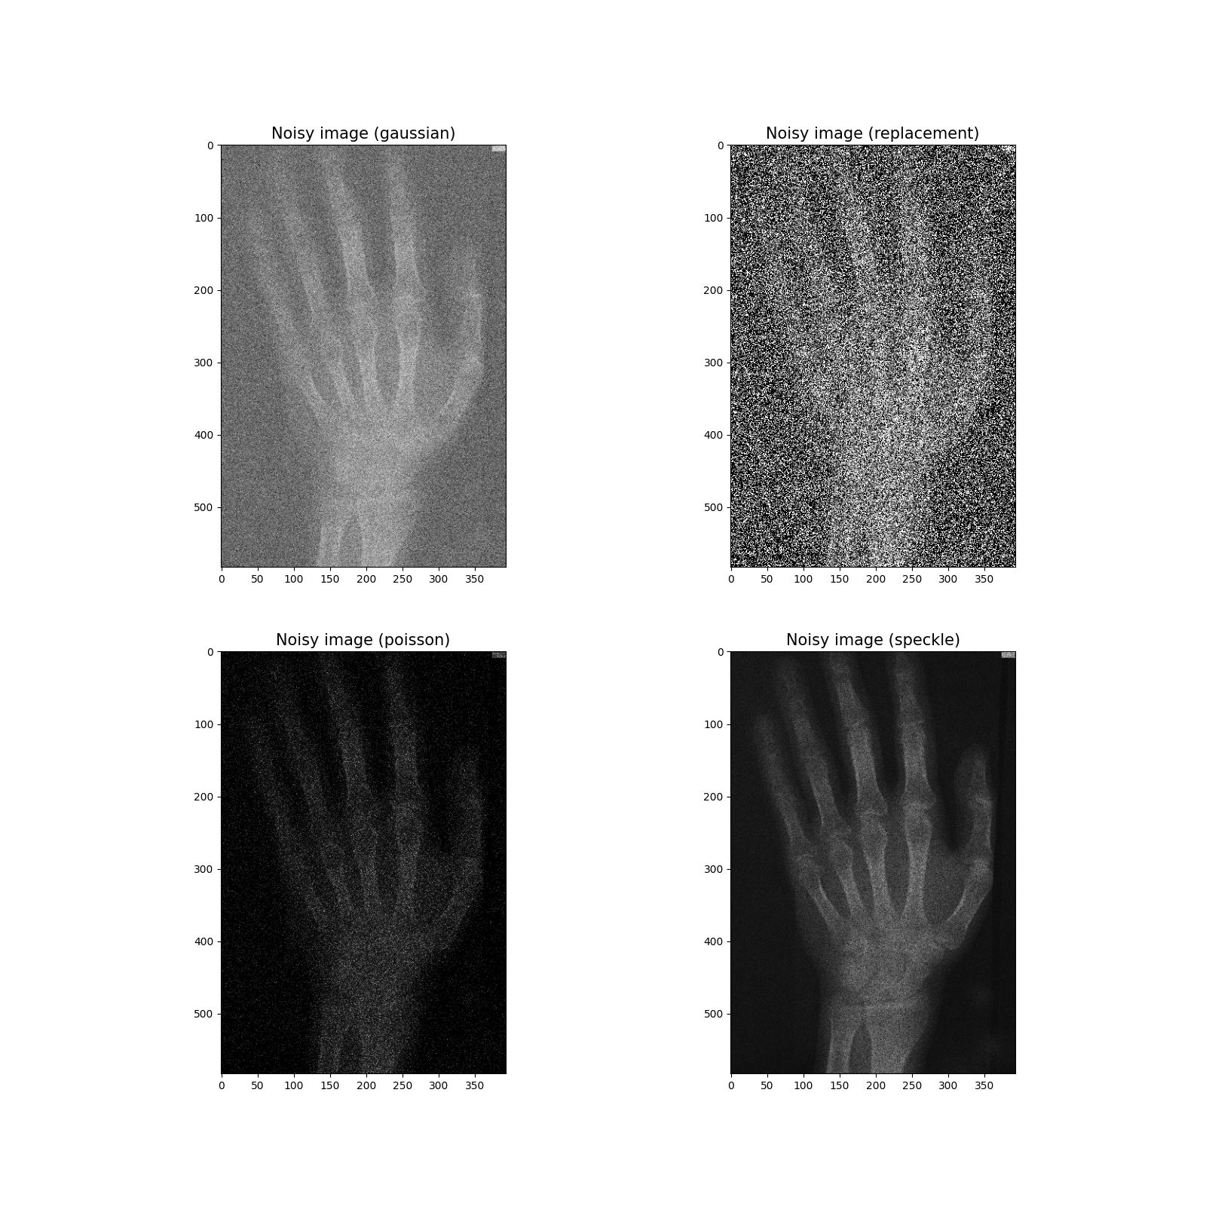Q2 Linear Filtering outputs:

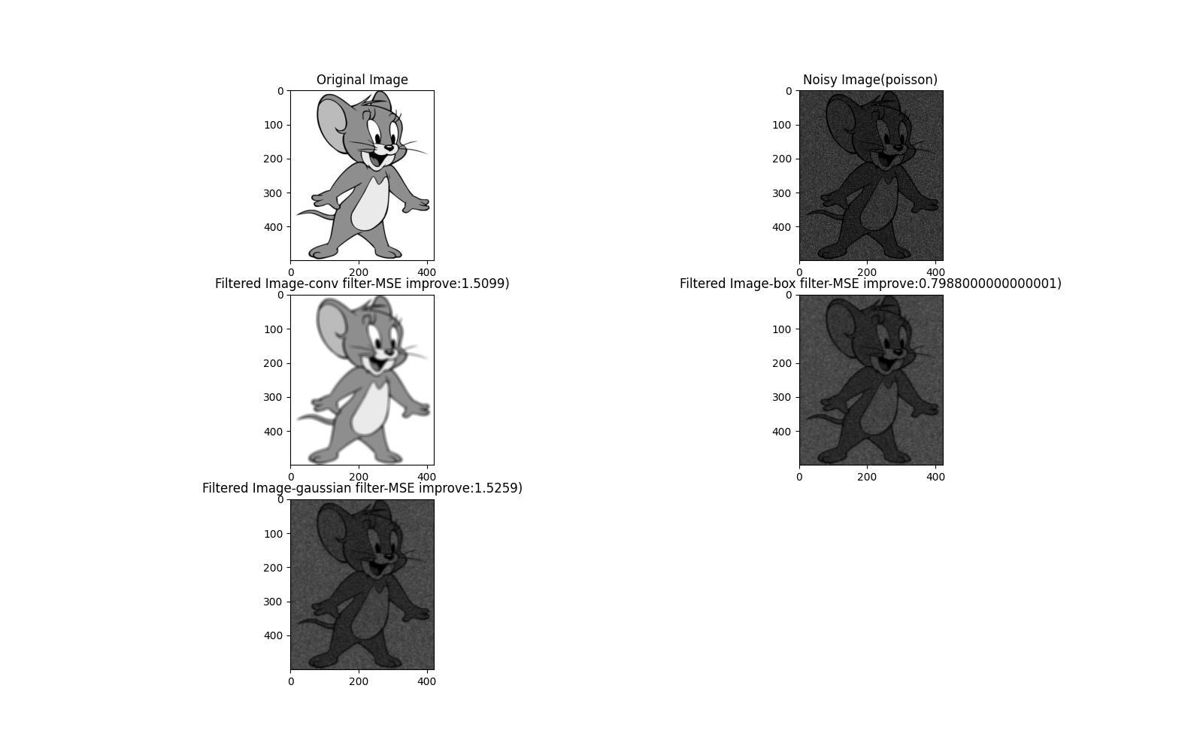

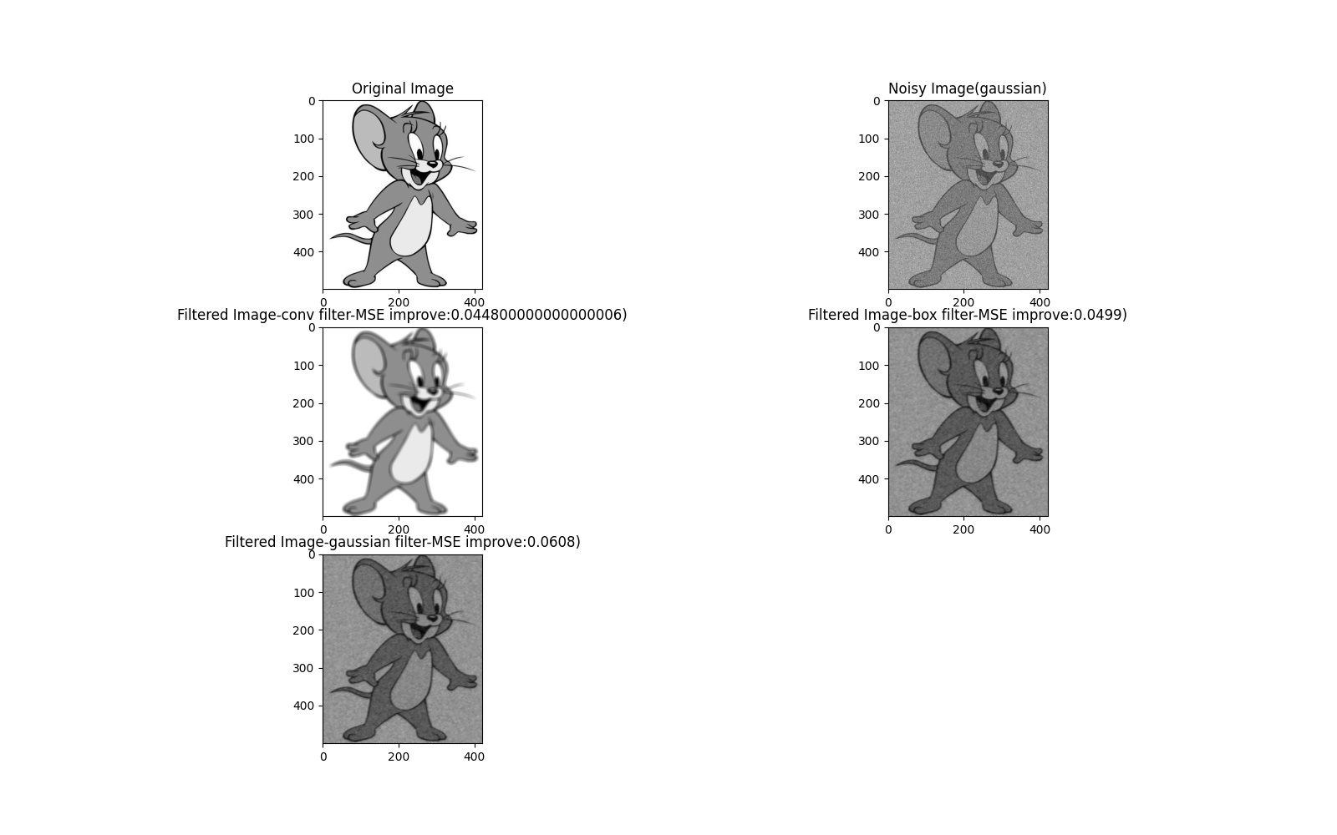Q3 Non-Linear Filtering Outputs:

