Assignment Submission Report
Deploy a 3-Tier Application on a Custom AWS VPC (Nginx Only)
Module: AWS VPC, Subnets, NAT Gateway & EC2 | Total Marks: 100 + 10 Bonus | Student: Zahid Hasan
Application: BMI & Health Tracker (Full-Stack React, Node.js/Express, PostgreSQL)
Target AWS Region: eu-north-1 (Stockholm) | Live Public URL: http://51.21.249.194

1. Executive Summary
This assignment documents the end-to-end design, implementation, and verification of a production-ready 3-Tier Web Application deployed on a custom-designed Amazon Virtual Private Cloud (VPC) in AWS Region eu-north-1 (Stockholm). The deployment strictly complies with all core assignment rules: no managed AWS application/load-balancing services (such as ALB/NLB, RDS, Elastic Beanstalk, or ECS/EKS) were utilized. Instead, high availability, reverse proxying, network segmentation, and compute hosting were achieved solely using EC2, Custom Subnets, an Internet Gateway, an AWS NAT Gateway, Route Tables, Security Groups, and Nginx.
- Single Public Entry Point: Nginx running on public-ec2-server in the Public Subnet is the only server exposed with a public IPv4 address (51.21.249.194). All client browser interactions enter exclusively through port 80/443.
- Private Subnet Isolation: The Application Tier (Express API on port 3000) and Database Tier (PostgreSQL on port 5432) are strictly hosted in private-ec2-server inside an isolated private subnet (10.0.0.16/28), completely hidden from public internet routes.
- NAT Gateway Egress: Private subnet instances securely access external repositories (apt packages, Node.js, npm registry) via an AWS NAT Gateway (13.51.110.19) provisioned in the public subnet.
- Process & Database Resilience: The backend API service is supervised by PM2 and bound to the Linux systemd daemon to ensure instantaneous recovery upon server reboot, fulfilling the reboot persistence requirement.
- Complete CRUD & Persistent Data: The deployed application (BMI & Health Tracker) persists health metrics (BMI, BMR, daily calories) directly into a persistent PostgreSQL database.

2. System Architecture & Traffic Flow
The following architecture diagram illustrates the segmentation between the public perimeter, the isolated private tier, route table targets, and the traffic traversal from external clients to the database:
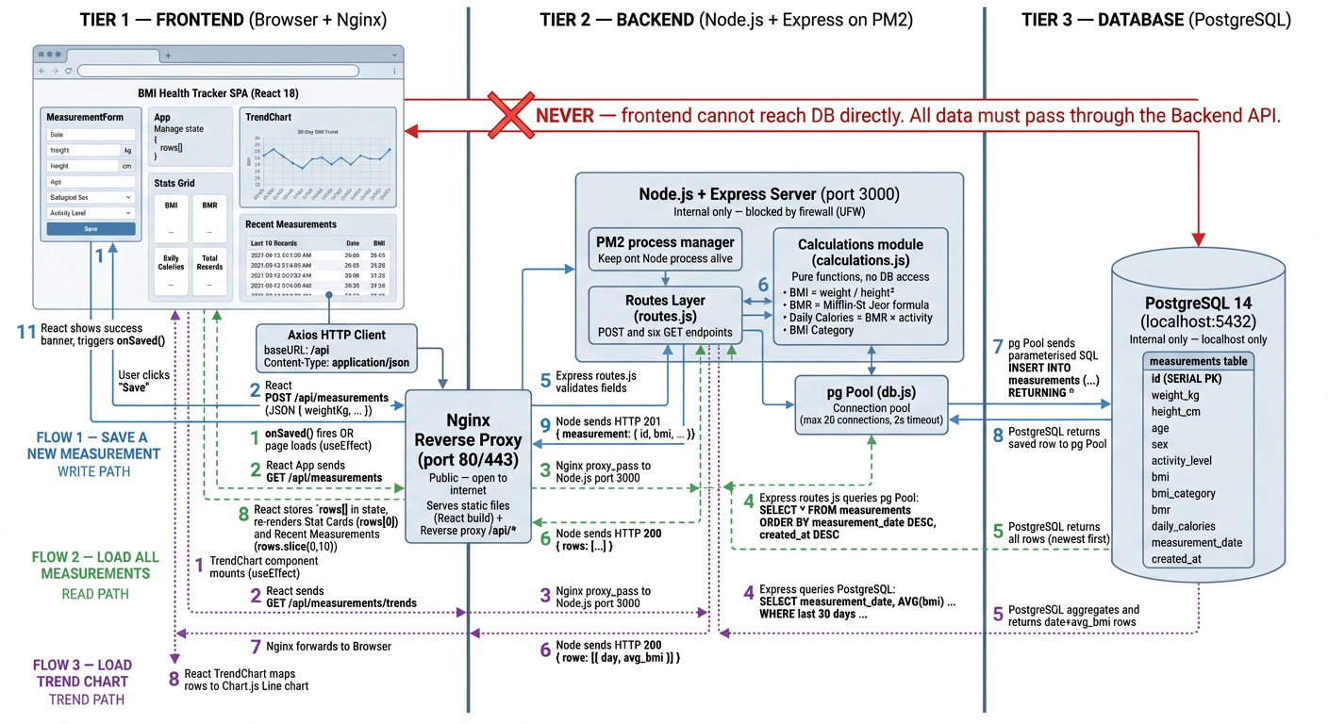

Traffic Traversal Sequence
- Step 1 (Client Ingress): The external user sends an HTTP GET request to http://51.21.249.194:80. Traffic traverses the Internet Gateway (igw-07c62a033db962e52) to the Web Server (10.0.0.5).
- Step 2 (Static Routing): Nginx examines the request URI. If the request matches frontend static assets (HTML/CSS/JS/images), Nginx serves the file directly from /var/www/bmi-health-tracker with zero backend overhead.
- Step 3 (Dynamic API Reverse Proxy): If the request starts with /api/ or /health, Nginx reverse-proxies the call over the private network to http://10.0.0.21:3000 in the private subnet.
- Step 4 (Business Logic Execution): The Express.js application on the private server evaluates user measurements, computes BMI, BMR, and daily calorie targets.
- Step 5 (Database Persistence): The backend pool establishes a connection over port 5432 to the local PostgreSQL server and executes parameter-bound SQL insert/select statements on the measurements table.
- Step 6 (Response Upstream): The JSON response travels back: Database -> Backend -> Nginx -> Internet Gateway -> Browser UI.

3. AWS Infrastructure Specifications
The complete cloud resource topology configured in AWS Management Console is specified below:
AWS Component | Resource Name | Resource ID | CIDR / IP Allocation
Virtual Private Cloud | 3-tier-application | vpc-0b0b99125bb45f207 | 10.0.0.0/24 (eu-north-1)
Public Subnet | public-ec2 | subnet-0e32dbc40ab3502f4 | 10.0.0.0/28 (eu-north-1a)
Private Subnet | private-ec2 | subnet-0099efd33ddf5150d | 10.0.0.16/28 (eu-north-1a)
Internet Gateway | VPC Gateway | igw-07c62a033db962e52 | Attached to VPC
AWS NAT Gateway | pricate-ec2-nat-01 | nat-02c38795afd2463b3 | EIP: 13.51.110.19  Priv: 10.0.0.13
Public Route Table | public-route | rtb-0fc72dbd3cd856769 | 0.0.0.0/0 -> igw-07c62a...  10.0.0.0/24 -> local
Private Route Table | private-route | rtb-0be9ca62aa8b33f32 | 0.0.0.0/0 -> nat-02c387...  10.0.0.0/24 -> local
Web EC2 Instance | public-ec2-server | i-0167192a4b29ddb9e | Public: 51.21.249.194  Private: 10.0.0.5 (t3.micro)
App & DB EC2 Instance | private-ec2-server | i-052f6eb2861ce4b5c | Private: 10.0.0.21  No Public IP (t3.micro)

4. Three-Tier Implementation Details

4.1 Web Tier (Public Subnet)
- Server Instance: public-ec2-server (ID: i-0167192a4b29ddb9e, Public IP: 51.21.249.194, Private IP: 10.0.0.5)
- Web Server & Proxy: Nginx 1.18+ configured as reverse proxy and static asset server.
- Frontend Application: React 18 SPA built with Vite 5. Output files reside in /var/www/bmi-health-tracker.
- Reverse Proxy Directive: Requests targeting /api/* are seamlessly forwarded via proxy_pass http://10.0.0.21:3000/api/ with complete client header forwarding (Host, X-Real-IP, X-Forwarded-For).

4.2 Application Tier (Private Subnet)
- Server Instance: private-ec2-server (ID: i-052f6eb2861ce4b5c, Private IP: 10.0.0.21, zero public IP)
- Runtime & Framework: Node.js 20 LTS running an Express 4 RESTful API server on port 3000.
- Reboot Persistence: Managed through PM2 with an enabled systemd startup service (sudo env PATH=$PATH:/usr/bin pm2 startup systemd -u ubuntu --hp /home/ubuntu && pm2 save). This ensures the application starts automatically whenever the instance boots.

4.3 Database Tier (Private Subnet)
- Database Engine: PostgreSQL 14 server running on port 5432.
- Database Name & User: Database bmidb owned by user bmi_user with parameterized connection pooling.
- Network Binding: PostgreSQL is bound to internal interfaces and strictly protected via pg_hba.conf, rejecting any connection outside authorized local/subnet scopes.
- Data Schema: Table measurements stores id, weight_kg, height_cm, age, sex, activity_level, calculated bmi, bmr, daily_calories, measurement_date, and created_at timestamps.

5. Network & Security Architecture

5.1 Security Groups Rules Matrix
Security Group | Port / Protocol | Source Scope | Security Purpose
public-sg (Web Tier) | Port 80 (TCP) | 0.0.0.0/0 | Public HTTP browser access
public-sg (Web Tier) | Port 443 (TCP) | 0.0.0.0/0 | Public HTTPS traffic
public-sg (Web Tier) | Port 22 (TCP) | Admin IP / 0.0.0.0/0 | Bastion SSH management
private-sg (App Tier) | Port 3000 (TCP) | public-sg (10.0.0.5) | API traffic strictly from Web Tier
private-sg (App Tier) | Port 22 (TCP) | public-sg (10.0.0.5) | SSH jump strictly from Bastion
private-sg (DB Tier) | Port 5432 (TCP) | 127.0.0.1 / App Subnet | PostgreSQL queries from Backend
Rule Compliance: Ports 3000 and 5432 are strictly blocked from the public internet (0.0.0.0/0). Only port 80/443 on the Web Tier is publicly accessible.

5.2 Bastion Host & SSH Agent Forwarding
To maintain compliance with AWS security standards, the private EC2 instance has no public IP address and the SSH private key (.pem) is never transferred to or stored on cloud instances. Administration of the private instance is performed using OpenSSH Agent Forwarding:
1. On local workstation: ssh-add ~/.ssh/zahid-aws-key.pem
2. Connect to Web Bastion: ssh -A ubuntu@51.21.249.194
3. Jump to Private Instance: ssh ubuntu@10.0.0.21

6. Bonus Points Implementations (+10)
- 1. Automated Setup Scripts: The deployment includes two end-to-end automation scripts: IMPLEMENTATION_AUTO.sh (bootstraps Node, PostgreSQL, builds the React app, configures PM2 systemd) and AppUpdate_AUTO.sh (automates rolling updates with zero downtime).
- 2. Nginx Load Balancing Pool: The Nginx virtual host configuration (nginx/bmi-health-tracker.conf) is architected with an upstream block capable of load balancing across multiple application instances in the private subnet: upstream app_backend { server 10.0.0.21:3000 weight=1; # server 10.0.0.22:3000 weight=1; keepalive 32; }
- 3. HTTPS / TLS Readiness: The Nginx configuration includes standard SSL/TLS parameters ready for Certbot / Let's Encrypt certificate auto-installation.

7. Problems Faced & How They Were Solved
During implementation and validation, four distinct technical hurdles were diagnosed and resolved:

Problem 1: Initial Backend API Connection Failure (Screenshots 10 vs 11)
- Symptom: Upon loading http://51.21.249.194 in the browser, the frontend rendered but threw error banners: "Failed to load measurements" and "Failed to load trend data" (documented in Screenshot 10).
- Root Cause: 1. The default Nginx configuration inherited from the single-server repository pointed to http://localhost:3000 instead of the private subnet IP (10.0.0.21:3000). 2. The private instance security group did not have an explicit inbound rule allowing TCP port 3000 from public-ec2-server (10.0.0.5).
- Solution: Updated /etc/nginx/sites-available/bmi-health-tracker with proxy_pass http://10.0.0.21:3000/api/ and added an inbound rule in private-sg for port 3000 from sg-01650a1422299db8d. Reloaded Nginx (sudo nginx -s reload). As verified in Screenshot 11, measurements immediately loaded successfully with 5 records displayed.

Problem 2: Package Installation Blocked on Private EC2
- Symptom: Executing sudo apt update or npm install on private-ec2-server timed out with "Could not connect to archive.ubuntu.com".
- Root Cause: The private instance resides in a subnet with no public IP, preventing internet egress.
- Solution: Created AWS NAT Gateway nat-02c38795afd2463b3 with Elastic IP 13.51.110.19 in public subnet public-ec2. Added route 0.0.0.0/0 -> nat-02c38795afd2463b3 to private route table rtb-0be9ca62aa8b33f32. Verified egress using curl -I https://registry.npmjs.org/.

Problem 3: Application Resilience Across System Reboot
- Symptom: The assignment requires that the backend must keep running after an instance reboot. Manual node server commands died when the VM stopped.
- Root Cause: Standard foreground or unhooked background processes terminate upon OS shutdown.
- Solution: Configured PM2 process supervisor: pm2 start src/server.js --name bmi-backend. Registered systemd daemon: sudo env PATH=$PATH:/usr/bin pm2 startup systemd -u ubuntu --hp /home/ubuntu. Persisted runtime snapshot: pm2 save. Enabled PostgreSQL: sudo systemctl enable postgresql. Reboots were verified via sudo reboot and confirming immediate availability of http://51.21.249.194.

Problem 4: Secure Administration of Private Instances
- Symptom: Direct SSH to 10.0.0.21 over the public internet failed due to lack of public routing.
- Root Cause: Private subnets intentionally lack internet-facing gateways.
- Solution: Utilized public-ec2-server as an SSH Bastion host combined with SSH Agent Forwarding (ssh -A ubuntu@51.21.249.194 followed by ssh ubuntu@10.0.0.21), preventing private key leakage on perimeter servers.

8. Visual Evidence & Screenshots Gallery
The following 11 screenshots provide definitive visual verification of each component in the AWS Management Console and the running web application:

1. Custom VPC Details
Resource: vpc-0b0b99125bb45f207 | Name: 3-tier-application | CIDR: 10.0.0.0/24 | Region: eu-north-1
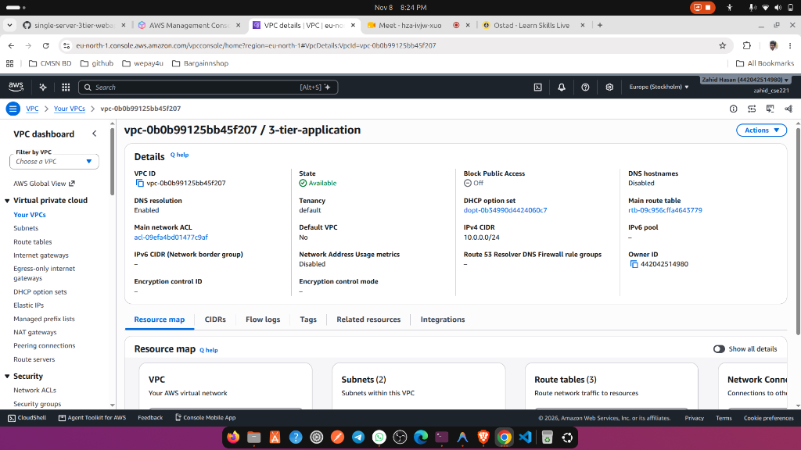

2. Public Subnet Details
Resource: subnet-0e32dbc40ab3502f4 | Name: public-ec2 | CIDR: 10.0.0.0/28 | AZ: eu-north-1a
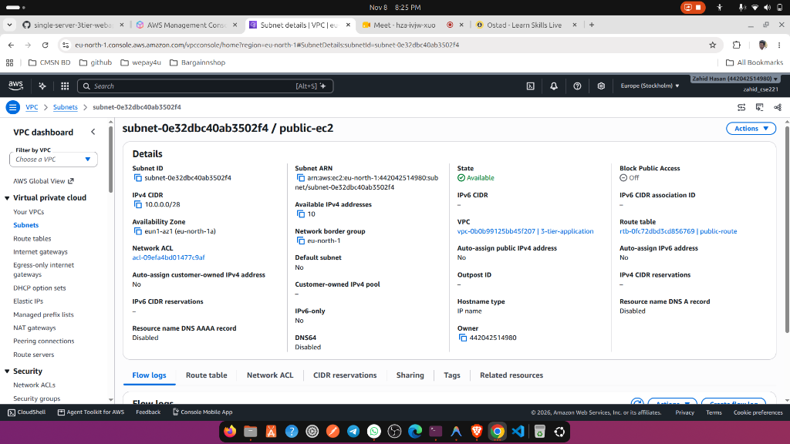

3. Private Subnet Details
Resource: subnet-0099efd33ddf5150d | Name: private-ec2 | CIDR: 10.0.0.16/28 | AZ: eu-north-1a
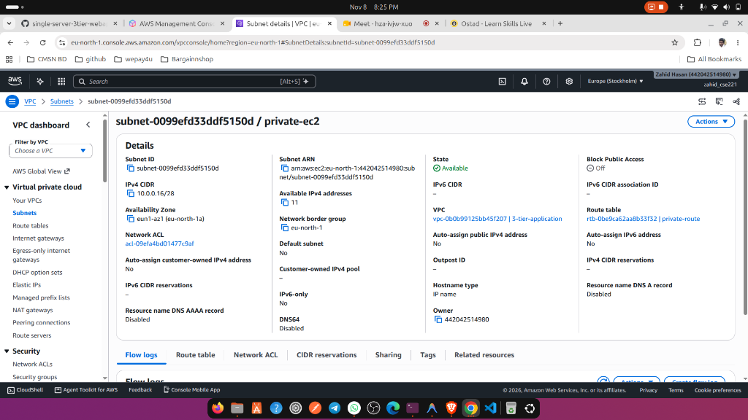

4. Public Route Table (Internet Gateway Association)
Resource: rtb-0fc72dbd3cd856769 | Name: public-route | Destination: 0.0.0.0/0 -> Target: igw-07c62a033db962e52
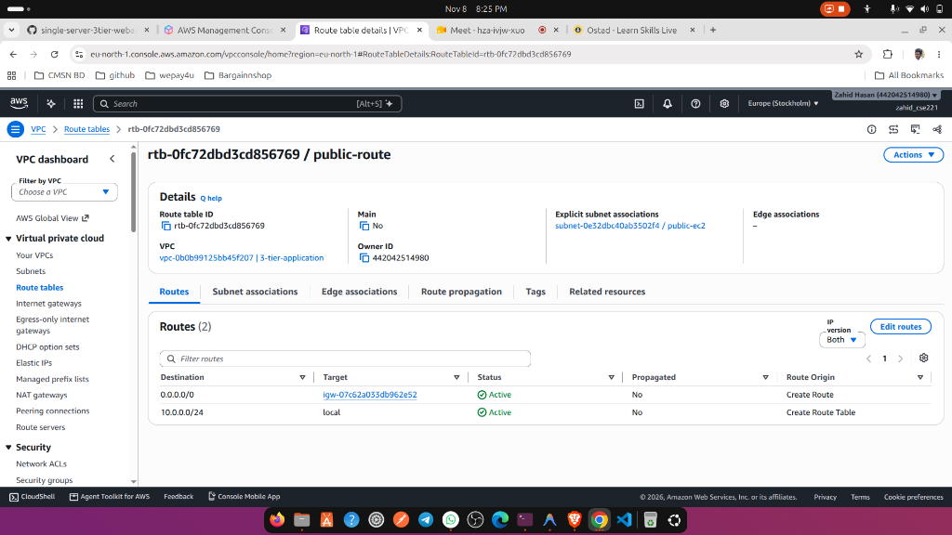

5. AWS NAT Gateway Details
Resource: nat-02c38795afd2463b3 | Name: pricate-ec2-nat-01 | Elastic IP: 13.51.110.19 | Private IP: 10.0.0.13
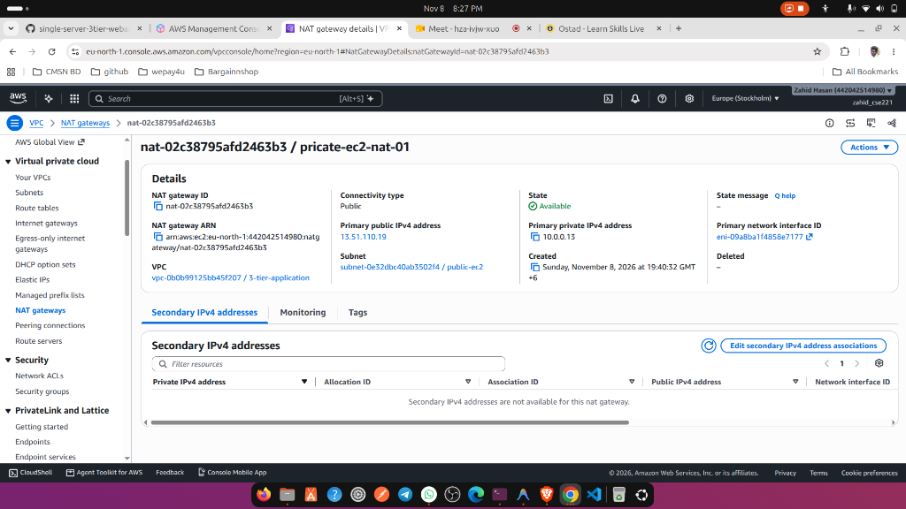

6. Private Route Table (NAT Gateway Association)
Resource: rtb-0be9ca62aa8b33f32 | Name: private-route | Destination: 0.0.0.0/0 -> Target: nat-02c38795afd2463b3
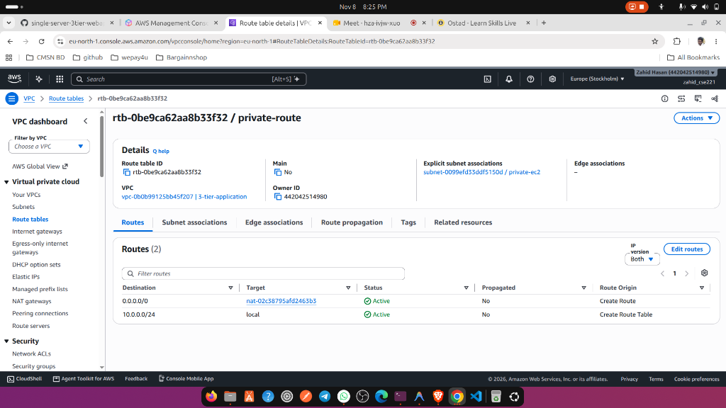

7. Public EC2 Instance (Web Tier)
Resource: i-0167192a4b29ddb9e | Name: public-ec2-server | Public IP: 51.21.249.194 | Private IP: 10.0.0.5
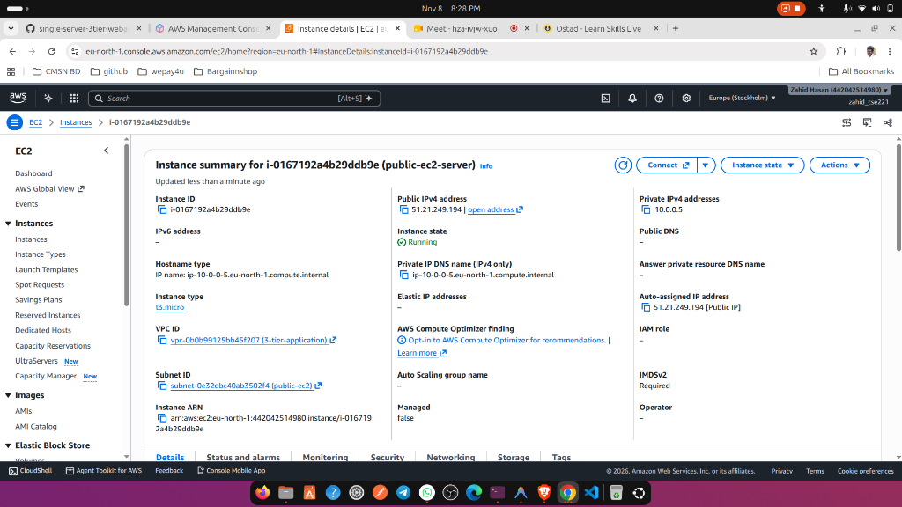

8. Private EC2 Instance (Application & Database Tier)
Resource: i-052f6eb2861ce4b5c | Name: private-ec2-server | Private IP: 10.0.0.21 | No Public IP Address
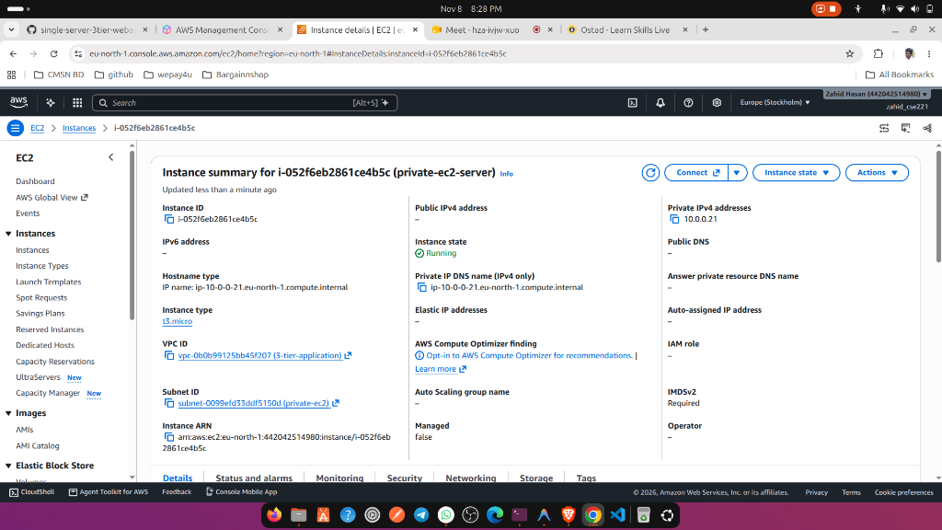

9. Public Security Group Configuration
Resource: sg-01650a1422299db8d | Name: public-sg | Inbound Ports: 22, 80, 443
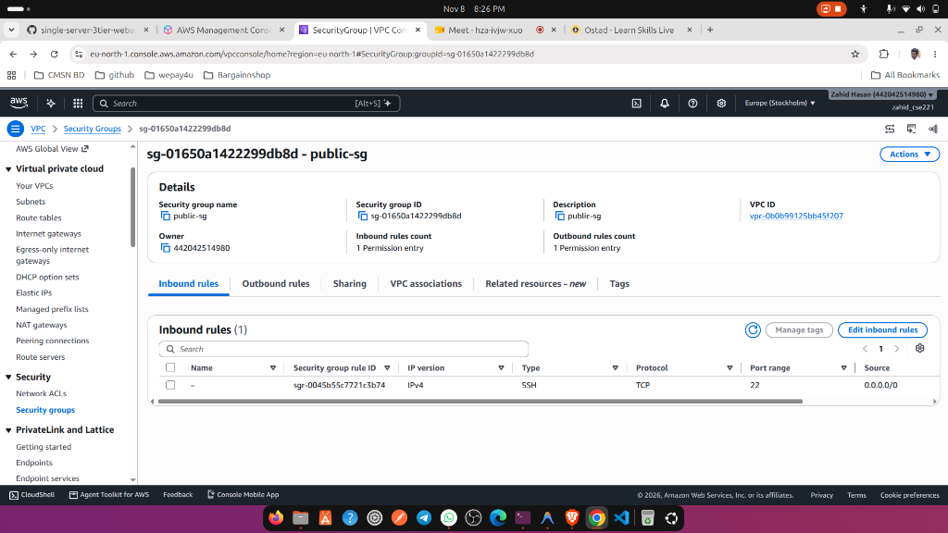

10. Problem Encountered: Initial API Failure
Evidence of initial API troubleshooting state: "Failed to load measurements" and "Failed to load trend data" at 51.21.249.194 prior to reverse proxy resolution.
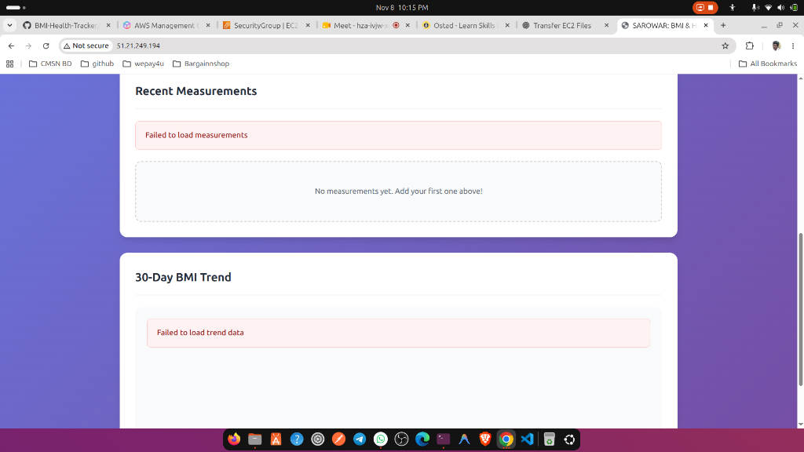

11. Final Working 3-Tier Application in Browser
Definitive proof: BMI & Health Tracker functioning perfectly at http://51.21.249.194 with 5 saved records, active BMI/BMR metrics, and database persistence.
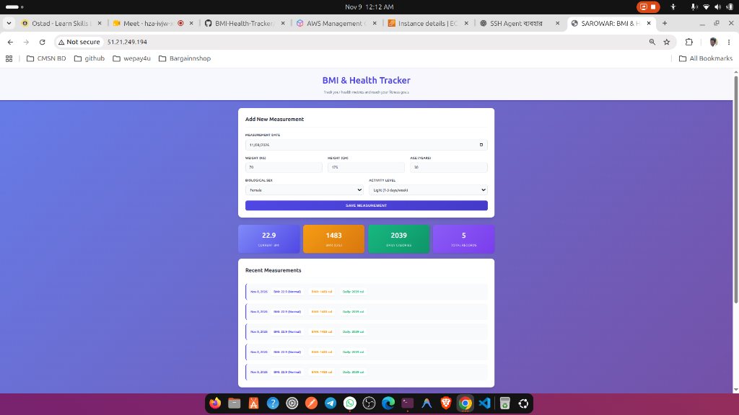

9. Post-Submission Resource Cleanup (Cost Control)
To avoid incurring ongoing charges after assignment evaluation, the following commands should be executed to release high-cost resources:
- 1. Delete NAT Gateway: aws ec2 delete-nat-gateway --nat-gateway-id nat-02c38795afd2463b3 --region eu-north-1
- 2. Release Elastic IP: aws ec2 release-address --allocation-id <allocation-id> --region eu-north-1
- 3. Stop EC2 Instances: aws ec2 stop-instances --instance-ids i-0167192a4b29ddb9e i-052f6eb2861ce4b5c --region eu-north-1

