**Git & GitHub complete Note**

1. **git –version**
2. **Ctrl+L >>clear terminal**
3. **git config**
4. **git config –list**
5. **git config --global user.email "**[**zahidhasan6474@gmail.com**](mailto:zahidhasan6474@gmail.com)**"**
6. **git config --global user.name "zahidhasan2"**
7. **git congif user.name**
8. mkdir first-repo
9. cd first-repo
10. git init
11. ls –a
12. touch one.txt(write something)
13. git status
14. git add one.txt
15. git add .
16. git diff
17. git restore one.txt
18. git rm –cached one.txt
19. git commit –m”Message”
20. git log
21. git add . && git commit –m” Message”
22. git reset --soft HEAD^
23. git reset HEAD^
24. git reset --hard HEAD^
25. git log --oneline
26. git show
27. git show comment_id
28. git show HEAD~number
29. git checkout comment_id
30. git pull

* How to connect Local Repository to Remote Repository -git & GitHub:

1.git remote add name “Remote URL”

2.git remote

3.git remote –v

4.git clone “Remote URL”

5.rm –rf first-repo

6.git branch

7.git checkout feature-1

8.git branch - d feature-1

9. git checkout –b “feature-10” //create branch and switch also

10.git merge feature-10

fast forward merge (2-way) -git & github

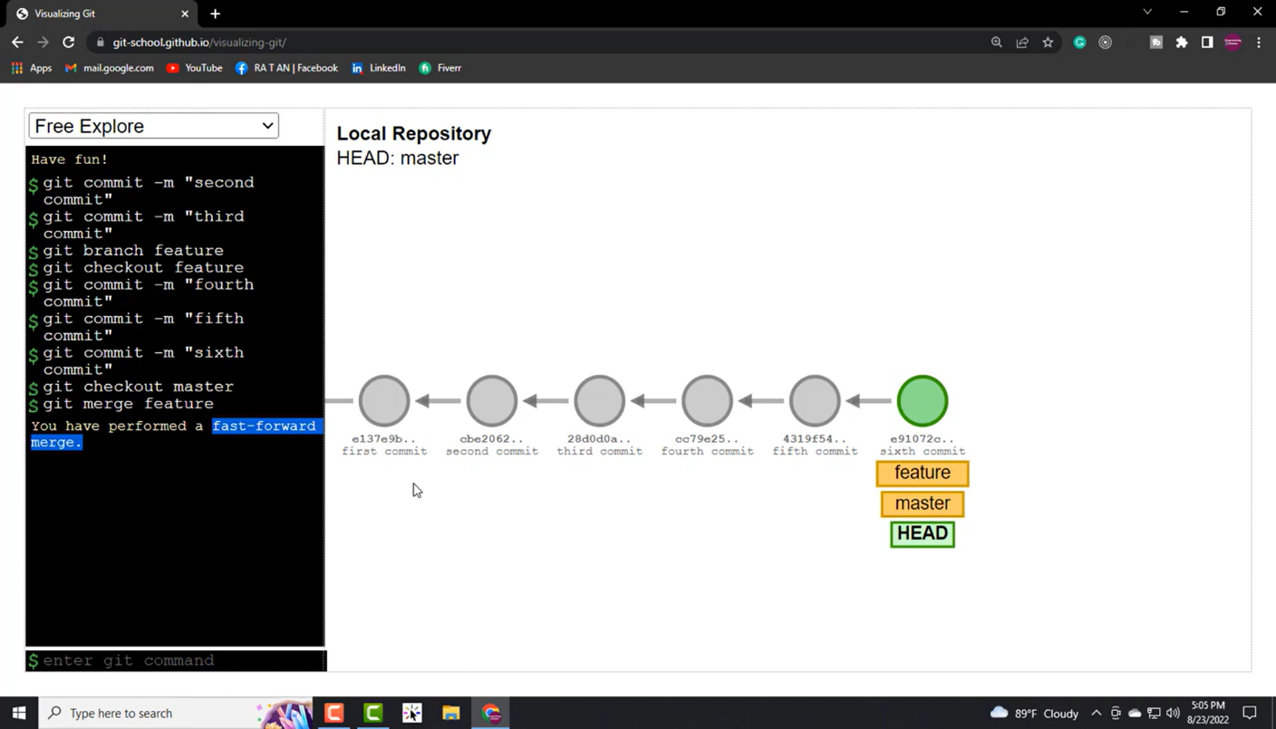

# fast forward merge (3-way) -git & github

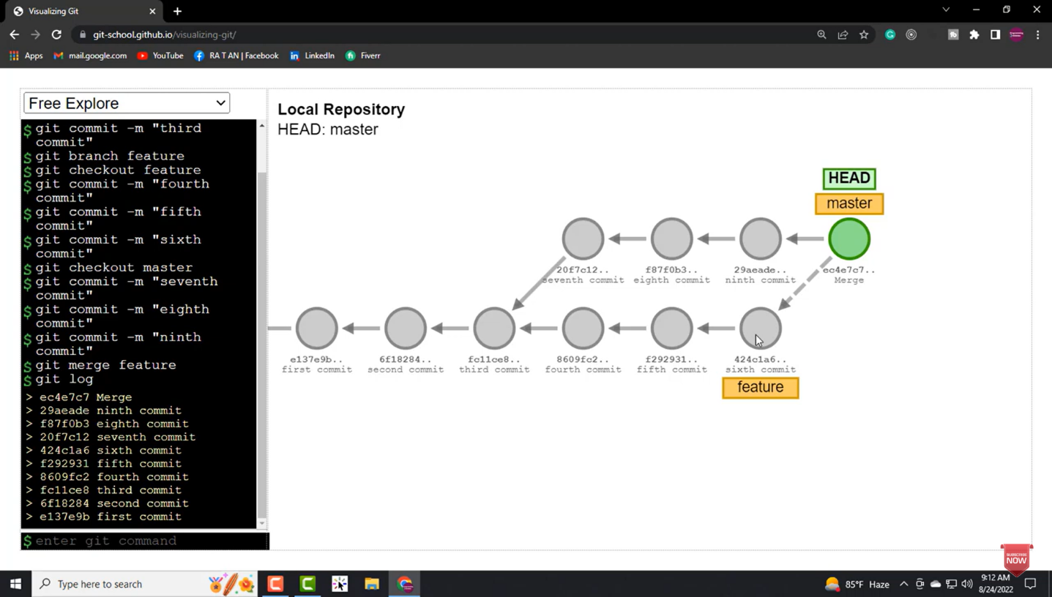

# resolved merge conflict git -git & github:

resolved merge conflict git -git & github

