Modified 6LoWPAN and UDP for IoT Devices

Name: Hasan Md Zahid
Id :17-34297-1
Department of Computer Science
American International UniversityBangladesh Dhaka,Bangladesh
jahid1234.jh@gmail.com

Name : Tahmidul Hasan Name: Sadia Afrin
Id :16-32886-3 Id :17-33877-1
Department of Computer Science Department of Computer Science
American International University Bangladesh American International University Bangladesh
Dhaka,Bangladesh Dhaka,Bangladesh

Abstract
In 6LoWPAN, while packet transferring TCP protocol is time consuming. So UDP is vastly used for 6LoWPAN but UDP is not reliable which can cause major problems. By taking advantages of TCP, the RUDP is a reliable connection-oriented protocol, which uses a three-way handshaking for connection establishment and a resending mechanism for packet loss. So we proposed a modified version of RUDP which will include an serial ID as header. We performed several sets of experiments to analyze the performance of the RUDP, comparing with that of the TCP and UDP to show the modified RUDP is faster and more reliable. We also perform an analytical comparison between two routing schemes in terms of the packet/fragment arrival probability.

Keywords: 6LoWPAN, RUDP, UDP.

1.Introduction
The augmentation of web availability into physical gadgets and ordinary items is Internet of Things.Different forms of devices can communicate and interact with other devices over the internet by the help of IoT which can be remotely monitored and controlled. One of the emerging technologies supporting IoT is 6LoWPAN. 6LoWPAN has characterized embodiment and header pressure component that empowers the utilization of IPv6 in IEEE 802.15.4low power and remote systems. That is, I can be applied in embedded applications for examples monitoring, building automation, security, object tracking, nuclear reactor control, fire detection and traffic monitoring and even in several human centered applications. The pressure of IPv6 and headers connected by UDP alongside fracture and work tending to highlights. 6LoWPAN pressure is stateless, and hence extremely basic and dependable.
This paper will discuss about modified 6LoWPAN and UDP for IoT devices by proposing new characteristics for RUDP and comparing it with TCP and UDP. It will show RUDP will able to be faster and simple than others. We also apply performed measurement on various number of packets and calculated the delay of packets to detect the packet loss.
This paper is composed as pursues. Area 2 portrays the foundation. Section 3 introduces the RUDP protocol and its characteristics. In section 4, experimental results of performance are presented in several aspects. Section 5, discuss the routing protocol. Section 6, shows the analysis. Section 7, shows the observation. Then we conclude in the last section.

2.Background
The IETF standard [5] deﬁnes the overview, assumptions, problem statement and goals for 6LoWPANs. The packet size of IPv6 is much larger than the MTU of IEEE 802.15.4 data link layer which leads to the fragmentation and compression of IPv6 packets. Energy eﬃciency is also an important issue for the transmission of 6LoWPANs. 6LoWPAN is an IETF standard about how to transit IPv6 packets over LoWPANs which is described in RFC 4944 [2]. 6LoWPAN introduces an adaptation layer between data link and network layers in TCP/IP protocol stacks 6LoWPAN also employs the mesh forwarding in data-link layer to deliver an IPv6 packet from source to destination over a multi hop scenario. One byte dispatch value of adaptation layer is employed to determine whether the frame is a LoWPAN frame or not. If the frame is a LoWPAN frame then type speciﬁc headers are taken place as part of dispatch value. The TCP is time consuming protocol for 6LoWPAN. UDP is vastly used for 6LoWPAN applications like home automation, automated factory etc. But UDP is not reliable which can cause major problems. And disappointment among the users.

3 Reliable UDP Protocol

In this section, we introduce the Reliable-UDP (RUDP) protocol with its characteristics which we developed
specially for 6LoWPAN protocol and IoT devices. We also compare the major characteristics among UDP, RUDP and TCP.
3.1 The RUDP protocol we propose has the following characteristics to ensure the reliable delivery between two parties:
- In order to establish a connection, the RUDP uses three-way handshaking with serialID agreement.
- The serialID is used for the sequences of communication.
- If any serialID is missing the receiver send and acknowledge to the sender.
- For recovery from a packet loss, the sender resends the same packet .
- In the mean time at receiver end, the last received serialID is formed into a loop.
- After receiving the lost packet the loop ended and the sequence continue.
3.2 Characteristic Comparison among the UDP, RUDP, and TCP In order to compare the major characteristics of UDP, TCP, and RUDP protocols, we list out considerable issues which are valuable in communication Quality of Service criteria.
• Connection-Oriented: A process of negotiation occurs to establish a connection, ensuring that both communication parties agree on how data is to be exchanged.

•Reliable: This characteristic helps to keep track of data that has been sent and received by ensuring all transmissions send to their destinations.

• Bidirectional: Both communication parties on a connection can send and receive in bidirectional, regardless of which of them initiates the connection.

• Acknowledged: It is whether unsuccessful transmissions are acknowledged, so that it can provide reliability.

• Stream-Oriented: This characteristic allows applications to send a continuous stream of data for transmission. Applications don't need to worry about making this into chunks for transmission.

• Data-Unstructured: there are no natural divisions between data elements in the application's transmitted data.

• Data-Flow-Managed: This ensures that data flows evenly and smoothly, by dealing with problems that arise along the way.

3.3 Table 1 : Comparison of Communication Protocol Characteristics

Characteristics | UDP | R-UDP | TCP
Connection-Oriented | No | Yes and fast | Yes but slow
Bidirectional | No | Yes | Yes
Multiply-Connected and Endpoint-Identified | No | Yes | Yes
Reliable | No | Yes | Yes
Acknowledge | No | Yes | Yes
Stream-Oriented | No | No | Yes
Data-Unstructured | No | No | No
Data-Flow-Managed | No | Yes | Yes

.4.Experimental Environment
In order to measure the performance of the proposed protocol RUDP, we set up the following experimental environment
The system topology consists of two machines: one for executing all clients and the other for executing the server. These systems were interconnected on an isolated network using a single network switch to remove unrelated traffic. Both server and client have the same system configuration as follows:
• Hardware configuration: Intel Pentium 4 3.0Ghz, 1 Gb RAM. • Platform configuration:
o Java version: Windows server 2003, Java(TM) 2 Runtime Environment, Standard Edition (build 1.4.2_04-b04), Java Hot-Spot(TM) Client VM (build 1.4.2_04-b04, mixed mode)
o .NET version: Windows server 2003, Microsoft .NET Framework version 1.1
• Network setting: Client and server are on the same network segment. 100Mbps Ethernet connection.
4.1 Performance Measurement on Various Numbers of Packets

In order to measure the performance improvement of RUDP compared to TCP, the first set of experiments is designed with various numbers of packets having the same packet size. To generate packets, the client machine creates threads as many as packets generated, and starts to transmit those packets toward the server. Thus, the number of packets is equal to the number of clients connected to the server. By increasing the number of packets, we measure the total elapsed time of transmitting packets. The size of each packet is 1024 bytes and the maximum waiting time is one second, where during the waiting time the RUDP client or server waits for the reply and, if there is no reply, it resends the packet that is previously sent.
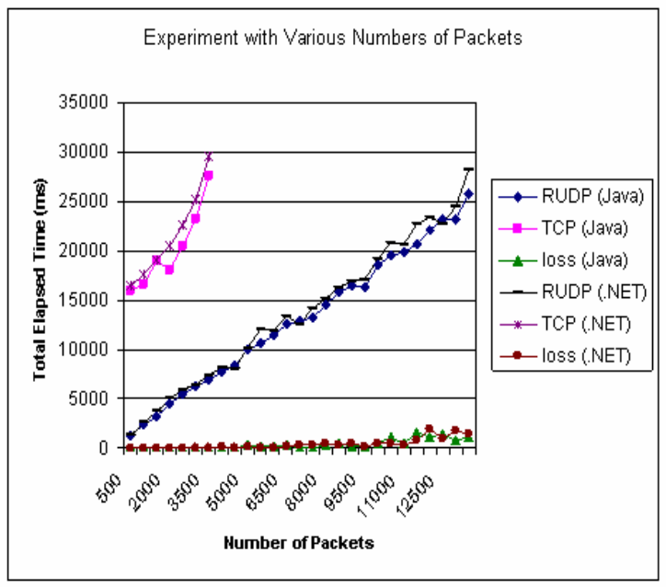
Fig 1 Performance Results with Various Numbers of Packets

4.2 Performance Measurement on Various Number of Packets
In this experiment, we also find that the TCP has the limitation to establish TCP communication connections with the server. In the TCP communication, a server cannot accept more than 4000 packets, since a server cannot create the large number of sessions. In contrast, the RUDP does not have any limitation to accept packets: the more the clients want to send requests, the more the RUDP can process.

4.3 Performance Measurement on Various Sizes of Packets
The next experiment is to measure transmission time by changing packets sizes. We fix the same number of packets generated. In this scenario, the number of generated packets is fixed to 2000 and the maximum waiting time is 1 second.
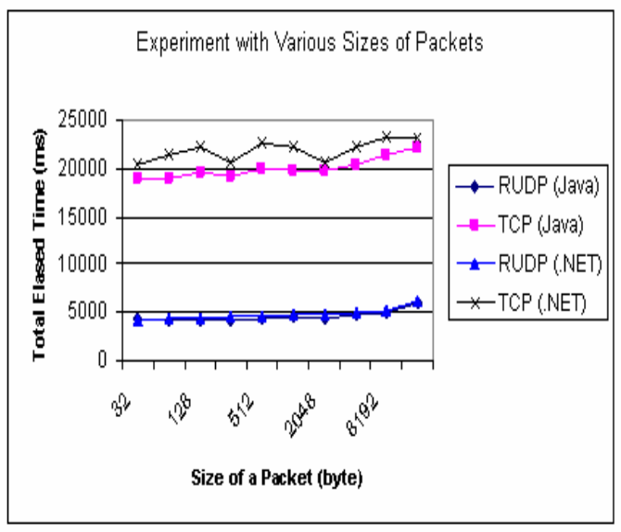
Fig. 2 Performance Results with Various Sizes of Packets
4.4 Performance Measurement on Various RUDP Waiting Time
In this set of experiments, we want to observe the effect of the RUPD waiting time on the overall performance. We change the maximum waiting time of RUDP from one second up to ten seconds in this test set. The size of a packet is fixed to 1024 bytes and we test with two different sets: one with 2000 packets and the other with 5000 packets.

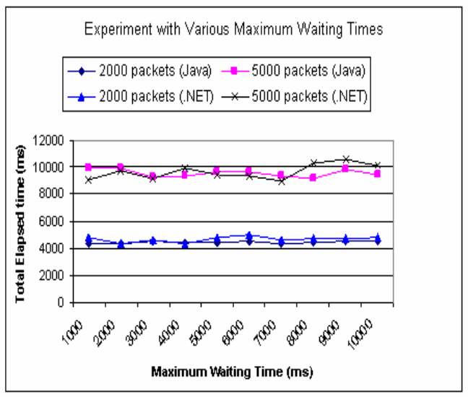
Fig 3 Performance Results with Various Waiting Times

5. ROUTING IN 6LOWPAN
The routing protocol in 6LoWPAN is sensitive because capabilities of nodes are limited in terms of energy, transmission range etc. There have been various improvements of routing conventions for LoWPAN ([7]∼ [10]). In light of utilization situations, the routing in 6LoWPAN can be classiﬁed as, ﬂooding, data-aware routing, geographic routing, probabilistic routing, event-driven, query-based routing and hierarchical routing, occasion driven, inquiry based routing and progressive routing . In view of which layer the steering choice . the datagram sending happens we can separation steering conventions in 6LoWPAN into two classes: the mesh under and the route over.
5.1 Mesh-under
In Mesh under plan, the system layer does not play out any IP steering inside a LoWPAN. The adaption layer plays out the work directing and advances parcels to the goal over different radio jumps. In mesh under plan, routing and sending are performed at connection layer dependent on 802.15.4 casing or the 6LoWPAN header. To send a bundle to a specific goal, the EUI 64 bit location or the 16 bit short location is utilized and sent it to a neighbor hub to draw the parcel nearer to the goal. Various network layer jumps are utilized to finish a solitary IP bounce thus it is called Mesh under. 6LoWPAN utilizes the possibility of the originator and the ﬁnal address to portray the first source and a definitive goal hub of a solitary IP jump inside a PAN individually. As the link layer originator and the ﬁnal destination address are included within the 6LoWPAN header, the mesh delivery for any protocol on the adaptation layer is possible. An IP bundle is divided by the adjustment layer to various parts. These pieces are conveyed to the following bounce by work steering and in the end reach to the goal. Diﬀerent parts of an IP parcel can experience diﬀerent ways and they are assembled at the goal. In the event that all pieces are come to effectively, at that point the adjustment layer of the goal hub reassembles all parts and makes an IP parcel. In case of any fragment missing in the forwarding process the entire IP packet i.e. all fragments for this IP packet are retransmitted to the destination for recovery.
5.2 Route-over
In Router-over plan all routing choices are taken in the system layer where every hub goes about as an IP switch. In router over, each connection layer jump is an IP bounce. The IP routing bolsters the sending of parcels between these connections. In the sending procedure IP routing tables and IPv6 jump by bounce alternatives are utilized. For routing and sending forms the system layer takes choice utilizing the extra embodied IP header. The adaption layer of 6LoWPAN sets up an immediate mapping between the edge and the IP headers. At the point when an IP parcel is divided by the adaption layer, parts are sent to the following bounce dependent on the directing table data. The adaption layer of the next hop checks received fragments. In the event that all parts are gotten effectively, the adaption layer makes an IP parcel from sections and send it to the system layer. On the off chance that the bundle is bound for itself, the network layer sends the IP parcel to the transport layer, otherwise forwards the packet to the next hop based on the routing table information. On the off chance that there are at least one sections missing, at that point all pieces are retransmitted to one jump separation. Subsequent to getting all sections effectively the adjustment layer makes an IP bundle from these pieces and pass it to the system layer. The system layer then advances or procedures the IP parcel dependent on the goal of the bundle and the routing table data.

the adaption layer. Additionally, expect that h be the quantity of bounces gone by each section from source to goal.

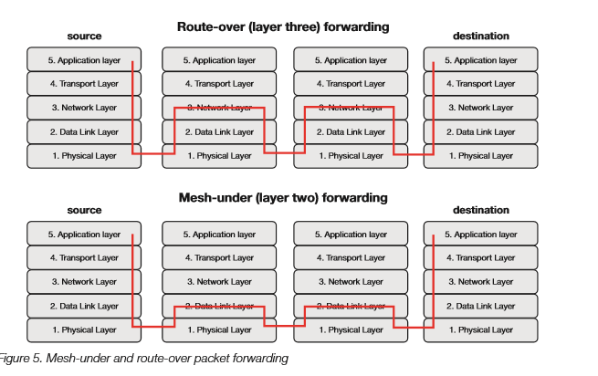6.CONCLUSION
In this paper, we proposed new characteristics of RUDP which is a modified version. This RUDP can perform faster, reliable and manage data flow control. By taking advantages of TCP, the RUDP is a reliable connection-oriented protocol, which uses a three-way handshaking for connection establishment and a resending mechanism for packet loss. We performed several sets of experiments to analyze the performance of the RUDP, comparing with that of the TCP and UDP. It also shows that between routing protocols, route-over scheme is more reliable to deliver fragments from the source to the destination and mesh-under scheme outperformed in case of total delay.

7. REFERENCES
[1] Aminul Haque Chowdhury, Muhammad Ikram, Hyon-Soo Cha, Hassen Redwan, S.M. Saif Shams, Ki-Hyung Kim, Seung-Wha Yoo. “Route-over vs Mesh-under Routing in 6LoWPAN”. June 21-24, 2009
[2] Doan Thanh Tran, Eunmi Choi.” A Reliable UDP for Ubiquitous Communication Environments”. January 17-19, 2007

[3] Jonathan Hui Pascal Thubert. “Compression Format for IPv6 Datagrams in 6LoWPAN Networks”. Appearing in 6LoWPAN WG Meeting, 74th IETF Meeting San Francisco, California. March 23,2009.
[4] Ju¨rgen Sch¨onw¨alder. “Internet of Things: 802.15.4, 6LoWPAN, RPL, COAP”. October 14, 2010

[5] Jayavardhana Gubbi,a Rajkumar Buyya,b* Slaven Marusic,aMarimuthu Palaniswamia. “Internet of Things (IoT): A Vision, Architectural Elements, and Future Directions”.

