

**CERTIFICATION**

This is to certify that the work presented in this project entitled “**ONLINE PHARMACY MANAGEMENT SYSTEM**” is the outcome of the work done by G M Jahid Hasan and Faisal Mahmud Zahid under the supervision of Sabbir Muhmmad Saleh, Assistant Professor, Department of Computer Science and Engineering, City University during January 2019 to June 2019. I also declare that neither this project nor any part of this report has been submitted elsewhere for award of any degree.

**Approved By:**

……………………

Supervisor

Sabbir Muhammad Saleh

Assistant Professor

Department of Computer Science and Engineering

City University,

Dhaka, Bangladesh

I



**ACKNOWLEDGEMENT**

Our profound gratitude to Almighty God for the knowledge, wisdom and understanding that he bestowed on us to carry out this project. We appreciate our supervisor SABBIR MUHAMMAD SALEH for the supervision and support that he gave, which helped the progression and smoothness of the project. The co-operation is much indeed appreciated.

We will also like to appreciate our friends;

May the Almighty God bless us all.

II

**ABSTRACT**

Pharmacy Management System are used widely in Pharmaceutical shop. And the employees in Pharmaceutical shop also manage their daily Pharmaceutical work easily with this system. This project’s perspective, I would have given a name and that’s “Online Pharmacy Management System”. Using this application Pharmacists can view the stock management, product upload, customer list, creating invoice, giving discount and many more things. This is Online Pharmacy Management System; it is used to manage most pharmacy related activities in the pharmacy.

III

TABLE OF CONTENT

CERTIFICATION…………………………………………………………………….I

ACKNOWLEDGMENT……………………………………………………………...II

ABSTRACT…………………………………………………………………………..III

TABLE OF CONTENT………………………………………………………………IV

LIST OF FIGURES…………………………………………………………………...VI

CHAPTER ONE………………………………………………………………………1

INTRODUCTION…………………………………………………………………….1

1.1 Introduction…………………………………………………………………...2

1.2 Application…………………………………………………………………....2

1.3 Background of The Study………………………………………………….2

CHAPTER TWO………………………………………………………………………3

HISTORY AND BENEFITS…………………………………………………….…….3

2.1 Pharmacy Practice In The Past…………………………………….………...4

2.2 The Present Day Pharmacy…………………………………………………...4

2.3 The Future of Pharmacy…………………………………………..….……...4

2.4 Benefits and Uniqueness of The Proposed System………………….5

CHAPTER THREE……………………………………………………………………6

SYSTEM ANALYSIS AND DESIGN………………………………………………..6

3.1 System Analysis……………………………………………………………...7

3.2 Analysis of Existing System……………………………………………….7

3.2.1 ZAMAN IT………………………………………………………………….....7

3.2.2 Bd Task IT Solution……………………………………………………………7

3.2.3 GenitBd………………………………………………………………………...7

3.3 Features of Existing Providers……………………………………………..8

3.4 E-R Diagram…………………………………………………………….........9

3.5 Class Diagram…………………………………………………………….....11

3.6 Use Case Diagram………………………………………………….13

3.7 Data Flow Diagram…………………………………………………14

CHAPTER FOUR………………………………………………….…….16

SYSTEM IMPLEMENTATION………………………………….…………..16

4.1 Choice of Programming Language………………………………….17

4.2 System Requirements……………………………………………….17

4.2.1 Hardware Requirements……………………………………………….17

4.2.2 Software Requirements………………………………………………..17

4.3 Database Specification……………………………………..……….17

IV

CHAPTER FIVE……………………………………………………….….18

CONCLUSION………………………………………………………...….18

5.1 Limitations………………………………………………………..19

5.2 Budget…………………………………………………………….19

5.3 Future Work………………………………………………………19

4.4 Conclusion………………………………………………………..19

REFERENCES…………………………………………………………….20

V

LIST OF FIGURES

Figure 3.4 E-R Diagram……………………………………………..9

Figure 3.5 Class Diagram……………………………………………11

Figure 3.6 Use Case Diagram………………………………………..13

Figure 3.7.1 Data Flow Diagram…………………………………………………12

Figure 3.7.2 Data Flow Diagram………………………………………………...15

VI

CHAPTER ONE

Introduction

1

1.1 Introduction

The primary aim of this project is that the management of the medical product of the pharmaceutical outlets. This is often done by making a database of the accessible medicines supplied by medicine companies within the shop. The database is then connected to the main program(website) by using interconnection of the website and the database created.

1.2 Application

This program will be utilized in any pharmaceutical outlets having a database to take care of. The software system used can generate reports in printable format, as per the user’s necessities. The software system can print invoices, bills, receipts etc. It can even maintain the record of supplies sent in by the provider in pharmaceutical outlets.

1.3 Background of The Study

We go through some renowned Pharmacy and found that they already using Pharmacy Management Software but facing some problems like stock management, software tough to maintain for non-technical people and many more problems. So, we thought there are scoop to do something new and helpful for them.

2

CHAPTER TWO

History and Benefits

3

2.1 Pharmacy Practice In The Past

In past, there aren’t any kind of software available for Pharmacy. The Pharmacist need to organize their medicine with their own and need to remember them. This is time killing and sometimes if you forget which self you kept medicine you can’t sell medicine.

2.2 The Present Day Pharmacy

Now Pharmacy is well organized and software is used for selling, stock management, billing and many more purposes. We can now easily find our products by using software. Automated billing system decreased the number of false billing and unwanted mistake in billing.

2.3 The Future of Pharmacy

In Future, the system will be more automated and uses of API will also increase. The medicine supplier will deliver all details about medicine through API and it will save time. Artificial Intelligence will also have it’s affect in this sector. We can also see virtual pharmacist in Pharmacy. And many more things that we haven’t imagined yet.

4

2.4 Benefits and Uniqueness of The Proposed System

This system will give benefits to small or big pharmacy. This software is easy to use and have all capabilities for modern pharmacies. We have point out some topics that make us different from existing system and that is-

1. We will use Q-R code to the medicine items and also use Q-R code scanner for quick data entry and less mistakes.

2. We will save patient prescription for future use like sending alert if he didn't buy the full course of medicine.

3. We will provide dual screen one for seller and one for customer (To check all medicine are billed and given as required).

4. Low cost from other existing software.

5

CHAPTER THREE

System Analysis and Design

6

3.1 System Analysis

It is the most creative and challenging phase is the system life cycle. The analysis phase is used to design the logical model of the system whereas the design phase is used to design the physical model. Many things are to be done in this phase. We began the designing process by identifying

Life cycle of software, database, easily user’s maintenance etc.

3.2 Analysis of Existing System

3.2.1 ZAMAN IT

ZAMAN IT is one of the top local Pharmacy Management Software provider and distributor. ZAMAN IT has established the name of the organization with quality and expertise along with a wide range of clients to address the specific purpose of creating meaningful software for Industry. Existing features from some local Pharmacy Management Software provider like Zaman IT, Bd Task IT Solution, GenitBd etc. [1]

3.2.2 Bd Task IT Solution

This company is also well-organized local Pharmacy Management Software provider and having in this field for many years. They provide many kinds of software and Pharmacy Management Software is one of them. [2]

3.2.3 GenitBd

GenitBd is also a Pharmacy Management Software provider and well known for their service. They also provide this software and they have reputation for their after sell support system. [3]

7

3.3 Features of Existing Providers

Sales Report: Day, month & year wise sales report with stock and profit information.

Categories Report: How much product are in your stock in category wise.

Customers Report: Check which customers take how much product with price by date wise.

Pharmaceuticals company Report: Pharmaceuticals company list & their medicine here.

Items Report: Stock report and sales report here date wise.

Employees Report: You can check which employee sale how much & deal with which customers.

Taxes Report: You can see all tax report here.

Discounts Report: You can see how much discount you provide to your clients and total summery.

Payments Report: You can see all payment details date wise.

Low Inventory Report: If your product is in a re-order level, this option show you the current status.

Inventory Summary Report: Full inventory report is here date wise.

8

3.4 E-R Diagram

PASSWORD RESET

USERS

PRODUCT_SALES

CUSTOMER

PRODUCTS

ROLE_USER

PERMISSION_ROLE

PERMISSION

ROLES

Figure 3.4: E-R Diagram

10

3.5 Class Diagram

**Role-User**

+ User ID:

+ role ID:

+ Display Name

+ Description

+ Created at

+ Updated at

**\***

**\***

**1**

**1**

**1**

**1**

**1**

**Customers**

+ ID: int

+ Customer Name

+ Customer Phone

+ Customer Mail

**Users**

+ ID: int

+ Name

+ Email

+ Phone No

+ Address

+ Image

+ Email Verified at

+ Password

**Product**

+ Name:

+ Id: int

+ Company Name

+ Group Name

+ Product-Price

+ Product-Quantity

+ Product-Description

+ Product-Image

**1**

**1**

**1**

**Products Sale**

+ ID: int

+ Customer ID

+ Product ID

+ Product Price

+ Product Quantity

+ Product Need

+ Product discount

+ Created at

**Roles**

+ ID: int

+ Name

+ Display Name

+ Description

+ Created at

+ Updated at

**Permission**

+ ID: int

+ Name

+ Display Name

+ Description

+ Created at

+ Updated at

Figure 3.5: Class Diagram

11

3.6 Use Case Diagram

**Super Admin**

**Admin**

**Salesman**

**Manager**

**Manager**

**Salesman**

**Super Admin**

**Admin**

13

3.7 Data Flow Diagram

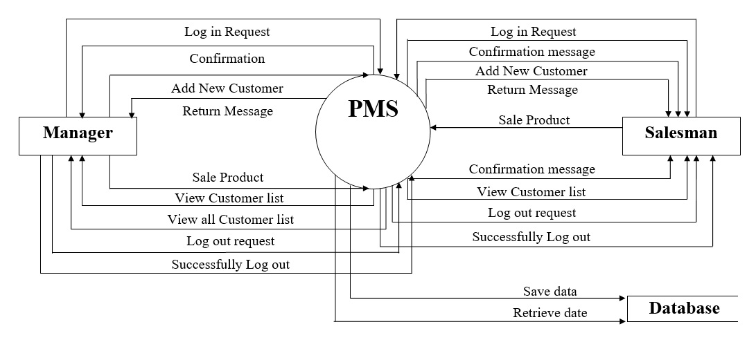

Figure 3.7.1: Data Flow Diagram

14

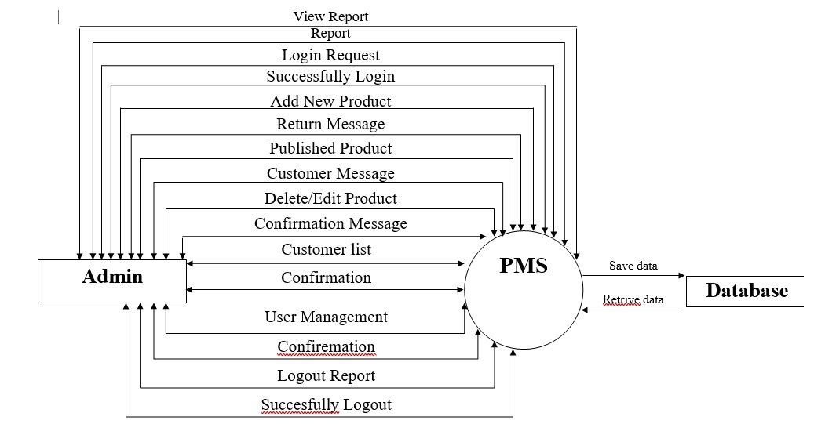

Figure 3.7.2: Data Flow Diagram

15

Chapter Four

System Implementation

16

**4.1 Choice of Programming Language**

We used PHP for programming. We also used Laravel framework because it is most popular framework of PHP and recommended by our supervisor. It is easy to use for coding and have many more facilities. Now-a-days PHP is most popular for web app and demand for it is increasing. These are the reason behind our choice.

**4.2 System Requirements**

The system services and goals are established by consultation with system user. They are then defined in details and serve as a system specification. System requirement are those on which the system runs.

**4.2.1 Hardware Requirements**

Computer

Q-R Code Scanner

Printer

**4.2.2 Software Requirements**

Windows (7/8/10) operating system.

Language: PHP(Laravel)

**4.3 Database Specification**

We used MySQL database. Because it is easy to use and perfect for small or medium size project. It can handle data quickly.

17

Chapter Five

Conclusion

18

**5.1 Limitations**

Getting all required medicine names is a tough challenge. As we are startup so there will be more difficulties for us to collect data. Q-R code only scans data but we want also scan products image.

**5.2 Budget**

Internationally a Pharmacy Management Software costs 15000$-30000$[5]. In our country it costs about 25000tk-30000tk(Only software without hardware). And maintenance cost 1000tk-2000tk per month. We will deliver our software at the price of 19999tk with additional features. [4]

**5.3 Future Work**

We will add Medicine ordering system for Pharmacy Catchment area. We will also make a database of 150000 medicine items.

**4.4 Conclusion**

The application is designed in such a way that future modifications can be easily done. The following conclusion can be assumed from the development of the project. It delivers a friendly graphical UI and gives proper access to the authorized users depending on their authorizations. It effectively overcomes the delay in communications. Updating of data becomes very easier. Application easily using, data security and reliability are the striking features. The System has passable scope for modification in future if it is essential.[5]

19

REFERENCES

Books:

1. Software Engineering: A Practitioner’s Approach,

Seventh Edition -Roger S. Pressman.

1. Systems Analysis & Design Methods,

Seventh Edition -Jeffrey L. Whitten, Lonnie D. Bentley

1. System Analysis and Design,

Second Edition - Elias M. Awad

Links:

[1] MagicBit Technologies,"ONLINE PHARMACY STORE MANAGMENT SYSTEM PROJECT REPORT".Available:<https://www.academia.edu/34972089/ONLINE_PHARMACY_STORE_MANAGMENT_SYSTEM_PROJECT_REPORT>

[2] <https://zaman-it.com/medicine-shop-management>

[3] <https://www.bdtask.com/pharmacy-management-system.php>

[4] <http://www.genitbd.com/pharmacy-management.html>

[5] Russell Murrow,"How much does pharmacy software cost?".Available:<https://blog.computer-rx.com/pharmacy-software-cost>

20