**Individual Risk Reductions:**

Zahid:

Left: Transmitter | Right: Receiver

*Transmitter:* Sending temperature and humidity as comma separated values, read from DHT22

*Receiver:*

Using strtok to separate text at comma

Using strtof to parse floating point

*Upload to Firebase Cloud Firestore:*

Using open source Firebase ESP Client library to interface between receiver ESP32 and database

Each data entry in database gets a timestamp, temperature, and humidity value. The timestamp is obtained by syncing with a Network Time Protocol (NTP) server, using the NTPClient library.

*Alvin:*

Vercel + Firebase stuff

**Team Risk Reduction:**

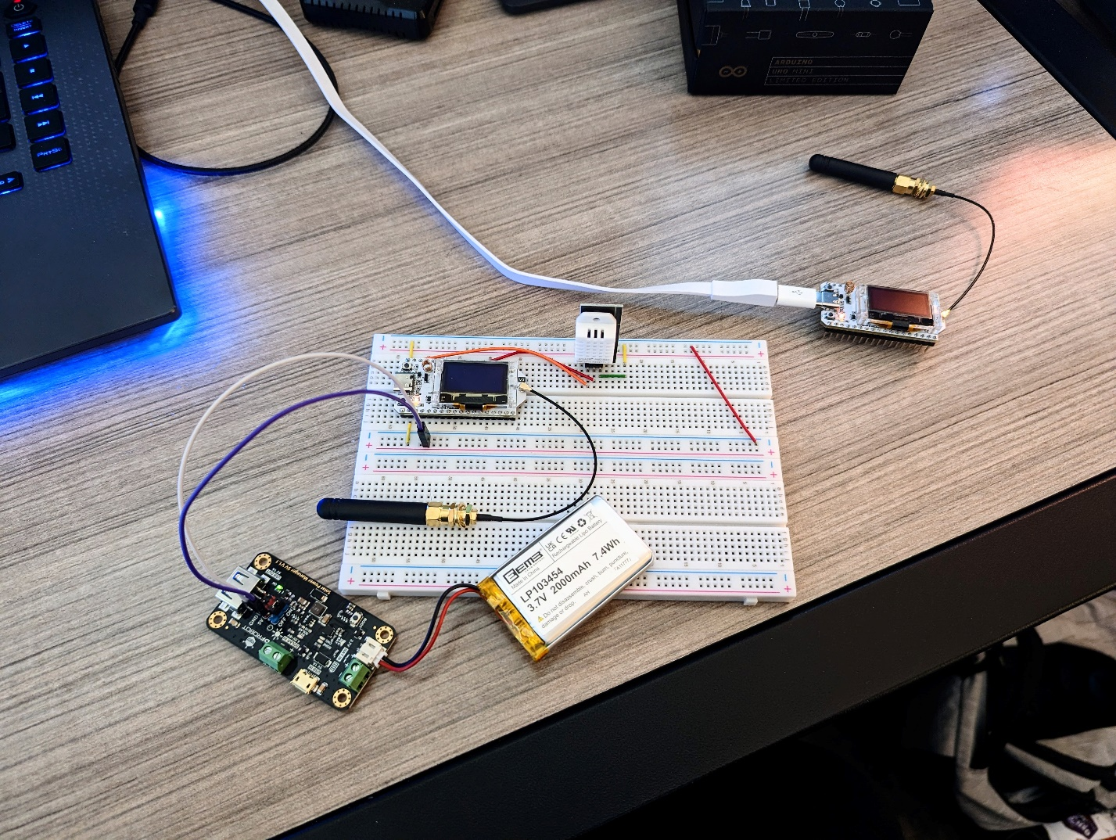

*On breadboard:*

LiPo connected to solar charge manager (panel not connected because it isn’t necessary for demonstration)

DHT22 temp+humidity sensor connected to ESP32 transmitter

*In corner:*

ESP32 receiver connected receiving LoRa packets, uploading to database over WiFi

*Database:*

In the serial monitor log, you can see the most recent uploaded packet matching with an entry in our Firebase database in the browser.

*Web app:*