README:

# How to open browser:

Open the Web Browser zip file, open the folder in the zip file and then open the file called Zahid’s Browser which is an Executable Jar File and you should now be able to use the browser.

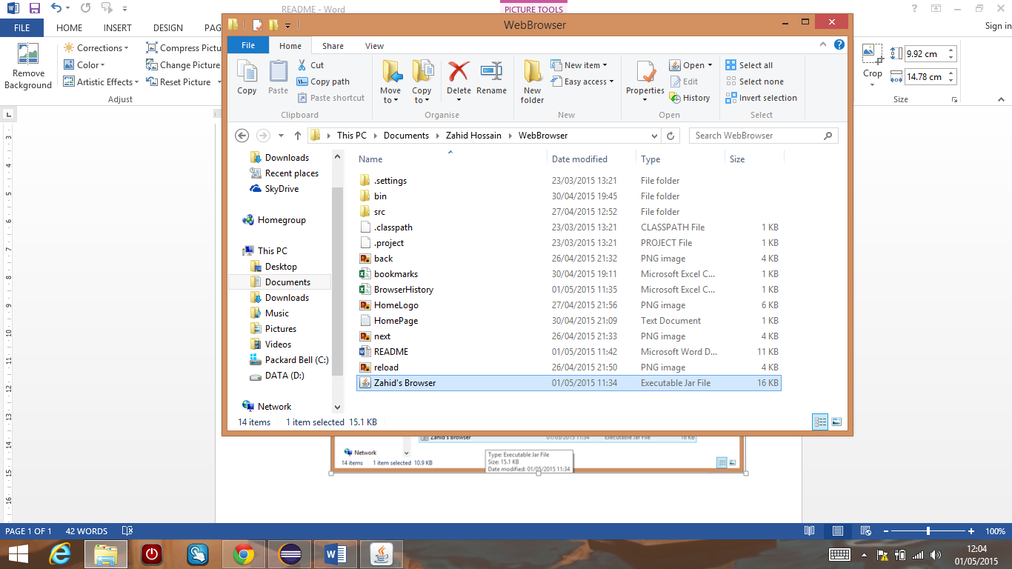

Double click Zahid’s Browser to open browser.

# Configuration Files:

Open the Web Browser zip file, open the folder in the zip file and then you will find the configuration files.

The configuration files are bookmarks.csv, BrowserHistory.csv and HomePage.txt.



These are the configuration files.