Integration of E-commerce and ERP Systems with other ICT (information and communication technologies) to create value for customers and shareholders.

Executive Summary
Advancement in technology is one of the major issues facing organisations today. It has been utilised as a way to acquire a competitive edge over a firm’s competitions. Because of the increased competition in the business environment, there is need for the organisation to take advantage of the technological advancement in order to ensure efficiency in their service provision resulting to increased customer satisfaction. BMW is a luxury vehicle manufacturer and in order to increase its competitiveness and provide optimal services to their clients, the company has taken advantage of this technological advancement through the application and integration of E-commerce in their business interactions and transactions. From the integration and use of ERP systems, the company has benefited through cost reduction on their major operations as well as increased their customer satisfaction levels. The company however faced difficulties of change resistance by their employees in using the new framework. This however was corrected by involving the employees in decision making and training and creating awareness on importance and advantages of implementing and integrating the new framework.

Table of Contents
Executive Summary 2
Table of Contents 2
Introduction 2
Description of Enterprise 3
ERP Implementation and Integration 3
Advantages of E-Commerce Implementation and Integration 5
Conclusion 6
List of References 6

Introduction
The advances in Information and Communication Technologies (ICTs) have resulted to a number of innovations in the world. The major aims of the innovations have been to improve the performance of organizations and adding them to acquire competitive advantage over their rivals (Dezdar & Sulaiman, 2009). It is important for organizations to understand the implementation issues of E-commerce systems and their integration with other ICT systems and how thy improve efficiencies and bring about competitive advantages in their operations as well as strategies (Pagani, 2012). The following is an analysis of ERP implementation and integration with other ICT systems in BMW, a leading luxury vehicle manufacturer.

Description of Enterprise
Bayerische Motoren Werke AG (BMW) is a company, which produces luxury vehicles as well as motorcycles in addition to engine manufacture and was founded in 1916 in Germany. The company further own mini cars and further serves as the parent company for the Rolls-Royce motors cars. BMW (2016) reports that the company is one of the highest selling luxury automakers worldwide. Further Forbes magazine in 2012 rated is as the most reputable company worldwide. In 2010, the company reported to have manufactured 1,481, 253 four wheeled vehicles and about 112,271 motorcycle under the BMW and Husqvarna brands. In addition to its headquarters in Germany, the company has operations in others parts of the world. This includes operations in the UK, USA, Egypt, South Africa, and Australia among others. The company manufacturer’s luxury vehicles, motorcycles, engines and other vehicle accessories. The company major competitors include porches, Mercedes Benz and Jaguar, Volkswagen, Audi, Masserati and Lexus.

ERP Implementation and Integration
Integration involves getting two IS systems to interoperate with the data on one system required and used in another systems. Integrations mean that there is an establishment of a secure and reliable connection between the two systems such that they are able to share data as well as provide flexible tools in managing the process (Pavlou & El Sawy, 2010). Integration can be undertaken through the movement of data from one system to another and then storing the data for later is while more complex scenarios involve direct requests from the E-commerce to the data base for example in a company (Premkumar, 2003). For instance, E-commerce can track down the quantity in stock before making a confirmation of the delivery to the customer. The following diagram illustrates ERP integration to other ICT systems
Figure 1: ERP Integration within a Business System
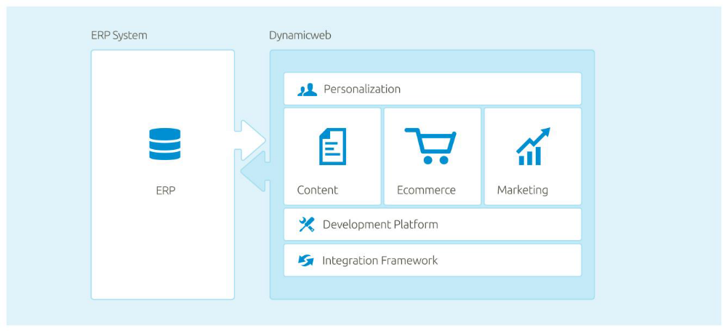
(Source, Kragelaud, 2009)
Integrations has allowed BMW to save as the resources available are optimised with the resources spent in daily tasks such maintenance product data through the use of e-commerce solutions, maintenance of price and inventory levels in the use of e-commerce solutions, maintenance of customer information in the use of these systems, calculations of discussions, taxes among others as well as getting online orders into the ERP system (Pavlou & El Sawy, 2010). In its application of the ERP systems, there are different integration methods that were available for BMW. These have different levels of functionality as well as different levels of complexity with the different methods categorised as batch, live and hybrid as illustrated in the figure below.
Figure 2: Live, hybrid and batch Integrations Methods

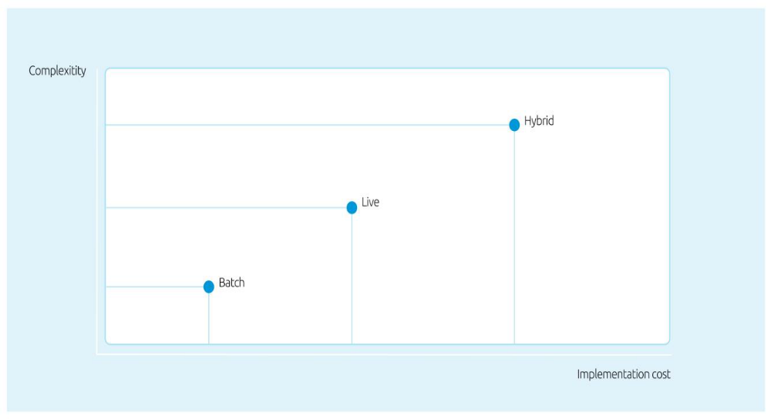
(Source: Kragelaud, 2009)
Batch integrations is one of the methods used by companies in acquiring operational efficiency. This involves periodically uploading of product as well as customer information from the ERP systems to other platforms such as their e-commerce platforms and download orders into the ERP systems (Hempel & Kwong, 2001). This ensures that there is re-use of master data already in the systems and ensuring that there are products that have been created in the ERP systems before they are sold or portrayed in their online platforms (Premkumar, 2003). It has been argued to be the least complex integration. Live integration involves a real time connection to the ERP websites when customers connect to the company’s website. This requires a fast connection as the visit is awaiting information from the ERP system (Ravichandran et al., 2007). This requires the online platform and the ERP systems being paled on a similar network.
The company in its implementation and integration of these systems were faced with a number of issues that mainly involved the change from the pat system to the new system. This included resistance by some employees on its implementation but though training, discussion and participative decision-making has resulted to an effective ERP implementation and integration (Sebastiao & Golicic, 2008).

Advantages of E-Commerce Implementation and Integration
BMW has resulted to implementing ERP into its systems in its bid to improve its service provision to its clients as well as in reducing their costs of operation. BMW has benefited from its ERP implementation and integration. The most critical is its generation of more revenue through its online challenges whereby clients are able to make orders on the product they want and are able to acquire all the information from online channels provided by the company (Premakumar, 2003). For instance, the company provides online services to its clients through its website. The major advantages that the company have been able to experience as a result of the ERP implementation and integration include deliverance of good customer experience which ensures that there is data consistency across all he channels available (Sebastiao & Golicic, 2008). Further, the company has been able to prepare its business operations to scale and have saved manual resources for interference of data again which already exists one system. This helps the company to reduce its operational cost. Further, the integration of these systems has enabled the company to offer more improved 24/7 customer service by further eliminating risk for typing errors and inconsistent data when the data is being re-entered into different systems (Pagani, 2012).
Hybrid involves the use of both batch and live integration for instance where it involves product data and customer price is uploaded into the ERP and the online platform such as the website. This integration approach has been adopted by BMW. It involves an integration of the ERP systems into its online platform with the customers able to request and make orders on the product they require. The company’s website has a platform for the client to create an account whereby they can acquire all the information about the products and services available from the company (BMW, 2016).

Conclusion
ERP implementation integration is an important element within an organisation and can result to crucial benefits in the company. BMW has resulted to a number of benefits from increased productivity to optimality of operations carried out by the company. The integration has enabled the company to further improve the customer satisfaction.

List of References
BMW, (2016), Company Overview, www.bmw.com/
Dezdar S and Sulaiman A. (2009) 'Successful enterprise resource planning implementation: taxonomy of critical factors'. Industrial management and data systems, 109(8), pp. 1037-1052.
Hempel, P S and Kwong, Y K (2001) 'B2B E-Commerce in Emerging Economies: i-metal.com's Non-ferrous Metals Exchange in China'. Journal of Strategic Information Systems, 10(4), pp. 335-355
Kragelaud, T., (2009), Integratitng your ecommerce with ERP, www.dynamicweb.com
Pagani, M. (2012). Digital business strategy and value creation: Framing the dynamic cycle of control points MIS Quarterly, 37.
Pavlou, P. A., & El Sawy, O. A. (2010). IT-enabled competitive advantage in turbulence through improvisational capabilities. Information Systems Research, 21(3), 443-471.
Premkumar, G. P. (2003). Perspectives of the E-Marketplace by multiple stakeholders. Communications of the ACM, 46(12), 279-288.
Ravichandran, T., Pant, S., & Chatterjee, D. (2007). Impact of industry structure and product characteristics on the structure of B2B vertical hubs. IEEE Transactions on Engineering Management, 54(3), 506-521.
Sebastiao, H. J., & Golicic, S. (2008). Supply chain strategy for nascent firms in emerging technology markets. Journal of Business Logistics, 29(1), 75-91.

