Importance and Application of Business Excellence Models in a Public Sector Organization in the UAE
Principles of Business Excellence

Word Count: 995

Introduction
Business Excellence Models (BEM) have become prevalent among public and private organizations in the UAE during the last two decades as an improvement strategy. Governments have encouraged the adoption of this trend for both private and public sectors organizations through the establishment of national quality awards (Lasrado & Uzbeck, 2017). BEM national awards are intended to boost competition, maintain firms’ reputations, attract more consumers, and ensure that organizations operate effective and efficiently. Nearly twenty years ago, the UAE introduced business excellence awards for public and private sector organizations which enabled it to boost organizational performance in their setting (Hawarna, Gani, & Islam, 2020).
Critical Assessment
Business excellence refers to outstanding practices that are adopted in managing organizations in order to accomplish desired results based on particular values and concepts. In this respect, Business Excellence Models (BEM) delineate frameworks which are applied within a firm to assist in focusing actions and thoughts in a more organized and structured way that will result in enhanced performance. Business excellence has enveloped in the contemporary world as the strongest approaches for firms to realize a competitive edge and balanced satisfaction among stakeholders. Hawarna, Gani, and Islam (2020) note that excellence models are an integral, systematic, and enduring strategies for business improvement. They enable firms to identify objectives that will position them towards the trajectory of excellence while revealing strong and or weak areas. Identified weaknesses present invaluable opportunities for continuous improvement.
The sole objective of business excellence models including the Dubai Quality Award is to integrate key performance metrics in order to accomplish and to realize the desired progress. National awards relating to business excellence and quality fulfill a pivotal role in enhancing excellence among organizations (Lasrado & Uzbeck, 2017). Importantly, they elevate quality standards among firms on a national scale, consequently improving the country’s profile as exemplified by the UAE through the Dubai Quality Award.
Evidence
Emirates National Oil Company (ENOC) is a renowned international gas and oil player operating in the UAE energy sector. The entity is wholly owned by the Dubai government and was awarded Dubai Quality (BEM) award in 2015 for its constant commitment towards business excellence and quality. ENOC has persistently implemented Dubai Quality Award, a business excellence model that is similar to EFQM. The model enabled it and one of its subsidiaries (EMGAS) to win the coveted Dubai Quality Award for its continued commitment towards business excellence and quality (ENOC, 2018). ENOC has extensive interest in the Dubai economy ranging from exploration to distribution and marketing of oil products. Since EMGAS is a subsidiary of ENOC, the Dubai government also owns EMGAS. The subsidiary’s core business is natural gas distribution. Following the adoption of business excellence model, it also won the Dubai Quality award signifying its continued commitment to quality and business excellence (Albawaba, 2013). It is vital to note clarify that the Dubai Quality Award compares to the EFQM business excellence model.
The EFQM framework views quality management from the lens of ‘results’ and ‘enablers and highlighted in the table below. These primary enablers include resources and partnerships, strategy, and people, leadership, and processes, services and products. The four factors covered by this business excellence model in the results section include business results, customer results, people results, and society results.
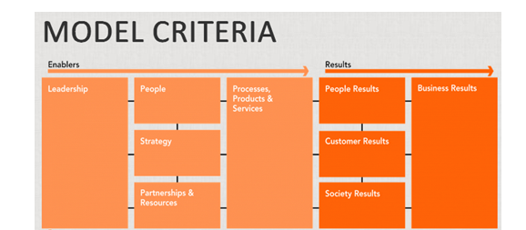
Fig. 1: EFQM Framework (Source: EFQM, 2020)
The EFQM framework enables firms to conceptualize the main components that are essential in realizing business excellence and how to evaluate results. The UAE’s business excellence framework compares to this model, especially in regards to measuring results for Dubai enterprises.
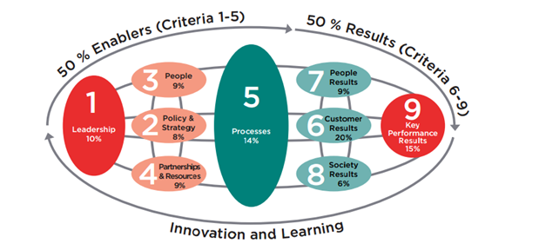
Fig. 2: Dubai Quality BEM framework (Source: Government of Dubai, 2020)
This model adopts a weighted system for assigning scores concerning particular areas of business operations. The criterion forms an essential facet in measuring the performance of a business and in determining eligibility for the coveted Dubai Quality Award (Lasrado & Uzbeck, 2017). Without doubt, ENOC extensively demonstrates the significance of receiving this precious award. Applying this framework involved fulfilling several activities. For instance, in EMGAS’ case, the subsidiary brought on board consultants to review their operations in regards to the model. The exercise enabled the firm to create benchmark and to formulate short as well as long-term objectives to receive this BEM award. A seven-months action plan was created to enabled EMGAS fulfill the criteria for conferment of this award. The company was re-assessed again after seven months and the consultants confirmed that it had achieved requisite progress in alignment with the BEM framework and qualified to apply for the Dubai Quality Award.
Conclusion
The Dubai Quality Award is a viable approach of enhancing business excellence among enterprises in the UAE. The framework aligns with the renowned EFQM BEM model thereby suggesting that it is easily applicable and recognizable globally. The framework is ideal for organizations and businesses in Dubai since it serves as a tool for ensuring efficiency and effectiveness in a firms’ processes and operations. Securing this award or successful implementation of this framework is a source of competitive edge for companies as they stand to reap from improved organizational performance. The firm’s brand reputation elevates significantly as exemplified by ENOC and its subsidiary following a win of this award. This translates to improved profitability and better insights regarding how to improve a firm’s performance further and competitive positioning in the market.

References
Albawaba. (2013). ‘EMGAS wins Dubai Quality Award for continued commitment to quality’. Albawaba.com. Retrieved October 23, 2020 from https://www.albawaba.com/business/pr/emgas-dubai-quality-award-488534
EFQM. (2020). ‘My first step with the EFQM Excellence Model’. Retrieved October 23, 2020 from https://sites.google.com/site/myfirststepwithefqmmodel2010/
ENOC. (2018). Awards & Recognition. Enoc.com. Retrieved October 23, 2020 from https://www.enoc.com/en/about-us/awards-recognitions
Government of Dubai. (2020). ‘Dubai Quality Award’. Dubaided.gov.ae. Retrieved October 23, 2020 from https://dubaided.gov.ae/Awards_details/en/dqa_award
Hawarna, S., Gani, A. O., & Islam, R. (2020). Effects of Dubai quality award on organisational performance in the United Arab Emirates. The TQM Journal.
Lasrado, F., & Uzbeck, C. (2017). The excellence quest: a study of business excellence award- winning organizations in UAE. Benchmarking: An International Journal.

