Bee population lab report

Name

Course

Institution

# Introduction

The environment plays a vital role in flora and fauna—it through the ecosystem that creatures can survive on earth. A sustainable ecosystem free from elements of destruction would result in the plants and animals being able to thrive (Mary Ann and Lonny, 2020). Thus, the aspect of being extinct would be curbed. As a result, our current generation and the future generation would be able to see the various elements that are in nature.

Various conventions have been enacted to protect the environment. Consequently, fighting climate change continues to be a menace in society (Marisi, 2020). for instance, bee populations need to be considered since they greatly assist in pollination.

Bees would lead to the seed dispersal of which ensure pollination. Thus, plants can germinate from wild and domestic animals, and human beings can thrive (Marisi, 2020). Hence having a lifespan on earth. Therefore, there is a need to protect the bee populations in various geographic regions on earth.

Hence, the WiBee initiative hat is out to improve the environmental conditions of the bee population. The bee count is important (Marisi, 2020). It greatly assists in keeping the insects in check. Given that there are various types of bees in the world. They can map out the different types of bees, thus protecting them from harsh environmental conditions.

Significance is placed on the bee types, habitat type, crop type, and management type. They greatly influence the kind of activities that the organization does (Marisi, 2020) since they are pertinent issues in the conservation of the various elements of nature.

Food webs are also vital in the longevity of the lives of living things on earth. For instance, the bees obtain nectar and pollen (Marisi, 2020). Furthermore, they are the primary elements of food. Without nectar and pollen, then bees cannot survive. Hence, human beings need to protect the trees and other types of plants from destruction.

Food chains are paramount for survival. The bees are seen to feed on nectar and pollen. Termites feed on honeycombs; human beings use honey as a food complement and for medicinal purposes (Mary Ann and Lonny, 2020). They greatly influence the type of environment that has been set up on earth. Thus, being a continuous cycle.

# Objective

1. To investigate the role of habitats in the bee population.

# Research question

1. Does the habitat have a role in the bee population?

# Methodology

The collection of the data was through the use of secondary data. It was mainly obtained from the WiBee site (University of Wisconsin Board of Regents, 2020). The analysis of the data was through the use of the platform. Thus, enabling the generation of graphs and pie charts.

The following variables were analyzed in the study.

# Results

Pollination visitation rate

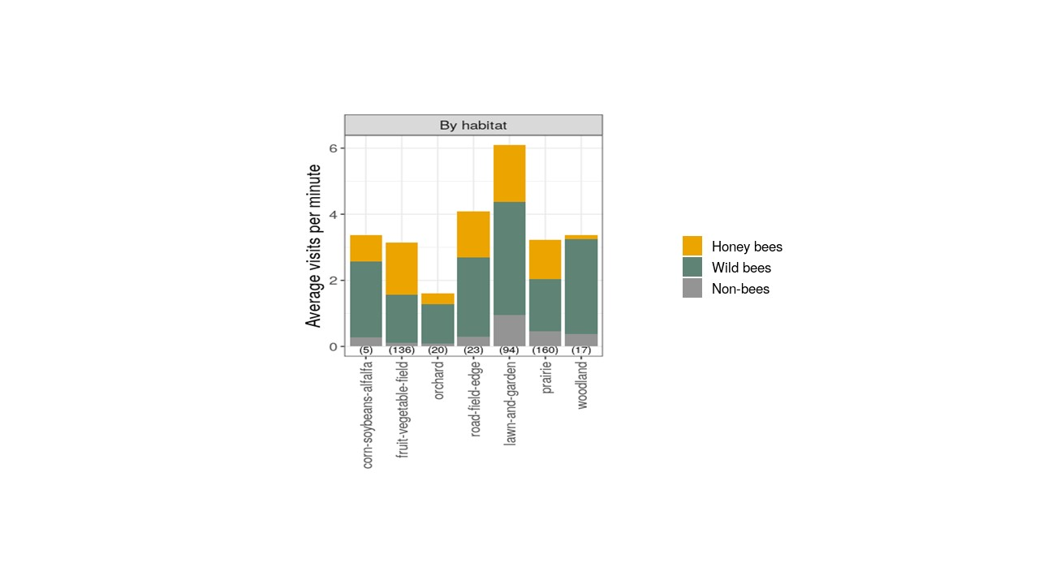

The study indicated that the lawn and gardens were a suitable habitat for the bees. Both the honey, wild, and non-bees had a significant average of six. Also, wild bees are seen to be much interested in woodland areas. Furthermore, the non-bees are in trivial amounts in nature. More so, when the bees are around.

**Surveys on the number of bees**

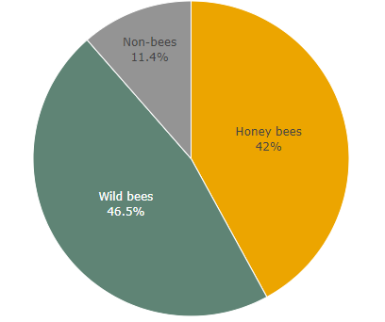

From the study, the honey (42%), wild (46.5%), and non-bees (11.4%). The wild bees are many in the environment. They are found in various locations, as opposed to the non-bees that are few in the climate. Bee numbers would vary from one type to another owing to the region.

# Discussion

The environment is observed to influence the number of bees. For instance, bees that produce honey are seen not to be many. The study agrees with Mary Ann and Lonny (2020). A sustainable ecosystem free from elements of destruction would result in the plants and animals being able to thrive. They are essential but can only be seen on fruit vegetable fields, road field edge, prairie, and lawn gardens. The habitat has an impact on the type of bees that is present.

Bees are an essential factor when it comes to pollination. They enable the transfer of pollen grains from the anthers to the filament. Thus, ensuring food security results in the individuals undertaking similar roles such as the mapping of the bees in various locations. They greatly influence food production.

Also, in terms of sustainable development. The bees would be able to improve environmental conditions. They are part of the food chain and food web. Thus, when their habitat is protected, people would be able to obtain food. The individuals would also be keen to protect the environment. They are hence leading to the impetus in the bee population in various geographic regions.

# Implications and limitations

The study is keen on ensuring that the bee population is maintained. Thus, keeping the numbers in check to mitigate the risk of certain types of bees becoming extinct in a particular region.

The study is done using a hypothesis. For instance, the line transect method. Some of the figures that are arrived at are based on estimations. Nevertheless, the theory has been scientifically tested and has been used over a period.

# Conclusion

The surrounding has a vital role in flora and fauna. Significance is placed on the bee types, habitat type, crop type, and management type. Both the honey, wild, and non-bees had a significant average of six. The survey indicated honey (42%), wild (46.5%), and non-bees (11.4%). Therefore, bee protection is vital in society.

# Recommendations

Bee populations need to be mapped out and also ensure that the bees close to extinction are monitored. Protection mechanisms would lead to more bees. For instance, non-bees play a significant role in pollination.

# References

University of Wisconsin Board of Regents. (2020). WiBee Data Dashboard. Retrieved from

https://data-viz.it.wisc.edu/wibee/. Accessed on November 1, 2020

Mary Ann, M., and Lonny Douglas, M. (2020). *Examining Biophilia and Societal Indifference to*

*Environmental Protection.* IGI Global.

Marisi, F. (2020). *Environmental Interests in Investment Arbitration: Challenges and Directions.*

Kluwer Law International.