**Aged Care Setting: Improving Knowledge among Caregivers on the Prevention of Pressure Ulcers Within a Care Facility for the Aged**

# **Abstract**

## **Introduction**

Pressure ulcers knowledge is of great importance in the aged care setting as well as understanding how to handle the process of care among the aged within a care facility. The percentage of those affected increases with an increase in the admission of the aged into care facilities (Tubaishat et al, 2018). There are abnormal health conditions which may result from the same and complications that may arise causing permanent damage to the person victimised by pressure ulcers. The knowledge and skills in this area of practice has to be well articulated and also very well executed in order to benefit those around.

## **Aim**

To evaluate the impact of having educational interventions for nurses on the knowledge of pressure ulcers management and prevention among the aged.

## **Method**

The project that has been initiated in an aged care setting has a sample size of 10. The sample was created from very well selected nursing care teams and also in some cases voluntary participation was required. The sample came with several nurses who were invested in the care facility on a daily basis and were considered the best in the field. The project uses pre and post-test quizzes that are selected specifically from an analysis of pressure ulcers based on reliable medical sources and research done over the years. The samples provide the clarity on the relevance of certain levels of knowledge and the need to pay rapt attention to studies made on the same over the years.

## **Results**

The results firstly include an educational intervention to understand what the participants know concerning pressure ulcers and the various steps taken towards ensuring that there is a conscious correction of the situation without causing more complications. The ability of the nurses to answer correctly to each quiz was at 40% on the basis of what was required from them as a part of the solution bearers. The factors that were incorporated include a sense of all round knowledge on the basics of aged care and the causes of pressure ulcers among them. The factors that were incorporated in the situations included a sense of development on the subject and being able to relate fully with the situations around. The ability to express prior knowledge comes with a sense of learning and the need to improve in one way or the other

## **Conclusion**

The chance to offer education interventions on the subject matter is very relevant in this case. Nurses and general caregivers have the responsibility to provide care against pressure ulcers among the elderly and ascertain good health altogether. The general purpose is not well focused on what necessitates the most reliable focus but looks into the benefits of acquiring in depth knowledge and being able to provide a general view on that which is necessary. The process used in the interventions looks to propel and increase the chances of greater levels of knowledge and alertness in line with the ability to show care. To understand the intensity of the matter, the factors are relative to health care specific to the aged and an aged care setting.

**Table of** **Contents**

Abstract 2

Introduction 2

Aim 2

Method 2

Results 2

Conclusion 3

Introduction 6

Background 6

Need of the Study 7

Significance of the Study 7

Literature Review 8

Methodology/Project Design 10

Sample and Setting 10

Data collection/Data Collection tool 11

Data analysis and Interpretation 12

Figures and Tables 13

Discussion 16

Summary and Conclusion 18

References 19

**List of Figures and Tables**

Figure 1: 1 Pre-Post Comparison of Nurse’s response on pressure ulcers knowledge………15

Figure 2: Post Test Comparison of Nurses’ and Staff response on pressure ulcers knowledge……………………………………………………………………………………15

Table 1: Pressure ulcers is to be blamed on Nurse and staff Negligence 16

Table 2: Number of Nurses and Staff alongside number of correct and incorrect responses during the posttest and pretest quiz 16

# **Introduction**

## **Background**

To understand the aspects of an aged care setting means that there needs to be an in depth understanding of what it entails to have aged care facilities and a knowledge thereof of the needed qualities. The case of pressure ulcers starts from a point of not understanding the necessity of having caregivers as well as their general role within the facility. This therefore also affects the role of the registered nurses within these care facilities. The regulation that runs aged care facilities is based on the mandate to have all registered nurses be available at all times to ensure health and well-being of the people within these facilities (Jokanovic et al, 2017). The need to bring this out through the knowledge invested in the aspect of pressure ulcers is crucial and evidently important as part of what the nurses ought to pay very close attention to and understand.

The factors that are implemented in the aged care setting are meant to improve. The people living in aged care facilities are at a higher risk of serious diseases such as Pressure ulcers, the association of these diseases with the aged care setting is very closely related (Chaboyer et al, 2016). The research literature has indicated that over 67 percent of the admissions that take place within aged care facilities, the diseases are avoidable. Aged care settings need improvement along with the knowledge that is instilled in the minds of the nurses.

The improvement in access of GPs and other care providers that are primary is of a great necessity and needs to be investigated. The other need involves the ascertaining of health discussions with the residents as well as their future personal care regimen among other important matters (McInnes et al, 2016). The enhancement of the capacity within the aged care settings is of great relevance since it makes it easy to respond to the care needs of the resident. This means that the health service providers have a great role in ensuring that aged care settings are enhanced and a sense of support for the people ensured in order not to be involved in complicated chronic disease matters but rather enhance the ability that there is in caregiving.

The benefit of having a complete aged care setting is that it creates a place where a lot of conflicting diseases can be avoided and a series of issues solved in the process (Gunningberg et al, 2017). In this case, the focus is more on the prevention of pressure ulcers and also a knowledge on the solutions that are meant to be shared in order to stop the issue. Showing care in an effort to avoid the spread of chronic diseases is relevant to the Australian health and welfare systems. It creates a standard by which they can function by and be relevant to the aged in terms of health and growth within the constraints of care services. The Australian health services work really hard towards enhancing the livelihood of residents within healthcare facilities.

## **Need of the Study**

It is relevant to understand that chronic diseases within Australia’s aged care settings are common and need to be dealt with. Instilling knowledge in line with this is important and requires a great focus on the requirements that create the essence of being in an aged care facility (Gunningberg et al, 2017).

## **Significance of the Study**

Many elderly people are prone to suffering from chronic illnesses and are also more exposed to a greater risk of contracting other serious diseases as well. The nurses have a very crucial role to play in ensuring that these illnesses do not cause them to be frail or even increase their chances of contracting other complicated illnesses (Slugett et al, 2017). The factors relevant for the study involve a sense of less complex health systems with several types of service providers made available and with a very high sense of knowledge therein. The knowledge should be made to function in line with the risks that they are exposed to.

## **Literature Review**

According to the Aged Care Assessment Program, there is a joint fund with the Australian government and also with the state and territorial governments that support the network of the various aged care assessment teams. These teams are operational at a single entry point and are packaged to fully serve the residential aged care facilities and be a point of referral for all other facilities. An aged care setting requires a high level of organisation with the relevant roles being well executed and also planned out to offer fully fledged services and also ascertain confidence while looking at the purpose by which the facility is established and the reason as to why there needs planning to enhance the health and future of the residents within the facility (VanGilder et al, 2017).

According to the previous survey carried out on the prevention of pressure ulcers in aged care settings there are several roles that are played, starting from the most relevant which are the nursing roles within these care facilities. It all develops from a point of nursing leaderships and clinical supervision. This means that residential nurses are in a position to vitally play the role as planners in the delivery of excellent services. They are influencers of what the rest of the staff does since they are involved in the coordination of activities and also the delivery and monitoring of the practices (Hultin et al, 2017). These factors make their availability important in terms of leadership and supervision on a clinical basis.

The prevention of pressure ulcers is based on several studies and surveys that have been focused on physicians and nurses who are based in aged care settings and also hospital settings. Survey shows that most of the services administered have also been tested in home social welfare settings. The data collected on a cross-sectional study by Kohta, Kameda & Korida, (2017) shows that the knowledge levels in one setting were moderate and low respectively and care managers did not receive enough education in line with the same.

According to a research done by Usher et al., (2018) There are several activities that are directly linked to overseeing, management and provision of health services for acute situations. The first is the nursing care procedure which must be supported by a high level of knowledge. This for example, may include a case such as the prevention of pressure ulcers and the necessities that are bore during these care processes, once a nurse understands that the proceBazlerdures require mastering and growth, it increases the level by which results are acquired and the excellence by which the processes in between are executed. The other activity is based on restorative care. In an aged care setting, the aspect of restorative care is mainly based on ensuring that the residents do not dwell on a current health state without retrieving their most basic health functions (Easton et al., 2016).The prediction from the dichotomous value depicted dependency of pressure ulcer health functions for long-stay residents to be at (p=02)

According to Balzer et al. (2014), the mixed methods exploratory study is very efficient in examining the way by which nurses can reduce pressure ulcer risk with the use of an extremely structured reticular activating system. The focus in this case is to ensure prevention through reassessments when the patient undergoes changes. It also gives information on how much risk the patient is at when it comes to pressure ulcers. It is an exploration of the various factors that make up the reticular activating system documentation and the different kinds that are made available for perusal. The study’s quantitative aspect (n=107) shows the nurses’ levels of risk based on judgement from a clinical perspective. This is what represents the fictitious comparison behind the aspects that make up semi-structured studies in several aged care settings. The study’s qualitative aspect involved in this assessment was at (n=15) which correlated with poor mobility and problems on the orthopaedic functions.

The aged care environment is well inclined to having a very responsive health emergency and also an aspect where the residents can be identified early enough in the case of deteriorating health due to acute health issues and factors that are relative to the same. This is on the basis of a study by Mahalingam et al, 2014 that involved a two-cycle audit where the focus was based on a group made up of 13 nurses. These studies showed that over 50% of the nursing staff do not prioritize risk assessment over admission. The documentation led to a total of 25% of cases being a result of a lack of knowledge on the right preventive measures.

The formal providers in an aged care setting have data that shows their predominance in several activities. This however does not guarantee excellence and the ability to execute the right procedures at any given time (Edvardsson et al, 2015). The greater proportion of these formal providers uses more government resources as compared to those informal ones more inclined to rely on privately acquired resources which are also effective in the aged care setting and provide fulfilment in the results that they give. It is a necessity to understand the age care setting to place the relevant roles and acquire results.

# **Methodology/Project Design**

## **Sample and Setting**

The work-based project conducted lasted a span of three weeks in order to easily analyse the knowledge areas that nurses need to prevent acute pressure ulcers in an aged care setting. The project took place in a caregiver facility and involved 20 residents as well as nurses. The facility had over 32 staff members with several of them being nurse and about ten of them holding other relevant posts within the facility. The sample was mostly selected from a series of voluntary participators and the need to have accurate information was vital. It was relevant to ensure that the work-based project provides accurate results therefore necessitating the aspect of diverse information. The sample method was meant to equalize the responses given for a more accurate report and more relevance towards the

## **Data collection/Data Collection tool**

The results were measured in terms of how well the nurses were acquainted with the improvement methods of the aged care setting. The level of knowledge had to be tested based on an intervention and the responses that were given. The responses were supposed to be in line with what the role of each staff member was in terms of the needs of each resident. The intervention involved an intensified discussion on the relevant aspects of acute pressure ulcers and why it was important to have a complete and intense understanding of the respective roles. This involved a series of research questions that assessed the nurses’ abilities to coordinate the setting and create a conducive environment for all the patients within the facility.

The first week of the data collection process entailed a knowledge of the basic surroundings of everyone in the facility. This means that several of the research questions asked were bent towards understanding the daily routine of both the patients and the nurses (Easton et al, 2016). This then created an awareness on what is to be expected in line with the relevant and general questions asked concerning the whole project. The reliance on this information was meant to create a series of other questions on the basis of what had been delivered. The second week involved a combination of questions to understand the roles of each one of the staff members. This included an assessment to understand the what the facility offered in terms of excellent services and why the high prevalence of acute pressure ulcers.

The pre and post quiz was a general way to understand the various specifications of what it would take to improve knowledge on care ulcers and the prevention of the same. This meant that an analysis was done for the members of staff whose work was relevant in the whole process and affected a great percentage of people (Magny et al, 2017). The education processes were targeted at ensuring that knowledge is enhanced, and a series of comparisons put in place to ascertain the relevance of the understanding needed in order to make improvements and create the necessary preventive measures on the basis of knowledge from the staff.

## **Data analysis and Interpretation**

The quiz design follows the standard Australian health services data collection questionnaire. This is in line with the risk factors that are put into consideration and the aspects that create an environment where most of the causes are inevitable and a series of people may suffer the consequences altogether. The data analysis process investigated the eating habits of the people affected and also the types of medications that the residents received altogether. The relevance of this analysis is to create an opportunity for all the events to be noted down and brought to the knowledge of the assessment team (McInnes et al, 2015). The aged care setting is well involved in ensuring that the processes do not affect the ways by which the research is conducted. The prevention of pressure ulcers is based on an intensified knowledge as seen from most of these results and as assessed in previous results altogether.

**Intervention**

The staff members were engaged in order to fully participate in the educative process of the whole project. This meant that they were bound to have an understanding of what was needed to satisfy the needs of the patients in each special way that each resident was meant to function in. The factors that were used to calculate their ability were based on the residents’ abilities and were well defined to suit the progress by which each one was to make at the end of the whole project.

During the intervention, the first step was to have individual conversations with each nurse on the quality of their personal life (Jokanovic et al, 2017). This reflected greatly on their performance and was bound to have more effect on how they treated the aged within the facility. The purpose was to assess utility and the effect that each percentage had on the performance of the staff. The communication process involved a series of aspects that were focused on creating the basis for all the solutions made available.

# **Figures and Tables**

*Figure 1* ***Figure 1 Pre-test quiz Comparison of Nurse’s response on pressure ulcers knowledge***

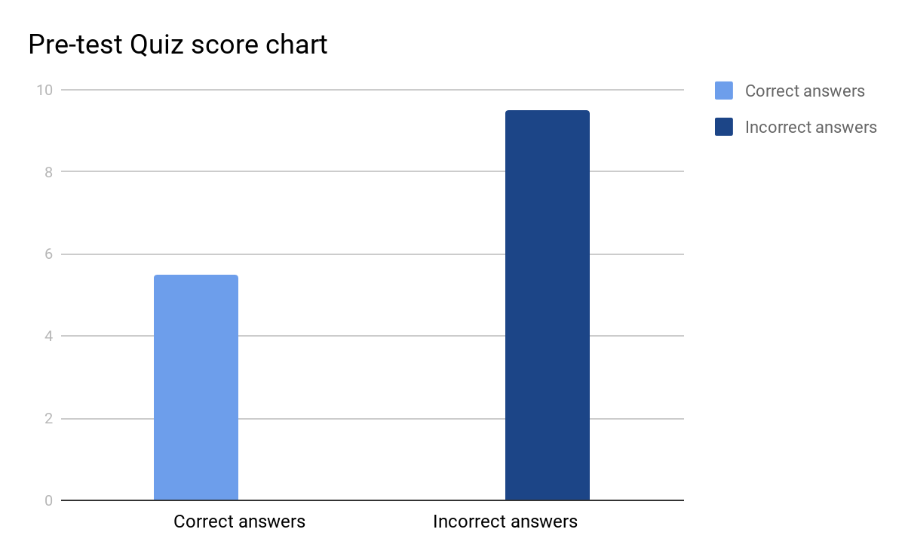

The score chart shows the ability and inability levels of participants to respond to questions based on the daily activities within the aged care facility.

*Figure 2:* ***Nurses’ and staff post-test quiz response on pressure ulcers knowledge***

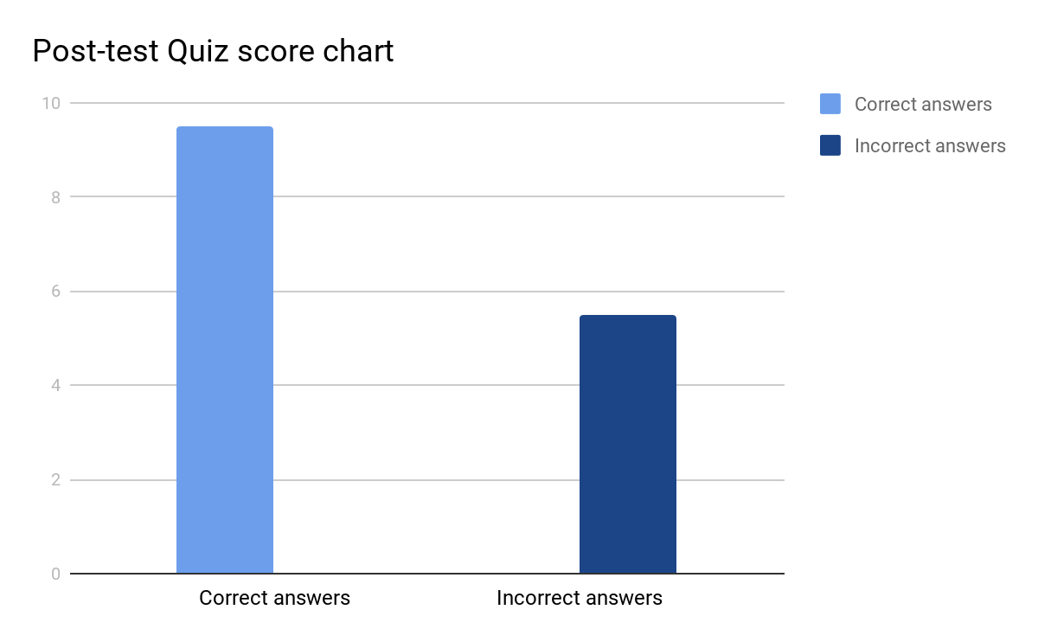

This score chart is an indication of the post-test scores of all the participants after intervention and educational sessions.

*Table 1:* ***Pressure ulcers is to be blamed on Nurse and staff Negligence***

|  |  |  |
| --- | --- | --- |
|  | **Pre-Intervention** | **Post-intervention** |
| **Response/Intervention** |  |  |
| **Correct Answer** | **2** | **10** |
| **Incorrect Answer** | **13** | **5** |

*Table 2:* ***Number of Nurses and Staff alongside number of correct and incorrect responses during the post-test and protest quiz***

|  |  |  |  |
| --- | --- | --- | --- |
| SL  NO | ITEMS (QUESTIONS) | PARTICIPANTS  PRETEST- SCORE | PARTICIPANTS  POSTTEST-SCORE |
| 1 | Are pressure ulcers a case that needs to be identified amongst people of your area? | 6 | 10 |
| 2 | Is limited movement a cause of pressure ulcers? Or are there other possible causes? | 4 | 10 |
| 3 | The poor eating habits and diet patterns are a contributor to pressure ulcers. | 5 | 9 |
| 4 | Pressure ulcer can be prevented by proper positioning of residents? | 5 | 9 |
| 5 | If I identify an area of skin that is red, it is possible that it is pressure ulcers. | 8 | 10 |
| 6 | The carelessness of caregivers and sloppy service are causes of pressure ulcers. | 6 | 9 |
| 7 | A pressure ulcer along a bone should not be disturbed through unnecessary rubbing. | 3 | 10 |
| 8 | Risk assessment tools are good for ulcer prevention in good time. | 7 | 10 |
| 9 | The care staff should always be alert and quick in their services as their duty to monitor the health and prevention of pressure ulcers amongst the aged. | 6 | 9 |
| 10 | Consistent check-ups and assessments are easy ways to prevent pressure ulcers. | 5 | 9 |
|  | **Mean score =** x̄ = (Σ xi ) / n  Total score/number of participants. | 5.5 | 9.5 |

# **Discussion**

The major finding on the project was that a high number of participants from the pre-test quiz showed that pressure ulcers was a case that needed to be well identified amongst the people. This mainly is due to the negligence in terms of a lack of knowledge from caregivers as well as from the nurses and the rest of the staff who played a role in the caregiving process. The factors that were assessed are mainly based on educative structures that need to be set up in an effort to nullify certain levels of ignorance in the field.

The other finding was that there were limited movements among the residents and little was done to offer physical exercise. The finding indicates that the highest number was on the post-test participants. These participants were not very acquainted with other activities other than what required their hands (Algoso et al, 2016). The nurses took little action towards protecting the residents from these situations. Looking into the poor eating habits of the residents, it is clear that the patterns involved foods that had no nutrient capacity well fit for the development of the people at the age in which they are. The purpose for improvement is realized post-test and shows a high series of habits that are limited to only what the nurses are able to offer. The aged care setting according to this finding does not focus on the least frequently managed problems.

The challenges that are well managed within the care facility are such as the understanding of a disease on a general aspect other than knowing individual patterns. This, for one, does not in any way improve the way in which the body of the person functions. The average number of issues that are managed are only increasing with an increase in the patient’s age and also gender (Bentley et al, 2016). The facility has recorded over 50 incidences and looks at the many most frequently managed issues. These issues are not well specified to fit the profile of an individual and the general knowledge is what acts as a hindrance to understanding other aspects of the needed knowledge within the facility. The purpose of having these quizzes was to ensure that all the issues are addressed in accordance to what the patients suffer and what they can prevent altogether. The most informative aspect is what the nurse obtained from the educational forum.

The project also brought the aspect of self-management and how unpopular it has become. The annual health checks for older people are not well compiled to and the knowledge that is in line with these checks is not well executed in any way. Most of the people who participated in the project ranged between 75-84 years and were funded mostly by the government. The same was a cause for concern seeing that it was not well planned out in terms of what the facility can offer as an extra service to ascertain growth and also progress while promising health for the people involved. The prescription patterns are mainly based on age and a growing use of pharmaceuticals which is a general increase that is also affected by age and comes as a means to reveal the types of surveys that need to be done to offer permanent solutions to those that are in need. The relevance of the project is that it highlighted the common prescriptions and medications that are given on a general basis without giving much thought to the gender or other outstanding differences such as age. The encounters that are illustrated on the quiz are based on the information that is collected on an individual basis and given mean values. These values illustrate the way by which the concern for aged care setting excellence is disregarded and not well articulated to fit into what is required and create a way in which the nursing practice can tap into more solutions rather than creating more complicated aspects of the

# **Summary and Conclusion**

This is an evaluation of the effect of spreading knowledge on acute pressure ulcers and the expected results therein. The purpose of the project has been partly met based on the response that is seen within the analysis done and data collected. The aged care setting functions fully on the basis of knowledge and an understanding of the various procedures that are relevant in ensuring a complete and less complex way of dealing with certain health situations. The main aspect is based on having a series of procedures to work by and ensure that these processes are well articulated to ascertain what is relevant in an aged care setting is maintained and kept relevant for as long as possible.

Working towards increasing knowledge has enhanced the ways in which staff handles their various roles to the way that they are executed and also managed as well. To have a complete view of the various ways by which improvements can stick even as changes are made throughout an aged care setting. The practices have to be enhanced and made to demonstrate positive impact across the necessary areas of change and improvement.

# **References**

Algoso, M., Peters, K., Ramjan, L., & East, L. (2016). Exploring undergraduate nursing students' perceptions of working in aged care settings: A review of the literature. *Nurse Education Today*, *36*, 275-280.

Balzer, K., Kremer, L., Junghans, A., Halfens, R. J. G., Dassen, T., & Kottner, J. (2014). What patient characteristics guide nurses’ clinical judgement on pressure ulcer risk? A mixed methods study. *International journal of nursing studies*, *51*(5), 703-716.

Bentley, M., Stirling, C., Robinson, A., & Minstrell, M. (2016). The nurse practitioner–client therapeutic encounter: an integrative review of interaction in aged and primary care settings. *Journal of advanced nursing*, *72*(9), 1991-2002.

Chaboyer, W., Bucknall, T., Webster, J., McInnes, E., Gillespie, B. M., Banks, M., ... & Cullum, N. (2016). The effect of a patient centred care bundle intervention on pressure ulcer incidence (INTACT): a cluster randomised trial. *International journal of nursing studies*, *64*, 63-71.

Easton, T., Milte, R., Crotty, M., & Ratcliffe, J. (2016). Advancing aged care: a systematic review of economic evaluations of workforce structures and care processes in a residential care setting. *Cost Effectiveness and Resource Allocation*, *14*(1), 12.

Edvinsson, J., Rahm, M., Trinks, A., & Höglund, P. J. (2015). Senior alert: a quality registry to support a standardized, structured, and systematic preventive care process for older adults. *Quality management in health care*, *24*(2), 96-101.

Gunningberg, L., Sedin, I. M., Andersson, S., & Pingel, R. (2017). Pressure mapping to prevent pressure ulcers in a hospital setting: A pragmatic randomised controlled trial. *International journal of nursing studies*, *72*, 53-59.

Hultin, L., Olsson, E., Carli, C., & Gunningberg, L. (2017). Pressure Mapping in Elderly Care. *Journal of Wound, Ostomy and Continence Nursing*, *44*(2), 142-147.

Jokanovic, N., Wang, K. N., Dooley, M. J., Lalic, S., Tan, E. C., Kirkpatrick, C. M., & Bell, J. S. (2017). Prioritizing interventions to manage polypharmacy in Australian aged care facilities. *Research in Social and Administrative Pharmacy*, *13*(3), 564-574.

Kohta, M., Kameda, Y., & Morita, S. (2017). Knowledge and practice for pressure injury prevention among care managers in a home care setting: a cross-sectional study. *Chronic Wound Care Management and Research*, *4*, 99.

Mahalingam, S., Gao, L., Nageshwaran, S., Vickers, C., Bottomley, T., & Grewal, P. (2014). Improving pressure ulcer risk assessment and management using the Waterlow scale at a London teaching hospital. *Journal of wound care*, *23*(12), 613-622.

Magny, E., Vallet, H., Cohen-Bittan, J., Raux, M., Meziere, A., Verny, M., ... & Boddaert, J. (2017). Pressure ulcers are associated with 6-month mortality in elderly patients with hip fracture managed in orthogeriatric care pathway. *Archives of osteoporosis*, *12*(1), 77.

McInnes, E., Jammali‐Blasi, A., Bell‐Syer, S. E., Dumville, J. C., Middleton, V., & Cullum, N. (2015). Support surfaces for pressure ulcer prevention. *Cochrane Database of Systematic Reviews*, (9).

Sluggett, J. K., Ilomäki, J., Seaman, K. L., Corlis, M., & Bell, J. S. (2017). Medication management policy, practice and research in Australian residential aged care: current and future directions. *Pharmacological research*, *116*, 20-28.

Tubaishat, A., Papanikolaou, P., Anthony, D., & Habiballah, L. (2018). Pressure ulcers prevalence in the acute care setting: a systematic review, 2000-2015. *Clinical nursing research*, *27*(6), 643-659.

Usher, K., Woods, C., Brown, J., Power, T., Lea, J., Hutchinson, M., ... & Zhao, L. (2018). Australian nursing students’ knowledge and attitudes towards pressure injury prevention: A cross-sectional study. *International journal of nursing studies*, *81*, 14-20.

VanGilder, C., Lachenbruch, C., Algrim-Boyle, C., & Meyer, S. (2017). The International Pressure Ulcer Prevalence™ Survey: 2006-2015. *Journal of Wound, Ostomy and Continence Nursing*, *44*(1), 20-28.

Wang, N., Yu, P., & Hailey, D. (2015). The quality of paper-based versus electronic nursing care plan in Australian aged care homes: A documentation audit study. *International journal of medical informatics*, *84*(8), 561-569.

Wilson, O., Avalos, G., & Dowling, M. (2016). Knowledge of palliative care and attitudes towards nursing the dying patient. *British Journal of Nursing*, *25*(11), 600-605.

Webster, J., Bucknall, T., Wallis, M., McInnes, E., Roberts, S., & Chaboyer, W. (2017). Does participating in a clinical trial affect subsequent nursing management? Post-trial care for participants recruited to the INTACT pressure ulcer prevention trial: A follow-up study. *International journal of nursing studies*, *71*, 34-38.