Developing a Sociological Imagination

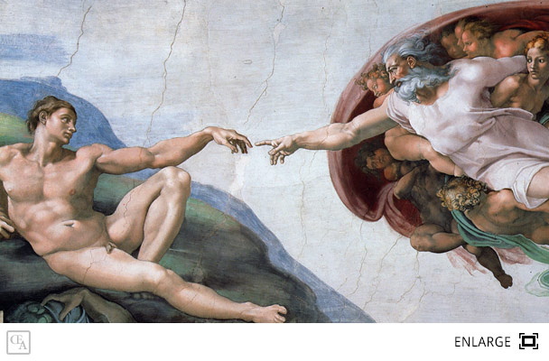Creation of Adam by Michelangelo: [www.artpieces.net](http://www.artpieces.net)

The creation of Adam, amongst all the breathtaking paintings that occupy all of the huge Sistine Complex Ceiling is, without doubt, the one that has most considerably made an impression on posterity. Even though the painting *The Creation of Adam* was done around 1511, it was in 1990 that a physician named Frank Meshberger publicised its existence when he wrote a paper that was featured in the Journal of the American Medical Association, decoding the imagery by Michelangelo, with the remarkable cognizance that the presentation in God Creating Adam was a precise anatomical exemplification of a person’s brain in transection. Meshberger theorised that Michelangelo beset God with a shroud characterising the human brain to insinuate that God was bestowing Adam in addition to life but also with superior human intelligence (Meshberger, 1990).

Another outlook is that hidden within the robes and the figure of God’s face, which represents the human brain – is perceived to be an attempt by the artist to dissent the contempt by the church for science. He also became tired of the corruption of the church and it was during this period that the church had denounced a monk named Copernicus when he theorised that the Earth rotates around the sun. It was a challenging time when scientific observations were not accepted in addition to intense conflict between Protestants and Catholics. Nonetheless, at present, the church has come to accept various elements of science, as alluded by the painting that Adam’s bestowed intelligence medicines are developed by scientists, and, even though, for instance, the church believes in divine healing, they also believe that God gave man the know-how to find cure. It is no secret that Michelangelo’s relationship with the Catholic Church became strained. The artist was a simple man, but he grew to detest the opulence and corruption of the Church (Fields, 2010).

An alternative meaning of why Adam lazily stretches his arm out could be the reason why God told Adam not to be lazy and toil for his livelihood. What is the same from the picture as it is today is that a large proportion of people believe that God is a spiritual being, and, when he created man, he gave him intelligence. This outlook, in practical terms, can be seen with the marvelous innovations and infrastructure that man has/is able to actualise. On all accounts, man uses his intellect in day-to-day life, and being lazy is not an option if one wishes to live a good life.

References

Fields, D. (2010). *Michelangelo’s Secret Message in the Sistine Chapel: A Juxtaposition of God and the Human Brain*. <https://blogs.scientificamerican.com/guest-blog>.

Meshberger, F. (1990). *An Interpretation of Michelangelo’s Creation of Adam Based on Neuroanatomy.* WellCorps International. wellcorps.com