E-PROJECT TITLE
“Liberty Electronics”

Teacher Name: Sir Jazib Aleem
Students:
Taha Muhammad Shahzad
Danish Wazir

Aptech Computer Education
Karachi, Pakistan

Aptech Computer Education
Certificate

This is certified that

Mr. Taha Shahzad / Danish Wazir

Have successfully Design and Developed
LIBERTY ELECTRONICS
Submitted by:
Taha Shahzad / Danish Wazir

Authorized Signature: Sir Arsalan

Aptech

Computer Education

Project Reported

By
Taha Shazad

Project Title: Liberty Electronics
Members Name: Taha Shahzad / Danish Wazir
Enrolment No: (Taha-78812852979) (Danish-788-13-852974)
Batch Code: CF201410B
Time Slot: 11:00 AM to 3:00 PM
Start Date: 06-FEBUARY-2015
End Date: 27-FEBUARY-2015
Course: ADSE (CPISM)
Teacher: Sir Jazib Aleem
Center Manager: Sir Nasir
Faculty Head: Sir Arsalan
Center Name: GLS Karachi, Pakistan

Submitted as
E Project Documentation

Acknowledgment

First and foremost, I would like to express my deep gratitude and most heartfelt thanks to almighty ALLAH for his blessings, for lightening up my heart with the torch of knowledge and for giving me the ability to complete this project.
I would like to thank Aptech and the team of E-Project for their generous support and clarifying the doubts regarding e-project. I would like to acknowledge the way of explanation which the team of e-project gave in e-project to make website and I am equally grateful to my teacher (Sir Jazib) for giving me a moral support and guiding me in different matters regarding project in all the time about the research and writing of this project.

Table of Content

Sr.No | Contents | Page No
01 | Problem Definition | 6
02 | Software Requirements | 7
03 | Hardware Requirements | 7
04 | Project Plan | 8
05 | Site Map | 8
06 | Page Structure | 8
07 | Check List of Work Progress | 10

Problem Statement

.

Requirement Specification:
The Web site is to be created based on the following requirements.

- The Home Page with some description about the club with proper template designed. (Also navigational link must be included.)
- The link Products like “Moibles”,”Tablets”,”Laptops” and “Cameras” .
- Membership link must be added in the website. ( a dummy form is supposed to be fill and submitted).
- Suggestion and complaints
- Feedback
- Contact Us
- Navigation facilities must be made précised in the application.
- Picture gallery must be added in the application.

Hardware/ Software Requirements

Hardware
- A minimum computer system that will help you access all the tools in the courses is a Pentium 166 or better
- 64 Megabytes of RAM or better

Software
- Notepad/HTML editor
- Dreamweaver
- IE 5.0/ Netscape 6.0

Project Plan

  - Website is able to execute quickly.

  - The color scheme of the site looks attractive (some predefined classes have been used throughout the website for styling eg margin_zero_auto to center the content etc..).

  - The collection of data is authentic.
  - There is complete information of products with their images in a gallery. (generated by javascript by rop_nav.js).

  - Javascript is used to compare the products (generated by compare_main.js).

  - The contact page is well prepared exactly for the same page as user clicks on the link.

  - We’ve used the latest technology where user just click and find the desire info easily.

  - About us page contains the information about the company.

SITE MAP

HOME
PRODUCTS
Products
CONTACT US
Apple

Mobiles

Get in Touch

Laptops

Samsung
Products
Comapare

Location Map

Google
Tablets

About

Social Media Links

Sony
Cameras & Lenses

Contact Us

Nikon

Address & Contact

Wearables

Snapshoots of the Project

Home Page

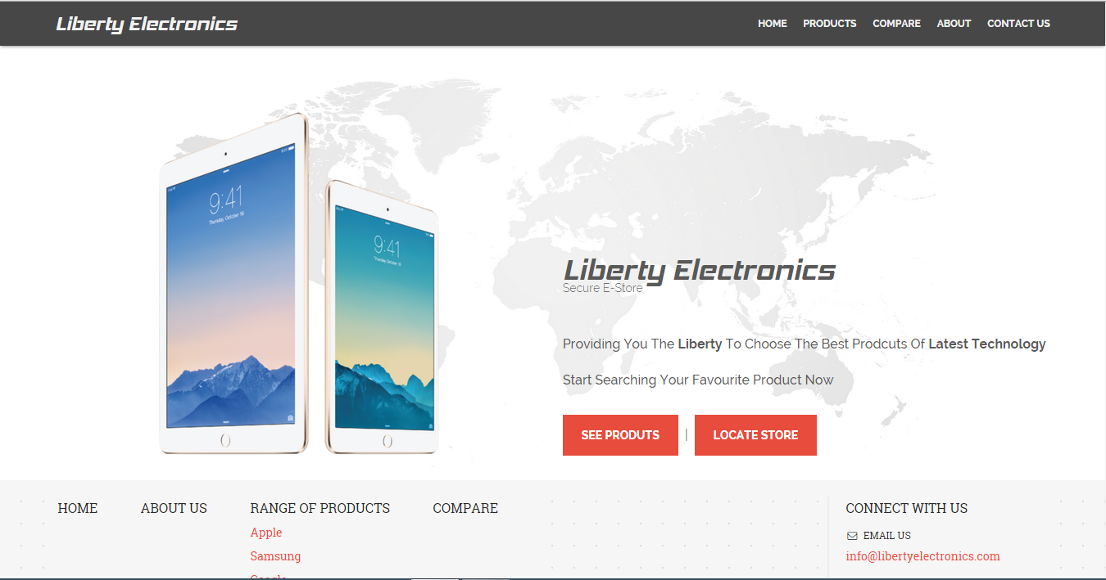

Contact Us

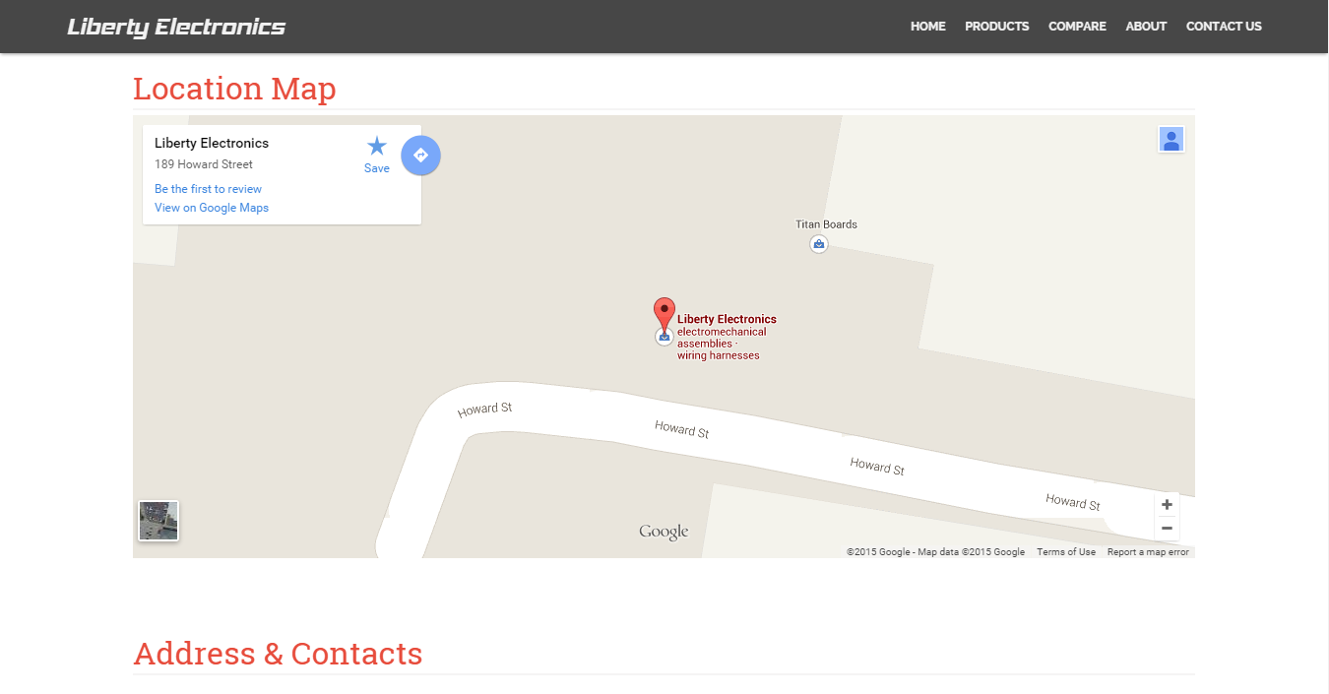

Gallery Page

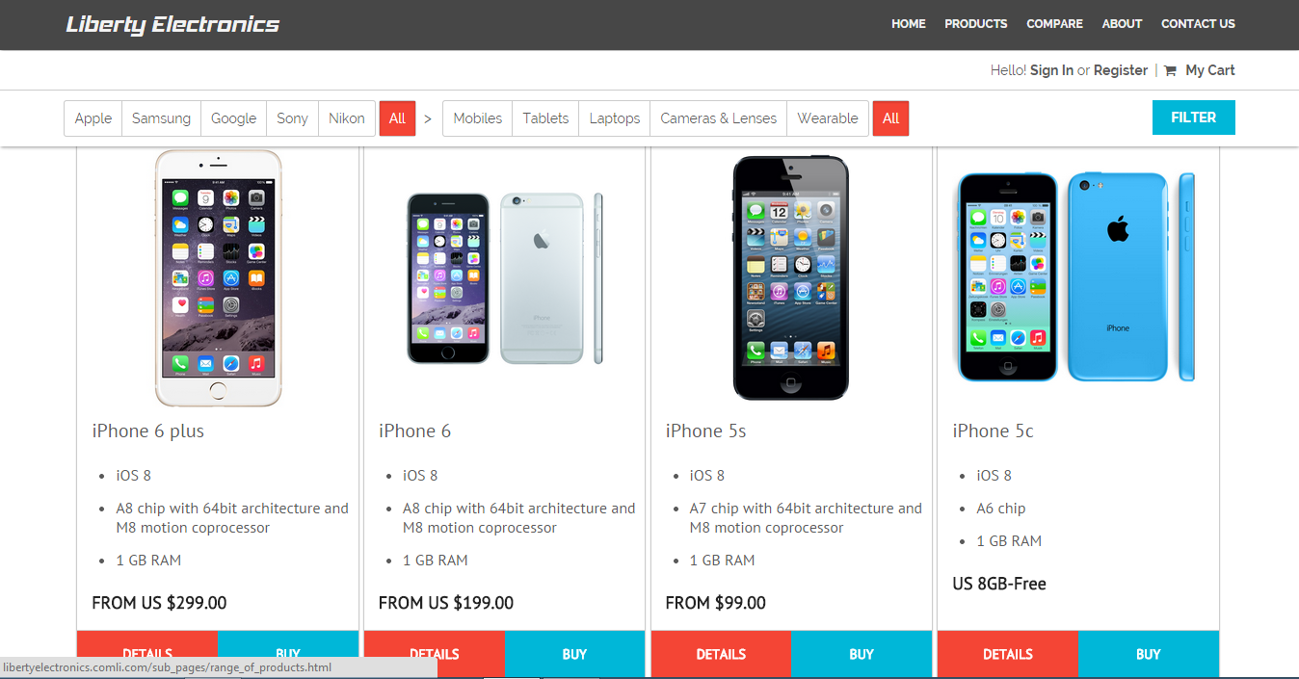

Compare Page

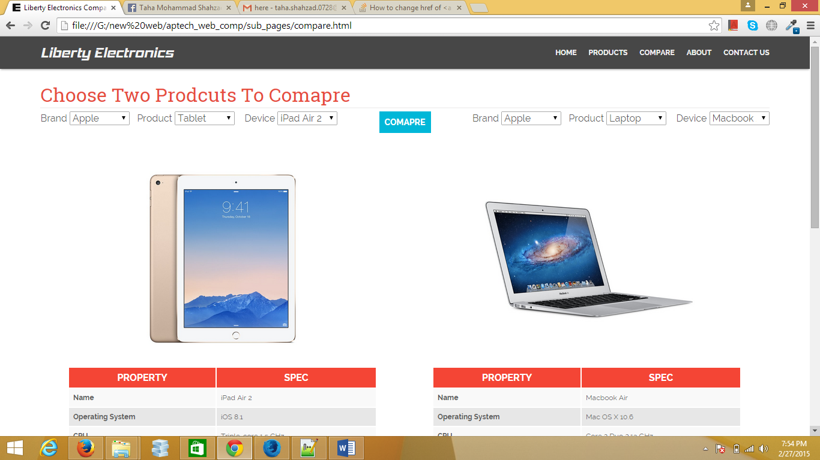

Check List of Work Progress

Sr.No | Aspect Tested | Remarks
1 | Data Collection | Yes
2 | Normalization | Yes
3 | Designing Home Page | Yes
4 | Developing Pages | Yes
5 | Linking Pages | Yes
6 | Finalizing the Site | Yes
7 | Testing the Site | Yes

