Usage Notes for WinSMTPServer

License:
WinSMTPServer was originally created by Chris Laforet Software (www.chrislaforetsoftware.com) and has been released to the world under the Mozilla Public License version 1.1 whose text can be found at http://www.mozilla.org/MPL/MPL-1.1.html for your perusal.

The contents of this file are subject to the Mozilla Public License
Version 1.1 (the "License"); you may not use this file except in
compliance with the License. You may obtain a copy of the License at
http://www.mozilla.org/MPL/

Software distributed under the License is distributed on an "AS IS"
basis, WITHOUT WARRANTY OF ANY KIND, either express or implied. See the
License for the specific language governing rights and limitations
under the License.

The Original Code is based on Strainer, a Spam filtering engine, created by and Copyright (C) 2004, Chris Laforet Software, Inc.

The Initial Developer of the Original Code is Chris Laforet from Chris Laforet Software. Portions created by Chris Laforet Software are Copyright (C) 2010. All Rights Reserved.

Contributor(s): Chris Laforet Software.

General information:
It is important to note that WinSMTPServer is a relay SMTP (store-and-forward) server and not a full-fledged Email server. This is important to note because WinSMTPServer does not provide mail storage along with POP3 and IMAP mailbox protocols. As stated earlier, it is a store-and-forward system that merely accepts connections from an SMTP client, accepts one or more messages bound for another server, and then delivers the messages to the MX (Mail Exchanger) servers for the ultimate Email target systems.

It came into being after I discovered that my Windows 7 did not have the standard Microsoft SMTP server that I was used to from NT, Windows 2000, and XP days. I decided to write one for the “fun” of it, and here it is in all its glory for your personal enjoyment.

Setup and Configuration:
WinSMTPServer, as shipped, depends upon a SQL Server 2008 server being configured on your Windows computer. If you do not have SQL Server 2008, you can download and use the free SQL Server 2008 Express from Microsoft. This package can be downloaded from http://www.microsoft.com/express/Database and installed on your target computer. You will need to download the Database and Management Tools package to get going.

To create the database, use the SQL Server Management Studio. Log in and right click on Databases under the server. Select the New database option:

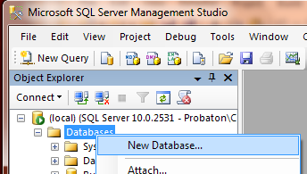

Key in the name of the database (WinSMTPServerDB) and I would recommend changing the initial sizes of the database to no less than 10MB and the log to 3.

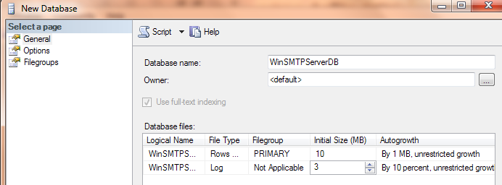

Clicking OK will create the database. To create the database tables, scroll down to the newly created database and right click on its name. Select the New Query option as shown below:

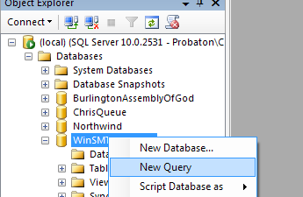

This will open a query window pane. Click on Edit then select Insert file as text to select the database script (or open the database script file in notepad, copy its text and paste it into the query window):

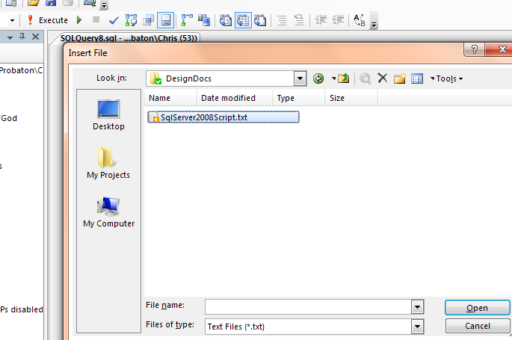

Either way, you now have a script loaded. Press the Execute button and the script will create all the tables that you need.

You can/should then create a new login specifically tailored to permit this database to be accessed from the WinSMTPServer system. To do this, follow the procedures that are documented on the Internet. Here are a few links to help get you started:

http://msdn.microsoft.com/en-us/library/aa337562.aspx
http://www.manifold.net/doc/example_configuring_sql_server_2008.htm

Make sure that you affiliate the login to have select, insert, delete, and update rights to this database only. The credentials for this login can then be inserted into the app.config files for the WinSMTPServer service and the WinSMTPServer management console. The app.config files are in the directories wherever you installed these components (see below) and they can be edited with plain old notepad. Look for the section beginning with <connectionStrings>:

Once this setup on the SQL Server has been completed, you can install the Windows SMTP Server service and tools. Run the setup.exe or double click the WinSMTPServerInstaller.msi and permit the installation to occur as Administrator. If you are not prompted, you may need to log out and log back in as Administrator. The same installer will permit uninstallation of the previous version and then the installation of a newer version as upgrades need to be done.
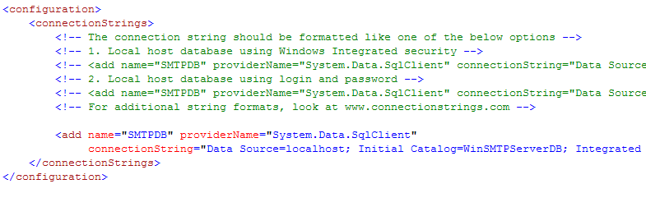
Once located, choose an appropriate form of the connection string to use. The default just uses Windows integrated security but you may prefer one of the other options which permit you to specify a specific login and password. For more in-depth information of different types of connection strings (if the samples are not good enough), look at ConnectionStrings.com (http://www.connectionstrings.com/sql-server-2008).

Remember to configure the app.config in both the service and the Windows console directories.

The first time you run this application on a Windows machine, you need to register the Event Source for the Windows Event Log. To do this, use the program called RegisterEventSource.exe one time. This application must be run as Administrator to work. To do this, select Start, All Programs, then right click on Command Prompt and select Run as Administrator:

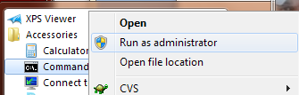

Find the directory containing the RegisterEventSource program and run the program. This is a screenshot of a successful run of this program as Administrator:

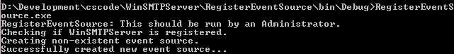

Here is an example of what you may see if you are not running this program as Administrator:

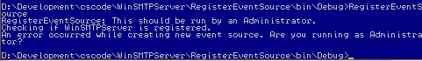
Next, run the Windows console application to configure your system. Select File then Configure:

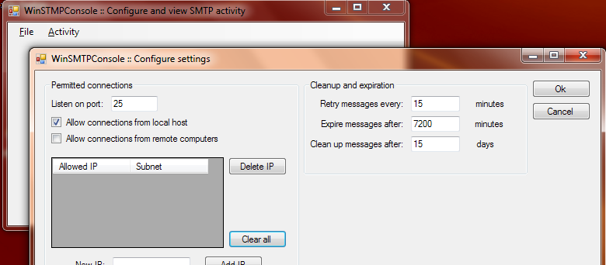

It is advised to not permit connections from any other computer other than localhost. If you must, then add the specific IP of an acceptable host with a subnet of 255.255.255.255 to lock it down as much as possible!

Depending upon your firewall software, you will also probably need to unblock the SMTP port from localhost to localhost. Below is a screenshot of how this is done using Norton Internet Security. This was reached by selecting Settings under Computer, Network Settings, Smart Firewall, Advanced Settings, then Settings under General Rules. A new rule was added to Allow traffic to and from other computers:

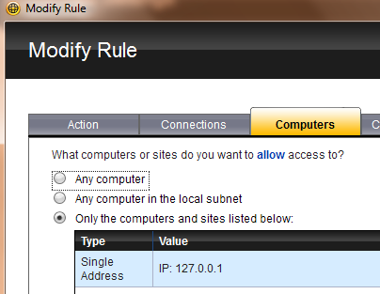

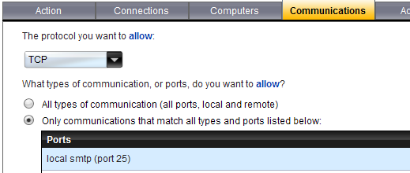

This rule was named and saved then moved up to the top of the list of rules to make sure that it would not eclipsed by another rule for the same port. Note that 127.0.0.1 is the address of the localhost, the internal address that the machine refers to itself as. It can only (technically) be reached by a process on your machine which makes it pretty safe.

Finally, start up the Windows service by selecting Start then Administrative Tools and then Services. While in this section, you can choose to start this program at will (set to manual, or have it start whenever Windows starts up. Make sure that you have also specified that your SQL Server starts when Windows starts if you plan to use this latter option).

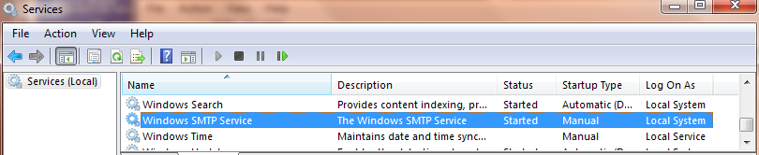

Double clicking on the service’s line will bring up the following screen which will permit you to start and stop the service manually. You can also set the startup type to Manual if you do not want it starting by itself at boot up.

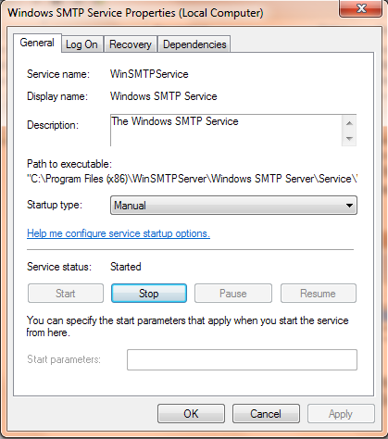

Error messages from the service will be logged in the Windows Event Log which can be reached through Start then Administrative Tools then Event Viewer.

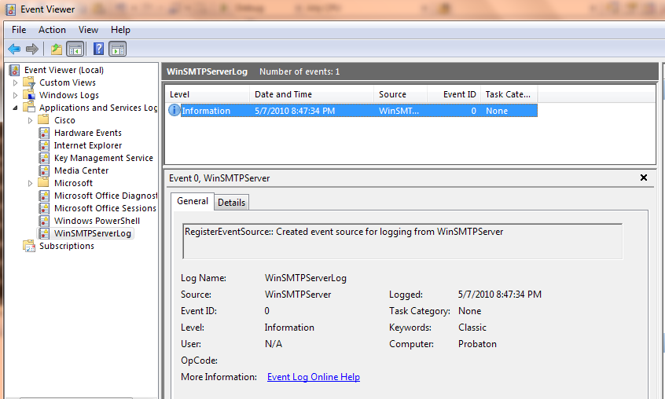

Here is a more realistic shot of the Event Viewer after the server has been started up.

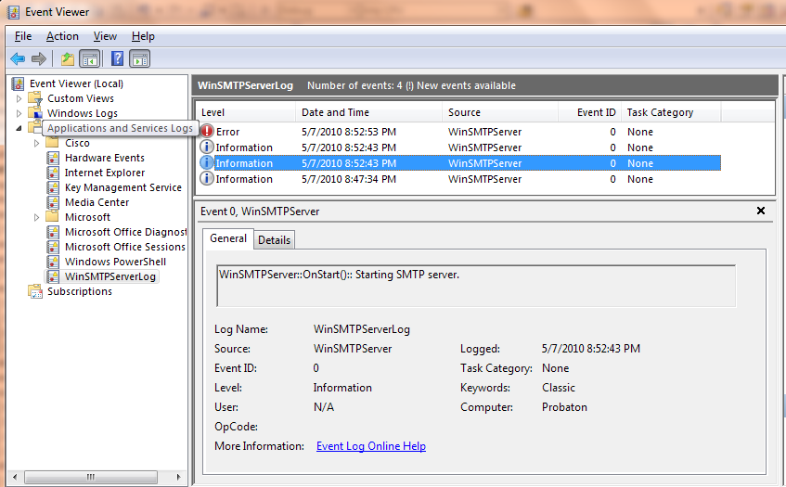

If your service has started successfully, you can now test it by opening a command prompt window from Start then Accessories. Type the following in and press Enter:

C:> telnet localhost 25

This should connect and you should see your SMTP server respond with a greeting. Type the following HELO xyz followed by an Enter and the SMTP server should, in turn, give you an acknowledgement. Finally, type QUIT and press Enter and the SMTP server should say goodbye to you. Here is a screenshot of what this test should look like:

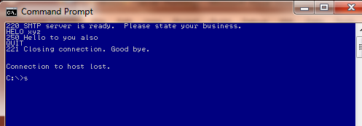

This indicates that everything is ready to go.

Version-specific information:
The initial release of the WinSMTPServer code is version 0.90.01. This is, technically, a full release and can eventually become version 1.00.00 but it is preferable to have some folks test it to see if there are any little issues that need tweaking first.

The source code is available from its SourceForge repository at:

https://sourceforge.net/projects/winsmtpserver/

